Getting started with WordToEPUB

Introduction
With this free tool from the DAISY Consortium you can quickly and easily convert Word documents to the latest EPUB 3 format. EPUB is a wonderful format for reading publications on laptops, tablets, and smartphones, and it includes features such as rich navigation and great accessibility. The EPUB files created with this tool can be used in a wide variety of reading apps on any platform, with the ability to personalize visual features such as colors, font, text size, and layout. Many reading apps have other useful features such as read aloud, the ability to add comments and bookmarks and support for electronic braille.

Who should use WordToEPUB?
Are you a lecturer or professor with students who want to read their materials in digital form? There are millions of digital textbooks and journal articles in EPUB format. Now you can provide your documents to students in a format designed for reading on the devices your students use (whether computer, tablet or smartphone), with an experience that can be personalized by everyone to meet their diverse needs.
Are you an author or report writer creating your own work? Now you can use the same publishing format as adopted by the publishing industry worldwide. You can check how your work will appear as you go, and make an eBook for distributing from your own blog or upload to multiple retail platforms with confidence.
Are you a team making accessible books for people with print disabilities? With WordToEPUB your volunteers and staff can use familiar skills to edit materials in Word, and then using the advanced features of WordToEPUB generate valid and accessible digital books that can be read with a wide variety of apps and devices, including audio players and braille displays.

Background to the Word to EPUB tool
This tool is developed as a volunteer project under the auspices of the DAISY Consortium. It provides a simple but powerful method to create EPUB files from Microsoft Word documents. You can also produce EPUB from Google Docs, Apple Pages and Libre Office, but you should find you get the best results with the combination of Microsoft Word and WordToEPUB from the DAISY Consortium.

Requirements
To use WordToEPUB you will need:
- Windows 7, 8 or 10 (earlier versions may work but are untested)
- Word 2010 or newer (earlier versions may also work)
In the future we may provide versions for macOS, mobile and in the cloud.

Downloading
You can read about WordToEPUB and download the current release at:
https://daisy.org/wordtoepub

Installation, updating and uninstalling the tool
Start the setup program and follow the simple steps. You will have the option to add a desktop icon and to install a button on the ribbon as a Word Add-in.
When you run the program, if there is a newer version available it will prompt you to update. You can turn this automatic checking off in Settings. Also, in Settings, you can manually check for an update.
To uninstall the program, use the Windows “Add or remove programs” feature. You can remove the Word Add-in this way also.

Create an accessible document in Microsoft Word
You can use regular Word documents to make EPUBs. If you make a great Word document, you will get a great EPUB.
The document “Creating accessible Word documents” provided with this tool describes in detail the process of creating accessible Microsoft Word documents. In addition, there’s lots of information freely available on the web to help you.
In brief, make sure that you:
- use the built-in styles for headings, this is necessary as the bare minimum
- use the proper Word feature for bulleted and numbered lists
- for a blockquote, use the built-in styles for Block Text
- ensure that images are inline (floating images will be included but the placement in the text will be unpredictable)
- provide alt text for non-decorative images that are not described in the surrounding text. For guidance on image description visit http://diagramcenter.org)
- insert proper Word tables, not images of tables
- if you have references to footnotes and endnotes, use the proper Word feature (i.e. References / Insert Endnote)
- if you include web addressed in the document, make them links (Insert / Link) and the user will be able to activate them in the EPUB
- include information such as title and author in the document properties

Use the accessibility checker
Make sure you’ve done your best to make an accessible document with the built-in accessibility checker in Word. This will help you identify issues that aren’t readily apparent. The way you get to this varies between versions. On recent editions of Word, move to the Review tab on the ribbon. Then select Check Accessibility.
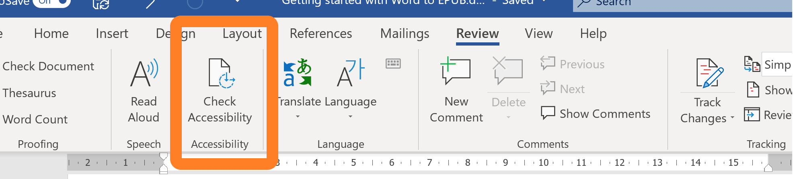
On older versions, select File > Info and select the Check for Issues button. Then select Check Accessibility from the drop-down menu.
The latest versions of Word provide the best accessibility features and the checker is easier to use.

Using the DAISY WordToEPUB tool
The tool can be used from within Word itself, or as a standalone application.
From within Word: the document you want to convert should be open. From the Home ribbon, select “WordToEPUB”. In the next step, confirm the filename and folder for the EPUB and select OK. Congratulations, you made an EPUB!
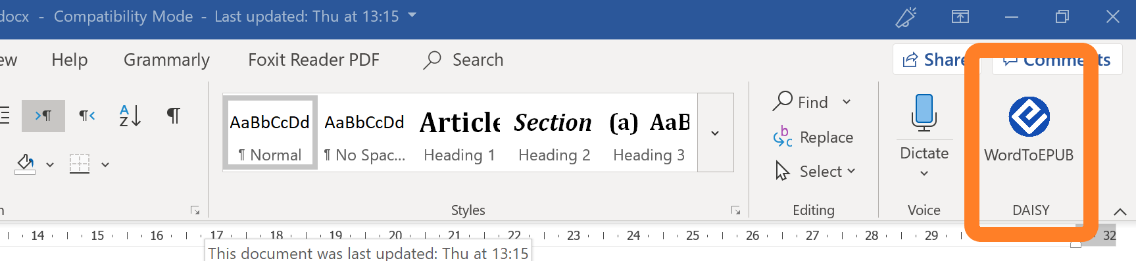
As a standalone program: Start the WordToEPUB program from the menu or desktop shortcut, then select the document you want to convert.
Alternatively, use File Explorer to select the Word document you wish to convert, then press right-click (or shift-F10) to bring up the context menu and select “Convert with WordToEPUB”.
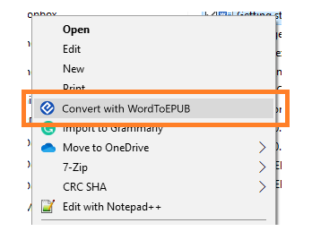
Confirm the filename and folder for the EPUB and select OK. Congratulations, you made an EPUB!
For additional features, select the "Advanced" button. Now you can change the cover image, language, page/text direction, metadata and more. See More advanced features

Read the EPUB on your choice of reading system
Now you have your EPUB, you can open it in an app that supports your reading preferences. Whilst you made the EPUB on Windows, you can read it on Windows, macOS, Android, iOS, in a browser or on a special reading device. Popular choices include Thorium on Windows and macOS, and EasyReader on iOS and Android, but there are many others for you to choose from.
The DAISY Consortium coordinates accessibility testing of EPUB reading systems by volunteers and accessibility experts. For more information about reading systems, including reviews and detailed test results, you can visit https://inclusivepublishing.org/rs-accessibility/

Advanced features
This guide should get you up and running with WordToEPUB, but the tool can do so much more. Learn about this in the companion document Advanced Guide to WordToEPUB.

About WordToEPUB
Select the About button to learn more about the WordToEPUB tool. The release notes for the installed version can be read from here, and you can also submit feedback. We’d love to hear from you! If you prefer you can send us email at wordtoepub@daisy.org

