How to create a Work Order in Accruent/FAMIS
The following instructions outline how to create a Work Order in Accruent/FAMIS. All current Staff and Faculty at UM have access. The form is best tackled with a top-down approach, as selections you make early on influence what you can select further down the form. Any field with a red box is a required field.
Navigate to the Create Request tab. 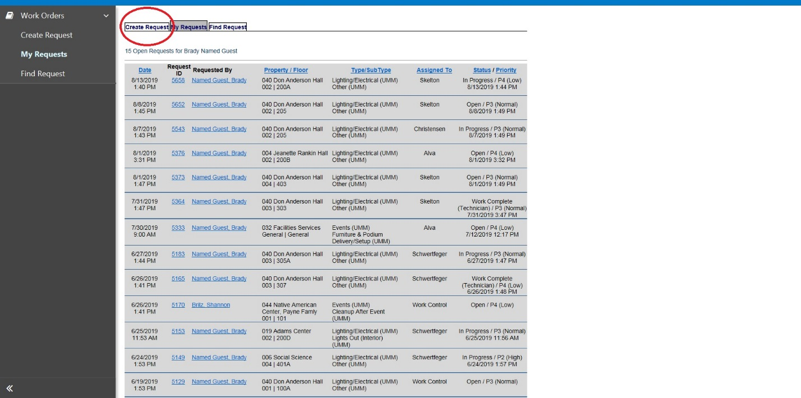
On the Property line, click the Select link. 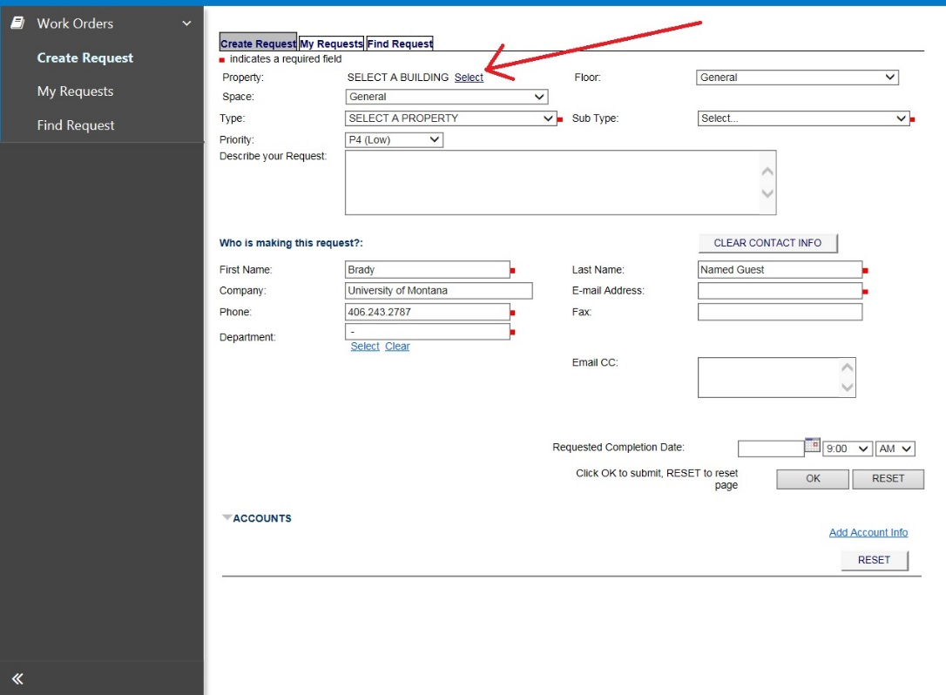
A pop up screen will appear. In the blank field on the left, enter the name of the building where the requested work is taking place. Ignore the Region field.
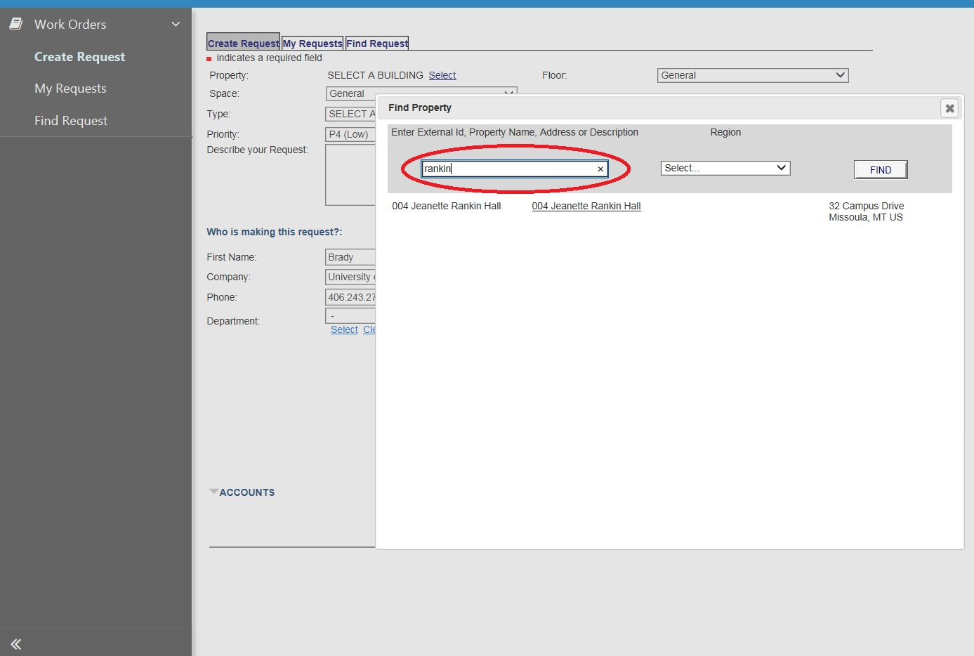
On the Floor line, select the appropriate floor from the dropdown menu. 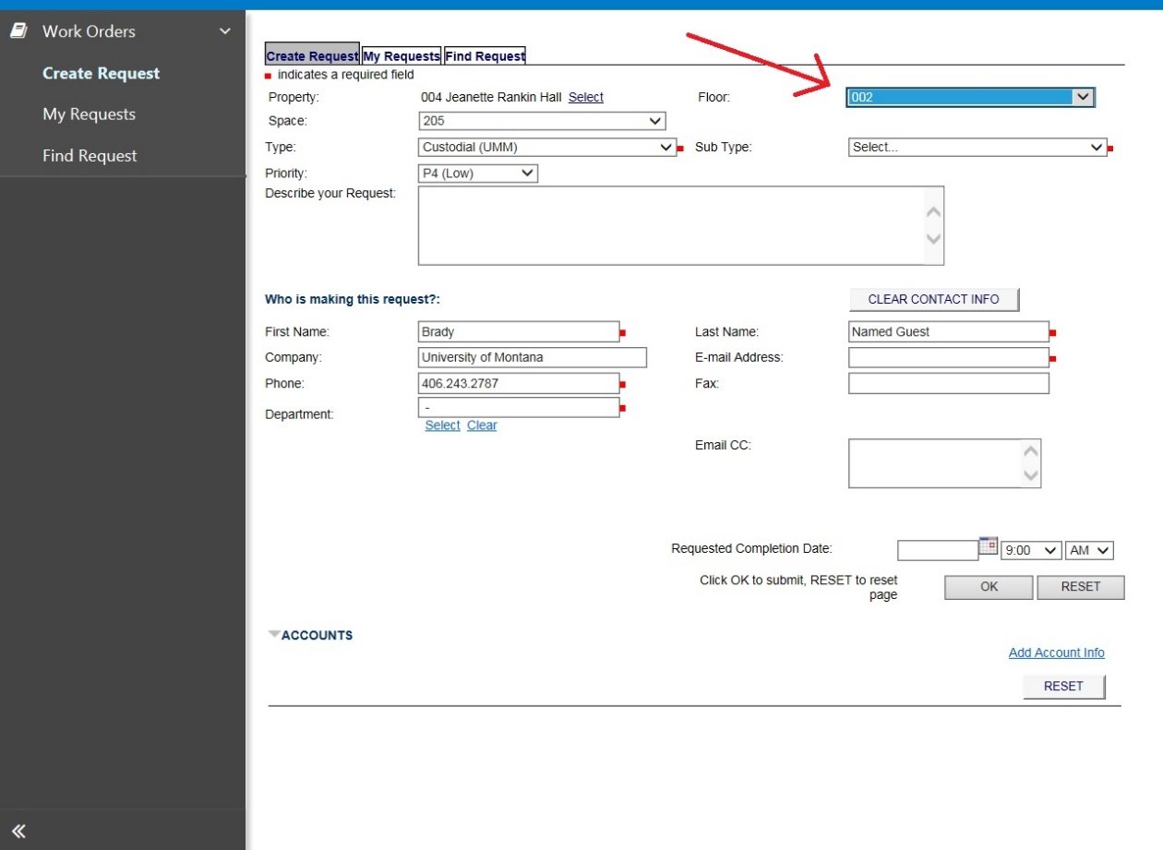
On the Space line, select the appropriate room number from the dropdown menu. 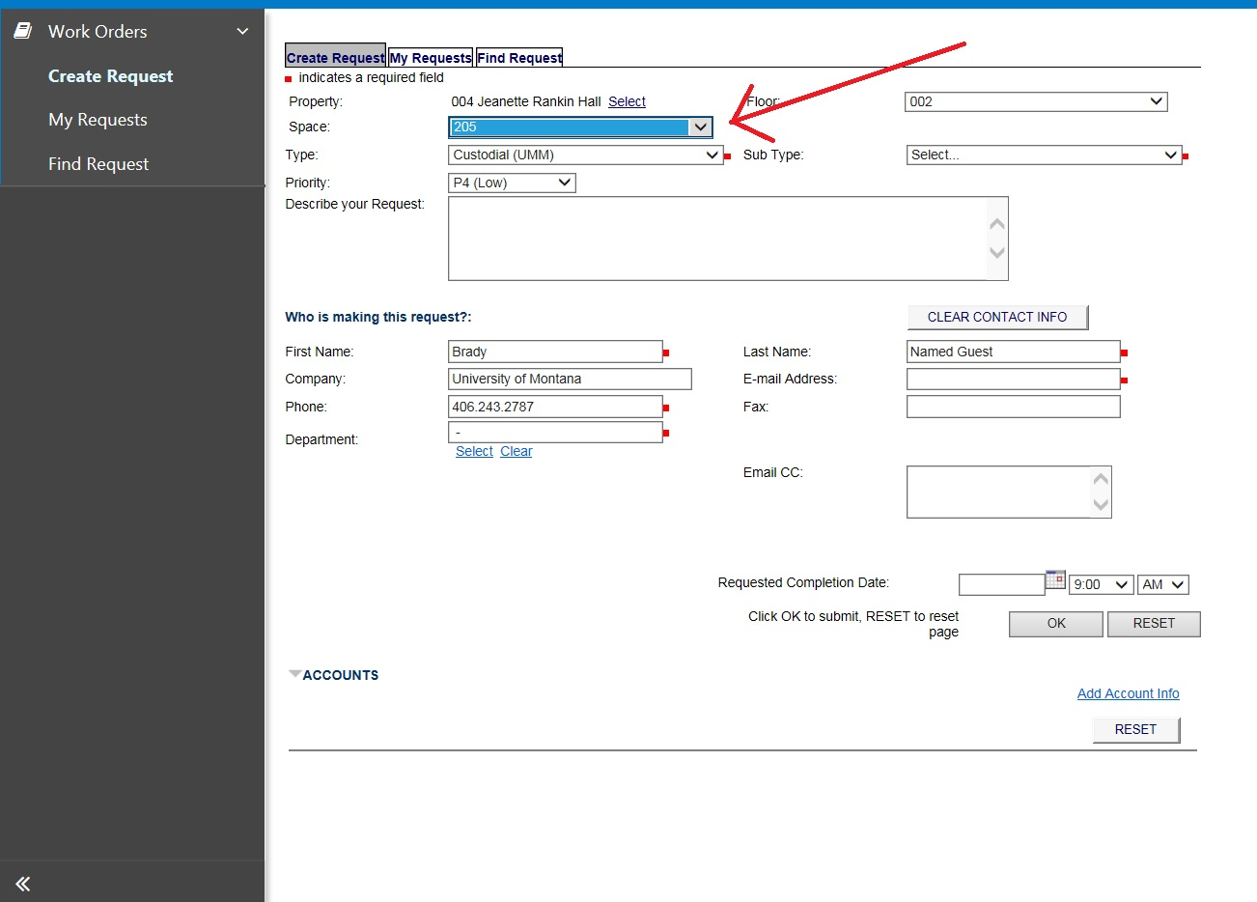
Select a Type from the dropdown menu.
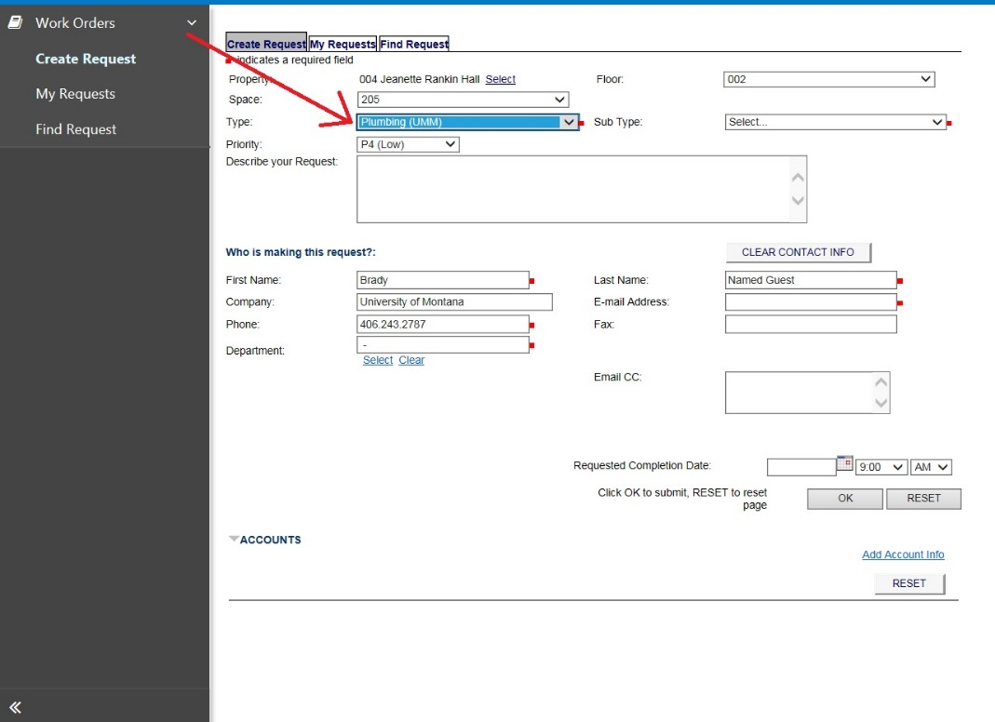
All work requested should fit in one of these general categories. To further refine the nature of your request…
Select a Sub Type from the dropdown menu.
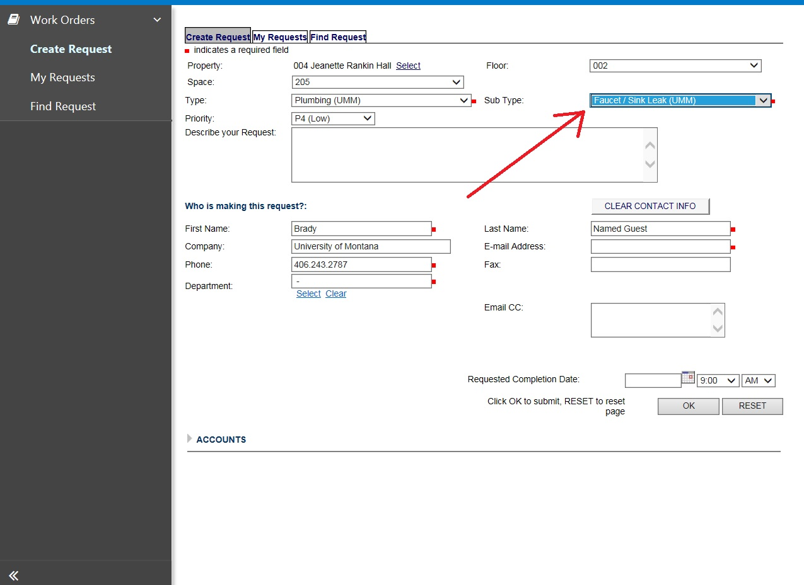
Select a Priority from the dropdown menu.
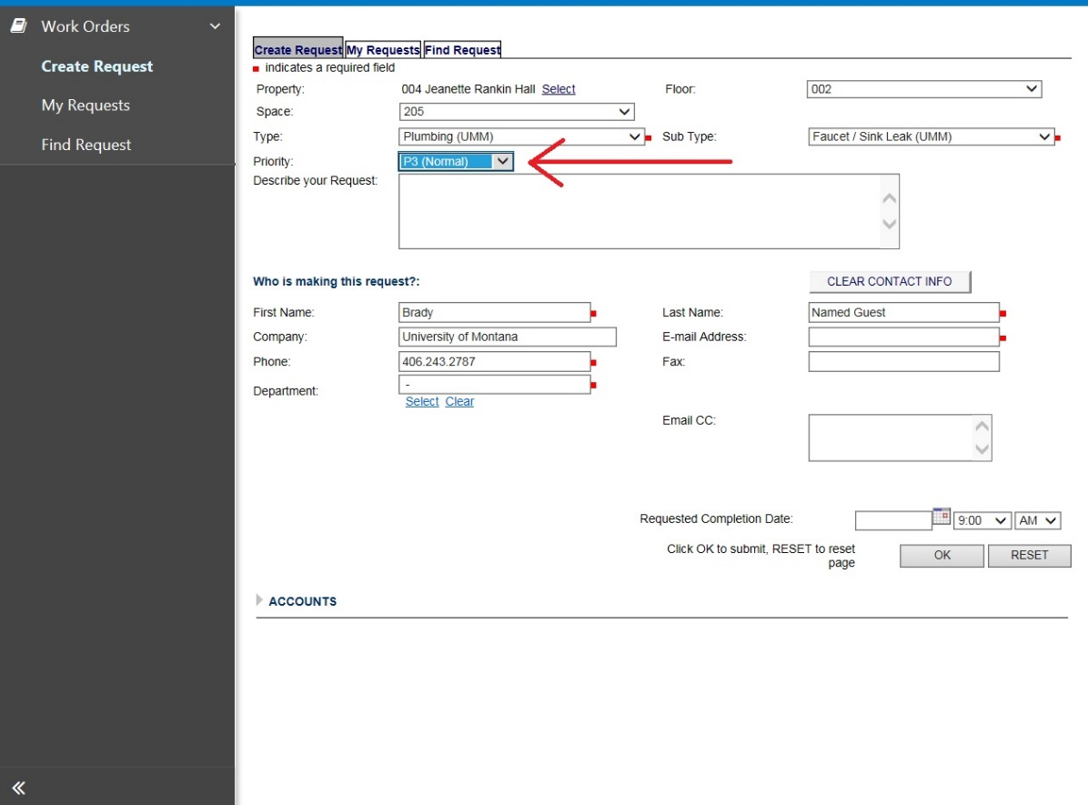
In the Describe your Request field, enter the details of the work you are requesting.
This field is effectively limitless, so we encourage you to be long-winded with your description so that we know precisely what it is you are requesting.
Note: Descriptions on Banner Reports will concatenate the Work Order number with the remaining characters from the front end of your description. In light of this, we recommend not starting your description with something like, “May I please have someone fix...” Instead, provide a succinct 20-character summary at the beginning of your description, like “DHC102 LIGHT OUT.” From there, press Enter and continue in more detail.
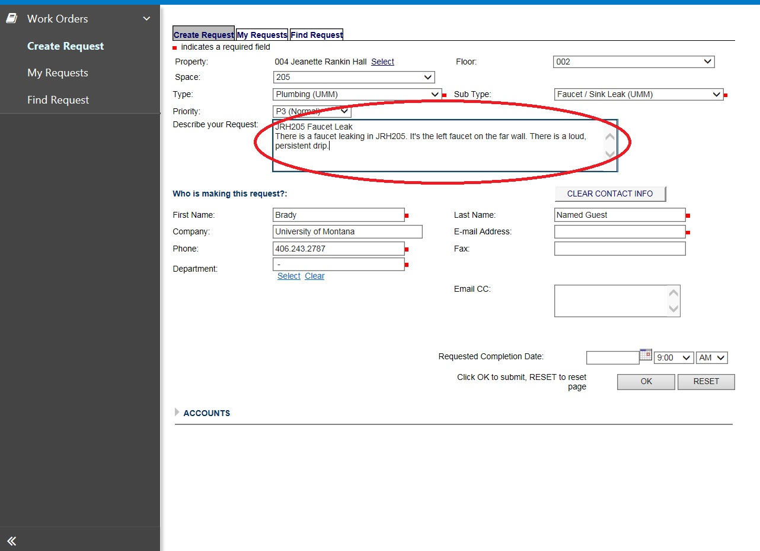

Verify the contact information in the Who is making the request? field.
This defaults based off of your User record, which is in turn pulled directly from Banner.
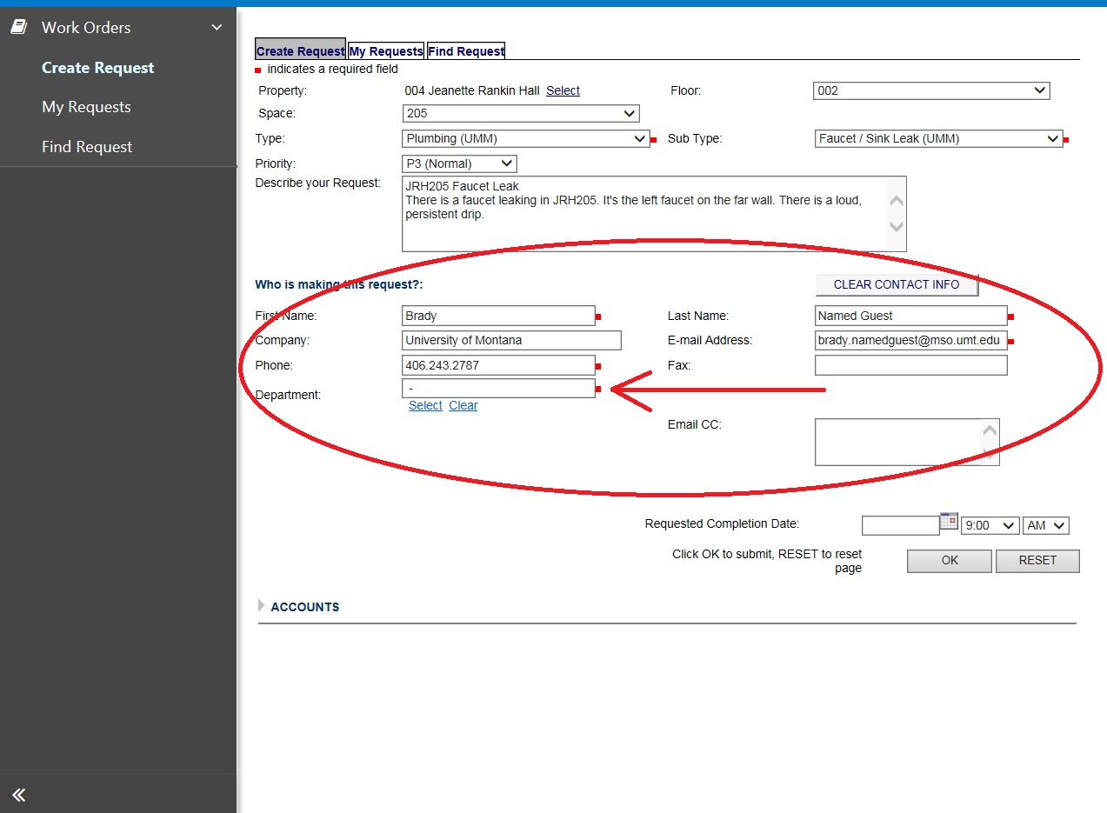
Though it is optional, Department can be added manually. Click the Select link underneath the empty field.
A pop up screen will appear. In the blank field, enter the name of your department.
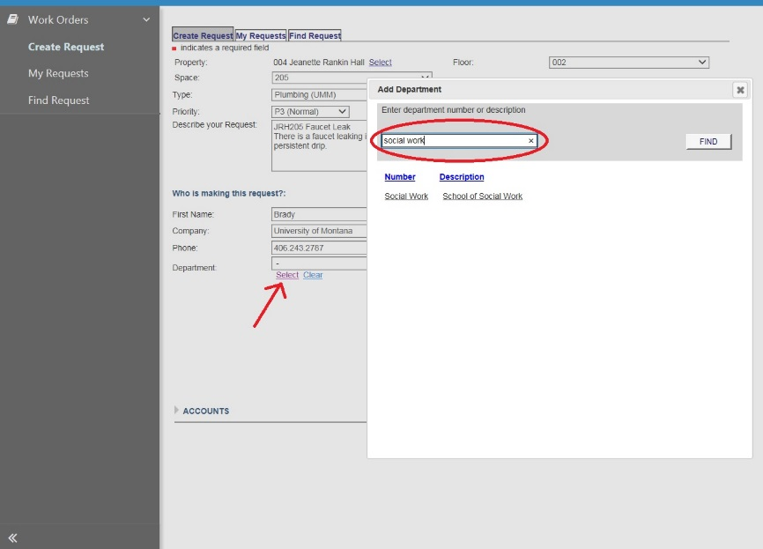
If necessary, enter a Requested Completion Date for when this work should be finished. Please also make note of this in the description of the request.
Navigate to the Accounts slider.
If the work being requested is taking place in a State-funded building, and the nature of your request is one that Facilities Services typically covers, our Account String (MFSM03-62701-311001-323120-OM07) will populate by default. In this case, you need not provide your Index and Account information.
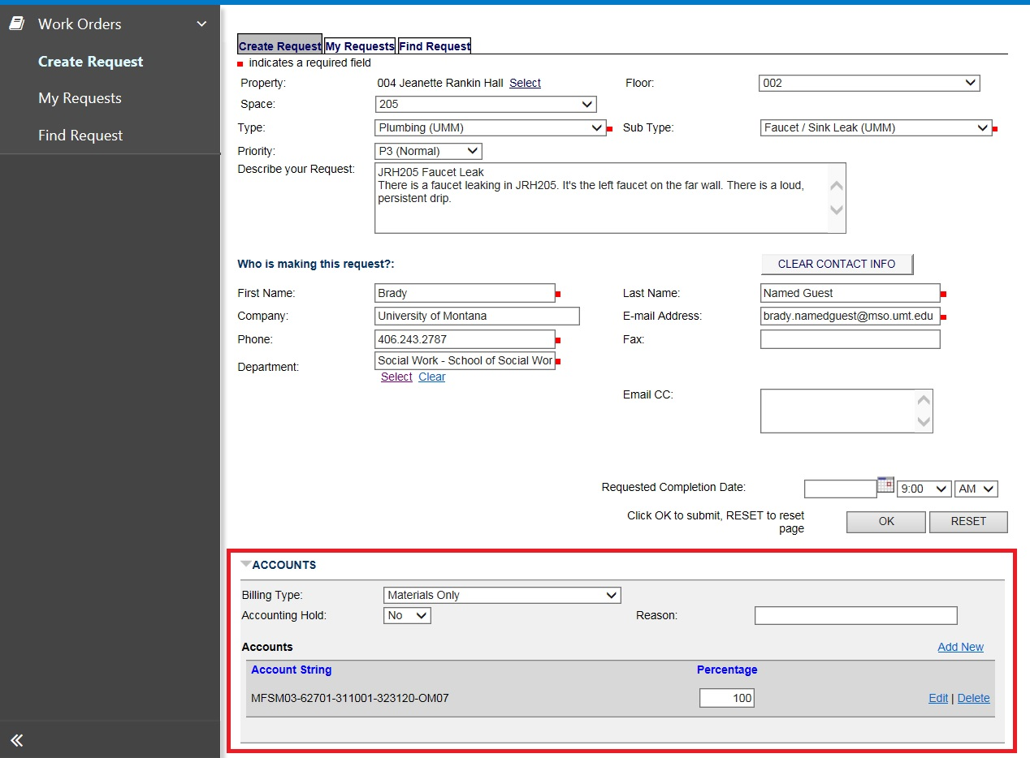
If the work being requested is taking place in a non-State-funded or Auxiliary building, you will need to provide your Index and Account information. In this case…

Click the Add Account Info link on the bottom right side of the page.
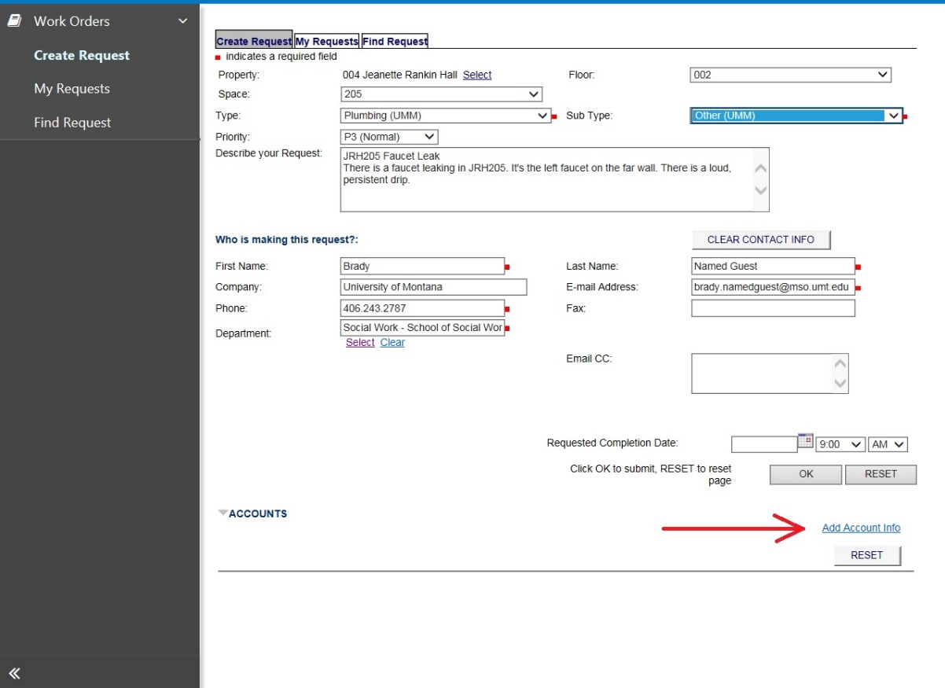
An expanded area will appear underneath the Accounts slider. Note: Billing Type will always default to Charge—this can be left alone. Accounting Hold and Reason should be ignored.
Click the Add New link.
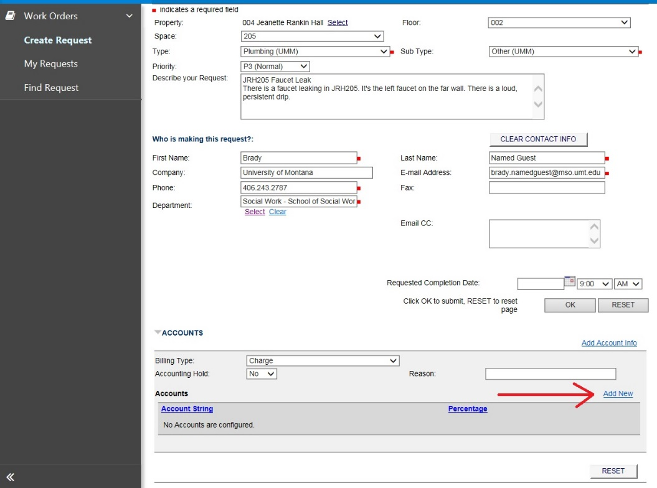
In the pop up screen, start at the top and enter your Index number in the Account Index field.
Note: The dropdown list will change to reflect the text of your entry. Select the matching Index from the dropdown, do not Tab or click off the field.
You will likely see some combination of the Index, Fund, Org, and Program fields populate once you’ve made your selection. From here, select or enter your account information in the Account field.
Click the ADD button. 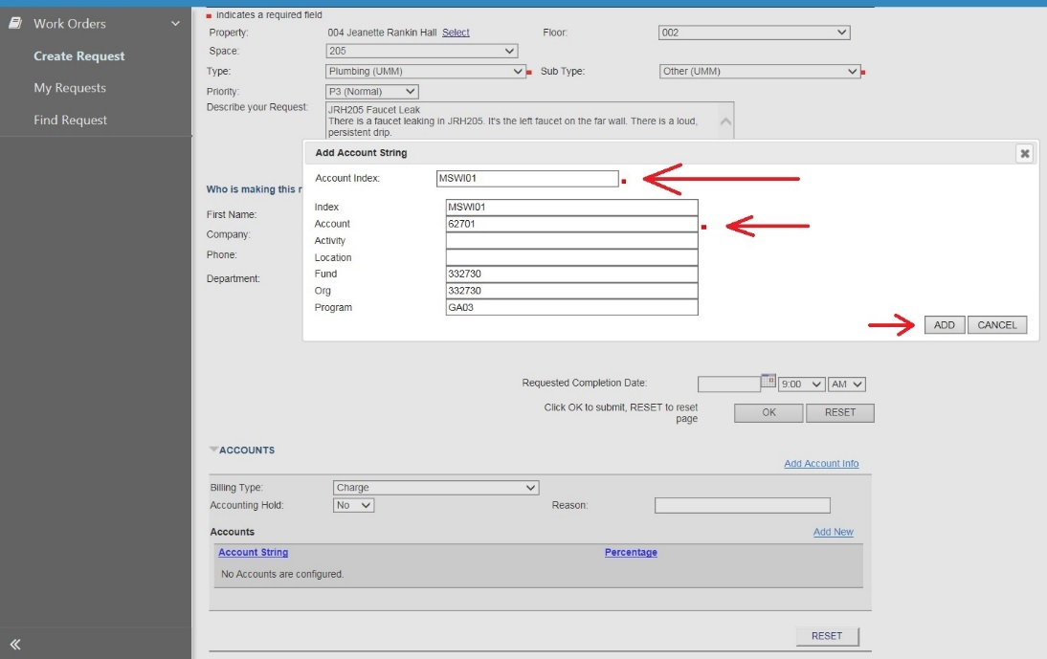
Click the OK button to submit your Work Order.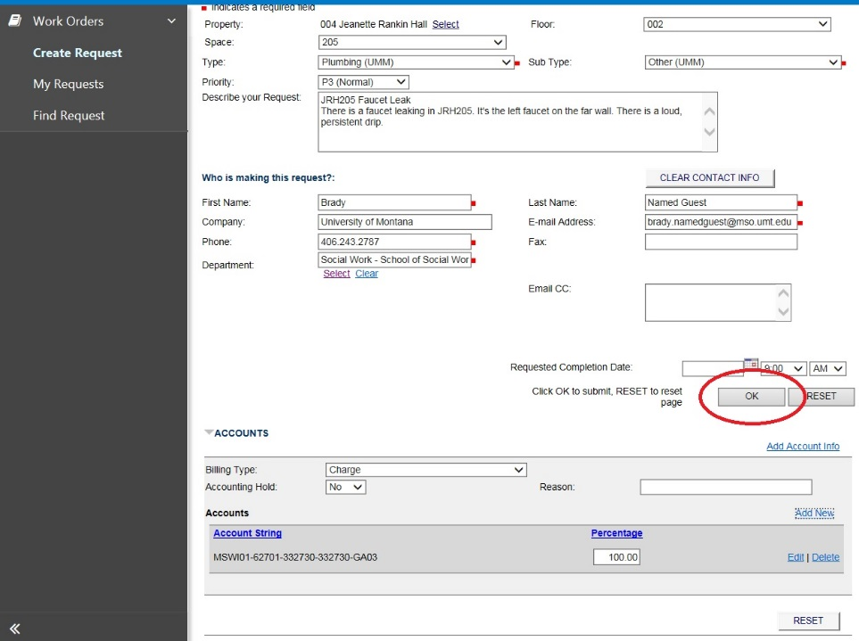
The resulting screen will provide you with your Work Order number for reference. Click the link in your number to view your request, or navigate to the My Requests tab.

