Managing “Cases” in Navigate – guidance for advisors and other users
Introduction
Alerts can be configured to automatically open a case. A case is an electronic case file where staff across departments can coordinate and collaborate on the follow-up with the student. Cases create a formalized next step for action or intervention on the issued alert, should that be needed.
Important Note: Cases can only be opened automatically as a result of an alert. It is not possible to manually open a case on behalf of a student.

Viewing and Managing Cases
There are three ways to view and manage cases through the Navigate platform: the Cases page, a Student Profile, or through Standard Reports.
Important Note: You cannot view your assigned or owned cases from your Staff Home page.
- Cases Page
With the correct permissions, you can view and manage all open and closed cases on the Cases page (see screenshot below. Please note the checkbox for “My Students Only” that allows advisors to display cases for their assigned students only). It is a streamlined view where users can access and search all cases they have permission to view in one place.
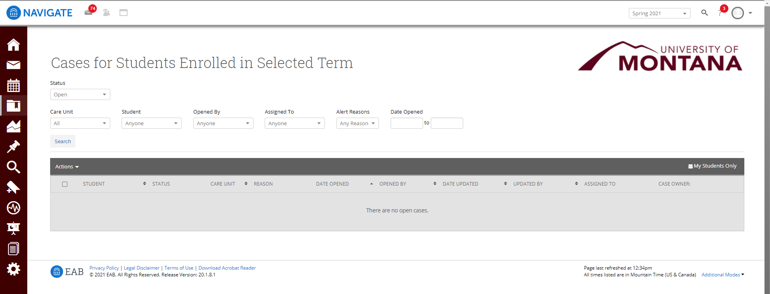
The table of student cases has the following column headers.
Student: Student name associated with the case.

Status: The status of the case, which can be open or closed.

Care Unit: Care Unit the case is associated with. Cases can only be associated with ONE Care Unit.

Reason: The alert reason that triggered opening the case.
Date Opened: Date the case was originally opened.

Opened By: Staff member who issued the alert.

Date Updated: Date the case was last updated. This could also be the date of closing the case.

Updated By: Staff member who last updated the case.

Assigned To: The staff members assigned to follow through on the opened case.

Case Owner: The case owner is someone who has been assigned to and is managing the case.

From this page, you can also manage the case from this section by selecting Manage Case (as shown in screenshot below).
The following list is information and actions in the Manage Case dialog (shown in screenshot below).
Student Name: Name of the student for whom the case is opened.

Class: The course associated with the issued alert.

Reasons: The alert reasons.

Case Owner: The case owner is someone who has been assigned to and is managing the case.

Assignees: The staff members assigned to follow through on the opened case.

Case Activity: All recorded changes to the case owner or assignees, as well as documented comments and case closed reasons (if closed).

Add Comment: Select this option to add a comment to the case record.
Warning: Any information you enter into the Navigate platform pertaining to a student becomes a part of their official student record and may be subpoenaed by that student, as outlined in the Family Educational Rights and Privacy Act (FERPA). Reference the “Documentation” section in the UM Advising Manual for guidance on documenting appointments or other interactions with students.
*Close Case
*Select this option if the case can be closed. You are directed to the next page, prompting you to choose a required case outcome and add comments to provide context to closing the case. See this guidance document for an overview of general interventions for cases and when cases can be closed.

Case Outcomes (you must select one of these when closing a case):

- Student Contacted; No Response: choose this case outcome when you have attempted to contact a student at least three times with no success.

- Student Contacted; Non-Issue: choose this case outcome when you have successfully connected with the student and the student reports that they have resolved the issue and no further support is needed.

- Support Administered: choose this case outcome when you have successfully connected with the student and have recommended a course of action to address the issue.

- Student Took Recommended Action: choose this case outcome when you can verify that the student took your recommended action(s) to address the issue (e.g. student scheduled appointment with support unit you referred them to).

- Student Profile
To view and manage cases on the student profile, navigate to the student profile. On the right side of the profile, the total number of staff alerts for that student is listed at the top right (see screenshot below). This count includes all Alerts, Cases, and Progress Reports issued for the student.
Important. Because the total count includes all Alerts, Cases, and Progress Reports, you may find duplicate information. For example, if one Progress Report issues one Alert, which in turn opens a Case, the total count will be three to include each of those actions, even though they all originated from the same Progress Report. Be mindful of what the total count means when using that information to inform student interactions or follow up.
To view additional information about the open Cases, either select the X Open Cases link or open the History or Reports/Notes tab of the Student Profile.
You can view all open and closed cases for the student either in the Cases section of the Reports/Notes tab or on the History feed.
In the Cases section:

In the History Feed:
Important. If you are viewing the History feed but would instead like to view all Cases together, select the dropdown menu at the top of the History feed, and choose Cases for [Student’s Name]. This shows the Cases section view only.
Information provided in the Cases section includes:
Date Opened: Date the case was originally opened.

Date Updated: Date the case was last updated. This could also be the date of closing the case.

Reason: The alert reason that triggered opening the case.

Issued By: Staff member who issued the alert.

Assigned To: The staff members assigned to follow through on the opened case. For example, if the alert reason is Needs Tutoring, a case could be automatically assigned to the head of tutoring. A Financial Aid alert reason could be assigned to a financial aid services employee. These assignments are configured on the Alert Reasons page and depend on your institution’s user roles and configurations.
You can also manage the case from this section by selecting Manage Case (dialog box for Manage Case shown on the following page):
Information and actions in the Manage Cases dialog are the same as on the Cases page as described on pages 1-3 of this document.

- Standard Reports
To view case information for many students at once, open the Cases Report on the Standard Reports page.
The Cases report shows any case created by a user in the platform and associated details regarding that case. Each row represents a single case in the date range.
To understand the fields included in the Cases report, see the Cases Report Data Fields article.
The following actions can be taken from the Actions menu:
- Send a Message
- Delete Case: this action allows the user to delete the selected case(s).
- Add Note
- Add Ad hoc Summary
- Create Appointment
- Appointment Campaign
- Tag
- Add to Student List
- Show/Hide Columns
- Export Results

Case Notifications

Case Assignee or Owner
When a case is opened, a message will be sent to all staff assigned to the case, notifying them of the new case. The message will inform the recipient if they have been assigned to the case or marked as the owner of the case. See the following page for an example.
Original Alert Issuer
When the case is closed, a message is sent to the original alert issuer, notifying them that the case has been closed. This message is simply an example and may look different for your institution.
Note. The message only contains the information in the screenshot on the following page. It does not display the case closed reason, comments, or the name of the individual who closed the case.

