**UNIT STANDARDS REVIEW SIGNATURE FORM**

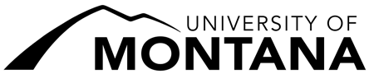

**Department of:**

**Year: _**

1) Department Chair:

Signature Date

2) Dean:

Signature Date

3) Chair, UM Unit Standards Committee:

Signature Date

4) Provost and Vice President for Academic Affairs:

Signature Date