**COMPRESSED GAS CYLINDER FACT SHEET**

Compressed gas cylinders can be extremely hazardous when misused or abused. Compressed gas cylinders can present a variety of hazards due to their pressure and/or content. Depending on the particular gas, there is a potential for simultaneous exposure to both mechanical and chemical hazards. Cylinders can also become flying projectiles when cylinder valves are damaged or broken off. Listed below are some regulatory requirements and/or guidance for proper storage and use of compressed gas cylinders on campus.

* The contents of any compressed gas cylinder must be clearly identified. Gas identification should be stenciled or stamped on the cylinder or a label. No compressed gas cylinder should be accepted for use that does not legibly identify its contents by name. If the labeling on a cylinder becomes unclear the cylinder should be marked “contents unknown” and returned to the supplier. Do not rely on the color of the cylinder for identification. Color-coding is not reliable because cylinder colors may vary with supplier.
* Always store cylinders in upright position. Gas cylinders **in use** must be secured at all times. It is recommended that all gas cylinders be secured with a chain or safety strap to prevent tipping and a potential fall/crush hazard. Always place valve protectors on gas cylinders when the cylinders are not connected for use.
* Cylinders must be protected from damage. Gas cylinders cannot be stored in public hallways or other unprotected areas. Do not store cylinders near elevators or in locations where heavy-moving objects may strike or fall on them. The proper storage for oxygen cylinders requires that a minimum of 20 feet is maintained between flammable gas cylinders and oxygen cylinders except when connected for use such as for oxy/acetylene welding.

**Moving Cylinders**

* Never drag, slide or roll a cylinder; use a

cylinder cart.

* Never transport the cylinder with the

regulator in place.

* Always have the protective cap covering the

valve when transporting the cylinder.

* Make sure the cylinder is secured to the cart with retaining straps or chains

before moving it.

**Use and Operation**

* Only properly trained personal should handle compressed gas cylinders.
* Back off the pressure adjusting screw of the regulator to release spring force before

opening the cylinder valve. Open the valve slowly and only with the proper regulator in place. Stand with the cylinder between yourself and the regulator (cylinder valve outlet facing away) when opening the cylinder valve.

* Never leave the valve open when equipment is not in use,

even when empty; air and moisture may diffuse through an

open valve, causing contamination and corrosion within the

cylinder. Close the cylinder valve and release all pressure

before removing the regulator from the cylinder.

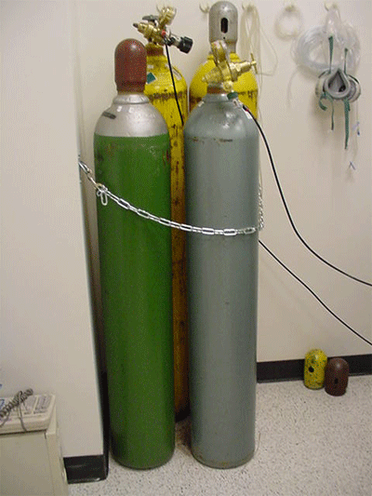 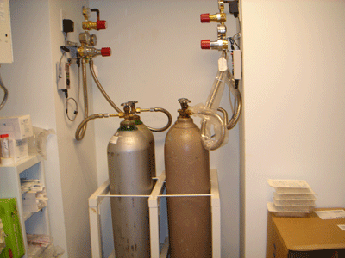 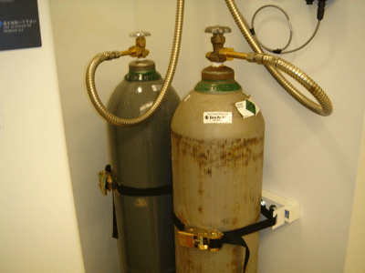

Illustrations of proper cylinder storage

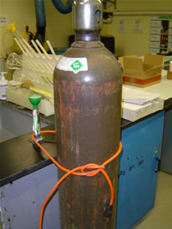 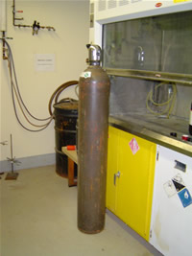 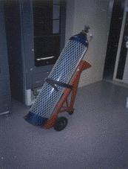

Improperly secured with Not secured with chain or Transporting without cap

Extension cord strap