LAPTOP BATTERY SAFETY FACT SHEET
From 2006 to 2011, hundreds of thousands of laptop batteries were recalled by such major companies as HP and Dell because metal particles were accidentally incorporated into battery cells during manufacturing. In rare cases, these particles could penetrate a plastic sheet called a separator that ordinarily prevents the positive and negative electrodes within a cell from touching. Such an event can generate heat, which can cause the separator to break down further, resulting in more shorting and more heating. There are a few possible scenarios for what can go wrong in the case of a short circuit:
- If it creates a spark, the flammable liquid can ignite, causing a fire.
- If it causes the temperature inside the battery to rise rapidly, the battery can explode due to the increased pressure.
- If it causes the temperature to rise slowly, the battery can melt, and the liquid inside can leak out.
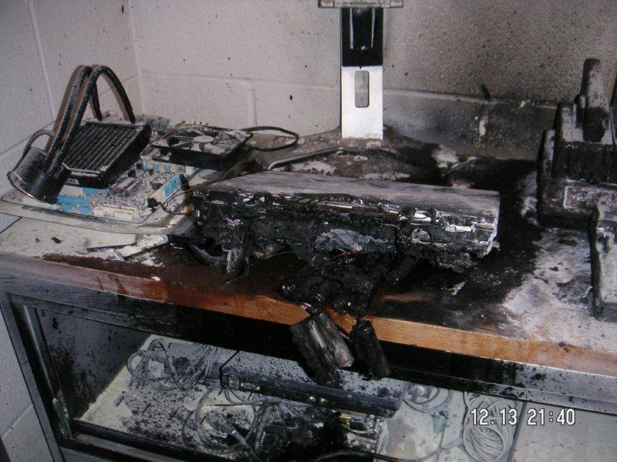
When lithium-ion batteries develop internal shorts, it doesn't take long before they can heat up to as much as 932 degrees Fahrenheit, making them likely to catch fire. At high enough temperatures, the electrode materials decompose, releasing oxygen and leading to more-rapid heating and, ultimately, an explosion and fire. Basic Precautions:
- Check for recalls. Check your manufacturer’s website or the Consumer Product Safety Commission at www.cpsc.gov. Aftermath of laptop fire on U of M Campus, December, 2011
- Don’t leave the laptop constantly charging. Once the battery is fully charged, unplug it. If the battery gets hot, unplug the laptop right away. Run the laptop directly off of power from an electrical outlet with the battery removed if the laptop is in a semi-permanent place such as an office or workstation. Otherwise, you'll be wearing out the battery--constantly charging and discharging it--at a time when you don't need to use it at all. You're also heating it up. Never remove the battery while the computer is on, or even in standby or sleep mode; doing so will crash your system and possibly damage your hardware. Even inserting a battery into a running laptop can damage the system. So only remove or reinsert the battery when the laptop is completely off or hibernating.
- Treat the battery with care. Damaged batteries pose a greater risk for fire.
- Buy name-brand batteries. Knock-off brands manufacturing may not be as good and may not be addressed in a recall.
When you use your laptop, make sure the vents are unblocked. Never work with the laptop on pillows or cushions. If possible, put it on a raised stand that allows for plenty of airflow. Also, clean the vents every so often with a can of compressed air. You can buy this for a few dollars at any computer store. Be sure to follow the directions on the can, and do this only when the notebook is off.

