

**Mansfield Library Trends and Directions:**

**FY2004-2008**

*Prepared by*:

Sue Samson, Chair, Assessment Services Group, and

Kate Zoellner, Assessment Coordinator

June 2009

*With Group Members*:

Barry Brown, Head, Access & Collection Services

Jennie Burroughs, Interim Head, Bibliographic Management Services

Kim Granath, Public Health Librarian

John Greer, Head, Technology & Systems Services

Kathy Hendricks, Head, Administrative Services

**Table of Contents**

Page

**Introduction**  3

**Section I. Mulit-year Trends at the Mansfield Library** 4

* Human Resources 5
* Collections 7
* Services 9
  + Reference and Instruction 9
  + Website Usage 11
  + Building Use 12
  + Circulation 13

**Section II. The Questions We Should Ask**

* What are the peak times of use for library services and what are library

users doing in the building? 15

* Who are the library users? 26
* What are our users perceptions of library services? 30
* What kinds of questions and suggestions are we receiving? 32
* What collections are most/least heavily used and requested? 33
* What monograph and serial collections are most/least purchased? 36
* What academic departments request the most/least library instruction   
  and at what levels? 38

**Section III. Institutional Data**

* Enrollment 41
* Blackboard 43

**Introduction**

This document analyzes core statistical information about the Mansfield Library, its services and operations. The analysis is based on data provided in Statistics Central, LibQUAL+ Survey data, unit-level operation information, and institutional data.

This document provides:

* multiple-year trends of library operations and services in three areas—human resources and budget, collections, and services;
* analysis of how and when library users use the library; and
* institutional data.

The goal of this analysis is to provide relevant data for informed data-driven decision making and to support strategic planning in the Mansfield Library. Section I provides trend data to identify how operations and services have evolved during the past six years and context for these trends. Section II addresses specific questions drafted by the Assessment Services Group to inform strategic planning. Section III provides relevant institutional data from The University of Montana.

**Section I. Multi-year Trends at the Mansfield Library**

Analysis of trend data is based on information posted in Statistics Central and is based on NISO standards used by academic libraries. Three categories—human resources, collections, and services—provide the basis for the data.

Analysis of data across multi-year fiscal postings identified the following notable trends:

* Staffing at all levels has remained static.
* Collections in all categories have increased with the greatest increase (140.0%) in access to journals.
* Journal subscriptions have increased dramatically due to the library’s acquisition of e-journal packages, consortial purchases of databases, and the systematic shift from paper to electronic journal access.
* The process of acquisitions of monographs has evolved from an uneven purchasing pattern with allocations and orders divided among departments and librarians to a carefully crafted approval plan that is supplemented by individual orders.
* The core services of Information Center Reference transactions and curriculum-integrated instruction are at an all time high.
* Usage of electronic databases increased dramatically, but data collection needs to be viewed with caution since the data gathering was not from the same source, but it does serve to indicate the impact of federated searching on database usage. Also, data connecting this usage with patron status is unavailable.
* Usage patterns of the web site, buildings, and collections are fluctuating.
* Circulation of materials has decreased slightly in all categories.
* Circulation of reserve materials has decreased at the Mansfield Library but increased dramatically at the Mansfield Library at the College of Technology.
* Interlibrary loan borrowing of articles has greatly decreased.
* Interlibrary loan borrowing of books, media, etc. has generally increased.

**Human Resources**

Library staffing levels have remained relatively static over the past four years. As a result of extending hours from 98 hours per week to 111 hours per week in 2006/2007, the library staff and student FTE increased slightly with some central funding support. There has been no increase in faculty FTE over the period being measured (Chart 1).

.

Personnel budgets also remained relatively static from FY2004 – FY2008. The faculty/staff budget increased slightly each year as a result of pay plan increases employees received and the addition in 2006 of a half-time night supervisor to cover extended hours (Table 1). Student/hourly payroll costs are not fully funded. The library is dependent on student staff to meet library goals and provide quality services. During the past five years, the library has depended on vacancy savings (Table 2) and designated funds to cover student payroll costs.

Student budget increases over the period being measured have come from reallocation of permanent salary savings from staff turnover and a small budget increase from the university in 2006 for extended hours staffing costs (Table 1).

Table 1. Personnel and operations budget, FY2004 – FY2008

|  |  |  |  |  |  |
| --- | --- | --- | --- | --- | --- |
|  | **General Operating Budget** | | | | |
|  | FY 2004 | FY 2005 | FY 2006 | FY 2007 | FY 2008 |
| Faculty/Staff | 1,989,861 | 1,974,877 | 1,962,255 | 2,098,774 | 2,125,482 |
| Student/Hourly | 7,090 | 27,135 | 59,137 | 70,484 | 99,091 |
| Total Personnel | 1,996,951 | 2,002,012 | 2,021,392 | 2,169,258 | 2,224,573 |
| Total Operations | 219,438 | 207,634 | 224,896 | 224,896 | 224,896 |

In addition to static staffing levels and personnel budgets, we have consistently had fairly high turnover in faculty and staff positions during the past four years further straining our human resources (Table 2).

Table 2. Faculty, staff, and contract professional turnover rates and vacancy saving, FY 2006-2008. Turnover statistics were not kept in FY2004 & FY2005

|  |  |  |  |
| --- | --- | --- | --- |
| **Turnover/Savings** | **FY 2006** | **FY2007** | **FY2008** |
| Faculty Turnover | 18.75% | 18.75% | 6.25% |
| Staff/Professional | 17.00% | 22.00% | 17.00% |
| Vacancy Savings | $116,616 (6.46%) | $185,378 (9.50%) | $186,851 (9.00%) |

Exit interview data gathered from resigning faculty and staff during the time period being measured targeted low salaries as one of the primary reasons for leaving. In addition, a UM Faculty pay equity study conducted by a UM professor confirmed that library faculty salaries were much lower than other UM faculty, especially at the Assistant Professor rank. Recruiting and retaining quality faculty and staff is a library priority. In late 2008, the library requested a retention market adjustment for all library Assistant Professors to a minimum entry salary of $44,815 (based on salary survey data collected). In mid-FY2009, UM granted a market adjustment equal to one-half of the proposed pay increase. The second half of the increase is expected to be implemented in FY2010.

As library services change and evolve, staffing needs or skills requirements may also change. With no budget for increasing staffing levels plus a static operations budget (Table 1), we must also rely on vacancy savings and designated funds to retrain or provide staff with professional development opportunities. Regularly evaluating staffing needs in each service area as changes occur or when positions become vacant continues to be a priority for the library.

As we improve our recruitment and retention of faculty and staff, we risk losing the very funding source (vacancy savings) we rely on to help fund student payroll and staff training and professional development, making it a high priority to identify a more stable funding source for our human resource needs.

**Collections**

During FY2004-2009, the nature of the collection and the process of acquisitions have been transformed by two primary changes.

* Journal subscriptions and electronic databases have increased dramatically due to the library’s acquisition of e-journal packages and consortial purchases of databases, a cost-effective way to provide access to a broader number of titles and indices.
* The process of acquisitions of monographs has evolved from an uneven purchasing pattern with allocations and orders divided among departments and librarians to a carefully crafted approval plan that is supplemented by individual orders.

There has been an average annual increase of 6.42% in the acquisitions allocation (Table 2). However, recissions in FY2005 and in FY2007 have caused fluctuations in funding.

Table 2. Total acquisitions allocation during FY2004 to FY2009.

|  |  |  |  |  |  |  |
| --- | --- | --- | --- | --- | --- | --- |
|  | 2004 | 2005 | 2006 | 2007 | 2008 | 2009 |
| Allocation | $2,673,741 | $2,823,606 | $3,102,270 | $3,224,670 | $3,450,396 | $3,691,925 |
| % increase | 6% | 6% | 9% | 9% | 7% | 7% |
| Rescission |  | $10,241 |  | $156,000 |  |  |
| % increase |  | 5.5% |  | 4% |  |  |

The changing nature of the collection is documented both by the acquisitions allocations and by the numbers of acquisitions in each format.

Chart 2 documents the transformative shift from paper journals to electronic access that has occurred from FY2004 to FY2009 in the allocation of dollars. E-resources include e-journal subscriptions.

Chart 3 documents the evolution of monograph acquisitions from an uneven purchasing pattern with allocations and orders divided among departments and librarians to a carefully crafted and cohesive approval plan that is supplemented by individual orders. The distribution of acquisitions funding reflects these changes.

Documentation of the collections in various formats during this same time period provides additional evidence of the changes in the collection (Table 3); notably, current journal subscriptions increased by 140.0% from FY2005 to FY2008. Subscriptions are those titles currently received and unique titles to which we have access through electronic resources, including e-journal packages and aggregators, using the Overlap Analysis reporting feature of Serials Solutions.

During the same time period, monograph holdings increased by 12.0%; media holdings increased by 19.4%; and the number of databases (both indices and full-text) decreased by 8.9% from FY2005-FY2008.

Table 3. Holdings of monographs and media from FY2004 to FY2008 and journals, and databases from FY2005 to FY 2008.

|  |  |  |  |  |  |
| --- | --- | --- | --- | --- | --- |
| **Format** | **2004** | **2005** | **2006** | **2007** | **2008** |
| Monographs | 629,374 | 648,226 | 666,183 | 686,017 | 704,692 |
| Media | 35,559 | 37,065 | 38,109 | 40,045 | 42,453 |
| Journals |  | 13,172 | 16,599 | 30,634 | 31,614 |
| Databases |  | 257 | 180 | 237 | 236 |

**Services**

While Information Center Reference transactions and curriculum-integrated instruction are at an all time high, usage patterns of the web site, buildings, and collections are fluctuating.

**Reference and Instruction**

Information Center reference transactions increased 24.9% from 30,875 in FY2004 to 41,123 in FY2009 (Table 4). Transactions are sampled during a two-week period each fall semester and extrapolated for the fiscal year.

Virtual Information Center Reference Service began in 2004 through the use of email reference assistance, an online suggestion box, and the implementation of virtual reference. While the email and suggestion box services have remained consistent, virtual reference shifted to the use of Instant Messaging in FY 2007. The data show a consistent use pattern of virtual reference with a greater increase after Instant Messaging was introduced. Virtual reference increased 120.8% from 644 in FY2004 to 1,422 in FY2008 (Table 4) but remains a small percentage of total reference transactions.

Table 4. Total number of Information Center reference transactions, both traditional and virtual, during FY2004 to FY2008.

|  |  |  |  |  |  |
| --- | --- | --- | --- | --- | --- |
| **Transactions** | **2004** | **2005** | **2006** | **2007** | **2008** |
| In-person Reference | 30,875 | 34,459 | 43,587 | 34,888 | 41,123 |
| Virtual Reference | 644 | 801 | 604 | 811 | 1,422 |
| TOTAL | 31,519 | 35,260 | 44,191 | 35,699 | 42,545 |

The Library Instruction Program is a major service element supported by all liaison librarians who represent all curricular departments at UM. The strategic integration of information literacy into the curriculum begins with first-year initiatives that serve as the basis for information literacy instruction in the disciplines at the junior and senior levels. At every opportunity, librarians seek to serve as research consultants and pedagogical guides and to facilitate the successful delivery of information literacy content by teaching faculty and teaching assistants in the disciplines.

Data trends support the strong outreach efforts of the liaison librarians to integrate instruction into the curriculum. Since FY2005, the total number of instruction sessions has increased 48.3% from 300 to 442 (Table 5). This total includes classes taught by liaison librarians (71.5%) and classes taught by ENEX 101, COMM 111, and Freshman Interest Group instructors (28.5%) who received collaborative program direction from the Undergraduate Services Librarian.

The number of students receiving instruction in these classes increased 72.8% from 6,374 to 11,012 (Table 5). Instruction outreach is detailed in Section II.

Table 5. Total number of instruction sessions and total number of students receiving instruction during FY2005 to FY2008.

|  |  |  |  |  |
| --- | --- | --- | --- | --- |
| **Instruction** | **2005** | **2006** | **2007** | **2008** |
| Instruction Sessions | 300 | 342 | 425 | 442 |
| Number of Students | 6,374 | 8,107 | 9,784 | 11,012 |

Math Tutoring and Writing Center services integrated their hours into the library beginning in FY 2007 (Table 6). Number of students participating in Math Tutoring and the Writing Center sessions are on the rise. The library is also actively used during summer orientations with the Student Learning Center and Buckhous Room scheduled for Advocates to provide registration training and to also provide assistance during the registration period for new students.

Table 6. Student participation in Math Tutoring and Writing Center sessions at the Mansfield Library during FY2008 to FY 2009.

|  |  |  |
| --- | --- | --- |
| **Student Service** | **2008** | **2009** |
| Math Tutoring | 2471 | 2369 (summer data missing) |
| Writing Center Consultations | 718 | 1,096 |

**Web Site Usage**

Web site visits fluctuated during the past four fiscal years, increasing 18.1% from 283,429 in FY2004 to 334,715 in FY2008 (Table 7). Visits are for the same IP requesting a page within a 30-minute time period. The principle of this number is to provide an estimate of the number of unique users to the site. The drop in the usage from 2007 to 2008 could be the result of users spending more time on our site, resulting in a lower turnover of IP’s and hence less “visitors.” The data sets show that there were more pages requested in 2008 than in 2007, an indication that our site use continued to climb but that each user looked at more information on the site. The drop in website visits from 2004 to 2005 coincides with a major website redesign, which could also have led to longer site use times for our users.

A noticeable increase of 44.8% occurred in the number of links to electronic databases from 262,083 in FY2004 to 379,449 in FY2007 (Table 7). Web site hits are a single link to a specific database. In FY2008, a federated search feature was introduced to the website. Database usage from FY2008 was compiled from vendor statistics that represented the same single link to a specific database. As predicted, database usage increased dramatically after the implementation of the federated search feature to 4,214,090, an increase of 90.9%. This huge increase must be viewed with caution since the data gathering was not from the same source, but it does serve to indicate the impact of federated searching on database usage. FY2009 data collected consistently with FY2008 data will better reflect database usage patterns within the federated search feature.

Table 7. Web site visits and database usage during FY2004 to FY2008.

|  |  |  |  |  |  |
| --- | --- | --- | --- | --- | --- |
| **Electronic Access** | **2004** | **2005** | **2006** | **2007** | **2008** |
| Web Visits | 283,419 | 234,964 | 308,008 | 359,653 | 334,715 |
| Web Database Hits | 262,083 | 349,529 | 379,741 | 379,449 | 4,214,090 |

**Building Use**

Since FY2005, overall use of the Student Learning Center (MLIB 283), the Buckhous Room (MLIB 282), and the Poetry Corner for all uses including instruction increased 43.2% from 729 uses to 1,283 uses; and the number of participants increased 63.7% from 10,711 to 17,430 (Table 8). In addition to classes scheduled by librarians, students and faculty have begun to identify and use locations in the library for a variety of activities, including meetings, readings, conferences, and group work.

Beginning in fall semester 2007, students were given the opportunity to schedule group study rooms up to two weeks in advance for planned study activities. This has proven to be a popular service, with over 13,000 reservations placed during FY2008 (Table 8).

Table 8. Use of library conference and classroom for all uses during FY2005 to FY2008 and reservations of Group Study Rooms from FY2007-FY2008.

|  |  |  |  |  |
| --- | --- | --- | --- | --- |
| **Room Use** | **2005** | **2006** | **2007** | **2008** |
| Sessions | 729 | 762 | 822 | 1,283 |
| Attendance | 10,771 | 14,762 | 16,617 | 17,530 |
| Group Study Room |  |  | 5,491 | 13,313 |

Gate counts, one-way entry counts, at the Mansfield Library increased 1.8% from 599,322 in FY2004 to 610,321 in FY2008 (Table 9). Although the trend is upwards, it is fluctuating and decreased from FY2007 by 2.3%. In FY2006, open hours increased 13.2% at the Mansfield Library from 98 to 111; total student enrollment increased 2.2% from FY2004 to FY2007 (see Section III).

Gate counts at the Mansfield Library at the College of Technology increased 25.1% from 41,232 in FY 2004 to 51,596 in FY 2008 (Table 9). During this same period of time, open hours remained unchanged but student enrollment increased 30.2% (see Section III).

Table 9. Gate counts at the Mansfield Library and at the Mansfield Library at the College of Technology during FY2004 to FY2008.

|  |  |  |  |  |  |
| --- | --- | --- | --- | --- | --- |
| **Location** | **2004** | **2005** | **2006** | **2007** | **2008** |
| Mansfield Lib | 599,322 | 618,224 | 608,868 | 624,285 | 610,321 |
| ML@COT | 41,232 | 45,140 | 50,712 | 49,178 | 51,596 |
| TOTAL | 640,554 | 663,364 | 629,580 | 673,463 | 661,917 |

**Circulation**

Circulation of all materials, excluding reserves, at Mansfield Library decreased 6.7% from 139,659 in FY2004 to 130,250 in FY2008 (Table 10). This decrease in circulation was consistent across all formats, including monographs (17.4%); print sources which includes books, serials, microforms, maps, and scores (18.4%); serials (34.0%); and media (20.4%).

Circulation of all materials, excluding reserves, at the Mansfield Library at the College of Technology decreased 3.0% from 4,459 in FY2004 to 4,327 in FY2008 (Table 10). Monographs (9.6%) and media (12.4%) increased in circulation while decreases occurred in print sources which includes books, serials, microforms, maps, and scores (4.5%) and serials (33.3%).

Table 10. Circulation of total materials and materials by format at the Mansfield Library and at the Mansfield Library at the College of Technology during FY2004 to FY2008.

|  |  |  |  |  |  |
| --- | --- | --- | --- | --- | --- |
| **Mansfield Library** | **2004** | **2005** | **2006** | **2007** | **2008** |
| Total charges and renewals | 139,659 | 124,848 | 118,867 | 117,980 | 130,350 |
| Monograph charges and renewals | 92,058 | 82,692 | 80,187 | 74,046 | 76,032 |
| Print charges and renewals | 98,066 | 88,126 | 85,765 | 78,628 | 80,042 |
| Serials charges and renewals | 5,775 | 5,249 | 5,367 | 4,374 | 3,812 |
| Media charges and renewals | 34,521 | 29,372 | 27,417 | 27,816 | 27,492 |
|  | | | | | |
| **Mansfield Library at College of Technology** | **2004** | **2005** | **2006** | **2007** | **2008** |
| Total charges and renewals | 4,459 | 4,289 | 5,630 | 5,083 | 4,327 |
| Monograph charges and renewals | 1,516 | 1,405 | 1,875 | 1,597 | 1,677 |
| Print charges and renewals | 2,312 | 2,230 | 2,659 | 2,239 | 2,208 |
| Serials charges and renewals | 796 | 825 | 784 | 642 | 531 |
| Media charges and renewals | 1,530 | 1,645 | 2,221 | 2,427 | 1,746 |

At the Mansfield Library, reserve circulation, both traditional and electronic, decreased as well (Table 11). Traditional reserve circulation decreased 32.2% from 24,265 in FY2004 to 18,354 in FY2008; electronic circulation decreased 54.7% from 680,147 in FY2004 to 439,629 in FY2008. The large change in electronic reserve use between 2005 and 2006 coincides with a major upgrade in the eres software and potentially a changed method of counting electronic reserve use. The pattern from 2006 – 2008 indicates a generally fluctuating but stable amount of electronic reserve use.

In contrast, reserve circulation, both traditional and electronic, increased at the Mansfield Library at the College of Technology. Traditional reserve circulation increased 39.3% from FY2005 to FY2008 and electronic reserve circulation increased 90.0% from FY2006 to FY2008, with no data gathered in FY2004. This may reflect both an increase in the number of online classes offered by the College of Technology and an increasing awareness on the part of COT faculty of the electronic reserve service and the importance of providing 24/7 access to course materials.

Table 11. Circulation of traditional and electronic reserve materials at the Mansfield Library from FY2004 to FY2008 and at the Mansfield Library at the College of Technology from FY2005 to FY2008.

|  |  |  |  |  |  |
| --- | --- | --- | --- | --- | --- |
| **Reserve Circulation** | **2004** | **2005** | **2006** | **2007** | **2008** |
| Traditional Reserves | 24,265 | 18,936 | 21,164 | 18,914 | 18,354 |
| Electronic Reserves | 680,147 | 749,319 | 416,262 | 397,438 | 439,629 |
| COT Traditional Reserves |  | 730 | 567 | 1,304 | 1,202 |
| COT Electronic Reserves |  | 0 | 327 | 462 | 3,275 |

Total interlibrary loan borrowing decreased 6.2% from FY2005 to FY2008 (Table 12). Within formats, borrowing for articles decreased 41.3%; borrowing for monographs increased 23.5%; and document delivery borrowing increased 39.8%. Beginning in 2007, document delivery was tabulated as the electronic delivery of Mansfield Library materials to UM patrons, a new service made available to faculty and graduate students. The decrease in article borrowing may reflect the 140.0% increase in journal subscriptions during this same time period.

Total interlibrary loan lending decreased 26.1%. Within formats, lending of articles decreased 42.2%; and lending of monographs remained stable. Throughout this entire time period, inaccurate serial holdings information was reflected in OCLC; accurate serials holdings were loaded into OCLC in FY2009.

Table 12. Interlibrary Loan

|  |  |  |  |  |
| --- | --- | --- | --- | --- |
| **Borrowing** | **2005** | **2006** | **2007** | **2008** |
| Articles | 9,294 | 8,296 | 6,984 | 5,459 |
| Loans | 7,254 | 9,033 | 8,053 | 9,488 |
| Document Del | 790 | 790 | 1,095 | 1,313 |
| TOTAL | 17,338 | 18,119 | 16,132 | 16,260 |
|  | | | | |
| **Lending** | **2005** | **2006** | **2007** | **2008** |
| Articles | 14,976 | 13,191 | 11,265 | 8,652 |
| Loans | 9,250 | 9,381 | 9,232 | 9,250 |
| TOTAL | 24,226 | 22,572 | 20,497 | 17,902 |

**Section II. The Questions We Should Ask**

The data presented in this section provides information on changing trends that can inform staffing patterns and outreach efforts based on more detailed library usage information.

***What are the peak times of use for library services and what are library users doing in the building?***

Fall Semester 2007:

* Mondays, Tuesdays, and Wednesdays are the busiest days of the week, both at ML and ML@COT.
* 11:00am to 5:00pm are the busiest hours of the day at ML.
* 9:00am to 2:00pm are the busiest hours of the day at ML@COT.
* Weeks 11, 15, and 16 were the busiest weeks of the semester for circulation and interlibrary loan transactions and group study room reservations at ML.
* Weeks 3, 5, and 8 received the most circulation transactions at ML@COT.
* Instruction peaked during weeks 3, 6, and 7.

Fall Semester 2008:

* Mondays, Tuesdays, and Wednesdays are the busiest days of the week, both at ML and ML@COT.
* 1:00 to 5:00pm is the busiest 4-hour period of the day at ML, based on circulation figures.
* 11:00am to 3:00pm is the busiest 4-hour period of the day at ML@COT, based on circulation figures.
* Weeks 8, 15, and 12 were the busiest weeks of the semester for circulation; weeks 15, 16, and 13 were busiest for interlibrary loan transactions; and group study room reservations at ML were highest during weeks 16, 15, and 10.
* Weeks 1, 3, and 2 received the most circulation transactions at ML@COT.
* Instruction peaked during weeks 4, 5, and 6.

**Gate Counts**

Fall semester 2007:

* 263,578 patrons entered the Mansfield Library.
* Based on daily averages, peak use occurred on Tuesday, followed by Monday, Wednesday, and Thursday (Chart 1).
* Open 111 hours per week, there was an average of 155 library users entering the building per hour.

Fall Semester 2008:

* 260,332 patrons entered the Mansfield Library.
* Based on daily averages, peak use occurred on Wednesday, followed by Monday, Tuesday, and Thursday (Chart 1).
* Open 111 hours per week, there was an average of 147 library users entering the building per hour.

COT fall semester 2007:

* 22,292 patrons entered the Mansfield Library @ the College of Technology.
* Based on daily averages, peak use occurred on Monday, followed by Wednesday, Tuesday, Thursday and Friday (Chart 2).
* Open 55.5 hours per week, there was an average of 25 Library users entering the building per hour.

COT fall semester 2008:

* 16,757 patrons entered the Mansfield Library @ the College of Technology.
* Based on daily averages, peak use occurred on Tuesday, followed by Wednesday, Monday, Thursday and Friday (Chart 2).
* Open 55.5 hours per week, there was an average of 19 library users entering the building per hour.

**Circulation of Collections at ML and ML@COT**

Fall semester 2007 at ML:

* 51,699 total transactions.
* Tabulated by hour of the day, the peak periods of check-outs occurred from 11:00am to 5:00pm (Chart 3).

Fall Semester 2008 at ML:

* 54,656 total transactions.
* Tabulated by hour of the day, the peak periods of check-outs occurred from 12:00 to 6:00pm (Chart 3).

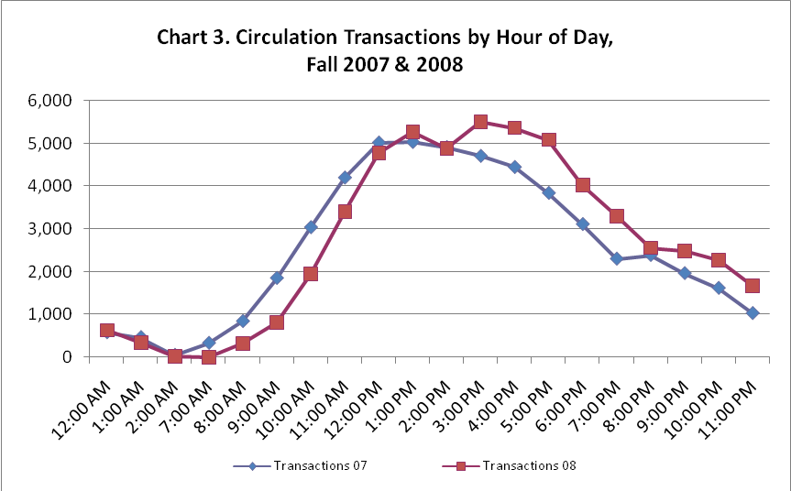

* Tabulated by day of week, the peak periods of check-outs for Fall semester 2007 occurred on Tuesday, followed by Monday, Wednesday, Thursday, and Friday (Chart 4).
* Tabulated by day of week, the peak periods of check-outs for Fall semester 2008 occurred on Monday, followed by Tuesday, Wednesday, Thursday, and Sunday (Chart 4).
* Tabulated by week of semester, the peak periods of check-outs for Fall semester 2007 occurred in weeks 11, 15, 12, 14, and 8 (Chart 5).
* Tabulated by week of semester, the peak periods of check-outs for Fall semester 2008 occurred in weeks 8, 15, 12, 5, and 10 (Chart 5).

Fall semester 2007 at ML@COT:

* 2,015 total transactions.
* Tabulated by hour of the day, the peak periods of check-outs occurred at 9:00am, 11:00am, and 1:00pm (Chart 6).

Fall semester 2008 at ML@COT:

* 1,836 total transactions.
* Tabulated by hour of the day, the peak periods of check-outs occurred at 1:00pm, 11:00am, and 2:00pm (Chart 6).
* Tabulated by day of week, the peak periods of check-outs for Fall semester 2007 and Fall Semester 2008 occurred on Monday and Wednesday (Chart 7).
* Tabulated by week of semester, the peak periods of check-outs for Fall semester 2007 occurred in weeks 3, 5, 8, 1, and 15 (Chart 8).
* Tabulated by week of semester, the peak periods of check-outs for Fall semester 2008 occurred in weeks 1, 3, 2, 7, and 9 (Chart 8).

Interlibrary Loan Activity Fall Semester 2007

* 13,273 total transactions
* Tabulated by week of semester, the peak periods of interlibrary loan requests occurred in weeks 11, 9, 14, 15, and 7 (Chart 9).

Interlibrary Loan Activity Fall Semester 2008

* 12,742 total transactions
* Tabulated by week of semester, the peak periods of interlibrary loan requests occurred in weeks 15, 16, 13, 12, and 10 (Chart 9).

**Web Site Visits**

* During both fiscal year 2007 and 2008, the web site had the most monthly hits at the beginning and end of each semester (Chart 10).
* During FY2007 the top five web site entry pages were (Chart 11):
  + Interlibrary Loan
  + Research Tools
  + A-Z Index
  + Mansfield Library Hours
  + Genetic Variation Guide
  + During FY2008 the top five web site entry pages were (Chart 11):
  + Research Tools
  + Study Room Reservations
  + Interlibrary Loan
  + A-Z Index
  + Mansfield Library Hours

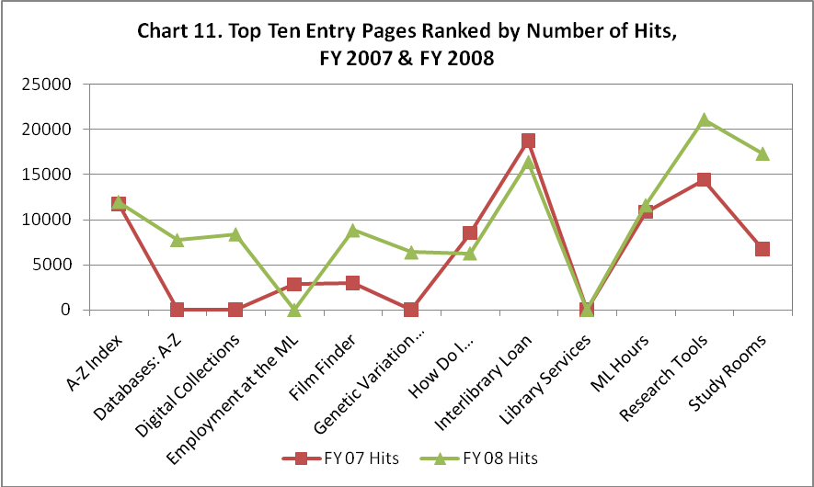

* During FY 2007 the top five web site exit pages were (Chart 12):
  + Interlibrary Loan
  + Research Tools
  + A-Z Index
  + Mansfield Library Hours
  + Study Room Reservations
  + During FY 2008 the top five web site exit pages were (Chart 12):
  + Research Tools
  + Interlibrary Loan
  + Study Room Reservations
  + Mansfield Library Hours
  + A-Z Index

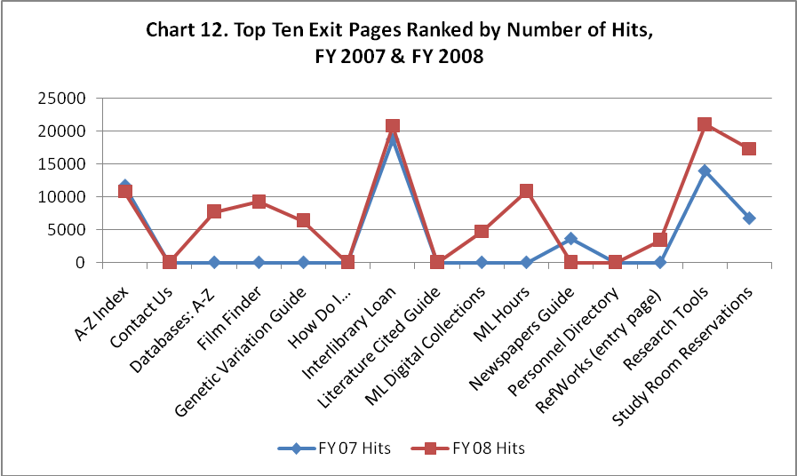

**In-Building Use at ML**

**Laptop Usage** in the Mansfield Library was evaluated during spring semester (2009) using sample times each day over a period of one week.

Laptop Usage

* + 4,744 total library users during sample periods
  + 1,422 (29.97%) laptop users
  + 929 (66.3%) connected to power source

Laptop usage by day of week:

|  |  |  |  |
| --- | --- | --- | --- |
| **Day of Week** | **Laptop Users** | **Total Users** | **Circulating Laptops** |
| Thursday | 289 (33.4%) | 865 | 64 |
| Wednesday | 275 (28.2%) | 975 | 80 |
| Tuesday | 255 (31.4%) | 813 | 72 |
| Monday | 231 (29.4%) | 785 | 72 |
| Sunday | 190 (31.3%) | 608 | 43 |
| Friday | 121 (24.3%) | 498 | 32 |
| Saturday | 61 (30.5%) | 200 | 8 |

Laptop usage by floor level:

|  |  |  |
| --- | --- | --- |
| **Floor Level** | **Laptop Users** | **Total Users** |
| Level 5 | 384 (55.6%) | 691 |
| Level 3 | 302 (11.9%) | 2,539 |
| Level 2 | 274 (47.4%) | 578 |
| Level 4 | 248 (51.0%) | 486 |
| Level 1 | 214 (47.6%) | 450 |

Laptop usage by individual study versus group study:

|  |  |  |
| --- | --- | --- |
| **Group Size** | **Number** | **Percent** |
| Individual | 1,144 | 90.1% |
| Group of 2 | 100 (200 individuals) | 7.9% |
| Group of 3 | 22 (66 individuals) | 1.7% |
| Group of 4 | 3 (12 individuals) | 0.2% |

* **Group Study Rooms**
  + 8,231 total reservations during fall semester 2007.
  + Peak use of group study rooms occurred during weeks 15 (844) and 16 (811). See Chart 13.
  + 7,125 total reservations during fall semester 2008.
  + Peak use of group study rooms occurred during weeks 16 (782) and 15 (736). See Chart 13.
* **Library Instruction Program** 
  + Weekly tallies of classes were identified for fall semester 2006, 2007 and 2008 (Chart 14).
    - Of a total of 235 classes taught in fall 2006, 32 were taught during week 5, 30 during week 4, and 28 during week 3 of the semester.
    - Of a total of 234 classes taught in fall 2007, 40 were taught during week 7, 39 during week 3, and 27 during week 6 of the semester.
    - Of a total of 218 classes taught in fall 2008, 36 were taught during week 5, 26 during week 4, and 25 during week 6 of the semester.
* **Math PILOT Tutoring**
  + Fall semester 2007: 859 students.
  + Fall semester 2008: 1,154 students.
* **Writing Center Tutoring**
  + Fall semester 2007: 266 sessions (underrepresented since the tracking form did not include location until part way through the semester).
  + Fall semester 2008: 576 sessions, 33% of the total writing center sessions for the semester (n=1,748).

***Who are the library users?***

Overall during both FY2007 and FY2008:

* Undergraduate students are the primary library user group in all categories with the exception of interlibrary loan.
* Graduate students and then faculty are the primary library user groups of interlibrary loan.
* First-year students are the largest group receiving instruction.

**Circulation at ML and ML@COT**

ML FY2007 and FY2008 circulation transactions totaled 115,046 and 125,602 respectively, and were identified by status of borrower with the following results:

|  |  |  |
| --- | --- | --- |
| **Patron Status** | **FY2007** | **FY2008** |
| Undergraduate | 55% | 58% |
| Graduate | 18% | 16% |
| Faculty | 10% | 10% |
| ILL | 6% | 5% |
| Staff | 4% | 4% |
| MT Borrowers | 3% | 4% |
| Alumni/Visiting Scholars/Community Borrowers | 2% | 2% |
| Professional Staff | 1% | 1% |
| Other | < 1% | < 1% |

At ML@COT, FY2007 and FY2008 circulation transactions totaled 5,467 and 5,016 respectively, and were identified by status of borrower with the following results:

|  |  |  |
| --- | --- | --- |
| **Patron Status** | **FY2007** | **FY2008** |
| Undergraduate | 59% | 54% |
| Faculty | 21% | 22% |
| ILL | 7% | 8% |
| Professional Staff | 2% | 6% |
| MT Borrowers | 2% | 2% |
| Graduate | 1% | 2% |
| Staff | 7% | 6% |
| Other | < 1% | < 1% |
| Alumni/Visiting Scholars/Community Borrowers | < 1% | < 1% |

**Interlibrary Loan**

FY2007 and FY2008 interlibrary loan transactions totaled 14,983 and 16,449 respectively and were identified by status of borrower with the following results. See Chart 19 for details.

|  |  |  |
| --- | --- | --- |
| **Patron Status** | **FY2007** | **FY2008** |
| Graduate | 43% | 41% |
| Faculty | 25% | 25% |
| Undergraduate | 19% | 22% |
| Staff | 11% | 10% |
| Distance Ed | 1% | 2% |
| Other | < 0% | < 0% |

**Instruction**

A total of 431 classes were analyzed by academic level for FY2007, and 445 for FY2008, with the following results. See Chart 20 for details.

|  |  |  |
| --- | --- | --- |
| **Patron Status** | **FY2007** | **FY2008** |
| Freshman | 38% | 46% |
| Junior | 19% | 19% |
| Graduate | 16% | 8% |
| Sophomore | 12% | 12% |
| Senior | 10% | 9% |
| High School | 4% | 5% |

***What are our users’ perceptions of library services?***

**Most important services** overall as measured by highest desired service level on LibQUAL+ survey Fall 2006:

1. Print and/or electronic journal collections I require for my work
2. A library web site enabling me to locate information on my own
3. Making electronic resources accessible from my home or office

**Areas of greatest concern** overall as measured by the gap between respondents perceived and desired service levels on the LibQUAL+ survey Fall 2006; areas where UM is furthest from meeting respondents’ desired service levels (Chart 21):

* 1. Print and/or electronic journal collections I require for my work
  2. A library web site enabling me to locate information on my own
  3. Easy-to-use access tools that allow me to find things on my own

**Least important services** overall as measured by lowest desired service level on LibQUAL+ survey Fall 2006:

1. Community space for group learning and study
2. Giving users individual attention
3. Quiet space for individual activities

**Areas of least concern** overall as measured by the gap between respondents perceived and desired service levels on the LibQUAL+ survey Fall 2006; areas where UM is closest to meeting respondents’ desired service levels (Chart 21):

1. Convenient service hours
2. Community space for group learning and study
3. Employees who deal with users in a caring fashion

Chart 21 shows ‘zones of tolerance’ defined as the distance between ‘minimally-acceptable’ and ‘desired’ service levels on the library service quality survey, LibQUAL+. Library users’ perceptions ideally fall within this zone. Looking at the distance between respondents’ perceptions of service levels and their minimally-acceptable and desired levels reveals areas in which the library is meeting respondents’ expectations and areas that fall short. The closer the perceived service level is to the desired service level, the better the library is doing in the view of respondents.

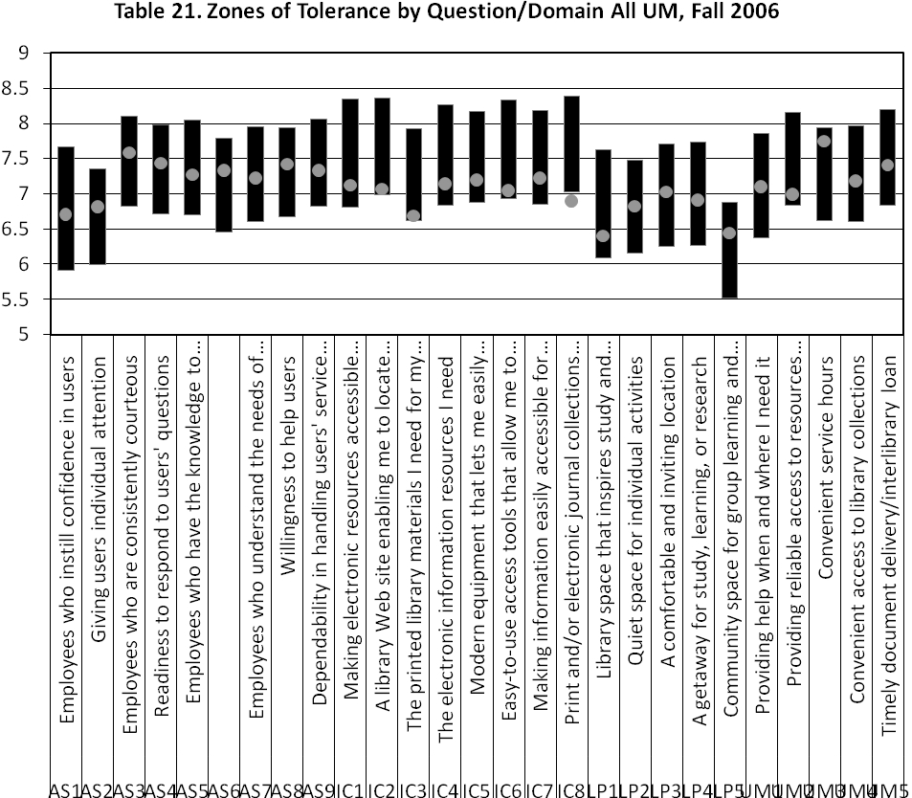

***What kinds of questions and suggestions are we receiving?***

Comments received from the online suggestion box, ask-a-librarian service, instant messaging, and open-ended comments from the 2003 and 2006 LibQUAL+ surveys were consistently categorized (Table 1).

Notable findings include:

* Information Center (15.8%) and Web Site (18.3%) received the highest number of comments in FY2008.
* Although Web Site (16.2%) received the highest number of comments as well in FY2007, Physical Collection (10.6%) and Resources (14.2%) received a higher number of comments in FY2007 than in FY2008.
* Information center (11.7%; 14.6%) and general/overall (11.3%; 12.1%) received the highest number of comments from the 2003 and 2006 LibQUAL+ surveys.

Table 1. Comment analysis and LibQUAL+ 2003 and 2006 submissions categorized using LibQUAL categories. Comments include Suggestion Box, Ask-A-Librarian, and instant messaging submissions during FY2007 to FY2009; LibQUAL+ comments were gathered in 2003, 2006, and 2009.

|  |  |  |  |  |  |  |  |  |  |
| --- | --- | --- | --- | --- | --- | --- | --- | --- | --- |
| **CATEGORIES** | **COMMENTS** | | | | | | **LibQUAL+** | | |
| **2007** | | **2008** | | **2009** | | **2003** | **2006** | **2009** |
| **No.** | **%** | **No.** | **%** | **No.** | **%** | **%** | **%** | **%** |
| Access to Physical Collection | 8 | 3.3 | 70 | 4.2 |  |  | 7.3 | 9.3 |  |
| Budget | 0 | 0.0 | 2 | 0.1 |  |  | 1.9 | 1.9 |  |
| Circulation | 3 | 1.2 | 105 | 6.4 |  |  | 2.8 | 1.6 |  |
| Computer Use | 1 | 0.4 | 49 | 3.0 |  |  | 1.1 | 0.3 |  |
| Databases | 22 | 8.9 | 133 | 8.1 |  |  | 4.0 | 5.3 |  |
| e-Journals | 4 | 1.6 | 22 | 1.3 |  |  | 6.2 | 6.2 |  |
| Electronic Collections | 21 | 8.5 | 113 | 6.9 |  |  | 4.3 | 5.0 |  |
| Environment | 5 | 2.0 | 1 | 0.1 |  |  | 6.3 | 4.7 |  |
| Equipment | 4 | 1.6 | 59 | 3.6 |  |  | 4.1 | 3.7 |  |
| Facilities | 1 | 0.4 | 6 | 0.4 |  |  | 2.2 | 1.6 |  |
| Furniture | 0 | 0.0 | 0 | 0.0 |  |  | 1.8 | 2.2 |  |
| General / Overall | 0 | 0.0 | 5 | 0.3 |  |  | 11.3 | 12.1 |  |
| Hours | 0 | 0.0 | 29 | 1.8 |  |  | 3.4 | 2.2 |  |
| Information Center | 0 | 0.0 | 260 | 15.8 |  |  | 11.7 | 14.6 |  |
| Interlibrary Loan | 2 | 0.8 | 110 | 6.7 |  |  | 4.7 | 4.7 |  |
| Other | 57 | 23.2 | 191 | 11.6 |  |  | 1.7 | 2.8 |  |
| Personnel | 0 | 0.0 | 9 | 0.5 |  |  | 5.6 | 2.5 |  |
| Physical Collection | 26 | 10.6 | 75 | 4.5 |  |  | 5.4 | 3.1 |  |
| Policies | 13 | 5.3 | 36 | 2.2 |  |  | 1.5 | 2.2 |  |
| Referral | 0 | 0.0 | 6 | 0.4 |  |  | 0.0 | 0.0 |  |
| Resources | 35 | 14.2 | 56 | 3.4 |  |  | 7.7 | 4.7 |  |
| Study Space | 4 | 1.6 | 11 | 0.7 |  |  | 3.4 | 6.9 |  |
| Web Site | 40 | 16.3 | 301 | 18.3 |  |  | 1.7 | 2.5 |  |
| TOTAL | 246 | 100.0 | 1649 | 100.0 |  |  | **100.00** | **100.0** |  |

***What collections are most/least heavily used and requested?***

**Circulation**

The 5 subjects measured by Dewey Decimal Classification number with the highest circulation from FY06-FY08 were:

|  |  |  |  |
| --- | --- | --- | --- |
|  | **FY2006** | **FY2007** | **FY2008** |
| 1 | 810 - 819 American Literature in English (8,129) | 810 - 819 (5,958) | 810 - 819 (6,429) |
| 2 | 970 - 979 History of North America (5,836) | 970 - 979 (4,294) | 300 - 309 (3,915) |
| 3 | 300 - 309 Social Sciences, Sociology and Anthropology (4,850) | 300 - 309 (4,131) | 970 - 979 (3,864) |
| 4 | 820 - 829 English and Old English Literatures (3,832) | 610 - 619 (3,391) | 610 - 619 (3,018) |
| 5 | 610 - 619 Medicine (3,035) | 820 - 829 (2,707) | 820 - 829 (2,597) |

The 5 subjects measured by Dewey Decimal Classification number with the lowest circulation from FY06-FY08 were:

|  |  |  |  |
| --- | --- | --- | --- |
|  | **FY2006** | **FY2007** | **FY2008** |
| 1 | 010 - 019 Bibliography (4) | 090 - 099 (3) | 080 - 089 (3) |
| 2 | 090 - 099 Manuscripts and Rare Books (8) | 080 - 089 (4) | 030 - 039 (6) |
| 3 | 450 - 459 Italian, Romanian, and Related Languages (8) | 250 - 259 Christian Pastoral Practice and Religious Orders (7) | 090 - 099 (8) |
| 4 | 030 - 039 Encyclopedia and Books of Facts (11) | 030 - 039 (10) | 010 - 019 (12) |
| 5 | 080 - 089 Quotations (15) | 010 - 019 (11) | 250 - 259 (12) |

**Databases**

The 5 most accessed databases as measured by search queries from FY07-FY08 were:

|  |  |  |
| --- | --- | --- |
|  | **FY2007** | **FY2008** |
| 1 | EBSCO Databases (includes Academic Search Premier, American Humanities Index, Business Source Premier and Communication and Mass Media Complete) (43,204) | CQ Electronic Library (354,919) |
| 2 | Academic Search Premier (EBSCO) (38,434) | Lexis Nexis Academic (173,755) |
| 3 | JSTOR (26,062) | Academic Search Premier (79,464) |
| 4 | Gale Databases (includes Academic Index ASAP, Business and Company ASAP, Health Reference Center and Predicasts PROMT) (23,153) | Literature Resource Center (59,400) |
| 5 | ScienceDirect Freedom Collection (22,020) | WorldCat (OCLC) (57,518) |

The 5 least accessed databases as measured by search queries from FY07-FY08 were:

|  |  |  |
| --- | --- | --- |
|  | **FY2007** | **FY2008** |
| 1 | Toxline (CSA) (5) | Art Full Text (13) |
| 2 | Education-line (8) | Biological & Agricultural Index Plus (17) |
| 3 | TreeCD (10) | Prokaryotes (19) |
| 4 | Early American Fiction (11) | Species Information Library (19) |
| 5 | Poiesis (13) | ulrichsweb.com (19) |

**Interlibrary Loan**

The 5 most requested serials via ILL from FY07-FY08 were:

|  |  |  |
| --- | --- | --- |
|  | **FY2007** | **FY2008** |
| 1 | Gaming Law Review (56) | International Journal of Pharmaceutics (87) |
| 2 | British Journal of Sports Medicine (30) | European Journal of Applied Physiology and Occupational Physiology (65) |
| 3 | Diagnostique: Professional Bulletin of the Council for Educational Diagnostic Services (26) | The ISME Journal (59) |
| 4 | The Journal of Ethnic Studies (26) | Evidence Report/Technology Assessment (57) |
| 5 | Journal of Traumatic Stress (25) | Hydrobiologia (52) |

The 5 most requested book subjects via ILL for 2007 and 2008, based on OCLC WorldCat Collection Analysis data, were:

|  |  |  |
| --- | --- | --- |
|  | **FY2007** | **FY2008** |
| 1 | Health Professions & Public Health (2,262) | Language, Linguistics & Literature (1,786) |
| 2 | Language, Linguistics & Literature (1,433) | Health Professions & Public Health (1,625) |
| 3 | History & Auxiliary Sciences (1,109) | Music (1,484) |
| 4 | Music (1,101) | History & Auxiliary Sciences (1,060) |
| 5 | Biological Sciences (537) | Philosophy & Religion (479) |

The 5 least requested book subjects via ILL for 2007 and 2008, based on OCLC WorldCat Collection Analysis data, were:

|  |  |  |
| --- | --- | --- |
|  | **FY2007** | **FY2008** |
| 1 | Medicine By Body System (7) | Communicable Diseases & Miscellaneous (3) |
| 2 | Communicable Diseases & Miscellaneous (10) | Health Facilities, Nursing & History (18) |
| 3 | Health Facilities, Nursing & History (12) | Preclinical Sciences (20) |
| 4 | Computer Science (30) | Medicine By Body System (21) |
| 5 | Preclinical Sciences (34) | Medicine By Discipline (29) |

**Subject Guides**

The 5 most visited subject guides as measured by web site hits from FY07-FY08 were:

|  |  |  |
| --- | --- | --- |
|  | **FY2007** | **FY2008** |
| 1 | Electronic Newspapers and News Resources Online (5,851) | Communication Systems for Persons with Disabilities, Language Finger (22,462) |
| 2 | Literature Cited (4,436) | Mansfield Library Subject Guides (7,563) |
| 3 | Specialized Writing Systems (2,990) | Bibliography of Genetic Variation in Natural Populations (7,458) |
| 4 | Classical Music Information Resources (2,338) | Literature Cited (4,638) |
| 5 | Psychology (2,207) | Language Finger (2,088) |

The 5 least visited subject guides, of those visited, as measured by web site hits from FY07-FY08 were:

|  |  |  |
| --- | --- | --- |
|  | **FY2007** | **FY2008** |
| 1 | Spanish, part 8 (51) | Education, Government Information Resources (43) |
| 2 | Energy Resources (51) | Penutian Languages, part 2, Language Finger   (42) |
| 3 | Italian, part 7 (50) | Comprehensive Language Index (42) |
| 4 | Niger-Kordofanian (48) | American Indian Material (42) |
| 5 | Successful Researching and Writing: Proofreading and Editing (pdf) (48) | Blackboard, Faculty Guide to Integrating the Library’s Subscribed Electronic Resources (40) |

***What monograph and serial collections are most/least purchased?***

**Monographs**

The 5 subjects measured by Dewey Decimal Classification number with the highest number of monograph acquisitions from FY06-FY08 were:

|  |  |  |  |
| --- | --- | --- | --- |
|  | **FY2006** | **FY2007** | **FY2008** |
| 1 | 810-819 American Literature in English (1,178) | 810-819 (2,039) | 810-819 (2,033) |
| 2 | 020-029 Library and Information Science (847) | 300-309 (1,338) | 300-309 (1,075) |
| 3 | 320-329 Political Science (830) | 330-339 Economics (1,186) | 330-339 (885) |
| 4 | 300-309 Social Sciences, Sociology and Anthropology (780) | 970-979 (856) | 820-829 English and Old English Literatures (866) |
| 5 | 970-979 History of North America (749) | 370-379 Education (826) | 790-799 Sports, Games & Entertainment (760) |

The 5 subjects measured by Dewey Decimal Classification number with the lowest number of monograph acquisitions from FY06-FY08 were:

|  |  |  |  |
| --- | --- | --- | --- |
|  | **FY2006** | **FY2007** | **FY2008** |
| 1 | 090-099 Manuscripts and Rare Books (1) | 450-459 (0) | 440-449 (0) |
| 2 | 480-489 Classical and Modern Greek Languages (1) | 080-089 Quotations (1) | 480-489 (0) |
| 3 | 450-459 Italian, Romanian, and Related Languages (2) | 250-259 Christian Pastoral Practice and Religious Orders (1) | 250-259 (1) |
| 4 | 030-039 Encyclopedias and Books of Facts (2) | 430-439 (1) | 430-439 (1) |
| 5 | 430-439 German and Related Languages (2) | 440-449 French and Related Languages (1) | 990-999 History of Other Regions (1) |

**Serials**

The 5 areas measured by fund code with the highest acquisition of serials from FY07-FY08 were:

|  |  |  |
| --- | --- | --- |
|  | **FY2007** | **FY2008** |
| 1 | Biology | Biology |
| 2 | English Literature | English Literature |
| 3 | History | History |
| 4 | Political Science | Political Science |
| 5 | Mathematical Sciences | Forestry and Mathematical Science |

The 5 areas measured by fund code with the lowest acquisition of serials from FY07-FY08 were:

|  |  |  |
| --- | --- | --- |
|  | **FY2007** | **FY2008** |
| 1 | Electronic Technology | Information Systems and Technology |
| 2 | African American Studies | Film Studies |
| 3 | Government Documents | Humanities |
| 4 | Media Arts | African American Studies |
| 5 | Women’s Studies | Latin American Studies |

***What academic departments request the most/least library instruction?***

During FY2008 liaison librarians taught or designed instructional components for 445 curriculum-integrated courses, a slight increase from the 437 in FY2007.

* As shown in Chart 22., instruction was higher in the following colleges or schools for FY08 compared with FY07: Arts and Sciences, College of Technology, Davidson Honors College, Forestry and Conservation, Health Professions and Biomedical Sciences and for the Undergraduate Advising Center.
* The number of instruction sessions provided to each department is evident in Table 2 on the following page. Overall, the sessions offered were consistent. The fluctuations in certain departments (e.g., Military Science, Music) may be due to varied course offerings from year to year.

Table 2. Instruction by University College or School and Department, FY2007 & FY2008.

|  |  |  |
| --- | --- | --- |
| **College or School, Department** | **FY07** | **FY08** |
| Arts and Sciences, College of | 245 | 256 |
| Anthropology | 10 | 11 |
| Biology | 8 | 12 |
| Chemistry | 4 | 4 |
| Communication Studies | 37 | 42 |
| Economics | 5 | 3 |
| English | 90 | 97 |
| Environmental Studies | 22 | 28 |
| Geography | 7 | 7 |
| History | 17 | 22 |
| Linguistics | 1 | 1 |
| Military Science Leadership | 13 | 0 |
| Modern & Classical Languages & Literatures | 3 | 5 |
| Native American Studies | 15 | 16 |
| Political Science | 5 | 2 |
| Psychology | 1 | 1 |
| Religious Studies | 1 | 0 |
| Sociology | 6 | 5 |
| Business Administration, School of | 8 | 5 |
| Accounting and Finance | 7 | 0 |
| Management and Marketing | 1 | 5 |
| College of Technology | 14 | 21 |
| Continuing Education | 11 | 3 |
| Davidson Honors College | 5 | 8 |
| Education, School of | 41 | 37 |
| Counselor Education | 1 | 1 |
| Curriculum & Instruction | 32 | 33 |
| Educational Leadership | 3 | 1 |
| Health and Human Performance | 4 | 2 |
| Intercultural Youth & Family Development | 1 | 0 |
| Fine Arts, School of | 35 | 15 |
| Art | 13 | 7 |
| Drama/Dance | 8 | 2 |
| Media Arts | 0 | 2 |
| Music | 14 | 4 |
| Forestry & Conservation, College of | 2 | 10 |
| Forestry | 0 | 3 |
| Wildlife Biology | 2 | 7 |
| Health Professions and Biomedical Sciences, College of | 8 | 10 |
| Pharmacy | 1 | 2 |
| Physical Therapy and Rehabilitation Science | 1 | 2 |
| Social Work | 6 | 6 |
| Journalism, School of | 4 | 2 |
| Journalism | 4 | 2 |
| Office of Student Success | 39 | 54 |
| Other | 25 | 24 |

**Section III. Institutional Data**

**Enrollment**

**Fall 2007 and 2008**

Full time undergraduate students by student level (2007-2008 Data Digest, p. 9; 2008-2009 Data Digest, p. 9):

|  |  |  |
| --- | --- | --- |
| **Undergraduate Student Level** | **Fall 2007** | **Fall 2008** |
| Freshman | 92% | 92% |
| Sophomore | 91% | 91% |
| Junior | 90% | 89% |
| Senior | 84% | 83% |

Part time students by student level (2007-2008 Data Digest, p. 9; 2008-2009 Data Digest, p. 9):

|  |  |  |
| --- | --- | --- |
| **Student Level** | **Fall 2007** | **Fall 2008** |
| COT | 18% | 18% |
| Undergraduate | 58% | 60% |
| Masters | 18% | 16% |
| Doctoral | 6% | 6% |



**Fall 2007 Trends:**

* Overall enrollment increased 43% for College of Technology students and 3% for doctoral candidates from FY2004 to FY2007 (2007-2008 Data Digest, p. 8).
* Overall enrollment decreased 1% for undergraduate students, 1% for graduate students and 4% for masters candidates FY2004 to FY2007 (2007-2008 Data Digest, p. 8).
* Full time student enrollment increased 36% for College of Technology, less than .5% for undergraduates, and 23% for doctoral candidates from FY2004 to FY2007 (2007-2008 Data Digest, p. 9).
* Full time student enrollment decreased 5% for masters candidates from FY2004 to FY2007 (2007-2008 Data Digest, p. 9).

**Fall 2008 Trends:**

* Overall enrollment increased 34.9% for College of Technology students and remained consistent for all graduate students from FY2004 to FY2008 (2008-2009 Data Digest, p. 2).
* Overall enrollment increased slightly by 1.7% for undergraduate students, but decreased by 5.4% for all graduate students and 8.5% for masters candidates from FY2004 to FY2008 (2008-2008 Data Digest, p. 2).



**Blackboard**

Blackboard course management system increased 97% overall for fully online courses from FY2005 to FY2008, and 111% overall for use of the system as a course supplement (Table 1).

Table 1. Course Sections in Blackboard, Both Supplements and Fully Online Courses, FY 2005 – FY 2008

|  |  |  |  |  |
| --- | --- | --- | --- | --- |
| **Supplement** | **FY05** | **FY06** | **FY07** | **FY08** |
| Summer | 61 | 38 | 95 | 114 |
| Fall | 449 | 529 | 782 | 970 |
| Spring | 495 | 658 | 780 | 1,035 |
| Totals | 1,005 | 1,225 | 1,657 | 2,119 |
|  | | | | |
| **Online** | **FY05** | **FY06** | **FY07** | **FY08** |
| Summer | 37 | 46 | 57 | 82 |
| Fall | 69 | 78 | 99 | 130 |
| Spring | 85 | 86 | 108 | 164 |
| Totals | 191 | 210 | 264 | 376 |