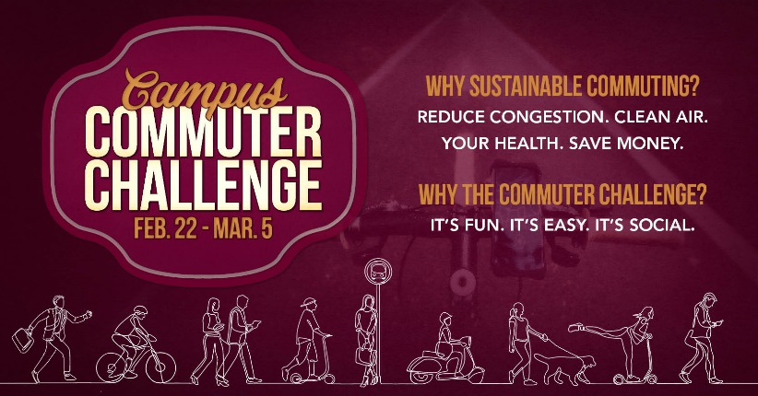

Commuter Challenge Email Templates: Week 2 (March 1st-5th )
ASUM Transportation has prepared some sample email messages that we hope might be useful to you as you spread the word about the UM Commuter Challenge in your workplace. Feel free to use and/or edit the materials to suit your purposes, style, weather etc. (please note the red bolds and edit as appropriate):

Day 6 – Monday, March 1st
We’ve all had the weekend off to recover, relax and reenergize. I can tell we’re all in the zone this week and that we’re ready leave the competition in. the. dust snow. It’s a new month and a great time to practice sustainable commuting.

If you’ve been unable to participate, you still have a chance to be entered into the raffle by logging just ONE sustainable trip, ONE time this week. And if that’s the case, that’s great! There is NO shame in this challenge. We’re here to support each other and I believe we’re all doing the best we can to change our habits and minimize one-person vehicle trips. I’ve said it once and I’ll say it again, it’s all about doing what we can, when we can.

Did you know Way To Go! has an app?! Logging trips on Way To Go! is pretty easy breezy but did you know that it gets even easier?! Don’t believe me? – download the free “Commute Tracker” app and see for yourself. The app will track you as you travel between your home address and your workplace so that when you arrive, all you need to do is confirm your mode. Your trips will automatically be logged to your account. Instructions on downloading and using the app can be found here!

Curious how the competition is shaping up? Check on the UM Commuter Challenge leaderboard to see which department we’ve gotta beat.

Link to leaderboard

Signed, XXXXXX
Your Commuter Challenge Captain

Day 7 - Tuesday, February 11

We are all experts at logging trips by now, but have you discovered the nifty “Favorite Trip” feature? It allows you to save your frequently traveled routes so that you don’t have to re-enter mileage or the start and end destinations when using the trip planning tool. Here’s a short video on how to save a Favorite Trip.
Also, as we all know by now, doing something awesome in your life doesn’t actually count unless you take a photo of yourself doing the awesome thing, AND post it on social media.
So, it’s time to step up Team WORKPLACE’S social media game! Tag @umtransportation to be in the running for Best Team Photo- the prize is the photo framed which would make for some sweet office décor.
Keep up the good work!
Signed, XXXXXX
Your Commuter Challenge Captain

Day 9 - Thursday, March 4th

TOMORROW is the last day of the UM Commuter Challenge!!

Wowzers! That went by fast! You all have been rocking this Commuter Challenge and if you haven’t had a chance to try a sustainable form of transportation, there’s still time! Do it tomorrow and remember that ALL sustainable commutes must be logged at waytogo.missoulainmotion.com by Tuesday March 9th at 5pm. But, as someone who forgets things easily, I suggest going ahead and doing it now.

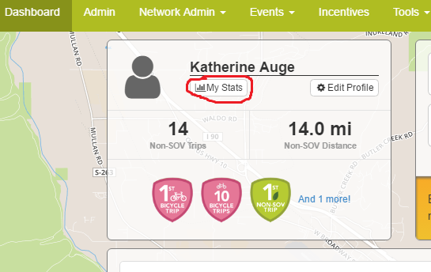
Now that the challenge is coming to a close you can calculate the amount of CO2 your sustainable trips diverted as well as the cold hard cash you saved! To find these stats, simply login at waytogo.missoulainmotion.com and open your “Dashboard”. From there you can select the “My stats” button under your name in the upper left-hand corner (see below). If you’ve logged trips before,
be sure to select that the display show stats for “this month” only.

Thanks to everyone for your efforts these past two weeks! I'll keep you posted on our participation total - cross your fingers!

Signed, XXXXXX
Your Commuter Challenge Captain

