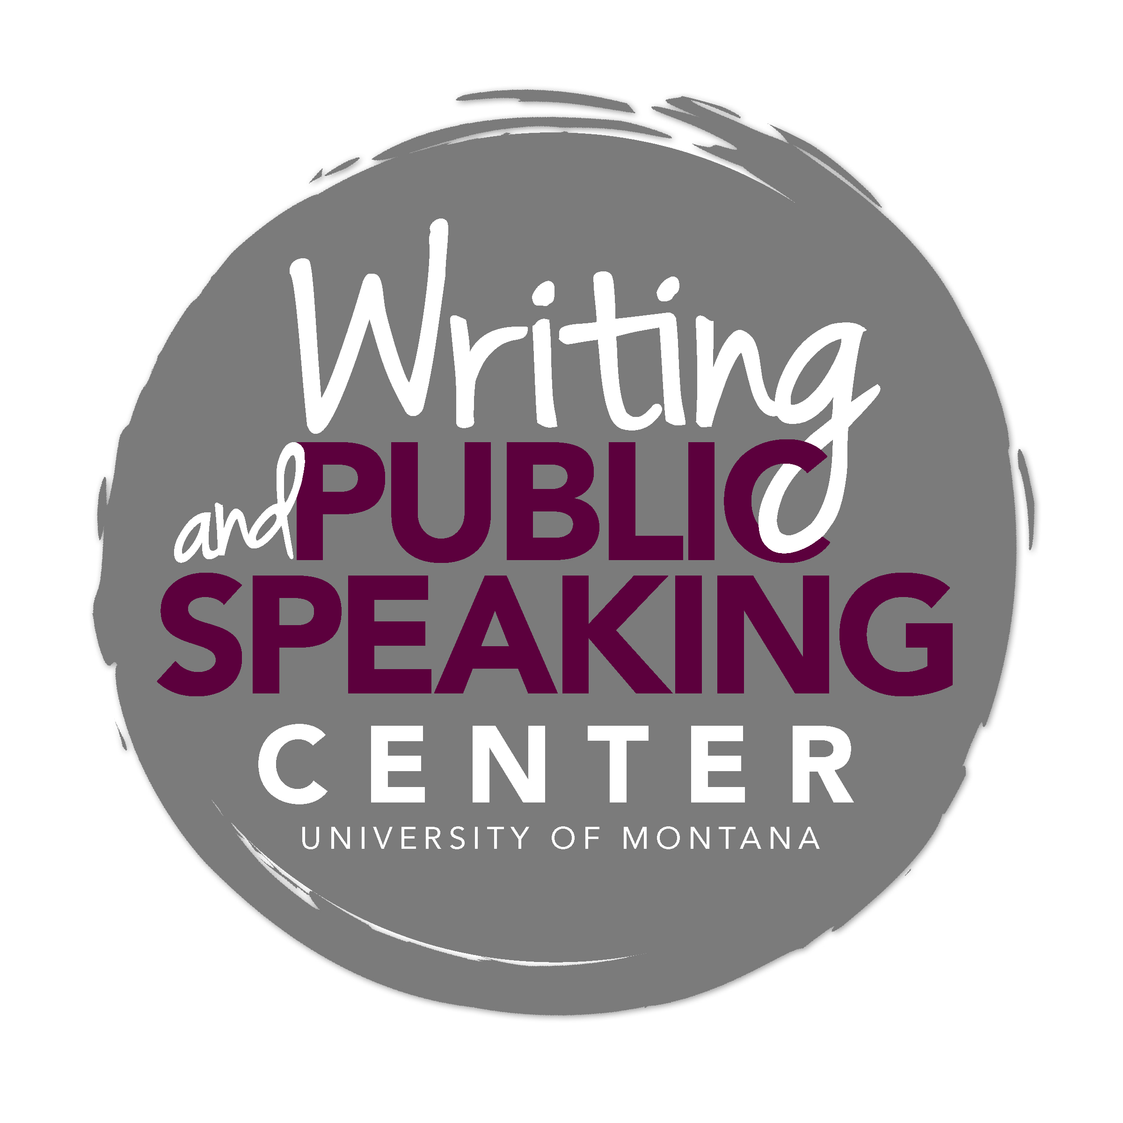
Writing about Literature

General Advice

Writing in the Humanities
As with most writing in the humanities, writing focused on literary texts seeks to examine and construct meaning by finding potential answers to intriguing questions. While writers in the sciences seek to inform other members of the scientific community of their findings to arrive at consensus, writers in the humanities explore possible answers to important questions based on the interpretation of texts. Through close reading of texts, writers in the humanities contribute to on-going conversations about the significance of those texts.

Close Reading and Argument
When writing a literary essay, you join a community of readers by making an argument in support of your perspective on a text or set of texts. Your argument should include a detailed, debatable thesis and evidence supporting this perspective. Closely reading a text and paying attention to what other readers have noticed about that text will help you develop a potential thesis for your paper.

For most assignments that ask you to write about a literary text or set of texts, you will need to:
- spend time with the text(s) – read and re-read.
- focus on some important aspect of the text(s).
- discover notable details that may hold significance for readers.
- develop questions about the significance of those details – ask how and why a text does or suggests something.
- refine and focus your questions until you have a single critical question.
- develop a thesis that answers your question and teaches readers something they may not otherwise have noticed.
- identify textual evidence in support of your thesis.

Common Expectations and Key Characteristics

Analysis and Explication
Whether you are being asked to write a literary analysis or an explication, the task is to perform a close reading in order to arrive at a perspective you will support in your essay. In the case of both literary analysis and explication, your goal is to help a reader see the text(s) in a new way, a goal that should move your paper beyond mere summary and the obvious themes a reader could glean on a first reading.
- Explication involves consideration of most aspects of a text in order to demonstrate a particular interpretation of the work’s meaning.
- Analysis, as the definition suggests, involves examining a specific and important part of the whole. In the case of a literary paper, analysis requires that you identify and focus on a significant element or thread in order to develop and demonstrate your interpretation.

Developing a Perspective/Thesis – Asking and Answering a Critical Question
A strong literary paper will present a perspective/thesis that takes readers beyond the surface of the text to unfold a not-so-obvious understanding. Your thesis should be an analytical assertion, not a descriptive summary, and it should require some work on your part to demonstrate its validity. This means you must read to discover not only what a text says but also to discover what it does and implicitly suggests. In your close reading of a text, you may begin to recognize significance, for example, in the language used, in key patterns, in repeated images, in an expanded metaphor, or in what is included and omitted. As you note these details, ask questions about their significance, eventually refining your questions to focus on a single critical question that you would like to answer in your paper.

Example: James Joyce’s “The Dead”
- Ask and refine a critical question
In response to James Joyce’s “The Dead,” you might initially ask, “Why is snow such an important part of the setting?” With more attentive reading, you might refine this question to make it more complex and focused: “What is the relationship between the ever-present snow and the desire for connection in a broken world?”
- Return to the text and re-read with your question in mind
Return to the text and, if necessary, reference secondary sources. Engage in close reading to discover what elements in the text (and in the larger social/political/historical context) suggest the idea of a broken world and to discover how the snow might represent a related idea. Allow the text to guide you to a better understanding of your question and its possible answers.
- Answer the question – make an analytical assertion about what a text does or suggests
Your answer should move readers beyond mere summary and surface observations (“Snow is everywhere in James Joyce’s “The Dead.”) to a compelling and argumentative claim: “The snow that is ‘general all over Ireland’ in James Joyce’s ‘The Dead’—by bringing the dead and the living into a melancholy unity—becomes a metaphor of connection in a broken world.” Notice how this statement reveals the writer’s perspective and invites readers to consider a not-so-obvious aspect of the story.

Supporting Your Perspective/Thesis

Textual Evidence
Strong literary arguments grow out of relevant and convincing textual evidence. The notable textual details that help you to develop a critical question and discover an answer to your question eventually may become the textual support you will present in your argument.

Example: Gathering evidence in James Joyce’s “The Dead”
- Note the answer to the question above: “The snow that is ‘general all over Ireland’ in James Joyce’s ‘The Dead’—by bringing the dead and the living into a melancholy unity—becomes a metaphor of connection in a broken world.”
- Return to the text and identify textual evidence that helps readers uncover these ideas of “melancholy,” “unity,” and “connection.” What supporting ideas do these textual details help to demonstrate?
- If necessary, reference secondary sources that help explain the social/political/historical context underlying the idea of a “broken world.”

Arranging Evidence
The general pattern of discussion in your paper will present an assertion in support of your thesis, provide textual support for that assertion, and discuss the assertion before another idea is presented. This means that unlike scientific papers, literary papers do not follow a rigid format in which discussion follows presentation of methods and results. Rather, literary papers embed discussion throughout, and your ideas and the logical connections among them will dictate how you organize your argument. When organizing your argument and textual evidence, be sure to:
- arrange evidence so that you logically advance your argument and move your reader from idea to idea rather than from example to example.
- make clear assertions substantiated by textual evidence.
- discuss each quotation and summary, demonstrating for your reader why each is significant and how it contributes to the overall perspective stated in your thesis.

Using a Theoretical Lens
You may be invited to use a particular theoretical lens—often referred to as a school of literary criticism or as a literary theory—through which you will perform your analysis. Be sure to ask your professor whether you are required to use a particular theoretical approach. There are many schools of literary theory that may help inform your reading of a text. For example, a writer might consider Shakespeare’s plays or Kate Chopin’s fiction through the lens of feminist criticism, cultural studies, or Marxist criticism. Whichever theoretical lens you use, it is imperative that you have a good understanding of the theory and its set of values and assumptions.

Documenting Sources
Writers in the field of English use the Modern Language Association (MLA) format for citation. Developed by professionals in the humanities, this documentation style allows writers to document consistently those aspects of source materials that most matter to the discipline. For example, MLA style places importance on authorship and on the original text, allowing the reader to find the specific information used. Because MLA format for citation is a strict system with prescribed rules, refer to a style guide such as the MLA Handbook for Writers of Research Papers (7th edition).

Using proper MLA style for citation allows you to:
- join a community of writers and readers who share certain values and a common citation system.
- build your credibility as a writer and researcher.
- provide readers access to your sources.
- make clear where your ideas end and another’s begin. Whether you are quoting, summarizing, or paraphrasing in your own words, you must cite your sources. Even if you do not intend to plagiarize, if you do not properly cite your sources, you have plagiarized.

Some Tips

Questions to Ask of Your Draft

As you write and receive feedback on your paper, consider asking the following questions:

- Does my thesis move my readers beyond the surface of the text(s)? Does my thesis have enough depth to unfold a new understanding for my reader? Is it appropriately limited in scope to allow me to focus my analysis on a key aspect of the text(s)?
- Does my essay have a meaningful organization that purposefully moves a reader from one idea to the next rather than from one example to the next? Before moving to a new idea/assertion, do I provide and discuss adequate support?
- Do I use relevant textual support to substantiate my thesis? For each example meant to support my thesis, do I use only those pieces that are relevant to my claim?
- For each piece of textual evidence presented, do I offer discussion that sheds light on its significance within the context of my thesis? Will my reader understand why I am using a particular example/quotation?
- Do I waste space on unnecessary summary of stories and plots? Do I make purposeful choices about when to summarize, paraphrase, and quote primary and secondary sources?
- Do I use proper MLA format for my paper and in documenting sources?

Common Pitfalls to Avoid

When writing a paper on a piece of literature, take care to avoid the following common pitfalls:

- Lack of an adequately complex thesis – A good thesis moves your reader beyond a simple observation. It asserts an arguable perspective that requires some work on your part to demonstrate its validity.
- Excessive summarizing – Your task is to move beyond mere summary to help a reader understand a not-so-obvious idea. You can assume your reader has read the literature but that he/she will not remember every detail relevant to your perspective.
- Assumption that there is one correct or “hidden” meaning – Your essay should aim to expand your readers’ understanding of a text, not to present a single, definitive meaning. This means that you are offering and supporting one potential interpretation.
- Excessive quoting – When quoting in order to provide textual evidence, use only the relevant part of the quotation. When you establish a claim/assertion and provide textual support, be sure to explain the relationship between the quotation and the assertion. Your reader can’t read your mind.
- Lack of adequate support – A well-crafted thesis requires substantiation in the form of textual evidence. Often, if your thesis doesn’t make a complex, arguable claim, the act of substantiation becomes difficult. Take care to develop a thesis that will require purposeful use of textual evidence.
- Improper use of a critical lens – If you are using a particular critical approach/literary theory in analyzing a text or set of texts, be sure you have a good understanding of the critical lens you will be using.
- Use of personal asides and value judgments – Your task is to shed light on what a text does and to make assertions grounded in textual evidence, not in personal opinion.
- Shifting verb tense – When writing about literature, use present tense, even if the events take place in the past.
- Passive voice – Use active voice as often as possible. Active voice generally is more concise and lively than passive voice.
- References to the composition of the essay – You do not need to refer to what your paper is doing or what you plan to do in the essay. Instead, move your argument forward – if your ideas are clearly and logically argued, your reader will recognize what you are doing without the need for announcements.
- Reference to the author by his/her first name – It is customary and respectful to refer to the author using his/her last name. The first time you mention the author, use his/her full name.

