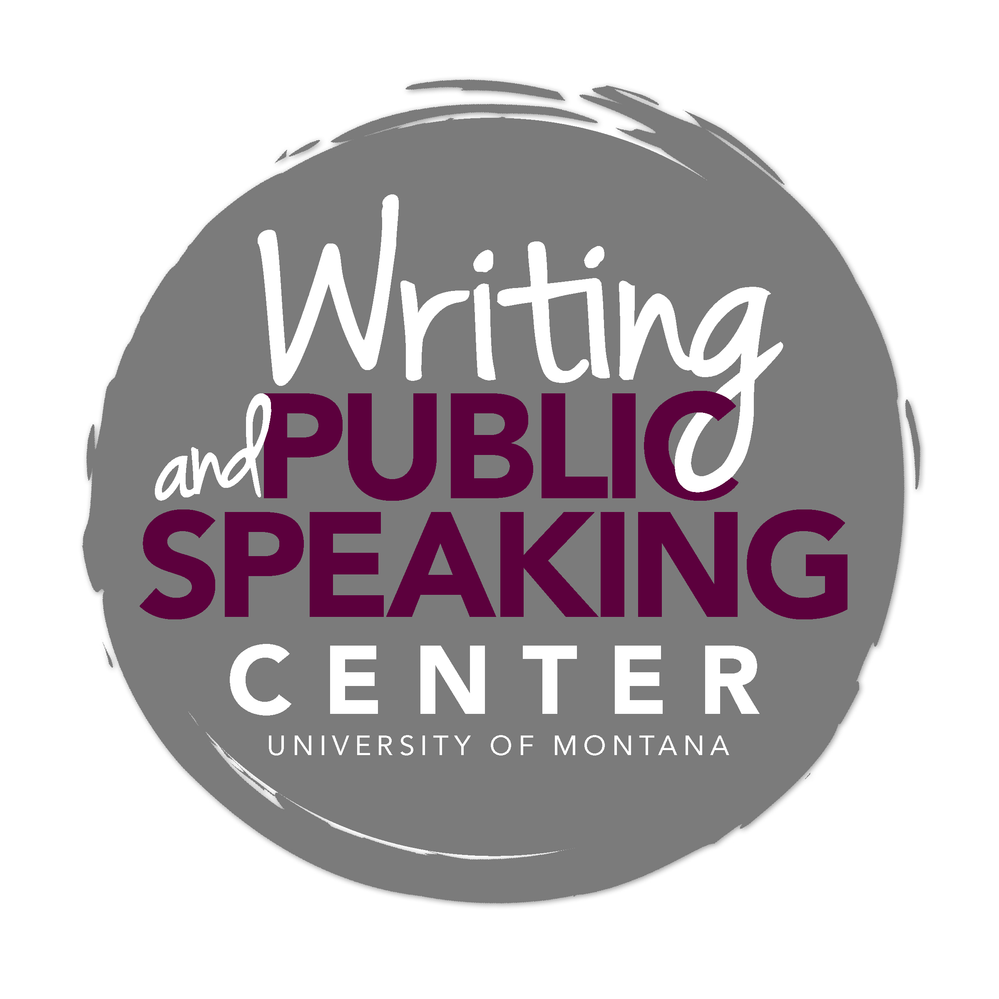

Writing in Environmental Studies
__________________________________________________________

General Advice and Key Characteristics

An Environmental Studies (EVST) Approach
The field of environmental studies is concerned with providing the skills and literacies needed to foster a healthy natural environment and create a more sustainable, equitable world. To achieve this, the EVST program employs an interdisciplinary approach, integrating the natural sciences, social sciences and humanities. This interdisciplinary approach allows students to “learn about and respond to the array of multifaceted problems and opportunities in environmental issues” (Professor Spencer).

EVST students not only learn to understand environmental problems and work toward social, economic and environmental sustainability, but also prepare for further education or training in related fields. The main facets of the program are as follows: environmental science (e.g., natural and social science principles; ecology); environmental policy and politics (e.g., history and theory of natural resource law and regulation); environmental thought, literature and communication (e.g., nature writing; history of environmental ethics); and engagement (e.g., strategies and techniques for addressing environmental problems).

Because of this interdisciplinary approach, there is no particular unifying theme or set of expectations for writing in the field. For some classes, the purpose of a writing assignment might be “to convince, persuade, and call to action; to foster examination, exploration, understanding; or to express and enact relationships to and with nature and culture” (Professor Condon). Or, the purpose might be to describe and measure phenomena, to interpret evidence, to inform others of findings, to construct or deconstruct meaning, or to interpret texts. Often, the purpose is “to make an argument and to marshal compelling and accurate evidence to support that argument” (Professor Hassanein).

Despite these varied purposes, EVST students can expect to encounter some common writing tasks and to be asked to make some common moves as writers. As the expectations for writing (substantive, conventional and mechanical) differ from one class to the next, adherence to the assignment is critical. If you find your assignment puzzling, it’s never a bad idea to ask your teacher for clarification.

Common Writing Tasks

As a student in EVST, you will produce academic papers that will help you learn, critically consider, communicate, and apply key elements of environmental science, history, policy and thought. Some common assignments in EVST include:

Critical Review of a Book, an Article, or the Literature (aka Literature Review)
Whether you are reviewing a book, a selected article, or literature on a particular topic, your task is not only to summarize but also to analyze and sometimes evaluate in order to identify the patterns, implications, strengths, and limitations of what you have read.

In the case of a book review or article critique, you will:
- Summarize—identify the text’s thesis, the methods used, the evidence/data presented, and any
contributions to the field.
- Analyze and Evaluate—move beyond summary to analyze the text’s relationship to key concepts and other texts in the field, its implications, its applicability to other scenarios, and its strengths and weaknesses.

In the case of a review of literature—an assignment that requires you to look at the relationships among texts—you must not only identify, summarize, and compare literature relevant to the topic under consideration, but also synthesize this literature in order to argue a point about the current state of knowledge.

Research Paper
Research papers in EVST often require that you identify a problem or question worth investigating and perform research that will help you to solve the problem or answer the question. Therefore, a key step in writing many EVST research papers is identifying an important question or problem, a step that requires lots of reading and note taking. Invest time in formulating a strong research question or problem that you can then work to answer or solve by collecting data or by reading relevant literature.

At other times, you may be asked to answer a specific question/prompt using what you’ve learned or read so far in the class. In cases like these, it’s about interacting with and integrating the information, not regurgitating it.
Example: Describe and analyze two characteristics of the dominant food system that you think are particularly important.

Or, you may be asked to respond to a detailed, hypothetical scenario by applying a legal rule or by synthesizing the policy and issues you’ve learned about through case studies.
Example: You are an attorney representing the US Fish and Wildlife Service. Outline your case against the landowners, claiming they will violate the Endangered Species Act if they build their home as planned.

Or, you may be asked to write something in a less conventional format, but with similar expectations.
Example: Write a letter to a friend or family member in which you, using what you’ve learned as evidence, respond to the question: What exactly is globalization and why is there such a hullabaloo about it?

Environmental Policy or Case Study Analysis
Environmental policy and case study analysis papers often ask you to critically evaluate the effectiveness of a policy/institution and its response/approach to a current case. You should demonstrate a clear understanding of the case and, after careful analysis, make informed recommendations. You may be asked to write from the perspective of another body, e.g., a critical organization. In these papers, remember that your task is to evaluate using valid criteria, not merely to summarize the policy/institution’s response/approach.

Original Nature/Environmental Essay
In order to show engagement with the assigned readings, you may be asked to write an original non-fiction piece that demonstrates understanding, connections, personal experience, independent research and new insights. These assignments invite you to use creative writing to gain a deeper understanding of self, nature and culture. This kind of assignment generally leaves a great deal up to you, in terms of form, content and organization, but the standard academic expectations for mechanical accuracy remain stringent.

Common Moves for Writers in EVST

Understand the Task and Revise
Before you begin thinking, researching, and writing in response to an assignment, know what is being asked of you. Are you being asked to analyze, describe, discuss, evaluate, explain, reflect, or summarize? Each of these verbs directs you to do something different, and sometimes you may be asked to do more than one thing in a single assignment. Also, do not confuse your writing process with your final product. The magic in good writing is careful revision. Make use of Writing Center tutors and other expert readers as you revise and refine your thinking and writing.

Know Your Audience
Remember that not every writing task in EVST asks you to write for the same audience. Knowing who you are writing for allows you to make purposeful decisions about content, organization, and approach. Do not make the mistake of assuming your audience always is your professor; rather, interrogate the assignment and determine for whom you are writing and for what purpose. “Depending on the purpose of the assignment, you may be trying to inform a decision maker, a stakeholder group, an influential media person, or any of many other possible target audiences” (Professor Watson). By identifying your audience, you can more effectively anticipate your reader’s needs, expectations, values, and other key factors that may influence your choices as a writer.

Narrow your focus to a feasible topic
Narrowing the scope of your topic, especially in a research paper or in a literature review, is a critical step in thinking and writing. Make note of the topics covered in published papers/essays, and commit yourself to finding a topic that will allow you to find ample information and that will sustain your interest.

Use Appropriate Evidence
Whether you are making a critical argument about a text or making a data-oriented argument, you must substantiate your argument with appropriate evidence. In EVST, always take care to distinguish between your opinion and evidence that is grounded in what a text actually says or in what the data actually tell you. Be rigorous in making this distinction. Also, you may be asked to distinguish between assumptions (made by you or by the writer you’re analyzing) that are scientific and those that are philosophical.

Use subject librarians throughout the research process
Librarians at the Mansfield Library can help you identify and evaluate source materials, narrow your focus, and refine your ideas. Effective research strategies are a key part of a successful writing process.

Use tables, graphs, figures, and displayed equations purposefully
Make purposeful decisions about which information needs to be presented visually, then present precisely and in a simplified form. Be clear. Be brief. Don’t force a reader to work too hard to understand your visual. Also, describe these visuals in the text, explaining the main point and significance of the information presented.

Document sources accurately and ethically
Writers in EVST use a host of formats for citation. Some instructors ask for formats following guidelines established by the American Sociological Association (ASA), the Council of Science Editors (CSE), or the Modern Language Association (MLA). Be sure you’ve read your assignment carefully so that you use the correct format. Because each format is a complex and strict citation system, refer to a style guide, consult with a reference librarian, or visit the Writing Center to learn how to use the citation system.

Using proper citation allows you to:
- Join a community of writers and readers who share certain values and a common citation system.
- Build credibility as a writer and researcher in the related environmental fields.
- Provide readers access to your sources.

Make clear where your ideas end and another’s begin. Whether you are quoting, summarizing, or paraphrasing in your own words, you must cite your sources.

Some Tips

Questions to Ask of Your Draft
As you write and receive feedback on your papers, consider asking the following questions (not all questions are applicable to all types of assignments):

- Does my paper accomplish the task described in the assignment? For example do I move beyond reporting and describing in response to an assignment that asks me to analyze or evaluate?
- Is my work interesting, individual, lively, good reading? Does it clearly demonstrate my engagement with the subject? Is it evident that I care?
- Is my paper clear and to the point, avoiding unnecessary information and showy phrasing?
- Do I use evidence that is grounded in the reading or in observable, collected data? Do I include only those details that are relevant to the purpose of the piece of writing?
- Do I organize my content in a way that is appropriate for the type of paper I am writing? Do I adhere to the organization guidelines provided by my professor?
- Do I distinguish my ideas from those of the authors/theories/articles I discuss? Do I make clear where others’ ideas end and where my ideas begin?
- Do I waste space on excessive summary of sources? Do I make purposeful choices about when to summarize, paraphrase, and quote primary and secondary sources?
- Do I use proper formatting for my paper and in documenting sources?
- Have I read my paper out loud to catch awkward phrasing and clunky sentences?

Common Pitfalls to Avoid
When writing a paper for an EVST course, take care to avoid the following common pitfalls:

- Lack of an adequately complex thesis: A good thesis moves your reader beyond a simple observation. It asserts an arguable perspective that requires some work on your part to demonstrate its validity.
- Lack of adequate support: A well-crafted thesis requires substantiation in the form of acceptable evidence. This may come from observations, collected data, or published research. What does your assignment require?
- Excessive summarizing/lack of analysis: Your task often is to move beyond summary to help a reader understand your evaluation and analysis of the text, data, policy or issue.
- Excessive quoting: When quoting a source in order to provide evidence, use only the relevant part of the quotation. When you establish a claim/assertion and provide textual support, be sure to explain the relationship between the quotation and the assertion. Your reader can’t read your mind.
- Assuming too much: Be mindful of your intended audience, hypothetical or otherwise, and what they do or don’t already know about your subject.
- Affected voice: The more comfortable you become in writing (the more practice you have), the more you will establish your own personal voice and tone. It can be tempting to try to adopt an academic-sounding voice in the hopes that your argument will come across with more authority. Your authority won’t come from a false voice, which often leads to convoluted, erroneous or indecipherable language, but from your evidence and from the many little techniques you’ll learn to make your argument convincing.
- Plagiarism: Plagiarism is the use of someone else’s work or ideas, in any form, without proper acknowledgement. Whether you are quoting, summarizing, or paraphrasing in your own words, you must cite your sources.
- Use of unreliable electronic sources: Rigorously evaluate your sources, particularly ones from the Internet. Ask who authored the information, who published or sponsored the information, how well the information reflects the author’s knowledge of the field, and if the information is accurate and timely.
- Shifting verb tense: Shift verb tense only when necessary. Your writing should accurately reflect that research was performed and events took place in the past and that certain knowledge is current.
- Passive voice: Use active voice as often as possible. Active voice generally is more concise and lively than passive voice.
- Miscellaneous: “Wordiness. Digressions that never return and/or are not engaging. Slow starts. Slow endings.” (Professor Condon).

