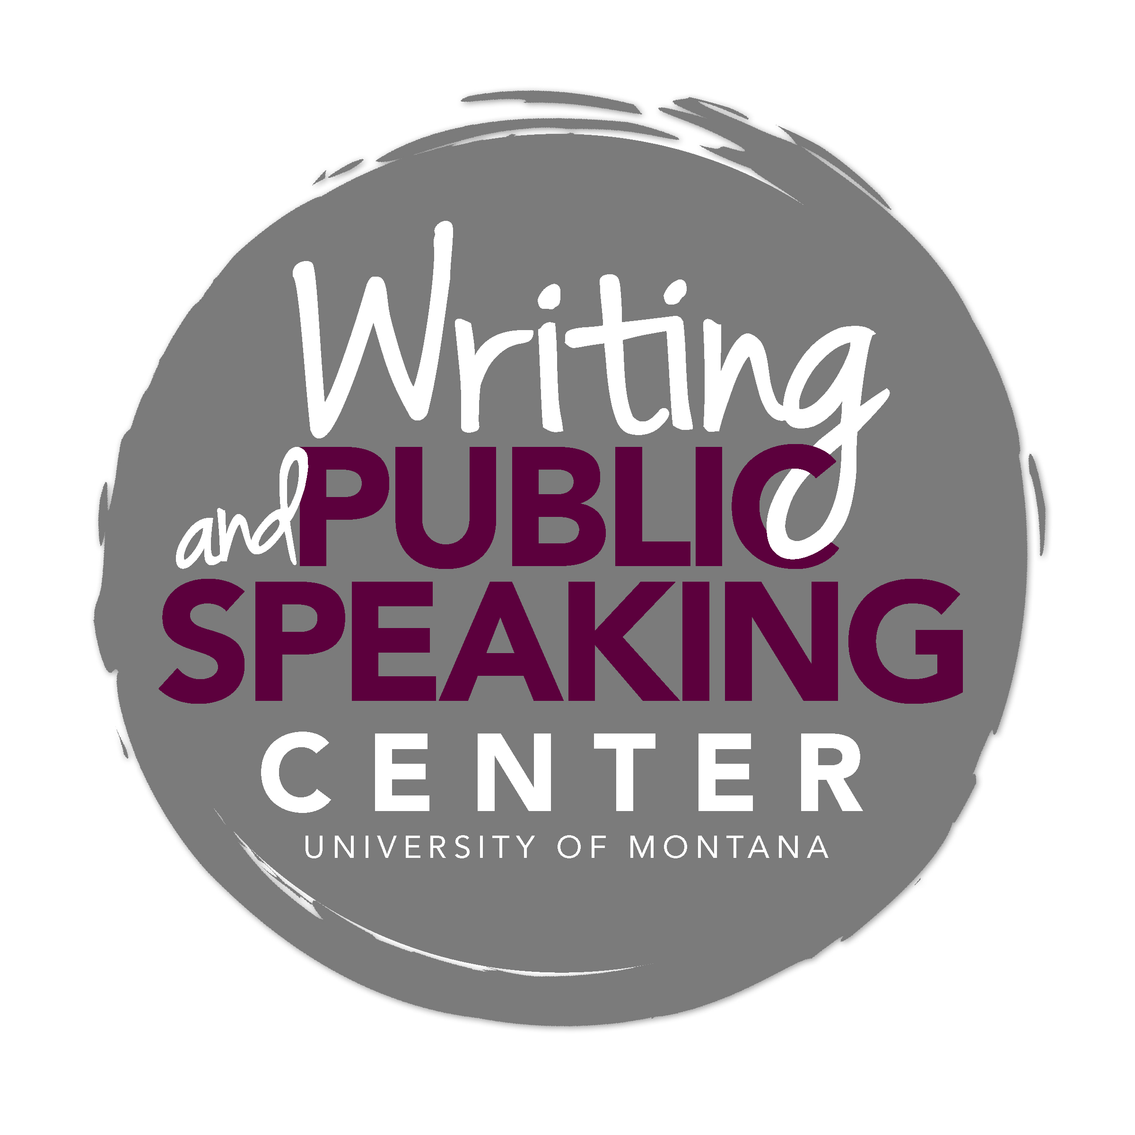

Writing and Communicating in Pharmacy Practice

General Advice and Key Characteristics

A Pharmacist’s Approach to Communication
As a writer in pharmacy at the University of Montana, you will write for real audiences to communicate important information. For example, you may write answers to real questions submitted to UM’s Drug Information Service (DIS). You will also practice generating the types of writing professional pharmacists produce. Because these writing tasks have real life consequences, communicating clearly and effectively is crucial.

Pharmacists serve people. This kind of service requires not only effective written communication but also effective oral and non-verbal communication. When interacting with patients, remember the elements of good non-verbal communication: attentive facial expressions, eye contact, focused listening, and personable interactions. UM’s pharmacy program will require you to hone these skills as a professional.

Writing in pharmacy emphasizes the tenets of scientific writing. This means you must accurately communicate complicated scientific information found through complete, discerning, and careful research. Successful research in pharmacy requires that you understand how to navigate databases like PubMed, Google Scholar, and those found on the Mansfield Library website.

Characteristics of Successful Writing in Pharmacy
- Audience awareness—ensure your written or oral work is appropriate for the audience
- Conciseness –get to the point quickly and clearly
- Strong research skills—discern the credibility of information, accurately interpret it, and clearly communicate it
- Appropriate format—follow the prompt’s guidelines exactly
- Formality—use a formal, professional tone
- Evidence – interpret and accurately represent evidence to support your points
- Organization – present information in a logical way that supports the purpose of your writing
- Polished – ensure your writing is free of grammatical, punctuation, and spelling errors
- Oral communication—focus on nonverbal cues, empathy, and attentive listening

Know your Audience
When beginning a new writing task, ask yourself: for whom am I writing? Your audience could be a physician, a patient, or a fellow pharmacist. Effective communication requires knowing the intended audience and writing to best reach that audience. For example, communicating something to a fellow pharmacist might require different strategies than those you might use communicating information to a physician or a patient.

Cultivate strong research skills
Developing strong research skills takes time and practice. Be patient with yourself. When in doubt, ask questions. Become familiar early in your pharmacy career with databases like PubMed, Google Scholar, and those found on the Mansfield Library website. Being able to navigate these databases will help you find credible resources more easily. The reference librarians at Mansfield are available to help with research and database questions.

Strong research skills require properly interpreting scientific information. If you don’t understand a study, ask questions. Using a study you don’t understand as evidence can lead to reaching inappropriate conclusions or other research blunders. When reading scientific studies, be critical and don’t make assumptions. Take nothing at face value. Generally, avoid using abstracts as evidence.

Ask Questions as a Researcher
Strong researchers approach others’ research with a critical eye. Ask the following questions:

- Who wrote and/or conducted this study?
- Are the authors credible? Why or why not?
- Are there any conflicts of interest (e.g., employees of a company, funding sources, etc.)? Does this impact my interpretation of the study’s results?
- Is this primary literature or secondary literature?
- Is this article peer-reviewed?
- Did I read the entire study?
- Do I understand this study (e.g., the motivations, the methods, the findings, the conclusions)?
- Have I accurately interpreted and communicated the findings of this study?
- Is this study appropriate to include in my work? If so, am I using this study properly in my own writing?
- Have I given credit/cited appropriately in my writing?

Use Formal Writing and Appropriate Shorthand
Most writing tasks in pharmacy call for formal writing. Remember, just because an assignment may require shorthand does not mean that other forms of shortened “lingo” (e.g., texting lingo) is acceptable. Use only appropriate abbreviations. If you’re not sure if your shorthand is acceptable, ask your instructor.

Generally, avoid the use of “I” in pharmacy assignments. Third person is most appropriate, unless otherwise specified in the prompt. Remember that communicating in pharmacy often has real world implications, so communicating in a professional way is crucial.

Cite Sources Using a Variation of AMA
UM’s pharmacy program uses a variation of the American Medical Association’s (AMA) citation style. A guide to this citation style can be found on the pharmacy department’s website. This guide supersedes any other AMA guides; follow this document closely as you cite your sources both within your text and in a reference list at the end of your text

Be Concise
Scientific writing gets right to the point. Use simple, straightforward sentences. Verbose or flowery language will only muddy your point.

Be Precise
Pharmacy requires precision in thinking and language. Avoid words like “it,” “that,” and “they.” Instead use words that precisely describe the drug, person, or item you are referencing.

Scope and Common Communication Tasks in Pharmacy

You will be asked to complete a number of writing tasks as a pharmacy student. Pay close attention to the prompt for every writing task you are assigned; each prompt will have different requirements, expectations, and audiences. The following section provides tips and suggestions for common writing and communication tasks in the pharmacy program.

Drug Information Service Responses
In your University of Montana DIS responses, be precise and concise. Always lead with the answer to the original question. Pharmacy faculty call this “leading with your aces.” Leave out unimportant details, and focus on answering the question quickly, but adequately. This will require you to make decisions about what information is important and what information to exclude. Remembering who your audience is (a pharmacist, a social worker, a physician, etc.) will help you decide what to include in your response. Aim for your response to be shorter than one page in length (approximately 3 to 4 paragraphs).

In some situations, you might be asked to write a traditional DIS response. Traditional DIS responses include the following parts: introduction, evidence, study summaries, and conclusions. Traditional DIS responses are often around three pages long. While UM does not use traditional DIS responses for its DIS service, your clinical preceptor or a faculty member might ask you to write a traditional response to familiarize you with the style. Always pay careful attention to writing prompts or your preceptor’s instructions to ensure that you are crafting a response that is appropriate for the task.

Sometimes you will deliver your DIS responses orally, perhaps over the phone. When communicating over the phone, conciseness and precision becomes even more important

Op-Eds and Position Papers
Op-eds and position papers require you to take a stance and then support your claims with evidence. These papers require that you carefully scaffold arguments in a logical, cohesive fashion.

Op-eds and position papers require careful research on the front end. Rather than taking a position and then finding source to support that position, approach a topic with an open mind, learn as much as possible, and then take a stance. Think of this writing process in terms of the scientific method: approach the topic with a question and seek an answer. This approach will help you to create an argument steeped in research and evidence.

Frequently, writing prompts will ask you to include counterarguments. Remember to take counterarguments seriously. Accurately portray compelling counterarguments, and then address them. Doing so creates a balanced, more persuasive argument.

Pearl Presentations
Pearl presentations are approximately five minutes long, which means you must be concise and precise. Often for these presentations, you will present on research from an op-ed assignment. Successful presentations begin with a roadmap for your talk. If the assignment requires PowerPoint slides, a good rule of thumb is one slide for every minute of your presentation. Your slides should present the information logically, following your roadmap. Always practice your presentation with an audience like a Writing Center tutor, and practice with a timer to ensure you don’t exceed the five allotted minutes.

Mock Counseling Sessions and Communicating with Patients
Pharmacy is about serving people. Your communications with patients should result in positive interactions. One of the most important ways to communicate effectively is to be present with the patient. Listen carefully and attentively in order to best address each patient’s unique needs. Some other tips for successful oral communication include:
- Be kind and courteous
- Make eye contact
- Use non-verbal and verbal cues to signal that you are listening (nodding and responses like “mhm” and “okay”)
- Listen carefully to the patient, which means being present, not jumping to conclusions, and not interrupting
- Be personable
- Empathize
- Answer questions honestly, but with empathy
- Be present; avoid letting your mind wander
- Practice cultural awareness and sensitivity
- Be aware of your own bias and stereotypes; avoid these biases and stereotypes in your communication
- Remain calm and don’t rush interactions
- Turn your body towards the patient
- Be aware of your body language and the unintentional messages you could be sending
- Read your patients’ body language
- Ask for wisdom from faculty members, preceptors, and fellow pharmacists
- Be confident!

Journaling
Some classes might require informal journaling. This kind of writing is an opportunity to let the teacher know you are present and paying attention in class. In this kind of writing, perfect grammar and spelling often are not important. Instead, focus on your ideas, your effort to grapple with course concepts, and your expanding pharmacy knowledge.

Service Learning Reports
Service learning reports require teamwork, effective communication, and thoughtful reflection. This assignment is composed of multiple tasks completed throughout the semester. You will produce progress reports at intervals throughout the semester, individual personal reflections, peer and self-evaluations, a final report, and a final presentation on your group’s work. The prompt for this assignment specifies what is required of each task, including what information to include in each section. Follow these directions carefully.

Your teacher will provide a rubric that outlines the grading criteria. Read this closely. Overall, your teachers are looking for evidence that you know your audience, for accurate descriptions of group members’ roles and processes, for a clear description of methods, and for a well-constructed project analysis. Always refer to the rubric and your instructor with questions about this multi-step assignment.

Reading Responses
All reading responses are different. Generally, they require reading a book or article, and then responding in some way. Reading responses may ask you to provide your opinion, to craft an argument in response to the source material, or to answer specific questions about the piece.

Literature Reviews
The literature review serves either as a prelude to developing your own research question or as a standalone synthesis of existing knowledge of a particular subject. After selecting a topic, your task is to summarize the current state of research; evaluate the quality of the sources you have selected; recognize where experts disagree, agree, or build upon one another’s’ ideas; and identify areas for further inquiry. Although more recent publications (from the last 5-10 years) are usually preferred, foundational papers in the field can also help you develop your argument. Simple summary won’t be sufficient – you must look at relationships between the texts and synthesize the findings of various authors to tell a cogent story. A thorough literature review can help you identify a research question that, once answered, contributes new information to the existing literature.

Common Pitfalls to Avoid

- Using overly verbose language
- Not following the assignment formatting described in the prompt
- Using “I” when it is inappropriate for the assignment
- Following examples provided by the teacher too closely
- Conflating shorthand with internet or texting lingo
- Not carefully reading and following the prompt
- Using non-specific language
- Assuming statistics or evidence stands for itself; interpret the meaning of evidence for your reader
- Not considering your audience
- Plagiarizing, intentionally or unintentionally
- Improperly using scientific studies as evidence

