

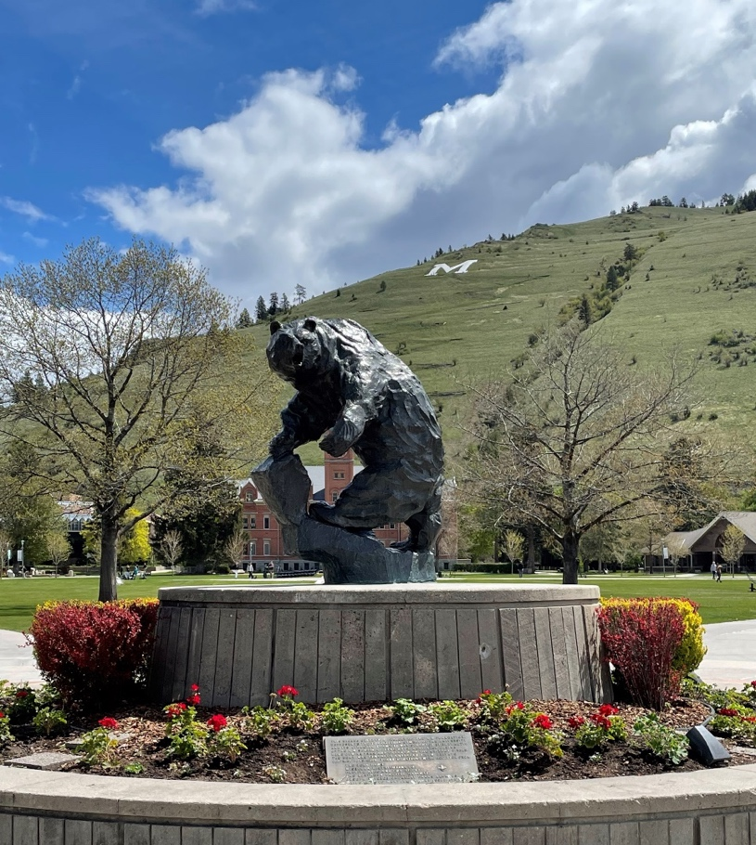
Athletic Training Program


Preceptor Manual

Table of Contents
Personnel 4
I. Preceptor Expectations 5
II. UM ATP Clinical Education 7
A. Clinical Education Plan & Overview 7
B. Clinical Experience Expectations 7
C. Clinical Experiences Outside of Missoula 8
D. Non-orthopedic/Non-sport Clinical Experiences 8
E. Clinical Education Objectives 9
F. Clinical Education Time Commitment and Expectations 12
G. Clinical Experience Time Logs 13
H. Immersive Clinical Experience Guidelines 13
I. Guidelines for Placement in Distance Clinical Experiences 13
J. Nametags 14
K. Emergency Action Plans for Clinical Sites 14
L. Clinical Experience Evaluations 14
M. Curricular Content Standards Grading Criteria: 14
N. Clinical Site Visits 15
III. Clinical Education Glossary of Terms 15
IV. Masters in Athletic Training Program Information 16
A. Pre-AT Requirements 16
B. Admissions Requirements 17
C. Admissions Policies 17
D. Pre-requisite Course Evaluation 18
E. Five Year Plan 20
F. Two Year Plan 21
G. Three Year Plan 22
H. Masters Requirements 23
V. Clinical Education Forms 24
A. Sample Affiliation Agreement 24
B. Preceptor Vitae Form 33
C. Calibration and Electrical Safety Checks 35
D. Therapeutic Equipment Table 36
E. Athletic Training Student/Preceptor Clinical Worksheet 37
F. Clinical Education Infraction Policy 38
VI. Clinical Evaluations 39
A. Preceptor Evaluations ATS 39
B. AT Student Evaluation of Preceptor 44
C. Faculty Evaluation of Clinical Site 48


University of Montana Non-Discrimination and Title IX Statement
The University of Montana is committed to providing a learning and working environment that promotes respect, dignity, and equity for all individuals. In accordance with federal and state law, the University does not discriminate—and prohibits discrimination—on the basis of race, religion, color, national or ethnic origin, ancestry, creed, sex (including pregnancy, childbirth, lactation or related medical conditions), gender, (including gender identity, gender expression, and gender transition), sexual orientation, physical or mental disability (including having a history of a disability or being regarded as having a disability), marital or family status, genetic characteristics or information, age, veteran or military status, political ideas, or any other legally protected classification in its educational programs and activities, including admission and employment.
In accordance with Title IX of the Education Amendments of 1972 and its implementing regulations, the University of Montana does not discriminate on the basis of sex in any education program or activity that it operates. This requirement extends to admission and employment. Inquiries about the application of Title IX may be referred to the University’s Title IX Coordinator.
The University of Montana has designated a Title IX Coordinator and Director of Equal Opportunity to coordinate its compliance with Title IX and other non-discrimination laws and policies. Their contact information is:
Title IX Coordinator and Director of Equal Opportunity
Office of Conflict, Resolution, & Policy
University Hall 004
University of Montana
Missoula, MT 59812
Phone: (406) 243-5710
Email: conflict@umontana.edu
Website: umt.edu/eo
Submit a report online
Individuals may also contact the U.S. Department of Education’s Office for Civil Rights (OCR) with inquiries, questions, or complaints at:
Office for Civil Rights (OCR)
U.S. Department of Education
400 Maryland Avenue, SW
Washington, D.C. 20202-1100
Phone: 800-421-3481
TDD: 800-877-8339
Email: OCR@ed.gov
Website: https://www.ed.gov/ocr
Any person may report discrimination, harassment (including sexual harassment), or retaliation—by using the contact information listed above, or by any other means that results in the Title IX Coordinator or the Office of Conflict, Resolution, & Policy receiving the report. Reports may be submitted at any time, including during non-business hours.
The University has adopted and published grievance procedures providing for the prompt and equitable resolution of student and employee complaints of discrimination, harassment, retaliation, and sexual harassment, including formal complaints under Title IX. Information about how to file a report or formal complaint, and how the University will respond, is available from the Office of Conflict Resolution and Policy on the Equal Opportunity and Title IX website, including:
- Discrimination, Harassment, and Retaliation Policy and Procedures
- Sexual Harassment Policy and Procedures (anticipated issuance in August 2025)
This non-discrimination statement is prominently displayed on the University of Montana’s website and included in relevant publications, including handbooks and catalogs distributed to students, employees, applicants, and unions or professional organizations holding collective bargaining or professional agreements with the University.

Personnel
(CAATE Standard III.22)

President Dr. Jeremiah Shinn
Provost Dr. Adrea Lawrence
Dean COH Dr. Matt Fete
Chair, School IPAT Dr. Valerie Moody
Medical Director Dr. Carla Fritz (CAATE Standard III.30)

Athletic Training Faculty
Valerie Moody PhD, LAT, ATC, CSCS
Program Director
Professor IPAT
406-243-2703
valerie.moody@umontana.edu

Mitch Willert MS, LAT, ATC
Clinical Associate Professor IPAT/Coordinator of Clinical Education
608-287-4077
Mitchell.willert@umontana.edu

AT Faculty/Instructors
Nick Cromidas MEd, LAT, ATC
Clinical Assistant Professor IPAT
nick.cromidas@mso.umt.edu

Charlie Palmer PhD
Paul Capp MS, LAT, ATC, CSCS
Taylor Purchio MAT, LAT, ATC

Preceptor Expectations
Preceptor Responsibilities: (CAATE Standard III.27)
- Supervise, instruct, and mentor athletic training students during clinical education in accordance with program policies and procedures.
- Preceptors who are athletic trainers or physicians assess students’ abilities to meet the curricular content standards

Preceptor Qualifications: (CAATE Standard III.27)
- Licensure as a health care provider, credentialed by the state in which they practice (where regulated)
- BOC certification in good standing and state credential (in states with regulation) for preceptors who are solely credentialed as athletic trainers
- Receive planned and ongoing education for their role as a preceptor
- Contemporary expertise (see Appendix C, pg. 37)

Expectations of the Preceptor:
The following is a list of expectations that are required of preceptors that are working as affiliates of the University of Montana Athletic Training Program. All expectations must be met in order for athletic training students to be able to complete clinical education hours at the clinical site.
- A current affiliation agreement with the clinical site must be on file with the Program Director/Coordinator of Clinical Education (Appendix C Pg 32) (CAATE Standard III.4)
- Preceptors must complete preceptor training every two years (CAATE Standard III.27) The following must be kept on file with the UM Athletic Training Program Director/Coordinator of Clinical Education and updated on a yearly basis:
  - Demographic Form (Appendix C, Pg 33)
  - NATA Membership number (if applicable)
  - A current copy of Montana Athletic Training License
      - Or applicable state credential to practice
  - A current copy of BOC card verifying that the preceptor is in good standing (for athletic trainers only)
  - NPI Number with appropriate health care field designation
  - Modality checks for modalities at clinical site (see Appendix B pg. 35 for specific information on this requirement)
  - List of equipment available to students (rehabilitation, modalities, emergency) (see Appendix C, pg. 36)
  - Emergency Action Plan for clinical site

- Preceptors are also expected to:
  - Assess and evaluate the knowledge, skills, and clinical competence of the athletic training student in clinical experience
  - Provide instruction and opportunities for the athletic training student to develop clinical, communication, and appropriate clinical decision-making skills during actual patient/client care
  - Completes and returns student evaluations by assigned dates
  - Provide instruction and evaluation of curricular content standards as needed
  - Maintain open communication with the Program Director/Coordinator of Clinical Education on a regular basis
  - Notify the Program Director/Coordinator of Clinical Education of any changes to the clinical site, or preceptor’s eligibility to serve as a preceptor
**Failure to meet these expectations may result in removal of the athletic training student(s) from the clinical site.

Preceptors Certified Less than One Year
In some instances, a preceptor may be a newly certified athletic trainer (as is the case with interns/fellows) and have students assigned to him/her. In this instance, the Program Director/Coordinator of Clinical Education will coordinate a meeting with the new preceptor prior to the start of the clinical rotation, and at least once a semester to determine his/her progress as a preceptor. Additional mentorship by more experienced preceptors may be arranged if requested.

What is Contemporary Expertise?
Knowledge and training of current concepts and best practices in routine areas of athletic training, which can include prevention and wellness, urgent and emergent care, primary care, orthopedics, rehabilitation, behavioral health, pediatrics, and performance enhancement. Contemporary expertise is achieved through mechanisms such as advanced education, clinical practice experiences, clinical research, other forms of scholarship, and continuing education. It may include specialization in one or more of the identified areas of athletic training practice. An individual’s role within the athletic training program should be directly related to the person’s contemporary expertise.

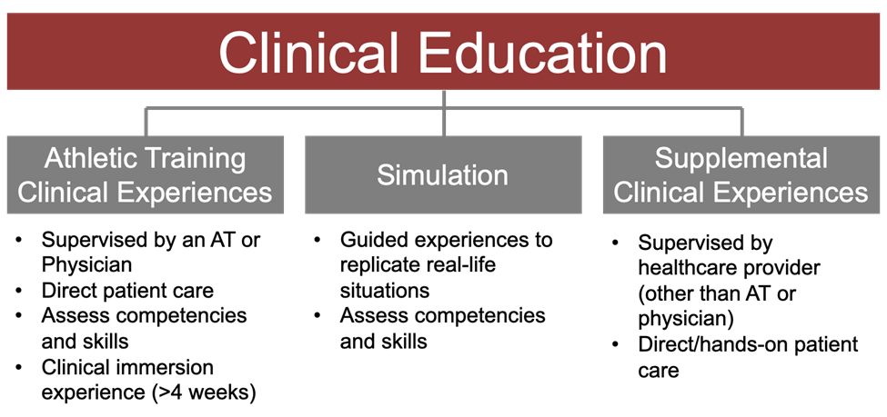

UM ATP Clinical Education

Clinical Education Plan & Overview
The clinical education portion of the athletic training curriculum is designed to provide comprehensive and progressive experiences in athletic training, with increasing levels of supervised, autonomous patient care under the direction of preceptors (CAATE Standard II.7). The Coordinator of Clinical Education decides placement of students with preceptors. Students will be exposed to a variety of orthopedic and medical conditions throughout their clinical experiences. Athletic training students will gain experience with a wide variety of patients and clients, including (CAATE Standard II.9 A-E):
- Patients/clients across the lifespan (pediatric, adolescent, adult)
- Patients/clients of different sexes
- Patients/clients with varied socioeconomic statuses
- Patients/clients of varying levels and types of physical activity and athletic ability
- Patients/clients involved in non-sport activities

During the first year of the professional program, students begin their clinical rotations with an immersive clinical experience during the pre-season/early fall. In addition, students are assigned to a variety of rotations, sometimes under the supervision of the same preceptor. These rotations are designed to provide a breadth of experiences in healthcare settings, with a variety of patients and preceptors. First-year athletic training students are expected to perform skills learned and evaluated in athletic training courses. At the conclusion of the athletic training student’s first year, athletic training students are expected to perform most skills at the advanced beginner stage. Students have the ability to recognize how the situation/environment may impact actions. Students have experienced performing skills in a ‘real’ environment and recognize when the principles learned in class may be used during their clinical experiences. Students are evaluated by preceptors at the conclusion of each rotation (a minimum of twice per semester). Specific expectations for successful performance and progression are outlined in clinical practicum course syllabi.

During the second year of the professional program, athletic training students are assigned to two separate immersive experiences, one taking place in the fall and one in the spring semester. The remaining clinical experience time is allotted to additional rotations that may vary in length, including non-orthopedic, non-sport clinical experiences. At the conclusion of the second year, athletic training students are expected to perform skills at least at the competent stage. Second-year athletic training students are expected to synthesize knowledge and skills taught in the curriculum to provide competent, comprehensive patient care under increasing levels of autonomy. Students display the ability to adjust to novel situations, work with large amounts of information and identify what is most important, and deliberately plan actions to achieve a goal. Students are evaluated by preceptors at the conclusion of each rotation (a minimum of twice per semester). Specific expectations for successful performance and progression are outlined in clinical practicum course syllabi.

The criteria used in the placement of students include the qualifications of the preceptor, contemporary expertise of the preceptor, the commitment of the preceptors in teaching students, adequate athlete/patient resources for teaching, the presence of up-to-date equipment and resources, and finally the needs and goals of the athletic training student.

Clinical Experience Expectations
The following guidelines and expectations apply to all clinical rotations and experiences for the athletic training program:
- Clinical experience rotations may begin and/or end outside of the typical semester timeline. Fall semester clinical experiences run August 1 – December 31, and Spring semester clinical experiences run January 1 – end of semester. Students are expected to make themselves available based on the schedule they are assigned.
- Students should contact their assigned preceptor at least 2 weeks prior to the scheduled start of a clinical rotation, to establish a report date and expectations for the clinical experience (CAATE Standard III.8 A-k).
- Students and preceptors should perform an orientation to the clinical site, and complete the Clinical Rotation Checklist, prior to the student providing patient care at the site. This must be submitted to the Coordinator of Clinical Education to keep on file prior to the start of patient care (CAATE Standard III.11).
- Students may only provide patient care when supervised by a preceptor.
- Students should actively seek opportunities to apply and practice athletic training skills with patients. Students should only perform those skills that have been learned and evaluated in class.
  - Skills taught by a preceptor, but not yet formally taught and evaluated in class, must be evaluated by the preceptor and documented on the appropriate form on ATrack (CAATE Standard II.7).
- There will be various events on campus and in the community that are outside of assigned clinical rotations. You may voluntarily sign up for these additional events as long as these hours are completed under direct supervision by a preceptor.
- Students should conduct themselves in a professional manner at all times during clinical experiences. Students are expected to follow all athletic training program policies, as well as any clinical site policies, at all times.
- Students completing off campus rotations need to carry a fanny/medical pack for practice and game coverage.
- Students must wear their program nametag at all times during clinical experiences (CAATE Standard III.8A).

Clinical Experiences Outside of Missoula
Athletic training students may seek out clinical experiences that are outside of Missoula, or outside of Montana. These clinical experiences may be several weeks long or for the length of a full season. Immersive clinical experiences may also be arranged. Travel to sites is the responsibility of the student. (CAATE Standard III.6K).

Athletic training students who are interested in a clinical experience outside of what is listed above should work with the Coordinator of Clinical Education to establish communication with the prospective clinical site and preceptor(s). Students should begin this process no later than the end of the fall semester of the first year in the program. Prospective clinical sites must become formally affiliated with the University of Montana and meet all program requirements for clinical experience sites.

Non-orthopedic/Non-sport Clinical Experiences
All ATSs may complete rotations through the Curry Health Center (CHC) and a local medical facility with a variety of health care providers (i.e., MD, PA, NP, etc.).

These medical facilities provide students with experience in a non-orthopedic, non-sport healthcare setting (CAATE Standard II.10 A-N, IV.19 A-M). Athletic training students are able to observe and gain hands-on experience with a variety of health care professionals. Students are expected to gain roughly 15-20 hours of clinical experience in this rotation. The Coordinator of Clinical Education will arrange the dates and times for these rotations at the start of each semester. These dates and times will be provided to both the preceptor as well as the student prior to the first week of classes. Required paperwork for these rotations will be completed prior to the start of the semester. Appropriate attire for this rotation includes dress pants and a collared shirt, as well as appropriate professional shoe wear for a clinic environment (closed-toe, no tennis shoes).

Clinical Education Objectives
First Year Master’s Athletic Training Students
Students formally admitted into the Master’s Program

Clinical Requirements:
- Completion of a minimum of 20 hours in a two-week period or maximum of 60 hours in two weeks during clinical education.
- Completion of an immersion experience, in which students are to complete at least 100 hours over the span of a 4-week time period. There is no maximum number of hours each week during the immersive clinical experience. Students are not required to take 1 day off every 7 days. However, preceptors are encouraged to discuss expectations with their student(s) and provide time off as appropriate for the clinical experience.
- Clinical education opportunities at high school/clinic, other healthcare facilities, and collegiate settings.

Objectives:
Preseason/Autumn:
At the conclusion of this semester, athletic training students will:
- Implement and abide by standard operational policies of an athletic training facility or clinic.
- Perform routine operational procedures of an athletic training facility or clinic. This includes, but is not limited to: opening and closing duties, cleaning, maintenance, preparing whirlpools and other modalities, administrative duties such as filing, and data entry.
- Perform appropriate injury/illness and treatment documentation utilizing both paper and computerized systems.
- Apply basic modality treatments with parameters provided by preceptor.
- Assist with the pre- and post-practice treatment of patients and athletes.
- Conduct a basic orthopedic evaluation that incorporates patient history, observation, palpation, range of motion, neurovascular, strength, and selective tissue testing.
- Identify normal and pathologic findings during a clinical evaluation.
- Describe and assist in appropriate immediate treatment and referral for patients.
- Use appropriate medical terminology.
- Understand and implement emergency action plans (EAPs), based on the setting and their role within the EAP.
- Perform basic taping, wrapping, and bracing techniques.
- Provide appropriate first aid and emergent care to injured patients under the supervision of a clinical preceptor.
- Adhere to OSHA standards and guidelines.
- Adhere to patient privacy and confidentiality standards, rules, and guidelines (including HIPAA, FERPA, and others as applicable).
- Describe the importance of evaluating patient needs and outcomes as a routine part of patient care.

Spring:
At the conclusion of this semester, athletic training students will:
- Identify potential hazards and factors that may place athletes and patients at increased risk of injury or illness during physical activity.
- Perform an appropriate evaluation of a patient that is appropriate to the setting (on-field vs. sideline vs. in clinic).
- Correlate examination findings to potential underlying pathology/ies.
- Determine a plausible diagnosis/assessment, and appropriate differential diagnoses, based upon the results of an evaluation.
- Implement appropriate immediate treatment(s) for a patient, based upon the results of an evaluation.
- Make an appropriate referral decision, when warranted, to an appropriate healthcare provider.
- Perform and document evaluations of patients with non-orthopedic medical conditions.
- Recognize non-orthopedic conditions that warrant referral, and refer to the appropriate healthcare provider.
- Develop rehabilitation programs under the supervision of a clinical preceptor.
- Instruct patients to perform therapeutic exercise in a safe manner with correct technique.
- Select and apply appropriate therapeutic modality treatment(s) to meet patient needs and goals.
- Describe the psychological and emotional impact of injury/illness on a patient.
- Explore methods for evaluating patient needs, goals, and outcomes during patient care.
- Adjust to challenging or novel environments while providing appropriate emergent care to injured patients under the supervision of a clinical preceptor.
- Apply effective taping, bracing, and wrapping techniques based on the needs of the patient and the unique circumstances of the environment.
- Utilize efficient and accurate documentation methods to communicate with other healthcare providers.
- Describe and initiate effective methods of communication with patients, coaches, parents, and others as warranted.
- Collaborate and communicate effectively with pre-professional athletic training students, other professional athletic training students, and supervising preceptors.

Year One Course Work:
Summer
ATEP 534 | Emergency Management in AT
ATEP 536 | Foundations in AT
ATEP 569 | Clinical Anatomy Laboratory
Fall
ATEP 560 | Clinical Immersion in AT I
ATEP 545 | Sports-Related Concussion
ATEP 581 | Therapeutic Interventions I
ATEP 543 | Orthopedic Assessment I
ATEP 540 | Practicum in Athletic Training I
Spring
ATEP 583 | Therapeutic Interventions II
ATEP 547 | Orthopedic Assessment II
ATEP 541 | Practicum in Athletic Training II
HHP 523 | Case Studies in Performance Psychology
ATEP 546 | General Medical Assessment

Second Year Master’s Athletic Training Student
Students formally admitted into the Master’s Program

Clinical Requirements:
- Completion of a minimum of 20 hours in a two-week period or maximum of 60 hours in two weeks of clinical education.
- Completion of two separate immersive experiences. The first spanning over 10 weeks and comprising of a 300-hour minimum. The second spanning over 8 weeks and comprising of a 150-hour minimum. There is no maximum number of hours each week during the immersive clinical experience. Students are not required to take 1 day off every 7 days. However, preceptors are encouraged to discuss expectations with their student(s) and provide time off as appropriate for the clinical experience.
- Completion of a clinical experience at a non-orthopedic/non-sport medical facility with a minimum of 15-20 hours completed.
- Clinical education opportunities at high school/clinic, other healthcare facilities, and collegiate settings.

Objectives:
- Develop and implement measures to decrease the risk of injury or illness during physical activity, based on identified hazards and risk factors.
- Perform a concise, accurate orthopedic evaluation of a patient that adapts to the environment, setting, and needs of the patient.
- Make a timely decision on return to activity status, activity restrictions, and need for referral to another healthcare provider.
- Develop and adjust rehabilitation programs for patients with specific needs, including post-surgical patients with specific restrictions, patients with pre-existing or chronic illness, and pediatric or geriatric patients.
- Develop and implement a comprehensive treatment and rehabilitation plan that addresses all aspects of patient recovery.
- Use information from both clinical and patient outcome assessments to alter, advance, or discontinue treatments and rehabilitation activities.
- Utilize a variety of techniques and tools during rehabilitation to meet patient goals.
- Design and implement appropriate return-to-activity progressions for a variety of patients and activity levels.
- Communicate the risk of re-injury, or injury to other structures, to patients as they resume physical activity.
- Apply procedures to limit the spread of communicable and infectious illnesses to patients and others at high-risk (teammates, roommates, others as appropriate).
- Recommend appropriate treatment, including over-the-counter medications, for non-orthopedic medical conditions and illnesses.
- Utilize effective documentation methods and strategies that facilitate communication, insurance billing, and are legally defensible.
- Describe methods and interventions to provide psychological and emotional support for patients and athletes.
- Analyze and critique administrative policies and procedures for a health care facility.
- Mentor first-year professional athletic training students and pre-professional athletic training students.
- Collaborate with healthcare professionals and students to enhance patient care as part of an interdisciplinary team.

Year Two Course Work:
Summer
ATEP 588 | Health Care Administration & Leadership in AT
ATEP 585 | Therapeutic Interventions III
ATEP 537 | Foundations of Research & EBP in AT
Fall
ATEP 590 | Research
ATEP 561 | Clinical Immersion in AT II
ATEP 550 | Practicum in Athletic Training III
ATEP 594 | Seminar in AT
ATEP 580 | Pharmacology in Sports Medicine
Spring
ATEP 562 | Clinical Immersion III
ATEP 551 | Practicum in Athletic Training IV
ATEP 599 | Research Capstone in Athletic Training
ATEP 576 | Performance & Tech in AT

Clinical Education Time Commitment and Expectations
Enrollment in the professional Master’s program is a full-time commitment from students. Using the Accreditation Council for Graduate Medical Education (ACGME) guidelines for program time commitment, we have developed our program guidelines (no more than 80 hours a week of combined didactic and clinical activities).

ACGME guidelines: Clinical and educational work hours must be limited to no more than 80 hours per week, averaged over a four-week period, inclusive of all in-house clinical and educational activities, clinical work done from home, and all moonlighting.

Combined didactic expectations with a maximum time of 30 hours/week or 60 hours in two weeks in clinical education, students fall below the 80 hours/week ACGME guideline.

On average students will complete about 15-20 hours a week of clinical education. There will be variation in the number of hours the student will be in the assigned clinical rotation depending on the preceptor to which the student is assigned and the demands of the clinical site and rotation. Some exceptions to the hour accumulation guidelines may be considered depending on the clinical rotation and communication with the Coordinator of Clinical Education (CAATE Standard II.5). Decisions are considered on an individual basis.
- Any concerns related to dedicated time (too much or too little) in clinical experiences should be addressed with the Coordinator of Clinical Education.
- The maximum requirement of clinical experience is 30 hours per week or 60 hours in a two-week period (exceptions exist with clinical immersive experiences). If students exceed the two-week 60 hours maximum, the Coordinator of Clinical Education will notify them to reduce their clinical hours the following week.
- The minimum hour requirement for students is 10 hours a week (unless a student is specifically scheduled to be off or if the student is in the clinical immersion experience).
- Students must have one day off in a 7-day period (unless they are in a clinical immersive experience)
- During the immersive clinical experiences, students will be expected to achieve at least the targeted minimum hours based off of the credit to hour ratio used for internships here at the University of Montana (~45 hours = 1 credit) (CAATE Standard II.4). There is no maximum number of hours each week during the immersive clinical experience. While students are not required to take 1 day off every 7 days, preceptors are encouraged to discuss expectations with the students and provide time off as appropriate for the clinical experience.

First-year Master’s Student Clinical Experience Hour Expectations

Second-year Master’s Student Clinical Experience Hour Expectations

Clinical Experience Time Logs
- Time spent in clinical experiences must be recorded online using ATrack software. Time logged must be verified by an appropriate preceptor on a weekly basis.
- Students have a maximum of 2 weeks to log hours. The Coordinator of Clinical Education must input clinical experience hours into ATrack after 2 weeks.
- Unsupervised time may not be included in the time log. Travel time to an event with a preceptor may not be included in the clinical experience time requirement.
- Students may also track hours on paper using the hour log for their personal records; however, all time must also be logged online in ATrack.
- The Coordinator of Clinical Education will audit clinical experience time logs every Monday at 8AM. Students should attempt to have hours fully up-to-date by this time.

Immersive Clinical Experience Guidelines
An immersive clinical experience is a practice-intensive experience that allows the student to experience the totality of care provided by athletic trainers. Students must participate in the day-to-day and week-to-week role of an athletic trainer for an accumulative of 22 total weeks throughout their time in the program. These 22 weeks will be broken into three separate experiences. One of which taking place during their first year (4 weeks; minimum of 100 hours) and two taking place during their second year (10 weeks; minimum of 300 hours, 8 weeks; minimum of 150 hours). There is no maximum number of hours each week during the immersive clinical experience. Students are not required to take 1 day off every 7 days. However, preceptors are encouraged to discuss expectations with their student(s) and provide time off as appropriate for the clinical experience. Specific dates will be determined by the clinical site and the Coordinator of Clinical Education. Preceptors should provide the students with opportunities to practice the “totality of care” provided by athletic trainers at the site, including evaluation, treatment, rehabilitation, emergency care, injury/illness preventative measures, administrative duties, communication with patients, parents, coaches and healthcare providers, and other duties as appropriate. (CAATE Standard II.8)

Guidelines for Placement in Distance Clinical Experiences
When determining clinical placement of an athletic training student (ATS) when the clinical experiences may be outside of the immediate area surrounding Missoula (a “distance” clinical experience), the following guidelines are considered:
- A “distance” clinical experience is defined as any clinical experience where the ATS cannot access campus on a day-to-day basis from the clinical site.

Placement in a “distance” clinical experience is made based on the following:
- Request(s) of the ATS
- Academic standing of the ATS,
- The availability of the requested site,
- The site’s ability to meet UMATP and CAATE standards,
- and at the discretion of the UMATP faculty.

Any student who is not in good academic standing within the UMATP would not be eligible for placement or participation in a “distance” clinical experience. This includes ATS placed on program probation for any reason.
- ATS who are on probation in their first year may not request any “distance” clinical experiences during the annual rotation request period (February-March).
  - If a student successfully completes all probationary criteria and returns to good standing at the end of the spring semester of their first year, they may become eligible for a “distance” clinical experience at the sole discretion of the AT faculty.
- If an ATS is placed on probation while participating in a “distance” clinical experience, they may be asked to end that clinical experience early to return to Missoula.
  - Decisions about terminating any clinical experience early are made at the sole discretion of the AT faculty. (CAATE Standard III.6.A-Q)

Nametags
Students are expected to wear nametags at all times during clinical rotations. Doing so helps patients differentiate students from credentialed providers. (CAATE Standard III.8A)

Emergency Action Plans for Clinical Sites
All current clinical site emergency action plans are available to students on UM Box in a shared folder. This folder is accessible at all times to students. Students should review the EAP prior to the start of any clinical experience with their assigned preceptor. (CAATE Standard III.8K)

Clinical Experience Evaluations
Students will be required to complete evaluations on preceptors and clinical sites. These evaluations are completed at the end of each rotation. Information obtained from these evaluations is utilized to make any necessary improvements or adjustments in the academic program. Summaries of these evaluations are also provided to preceptors and sites to provide feedback on the site and the efficacy of preceptorship.

The preceptor may also evaluate students at the clinical site. The preceptor may evaluate students during clinical practicum courses, during any lab/course setting in which there is time, or during any study session. All curricular content standards must be practiced with a peer and successfully completed under preceptor/instructor observation prior to performing that skill on a patient. The following terms are descriptions of the evaluation criteria for clinical content standards.

Curricular Content Standards Grading Criteria:
Development: ATS needed verbal cuing and physical assistance from preceptor. Constant preceptor support throughout tasks/evaluations/skills was needed in completing tasks. Inconsistent ability to recognize and treat the signs/symptoms and issues noted while performing the tasks/evaluations/skills. However, the ATS is progressing toward the standard while demonstrating partial skill acquisition and knowledge.

Proficient: ATS was able to handle situation better than average. Needed minimum guidance or prompting at times from preceptor in competing tasks/evaluations/skills. ATS was able to recognize and properly treat/handle situation as well as expected for current standard level of care.
Advanced: ATS successfully completes tasks/evaluations/ skills without Preceptor guidance or prompting. Completed tasks/evaluations/skills safely, consistently, and thoroughly. Completes necessary steps and in proper sequence. Demonstrates confidence in abilities. ATS exceeds the standard.

These forms are available and to be completed on ATrack by the dates set by the program.

Clinical Site Visits
UM ATP Faculty will perform clinical site visits at a minimum of one per academic year for each clinical site that has an assigned student. An evaluation form will be filled out upon completion. (appendix C: pg 49)

Clinical Education Glossary of Terms

Affiliation Agreement: A formal agreement between the program’s institution and a facility where the program wants to send its students for course-related and required off-campus clinical education. This agreement defines the roles and responsibilities of the host site, the affiliate, and the student.

Athletic training clinical experiences: Direct client/patient care guided by a preceptor who is an athletic trainer or physician. Athletic training clinical experiences are used to verify students’ abilities to meet the curricular content standards. When direct client/patient care opportunities are not available, simulation may be used for this verification.

Clinical Education: A broad umbrella term that includes three types of learning opportunities to prepare students for independent clinical practice: athletic training clinical experiences, simulation, and supplemental clinical experiences.

Contemporary Expertise: Knowledge and training of current concepts and best practices in routine areas of athletic training, which can include prevention and wellness, urgent and emergent care, primary care, orthopedics, rehabilitation, behavioral health, pediatrics, and performance enhancement. Contemporary expertise is achieved through mechanisms such as advanced education, clinical practice experiences, clinical research, other forms of scholarship, and continuing education. It may include specialization in one or more of the identified areas of athletic training practice. An individual’s role within the athletic training program should be directly related to the person’s contemporary expertise.

Immersive clinical experience: A practice-intensive experience that allows the student to experience the totality of care provided by athletic trainers.

Preceptor: Preceptors supervise and engage students in clinical education. All preceptors must be licensed health care professionals and be credentialed by the state in which they practice. Preceptors who are athletic trainers are state credentialed (in states with regulation), certified, and in good standing with the Board of Certification. A preceptor’s licensure must be appropriate to his or her profession. Preceptors must not be currently enrolled in the professional athletic training program at the institution. Preceptors for athletic training clinical experiences identified in Standards 14 through 18 must be athletic trainers or physicians.

Professionalism: Relates to personal qualities of honesty, reliability, accountability, patience, modesty, and self-control. It is exhibited through delivery of patient-centered care, participation as a member of an interdisciplinary team, commitment to continuous quality improvement, ethical behavior, a respectful demeanor toward all persons, compassion, a willingness to serve others, and sensitivity to the concerns of diverse patient populations.

Supervision: Supervision occurs along a developmental continuum that allows a student to move from interdependence to independence based on the student’s knowledge and skills as well as the context of care. Preceptors must be on-site and have the ability to intervene on behalf of the athletic training student and the patient. Supervision also must occur in compliance with the state practice act of the state in which the student is engaging in client/patient care.

Supplemental clinical experiences: Learning opportunities supervised by health care providers other than athletic trainers or physicians.

Masters in Athletic Training Program Information
First Steps
Your first task is to inform the academic adviser of the School of Integrative Physiology & Athletic Training of your interest in the Athletic Training Degree. Many times, this step will be completed during an orientation meeting. However, if you are a transfer student or fail to go through the orientation procedure, it becomes your responsibility to confer with the academic adviser. The academic adviser will direct you to an athletic training mentor to schedule an appointment. We will provide you with the following information:
- Pre-requisite course requirements
- Curricular plan
- Admission policies
- Degree requirements

About our Athletic Training Program
The University of Montana offers an accelerated Master of Athletic Training Program. This program allows students to take three years of pre-requisite courses and general education requirements, followed by 2 years’ full time in a Master’s in Athletic Training program, including summers. There are three ways in which a student may attain a Master’s Degree in Athletic Training:

Option 1: A five-year program in which students earn a Bachelor of Science Degree in Integrative Physiology and a Master’s Degree in Athletic Training.

Option 2: A two-year Master’s Degree in Athletic Training program designed for students who already have a baccalaureate degree.

Option 3: A three-year degree completion plan that allows students increased flexibility for pursuing a Master’s Degree in Athletic Training.

Upon completion of the Master of Athletic Training Program, students will be eligible to sit for the Board of Certification (BOC) Exam.

*For students completing Option 1, both the Bachelor’s degree and Master’s degree will be officially awarded at the time of graduation.

Pre-AT Requirements
The following pre-requisite classes or their equivalents are required to be completed before the start of the Master’s program with a grade of "C" or better (CAATE Standard IV.1):

- Anatomy & Physiology I & II (both with labs)
- Exercise Physiology
- General Psychology
- Basic Nutrition
- Statistics
- Biology
- Chemistry
- General/Introductory Physics or a Biomechanics or an Anatomical Kinesiology if it includes the following course content: Basic principles of mechanics, including Newton’s Laws
- Kinetics
  - Motion (linear and angular)
  - Center of Gravity
  - Forces (static and dynamic)
  - Kinematics
  - Motion (position, acceleration, velocity)
  - Coordinate systems

Transfer Policy:
Please note that all transfer students should meet with the Program Director to review application and program requirements. Transfer students must satisfy admissions criteria. Transfer credits will be evaluated by the Program Director on an individual basis.

Admissions Requirements
- Submit Athletic Training Student Application through ATCAS (found online at: https://atcas.liaisoncas.com) (pay application fee to ATCAS $90)).
- Students must have a minimum GPA of 3.0 for all college coursework (a GPA below 3.0 may be considered).
- Completed pre-requisite courses with a grade of “C” or better (students may be enrolled in pre-requisite courses at time of application). Prerequisite coursework must be completed prior to the start of the professional program.
- Official transcript(s) of all college coursework (submit to ATCAS).
- Obtain a current official copy of all college course work. Students must complete or be in the process of completing required course work prior to application to the professional athletic training program.
- Submit 2 professional letters of recommendation (submit to ATCAS).
    - All recommendations must be received by before your application can be reviewed and scored.
    - Please do not request recommendations from personal friends. (At least one letter from a Certified Athletic Trainer or other healthcare professional who engages in routine clinical practice is strongly recommended.)
- Application essay which should address your professional goals and desire for pursuing athletic training as a career. (submit to ATCAS)
- Current resume (submit to ATCAS).
- Program Interview- in person, videoconference, or by phone.
- Submit secondary application to the University of Montana’s Graduate School upon acceptance to AT program (https://gradapply.umt.edu/register/gradapply) (separate application fee from ATCAS $60).
***Please note that the GRE requirement for admission has been removed for future application cycles (approved by Graduate Council September 2021).

Admissions Policies
Students who desire admission into the Master of Athletic Training Program must submit a formal application to ATCAS. Applications will open on August 1st and will be reviewed on a rolling basis until the cohort is filled.

Formal notification of admission to the Master’s program will be made in writing.

Candidates who are NOT admitted to the program will also receive written notification of this decision. Students may be selected as alternates and if a vacancy should become available prior to summer semester, these students will be informed. Not all qualified candidates may be admitted to the Master’s program due to limited enrollment in clinical experiences.

Provisional Acceptance Guidelines
Once students are provisionally accepted into the professional program, students must provide the following documentation to be considered for full admission:
1. Each student must complete and provide verification of a Hepatitis-B vaccination series and titer (or must sign a waiver) (students may be in process).
2. Technical Standards:
Each applicant must read and sign the “technical standards” document confirming that they understand and are able to comply with the established standards (included in the professional manual).
3. Completion of the agreement statement located in professional manual.
4. Criminal Background Check: the student will be required to contact the vendor (Castle Branch) to begin the online process. The cost will be approximately $55. For international students the background check may cost up to and over $150. Contact the Program Director for the necessary information.
Scoring of Applications
Application Review
Grade Point Average 20 points
Pre-Requisite GPA 10 points
Application Essay 20 points
Letters of Recommendation 20 points
Professional Development Points* 20 points
*Includes observation hours, professional organization memberships, community service identified on resume
Interview 30 points

(CAATE Standard III.6C, III.6P, III.10)

Observation Hours Recommended (NOT REQUIRED)
Observation hours are designed for the purpose of exposing students to the field of athletic training. They will provide you with insight to the day to day responsibilities of an athletic trainer and the type of medical care that they provide to their patients. Students completing observation hours should not engage in patient care. Although completion of observation hours is no longer an admissions requirement, we recommend you take time to fully explore the field prior to application.

Pre-requisite Course Evaluation
Name of Course | UM Students | Non-UM student | General Course Description
Kinesiology | KIN 322/323 | Kinesiology course OR biomechanics course | Anatomy and kinesiology of the neuromusculoskeletal system and body cavities in relation to movement and function.
Biomechanics | KIN 425/426 | Kinesiology course OR biomechanics course | Description and analysis of the fundamental principles of human movement. Includes quantitative study of the Newtonian mechanics governing biological motion and the roles of the musculoskeletal, nervous and cardio-vascular systems during human activity.
Anatomy & Physiology I with lab | BIOH 201/202 | Human Anatomy w/Lab  Physiology w/Lab  OR 2 semesters combined | Comprehensive knowledge of human form and function necessary for students preparing for health-related professions. Emphasis on structure, function and homeostatic regulation of body systems with presentation of basic concepts in chemistry and microbiology as they relate to human anatomy and physiology. Covers tissues through nervous system.
Anatomy & Physiology II with lab | BIOH 211/212 | Human Anatomy w/Lab  Physiology w/Lab  OR 2 semesters combined | Comprehensive knowledge of human form and function necessary for students in health-related programs. Emphasis on structure function and homeostatic regulation of body systems with presentation of basic concepts in chemistry and microbiology as they relate to human anatomy and physiology. Covers endocrine through reproductive systems.
Exercise Physiology | KIN 320/321 | Exercise physiology course  (with a lab preferred) | Investigation of the physiological changes and the significance of these changes as they occur during physical work, activity and exercise. Focus on basic energy, musculoskeletal, nervous, cardiovascular and respiratory systems as they relate to aerobic and anaerobic exercise. Emphasis will be placed on the response of these systems to both acute exercise, and the adaptations to chronic exercise.
General Psychology | PSYX 100 | General psychology, developmental psychology,  lifespan psychology or sports psychology accepted | Introduction to the scientific study of behavior in humans and other animals.
Basic Nutrition | NUTR 221 | General nutrition or sport nutrition accepted | The principles of science as applied to current concepts and controversies in the field of human nutrition
Statistics | STATS 216 | Any introduction to basic statistics accepted | Introduction to major ideas of statistical inference. Emphasis is on statistical reasoning and uses of statistics.
Chemistry | CHMY 121 | General chemistry (with a lab preferred) | First semester of an introduction to general, inorganic, organic and biological chemistry.
Biology | BIOH 112 | General biology  (with a lab preferred) | Explores the fundamentals of structure and function at basic cellular and tissue levels, in addition to the anatomy and physiology of the integumentary, musculoskeletal, and nervous systems
Physics | PHSX 205/206 | General Physics (with a lab preferred) | Mechanics, sound, and heat. For non-physical science majors. This course satisfies the lecture portion of medical school requirements in general physics.  **(students may also meet this requirement with a Kinesiology or Biomechanics course with physics content embedded)

Prerequisites are evaluated based on the criteria listed above and must be completed within the last 10 years. If you have questions about whether a course meets the criteria, please contact the Program Director. Prerequisite courses may still be in progress during the application process. Considerations for admissions are partially based on grades received in prerequisite courses, and therefore, it is recommended that the majority of these courses be completed at the time of application. All prerequisites must be completed prior to starting the MAT program in the summer.

Five Year Plan
SAMPLE ACCELERATED FIVE YEAR ACADEMIC PLAN (CAATE Standard III.6B)

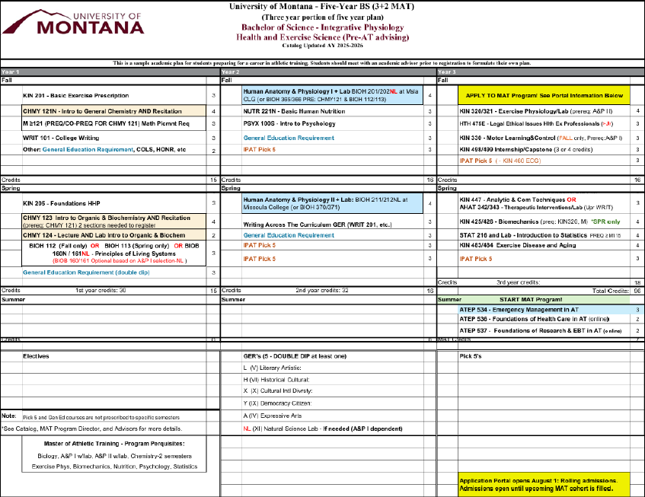
Program fee: There is an additional fee of $1200/semester in addition to regular tuition and fees. This fee will help cover the cost of lab equipment, accreditation costs, adjunct teaching, and software. Other fees include criminal background check ($55), vaccinations ($50), NATA membership fee ($70), ATCAS application fee ($90), graduate school application fee ($60), cadaver lab fee ($300).
Please Note:
ATEP 540, 541, 550, 551, 560, 561, 562 each requires clinical education at various sites. Hour commitments may vary per class (note: these clinical rotation assignments and expectations do run outside of the typical semester timeline). Students should be aware that this is a considerable time commitment and should plan accordingly. Students may be expected to accumulate more hours each semester in some rotations due to the demands of the particular rotation and may be placed on rotation outside the typical semester. Students must also be available nights and weekends for clinical assignments.

Two Year Plan
SAMPLE TWO -YEAR MASTER’S PROGRAM
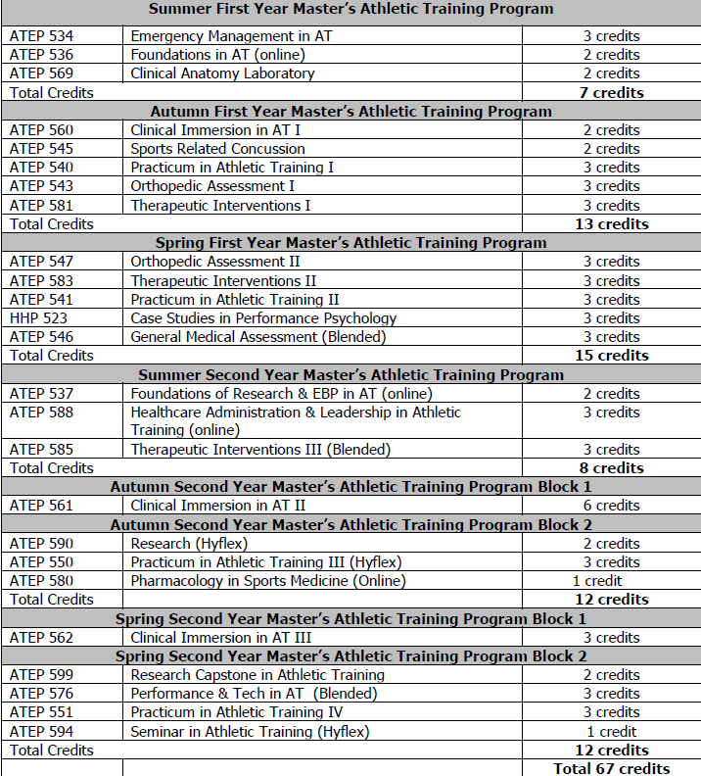
Program fee: There is an additional fee of $1200/semester in addition to regular tuition and fees. This fee will help cover the cost of lab equipment, accreditation costs, adjunct teaching, and software. Other fees include criminal background check ($55), vaccinations ($50), NATA membership fee ($70), ATCAS application fee ($90), graduate school application fee ($60), cadaver lab fee ($300).
Please Note:
ATEP 540, 541, 550, 551, 560, 561, 562 each requires clinical education at various sites. Hour commitments may vary per class (note: these clinical rotation assignments and expectations do run outside of the typical semester timeline). Students should be aware that this is a considerable time commitment and should plan accordingly. Students may be expected to accumulate more hours each semester in some rotations due to the demands of the particular rotation and may be placed on rotation outside the typical semester. Students must also be available nights and weekends for clinical assignments.

Three Year Plan
Sample Three Year Degree Plan
Summer First Year Master’s Athletic Training Program
ATEP 534 | Emergency Management in AT | 3 credits
ATEP 536 | Foundations in AT (online) | 2 credits
ATEP 537 | Foundations of Research & EBP in AT (online) | 2 credits
Autumn First Year Master’s Athletic Training Program
ATEP 569 | Clinical Anatomy Laboratory | 1 credit
ATEP 580 | Pharmacology in Sports Medicine (Online) | 1 credit
ATEP 543 | Orthopedic Assessment I | 3 credits
ATEP 581 | Therapeutic Interventions I | 3 credits
Spring First Year Master’s Athletic Training Program
ATEP 547 | Orthopedic Assessment II | 3 credits
ATEP 583 | Therapeutic Interventions II | 3 credits
ATEP 546 | General Medical Assessment (Hybrid) | 3 credits
Summer Second Year Master’s Athletic Training Program
No Summer Class Work
Autumn Second Year Master’s Athletic Training Program
ATEP 560 | Clinical Immersion in AT I (Hybrid) | 2 credits
ATEP 545 | Sports Related Concussion | 2 credits
ATEP 540 | Practicum in Athletic Training I | 3 credits
ATEP 594 | Seminar in Athletic Training (Hybrid) | 1 credit
Spring Second Year Master’s Athletic Training Program
ATEP 541 | Practicum in Athletic Training II | 3 credits
ATEP 576 | Performance & Tech in AT (Hybrid) | 3 credits
HHP 523 | Case Studies in Performance Psychology | 3 credits
Summer Third Year Master’s Athletic Training Program
ATEP 588 | Healthcare Administration & Leadership in Athletic Training (Online) | 3 credits
ATEP 585 | Therapeutic Interventions III | 3 credits
Autumn Third Year Master’s Athletic Training Program
ATEP 561 | Clinical Immersion in AT II (Hybrid) | 6 credits
ATEP 590 | Research (Hybrid) | 2 credits
ATEP 550 | Practicum in Athletic Training III (Hybrid) | 3 credits
Spring Third Year Master’s Athletic Training Program
ATEP 551 | Practicum in Athletic Training IV (Hybrid) | 3 credits
ATEP 599 | Research Capstone in Athletic Training (Hybrid) | 2 credits
ATEP 562 | Clinical Immersion in AT III (Hybrid) | 4 credits
 |  | Total 67 credits

Program fee: There is an additional fee of $1200/semester in addition to regular tuition and fees. This fee will help cover the cost of lab equipment, accreditation costs, adjunct teaching, and software. Other fees include criminal background check ($55), vaccinations ($50), NATA membership fee ($70), ATCAS application fee ($90), graduate school application fee ($60), cadaver lab fee ($300).
Please Note:
ATEP 540, 541, 550, 551, 560, 561, 562 each requires clinical education at various sites. Hour commitments may vary per class (note: these clinical rotation assignments and expectations do run outside of the typical semester timeline). Students should be aware that this is a considerable time commitment and should plan accordingly. Students may be expected to accumulate more hours each semester in some rotations due to the demands of the particular rotation and may be placed on rotation outside the typical semester. Students must also be available nights and weekends for clinical assignments.
(CAATE Standard III.6B)

- Masters Requirements (Agreement Statement)
As a student in the Athletic Training Program at the University of Montana, I agree to the following retention standards:

- enroll as a full-time student (some exceptions allowed as approved by Program Director).
- maintain a cumulative grade point average of 3.00 or higher.
- achieve no more than 2 “C” grades in graduate courses.
- achieve no less than a “C” grade in graduate courses.
- achieve satisfactory evaluations in each Clinical Phase before progressing.
- successfully complete coursework in the sequence indicated by the program of study unless approved by Athletic Training Program Director.
- abide by the Code of Ethics of the University and those established by the National Athletic Trainers’ Association.

Students proceed through the program in cohorts and are required to complete all the required courses each semester with a grade of “C“ or better. Students who fail to meet the retention criteria will be placed on probation in the Athletic Training Program for a maximum of two semesters. This may limit progress of course sequencing and clinical assignments. If standards are not met by the end of the probationary period, the student will be dismissed from the Athletic Training Program. Students who are placed on probation may require a remediation plan as deemed appropriate by the Program Director.
(CAATE Standard III.6G)

Clinical Education Forms

Sample Affiliation Agreement
UNIVERSITY OF MONTANA STANDARD AFFILIATION AGREEMENT
This University of Montana Standard Affiliation Agreement (the “Agreement”) is entered into by and between the University of Montana, an educational institution with an address of 32 Campus Drive, Missoula, MT 59812 (the “University”) and Type Affiliate Name Here, a State of residence and type of Entity (corporation, llc, etc) with an address of Affiliate Address, (the “Affiliate”) and having a physical location at Address of placement facility (the “Facility”), as of the last date of authorized signature (the “Effective Date”). This Agreement sets forth the intent of both parties to mutually cooperate in providing clinical education to students (collectively the “Students” and individually a “Student”) enrolled in the University’s Name of UM's educational program program (the “Program”). The University and the Affiliate are collectively referred to herein as the “Parties.” Throughout this Agreement whenever the term “placed with the Affiliate” is used it is referring to a Student’s participation, education, experience, and placement with the Affiliate at the Facility (the “Clinical Placement”).
RECITALS
WHEREAS the University desires to place Students with the Affiliate for the purpose of providing clinical education experience for the Students under the terms and conditions set forth in this Agreement; and
WHEREAS the Affiliate desires to provide clinical education experience to the Students under the terms and conditions set forth in this Agreement; and
WHEREAS the Affiliate has the facilities and employs skilled professional personnel relevant to the special educational experience for furnishing clinical experience and satisfies the criteria for selection of clinical education centers;
NOW, THEREFORE, in consideration for the mutual covenants and promises contained herein, the sufficiency of which is hereby acknowledged, the Parties agree as follows:
SECTION 1
THE UNIVERSITY’S REPRESENTATIONS AND WARRANTIES

The University represents and warrants to the Affiliate that as of the effective date of this Agreement:

- Accreditation: The University is accredited by the appropriate state, national, or regional bodies.

- Employment: With respect to the Clinical Placement of any Student, said Student is not an employee of the Montana University System.

- Student Health Insurance: The University requires all Students to maintain personal health insurance coverage while enrolled at the University.

SECTION 2
THE AFFILIATE’S REPRESENTATIONS AND WARRANTIES

The Affiliate represents and warrants to the University that as of the effective date of this Agreement:

- Affiliate Standing: The Affiliate has been licensed or accredited as necessary to conduct its operations at the Facility.

SECTION 3
THE UNIVERSITY’S COVENANTS

- Compliance: The University shall exercise reasonable efforts to assure that all Students and faculty sponsors placed at Affiliate shall comply with all applicable Affiliate rules, regulations, and policies while performing services at the Facility.

- Confidentiality: The University shall exercise reasonable efforts to assure that all students and faculty shall treat appropriate information acquired by them regarding the Affiliate as confidential, during and after the placement period. The University may provide further instruction to Students and faculty regarding the importance of respecting the confidential nature of all information. The University shall take reasonable steps to prohibit the publication of information by Students or faculty of any material pertaining to the learning experience that has not been approved for release by the Affiliate. The University recognizes that the Affiliate has a duty to its clients to keep records confidential; if a Student shall jeopardize the Affiliate’s client confidentiality, the University and/or the Affiliate shall be entitled to demand the student be removed from the placement immediately.

- Student Health: The University will ensure that Students have up-to-date immunizations as required for attendance at the University. Notwithstanding any of the foregoing, in the event that a Student has a religious or disability exemption to vaccination, the University shall communicate with the Affiliate in advance of the Student’s dates of assignment to determine if a reasonable accommodation may be provided to allow the Student to participate in the Program at the Affiliate’s Facility.

- Background Check: The University shall require all Students placed with the Affiliate to complete a criminal background check prior to participating in the Program at the Facility. Upon request, the University shall provide proof of background check to the Affiliate.

- Health Insurance Portability and Accountability Act Training: The University shall provide any Students placed with the Affiliate pursuant to this Agreement with the appropriate Health Insurance Portability and Accountability Act training and, upon request, provide the Affiliate with documentation verifying that such training was completed.

- Insurance: The University shall maintain for each Student and faculty sponsor substantially participating in the Program either commercial professional liability insurance or documentation of adequate self-insurance. The professional liability insurance or self-insurance shall have limits of at least one million dollars ($1,000,000) per occurrence and three million dollars ($3,000,000) in the aggregate covering the acts or omissions of the Student or faculty sponsor. A certificate of insurance is available to the Affiliate upon request.

- Program Oversight: The University shall assume full responsibility for planning and execution of the educational program, including programming, administration, curriculum content, promotion, and certification. Provided that the Affiliate provides a copy of the applicable rules, regulations, and policies, the University shall distribute the said applicable rules, regulations, and policies to all Students participating in the Program at the Affiliate’s Facility. The University shall also establish a procedure for notifying the Affiliate when a Student is unable to report for placement work.

- Faculty Sponsor: The University shall provide a qualified faculty sponsor for supervision of Students placed with the Affiliate. The University will notify the Affiliate in writing of any change regarding the faculty sponsor.

- School Liaison: The University shall designate an employee of the University to coordinate Clinical Placement related matters between the University and the Affiliate.

- Prior Education: The University shall ensure each Student has received necessary prerequisite education in theoretical background, basic skills, professional ethics, and attitude and behavior. The University shall only place Students with the Affiliate who have completed the necessary prerequisite course work, taught by certified and/or licensed faculty members.

- Notification of Student Assignments: The University shall notify the Affiliate of the start and end dates for the Clinical Placement for each Student and shall provide the Affiliate with reasonable notice as to said Student assignments.

SECTION 4
THE AFFILIATE’S COVENANTS

- Furnishing Policies and Procedures: The Affiliate shall provide the University a written copy of applicable Affiliate policies and procedures that govern the Student’s activities while placed with the Affiliate at least sixty (60) days before the commencement of the Clinical Placement. The Affiliate shall permit, on reasonable request and reasonable notice, the University or those agencies responsible for accreditation of the University’s Program to inspect the Facility, the services available for each placement, and such other items pertaining to the Program.

- Affiliate Liaison: The Affiliate shall designate an employee of the Affiliate to coordinate Clinical Placement related matters between the University and the Affiliate.

- Proctor: If required by the Program, the Affiliate shall appoint a suitably experienced and qualified licensed professional employee of the Affiliate as a proctor to administer the Student participation in the Program at the Facility (the “Proctor”). The Affiliate shall identify potential Proctor(s), who shall be subject to the approval of the University and any applicable governmental or accrediting body. Upon request, the Affiliate will provide the professional and academic credentials of the Proctor(s) to the University in writing.

- Student Supervision: The Affiliate shall not allow Students to replace the Affiliate staff and shall not allow Students to render service outside of the scope of the Program. If the Clinical Placement involves patient care or service to the Affiliate’s clients, an Affiliate staff member shall supervise contact between Students and patients and/or clients. The Affiliate is responsible for all patient and client care at all times.

- Student Orientation: Upon the start of a Student’s Clinical Placement, the Affiliate shall provide the Student with an orientation of the Facility, including but not limited to, the rules, regulations, administrative policies, standards and practices, and appropriate operations safety and health training relevant to the Student’s Clinical Placement.

- Family Educational Rights and Privacy Act: The Affiliate shall take all measures necessary to guard against improper disclosure of information in its possession regarding the Students who are placed with the Affiliate pursuant to this Agreement and shall comply with applicable provisions of the Family Educational Rights and Privacy Act of 1974 (“FERPA”). The University shall not be obligated to provide any Student information to the Affiliate except as permissible under FERPA. The Affiliate shall, within five (5) days of becoming aware of a use or disclosure of any University data by Affiliate or its directors, officers, workforce, contractors or agents in violation of this Agreement or the FERPA Privacy Standards, report such violation to the University.

- Reporting and Evaluation: The Affiliate shall provide timely reports and evaluations for each Student when requested by the University. The reports and evaluations shall be provided in the form requested by the University.

- Resources and Equipment: The Affiliate shall provide the appropriate space, personnel, and resources necessary for the Students’ meaningful participation in the Clinical Placement.

- Safety Equipment and Clinical Supplies: The Affiliate shall make such equipment available to Students and faculty as is necessary to implement appropriate safety precautions and shall further furnish such clinical supplies as is necessary to perform any clinical tasks required of the Student during their Clinical Placement. The Affiliate shall provide suitable facilities for Students and faculty to change in to, don, or doff: uniforms, attire, and safety equipment as is necessary.

- Cooperation in Education: The Affiliate shall cooperate in providing to each Student a meaningful and appropriate learning experience.

- Emergency Medical Care: The Affiliate shall provide Student(s) with adequate emergency medical care as needed and reasonably available at the Facility for illness or injuries suffered during the Clinical Placement. Such treatment shall be at the expense of the Student if treatment is provided.

- Affiliate Standing: The Affiliate shall maintain all certifications, accreditations, and licenses appropriate for its business.

- Affiliate Staff: The Affiliate shall make no reduction in staff, including but not limited to clinical instructors, solely on the basis of the presence of the Student(s). The service or duties of all Students are for the purpose of obtaining clinical education and experience and are not for the purpose of furthering the business of the Affiliate.

- Student Status: The Students placed with the Affiliate shall not be considered employees of the Affiliate. The Affiliate shall not pay, or be responsible for any salary, compensation, or benefits for the Students in relation to Clinical Placement.

SECTION 5
JOINT RIGHTS AND RESPONSIBILITIES

- Student Misconduct: The Affiliate and the University shall provide written notice to the other party within a reasonable time if a claim involving misconduct by a Student placed with the Affiliate arises in relation to the Clinical Placement.

- Student Removal: Both the University and the Affiliate shall have the right to remove a Student from their Clinical Placement under the following conditions:
  - The University may remove a Student at any time. The University shall notify the Affiliate of such removal in writing.
  - The Affiliate may immediately remove any Student from the Facility for behavior that the Affiliate deems to be an immediate threat to the health or welfare of the Affiliate’s patients, staff members, or visitors. The Affiliate shall notify the University in writing of the actions and the reasons for its actions as soon as practicable.
  - If the Affiliate desires to remove a student from their Clinical Placement entirely for any reason, the Affiliate shall notify the University in writing of the reasons for the removal and will consult with the University before removing the Student. However, removal of the Student under this clause is within the sole discretion of the Affiliate.

- Additional Expectations: This Agreement may contain Note number of exhibits exhibits which outline the Teacher-Learner Expectations, the Student Conduct Code, or additional expectations the University has placed on the Students. Any such exhibits are informational only and intended to provide guidance to the University and the Affiliate and shall not be interpreted to place additional obligations on either party.

SECTION 6
THE AFFILIATE’S RIGHTS AND RESPONSIBILITIES

- Authority to Decline Placements: The Affiliate reserves the right to decline Student placements where the proposed number of Students exceeds that which the Affiliate believes can reasonably be supervised on-site, or for any other legitimate reason.

SECTION 7
TERM AND TERMINATION

- Term: The term of this Agreement is for one year from the Effective Date and thereafter from year to year unless terminated by either party on three-month prior notice to the other party. Unless and until notice of non-renewal is received by any party, this Agreement shall renew each year for a subsequent year on the same terms and conditions as the previous year, provided, however, that the initial term of this Agreement plus any subsequent terms shall not exceed seven (7) years. Should either party terminate this Agreement, the University shall have the option to allow any Student(s) currently placed with the Affiliate to complete their Clinical Placement(s).

- Termination for Breach: Notwithstanding any other provision of this Agreement, this Agreement may be terminated immediately for material breach of any material term or condition of this Agreement if the breach is not corrected within ten (10) business days after written notice of the breach is sent to the breaching party pursuant to Section 9.13 of this Agreement.

- Termination by Affiliate: Notwithstanding any other provision of this Agreement, this Agreement may be terminated by the Affiliate in the event of a situation reasonably determined by the Affiliate to put the Affiliate, its personnel, invitees, guests, or patients at risk of personal harm.

SECTION 8
HOLD HARMLESS
  - Hold Harmless: Each party shall defend, indemnify and hold harmless the other party from and against any and all liability, loss, expense, attorney fees, or claims for injury or damages arising out of this agreement in proportion to and to the extent such injury or damages are caused by or result from the negligent or intentional acts or omissions of the indemnifying party and its officers, agents or employees.

  - Limitation and Immunity: The liability of the University under this Section shall be subject to the limitations on damages and immunities of the University as provided by law. This Section 8.2 shall survive the termination of this Agreement.

SECTION 9
MISCELLANEOUS PROVISIONS

- Choice of Law: This Agreement is governed by and shall be interpreted in accordance with the laws of the State of Montana.
- Venue: Any disputes or claims arising under or relating to this Agreement shall be brought in an appropriate court in the State of Montana and the Parties consent to the jurisdiction of said court.
- Non-assignability: The Affiliate may not assign its rights or delegate its obligations hereunder without the prior written consent of the University, which consent may be withheld in the sole discretion of the University. The Affiliate is responsible to the University for the acts and omissions of all subcontractors or agents and of persons directly or indirectly employed by such subcontractors, and for the acts and omissions of persons employed directly by the Affiliate. No contractual relationships exist between any subcontractor and the University under this Agreement.
- Severability: The invalidity, in whole or in part, of any term of this Agreement, other than Section 8.2, does not affect the validity of the remainder of the Agreement. If Section 8.2 is found to be invalid, the entire Agreement shall be found to be invalid. A court shall enforce all provisions of the Agreement which are not invalid.
- Entire Agreement: This Agreement contains all the terms, conditions and representations upon which the Parties have covenanted to in connection with and related to the Agreement and supersedes any and all other agreements, either oral or written, between the Parties with respect to the subject matter hereof.
- No Oral Modification: This Agreement may be modified only upon the written consent of all Parties hereto. No oral modifications are authorized or valid.
- Attorney Fees: Should any action be brough by any party to enforce any of the terms of this Agreement, the prevailing party in such action shall be entitled to such reasonable attorney fees as the court shall determine.
- No Special Damages: In no event shall either party be liable hereunder (whether in action in negligence, contract, or tort, or based on a warranty or otherwise) for any indirect, incidental, special, or consequential damages incurred by the other party or any third party, even if the party has been advised of the possibility of such damages.
- No Third-party Beneficiaries: This Agreement shall be exclusively for the benefit of and be binding upon the Parties and their respective successors, assigns, executors, and legal representatives. Nothing in this Agreement, express or implied, is intended to confer on any other person other than the Parties any rights, remedies, obligations, or liabilities under or by reason of this Agreement.
- Legal Counsel: All Parties acknowledge that they have had the opportunity to consult with their respective legal counsel in the negotiation and execution of this Agreement.

- Notice: Any written notice required or permitted under this Agreement shall be delivered by hand or by certified mail, return receipt requested, and directed to the representative party at its last known address. Unless and until changed the address of each party shall be:

University:
University of Montana
Office of Legal Counsel
32 Campus Drive
Missoula, MT 59812
ATTENTION: Legal Services

Affiliate:
Type address of Affiliate here

- Force Majeure: A party shall not be held responsible if the fulfillment of the party’s obligations hereunder are delayed or prevented by revolutions, wars, acts of enemies, strikes, fires, floods, other natural disasters, epidemics, acts of God, or without limiting the foregoing, by any other cause not within the control of the party whose performance is interfered with, and which by the exercise of reasonable diligence, the party is unable to prevent, whether of the class of causes hereinbefore enumerated or not.

- Waiver: A party may waive an obligation that the other party owes under this Agreement, or any rights granted hereunder, only in writing, which shall be signed and delivered to the party who is obligated. No verbal statement made to the other party shall be an effective waiver of any obligation. No failure of either of the Parties, on one or more occasions, to enforce any of the provisions of this Agreement or to exercise any right or privilege herein shall be construed as a waiver of any subsequent breach or default of a similar nature, or as a waiver of any provisions, rights, or privileges under this Agreement.

- Costs and Expenses: Except as otherwise stated in this Agreement, the Parties are responsible for their own costs and expenses related to the transaction contemplated by the Agreement.

- Employment Disclaimer: This Agreement shall not be interpreted as creating any agency or employment relationship between the Affiliate and the University or the Affiliate and the Students. Students shall not be entitled to receive any sort of compensation or employment benefits from the Affiliate. The Affiliate shall not be required to purchase any form of insurance for the benefit or protection of the Students.
- HIPAA Classification: For the purposes of the Health Insurance Portability and Accountability Act of 1996 and the requirements of any regulations promulgated thereunder (“HIPAA”), Students participating in the Program at the Facility are members of the Affiliate’s workforce within the definition of “health care operations” and therefore may have access to patient medical information as provided for in the Privacy Rule of HIPAA. Therefore, additional agreements are not necessary for HIPAA compliance purposes. This Section 7.17 applies solely to HIPAA privacy and security regulations applicable to the Affiliate and does not establish an employment relationship as previously stated in this Agreement
- Compliance with Law: Both Parties shall comply with all applicable state, tribal and federal laws, rules, and regulations, including without limitation, those regarding patient privacy and data security, and the requirements of any regulations promulgated thereunder.
- Nondiscrimination: The University and the Affiliate shall not discriminate against any Student, faculty, staff, or administrator based upon race, color, religion, national origin, creed, service in the uniformed services (as defined in state and federal law), veteran status, sex, age, political ideas, marital or family status, pregnancy, physical or mental disability, genetic information, gender identity, gender expression, sexual orientation, or any other protected class under state or federal law.
- Headings: Headings in this agreement are used as a convenient reference and those headings are not to be given any substantive effect or used in the interpretation of the Agreement.
The Parties execute this agreement as of the Effective Date.
University:  The University of Montana  By: ______________________________  Type Signer's Name Here, it’s Title of signer  Date: _____________________________  By: ______________________________  Andrea Lawrence, it’s Provost  Date: _____________________________ | Affiliate:  Type Affiliate Name Here  By: ______________________________  Type Signer's Name Here, it’s Title of signer  Date: _____________________________
Approved as of legal content:
By: UM Standard Affiliation Agreement approved as of Jul 1, 2024. Signature not required.
UM Legal Counsel
Date: UM Standard Affiliation Agreement. Signature not required.

Preceptor Demographic Form

University of Montana Athletic Training
Preceptor Demographic Form

Last Name | First Name | Middle Initial | Credentials
Email Address
Work Phone #
Mobile Phone #
Current Employer
Employer’s Address
Employment Position

Education (begin with most recent education and include all professional education leading to a degree or professional credential)
Institution | Location | Degree | Year | Field of study

BOC Certification Number | Month and Year of BOC Certification
State Credential Type(s)  (e.g. LAT, RN, MD or indicate not applicable in your state)  (Provide information on all state credentials) | State Credential Number(s)
Type: | Number:
Type: | Number:
Type: | Number:

* Clinical Preceptor Training (date of most recent training) | * NATA Membership Number | NPI Number

Demographic Information:
Sex (please select): Male Female Transgender

Race/Ethnicity (please select all that apply):
Hispanic/Latino of any race
American Indian or Alaskan Native, not Hispanic/Latino
Asian, not Hispanic/Latino
Black or African American, not Hispanic/Latino
Native Hawaiian or Other Pacific Islander, not Hispanic/Latino
White, not Hispanic/Latino
Two or more races
Do not know/do not wish to answer



Calibration and Electrical Safety Checks

Equipment Calibration

Per CAATE standards, any piece of therapeutic equipment that is recommended, by the manufacturer, to receive annual calibration and inspection must receive that service. Typically, items that require annual calibration and inspection include (but are not limited to):
- Electrical stimulation units (that plug into a wall outlet)
- Ultrasound/combo units
- Diathermy
- Low-Level LASER or light therapy (that plug into a wall outlet)
- Hydrocollators
- Mechanical traction devices/tables

Clinical sites should obtain these calibrations and safety inspections annually. These must be performed by a qualified technician, and documented appropriately. The minimum documentation required, for each unit, is:
- Name/Model of each unit calibrated/inspected
- Date of the calibration/inspection
- Result of the calibration/inspection (i.e., passed/did not pass)
- Name and contact information for the technician

Clinical sites must provide this documentation, and ensure that all units have been calibrated/ inspected, at least two weeks before a student is on-site. Calibrations/inspections must be kept current for as long as students are assigned to the clinical site.

If you have any questions about these requirements, or if you wish to see examples of proper documentation, please notify either Valerie (valerie.moody@umontana.edu) or Mitch (Mitchell.willert@umontana.edu).

Therapeutic Equipment Table

Athletic Training Student/Preceptor Clinical Worksheet

Preceptors and Students: Please review the following items PRIOR to any patient care by the AT student, and initial once these items are completed. These items will assist you both in your initial orientation, and should provide the framework for a successful clinical experience. AT student must submit this worksheet to the CCE before the student participates in any patient care.

Student Initials Preceptor Initials

____________ ____________ We have conducted an initial orientation to the clinical site.

____________ ____________ We have reviewed the clinical site’s Emergency Action Plan(s), and the AT Student has immediate access to the EAP for each site in case of an emergency.

____________ ____________ We have practiced the clinical site’s Emergency Action Plan(s) with the AT Student(s) and preceptor(s).

____________ ____________ We have reviewed the Blood-borne pathogen, and Communicable and infectious disease, policies for the clinical site. Student understands what to do in case of BBP exposure, and expectations regarding communication and absences due to illness.

____________ ____________ We have reviewed the documentation policies and procedures for the site. Students understand their role in appropriate documentation and maintenance of patient files.

____________ ____________ We have reviewed patient privacy and confidentiality procedures and expectations, including HIPAA/FERPA and other applicable regulations.

____________ ____________ We have reviewed the clinical site’s Policies and Procedures, including dress code, building access, and other policies that differ from the UM ATP Student Handbook.

____________ ____________ There is a clear method for patients to differentiate AT students from practitioners (nametags, shirts, etc.) that is used at all times.

____________ ____________ We have discussed the AT Student’s academic schedule, including any possible conflicts between class & clinical hours.

____________ ____________ We have discussed the skills and curricular content standards that will be evaluated during the semester.

____________ ____________ We have discussed the goals and expectations for the AT Student during the clinical experience.

By signing below, you indicate that you have completed the above items before any patient/client encounters have occurred, and mutually agree to the preceding schedule and goals for the course of the rotation.

Preceptor Signature: __________________________________ Date:________________

Student Signature: _____________________________________ Date:________________

Coord. of Clinical Ed. Signature: __________________________ Date:________________

Clinical Education Infraction Policy
Part I: To be filled out by Preceptor

Date of Infraction:

Name of Student:

Type of Infraction
(Please check appropriate infraction and circle detailed type of infraction):

Absence from clinical assignment / seminar / program meeting
Repeated tardiness at clinical assignment / seminar / program meeting
Attire
Conduct
Violation of Clinical Experience hours expectations
Preceptor evaluation form not turned in within one week of rotation completion
Other; please explain:

Please explain the above infraction in detail as appropriate.

Signature of Preceptor Date

Part II: To be filled out by Coordinator of Clinical Education

Previous warning for similar incident?

No
Yes

Type of Previous Infraction_____________________________________ Date
Preceptor Involved

(continued on back side)

Part III: To be filled out by Coordinator of Clinical Education

INFRACTION REVIEW MEETING

Date:

Comments:
____________________________________________________________________________________________________________________________________________________________
________________________________________________________________________________________________________________________________________________________
________________________________________________________________________________________________________________________________________________________

Action Taken:
Warning

3% Deduction off final grade from Clinical Course (540/541; 550/551; 560/561/562)

Repeated Offenses; Suspension from ATP as decided by Program Director

Repeated Offense after suspension; Removal from ATP as decided by Program Director & Department Chair

Other:

Signature of Student Date

Signature of Coordinator of Clinical Education Date

Other Participants (as needed):

Signature of Preceptor Date

Signature of Program Director Date

Signature of Chair, School of IPAT Date

Clinical Evaluations

Preceptor Evaluations ATS

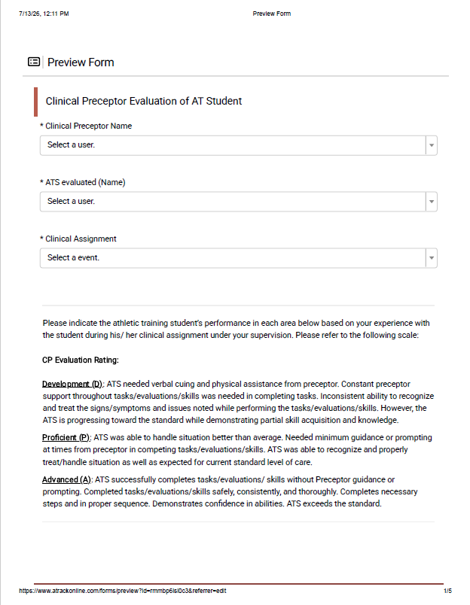
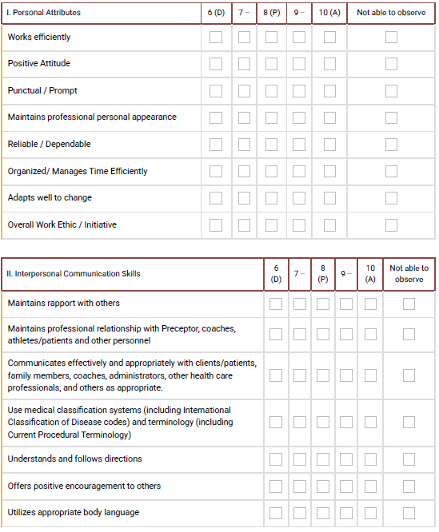

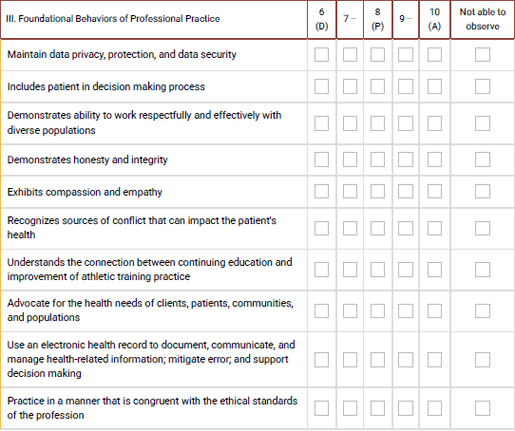

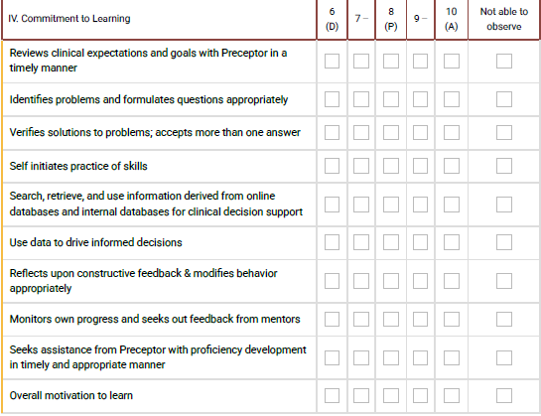

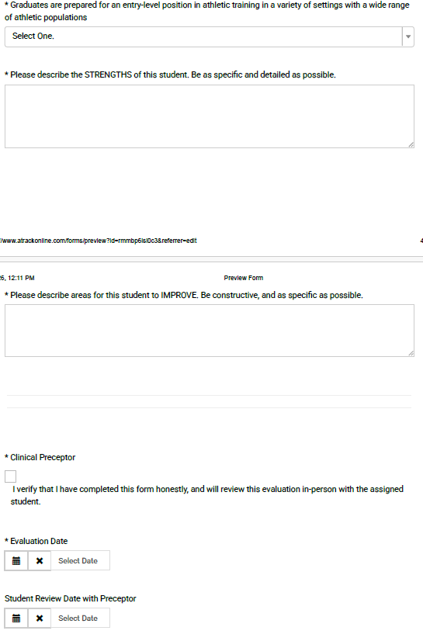

AT Student Evaluation of Preceptor

Please answer the following questions honestly and accurately regarding your most recent clinical education experience (rotation). Information obtained from this survey will not be associated with your name in any way. It is used for on-going program evaluation in order to make continued improvements of the ATP. Thank you in advance for your time providing constructive feedback.

1. Most Recent Clinical Preceptor (CP)
Select a user.
- 2. Clinical Assignment/Site
Select a event.
- 3. Within the ATP, I am a:
  - First Year
  - Second Year
Student Evaluation of Preceptor: Please use the following rating scale to answer questions 4 - 30. Please include any additional comments or feedback related to these questions in the space provided below.
Not applicable
Strongly Disagree (does not meet performance expectations)
Disagree (less than satisfactory performance)
Neutral (meets performance expectations)
Agree (meets and exceeds performance expectations)
Strongly Agree (consistently exceeds performance expectations)

* Evaluation | Not Applicable | Strongly Disagree | Disagree | Neutral | Agree | Strongly  Agree
4. Preceptor clearly outlines clinical education expectations appropriate for your needs.
5. Clinical education experience provided an active, stimulating environment appropriate for your learning needs.
6. Clinical education experience was planned to meet your specific clinical goals.
7. Preceptor was available to help you complete clinical proficiencies and/or competencies.
8. Clinical education experience provided you with a variety of learning experiences/opportunities.
9. Preceptor communicated high expectations which were challenging but appropriate for your level in the athletic training program.
10. Preceptor practiced ethically and legally.
11. Preceptor encouraged students €“staff contact or communication and was readily available to answer questions related to your clinical education experience.
12. Preceptor integrates evidence based medicine concepts into your clinical education experience.
13. Preceptor effectively organized your clinical education experience.
14. Preceptor encouraged active learning.
15. Preceptor encouraged on-going practice of learned skills.
16. Preceptor reinforced and facilitated integration of classroom theory with clinical practice.
17. Preceptor was enthusiastic about his/her role as a preceptor.

* Evaluation | Not Applicable | Strongly Disagree | Disagree | Neutral | Agree | Strongly  Agree
18. Preceptor encouraged cooperation and collaboration among students to facilitate clinical learning.
19. Preceptor provided regular and prompt feedback regarding your performance.
20. Communication with your preceptor was effective and positive.
21. Preceptor provided an adequate amount of time to complete assigned tasks.
22. Preceptor showed respect for diverse talents and ways of learning.
23. Preceptor showed respect for diverse backgrounds.
24. Preceptor showed interest in professional associations and activities related to athletic training.
25. Preceptor(s) interact with athletic training student(s) professionally.
26. Preceptor(s) were adequate in number to provide a good clinical education experience.
27. Administrators (e.g., athletic directors) and / or coaches were supportive of your clinical education experience.
28. Patients / Athletes were supportive of your clinical education experience.
29. There was adequate space in the clinical environment for the treatment of athletes / patients.
30. The equipment and supplies of the clinical education setting were adequate for meeting goals/objectives of clinical rotation.

Please provide written feedback for the previous questions (4-30).
- 31. Please provide the current STRENGTHS of this clinical preceptor and site. Be specific and as detailed as possible.

- 32. Please provide specific areas for IMPROVEMENT in this clinical preceptor and site. Be constructive and detailed.

Faculty Evaluation of Clinical Site
Faculty Evaluation of Clinical Site
* Clinical Site
Select a location.
- Evaluation Date

Faculty Evaluation of Clinical Site: Please use the following rating scale to answer questions 1 - 8. Please include any additional comments or feedback related to these questions in the space provided below.
Not applicable
Strongly Disagree (does not meet performance expectations)
Disagree (less than satisfactory performance)
Neutral (meets performance expectations)
Agree (meets and exceeds performance expectations)
Strongly Agree (consistently exceeds performance expectations)

* Evaluation | Not Applicable | Strongly Disagree | Disagree | Neutral | Agree | Strongly  Agree
1. Clinical education experience provided an active, stimulating environment appropriate for learning needs.
2. The clinical education setting has a variety of learning experiences available to the student(s).
3. The equipment and supplies of the clinical education setting were adequate for meeting goals/objectives of clinical rotation.
4. Clinical education experiences reinforce the information learned by the athletic training student(s) in the classroom.
5. Preceptor(s) promote discussion with athletic training student(s).
6. Preceptor(s) interact with athletic training student(s) professionally.
7. Clinical education setting provided student with opportunity to see many injuries and situations
8. Preceptor(s) provided adequate direct supervision of athletic training student(s).
9. Students have access to and use of appropriate blood-borne pathogen barriers and control measures
10. Students have access to sanitation precautions, including ability to clean hands before and after patient encounters

- 9. Comments and specific recommendations

- 10. Any change in signatory authority or personnel at site?
- 11. Any new equipment at site?
Select one or more users.
- 12. Any broken equipment at site?
Please explain any "yes" answers to questions 10-12 here.

- Faculty Evaluator
Select one or more users.

