DEFINITION
Deferred revenue is revenue collected in the current fiscal year that will be earned in the next fiscal year. This revenue is reported as a liability on the current year’s balance sheet and as revenue in the next fiscal year. Departments that record deferred revenue include, but are not limited to: Continuing Education, Bio Station, Dining Services, Athletics, Campus Recreation, and Residence Life. Summer session tuition and fees collected prior to July 1st are also recorded as deferred revenue per Montana University System policy.

PROCEDURES
- General Guideline for Recording Deferred Revenue:
- For ease of processing deposits, please use a separate deposit line for deferred revenue transactions!
- Deferred Revenue must be recorded with an activity code. See attached list for current activity codes. Please contact your fund accountant if a new activity code needs to be established. The activity code is the revenue account code with the ‘5’ replaced by an ‘R’ – For example, the activity code for revenue account code 50404-Auxiliary Campus Recreation would be R0404.
- Balance sheet account number is 2505 – Deferred Revenue.

Example Transaction:
Campus Recreation has a raft trip scheduled for July 17th. A registration payment is sent to Campus Recreation (index code MCR813) and is received on June 21st.

Record Deposit Using the Departmental Deposit Card (manual process)

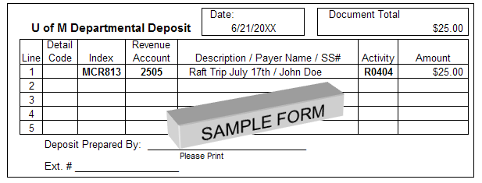

- Banner Student A/R
- Summer session tuition and fees recorded in the Banner Student System with a term based detail code will automatically be coded as deferred revenue in the current fiscal year. Any detail code that is designated as "term based" will have an account code of 2505 AND an activity code of Rxxxx. This combination of account and activity will ensure the proper recording of deferred revenue.

- Business Services Review
- Prior to FYE Business Services will review the deferred revenue activity to ensure an activity code is included in the transaction. Business Services will reverse deferred revenue to the revenue accounts determined by the activity code indicated on the deposit form/cards

Departments-
Please contact Connor Smith, Accounting Services, ext. 6628 for any questions or concerns regarding this procedure.

Note-Refunds relating to deferred revenue must be so noted on document

.

