Grizmart Travel Entry Instructions
Prior to entry in Grizmart all Travel Expense Report/Request and Authorization to Travel must be completed and signed.
Select Travel Form
Enter Vendor
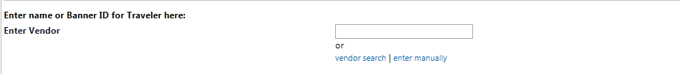
Select Type of Request that you are entering from the Dropdown Menu, either Per Diem/Travel Advance or Travel Reimbursement.
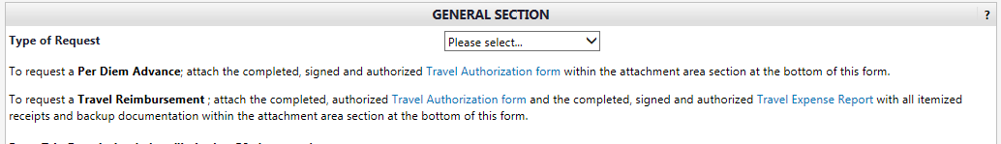
Enter Trip Description-Maximum of 50 Characters (This is the information that will feed into Banner and Print on the Check)
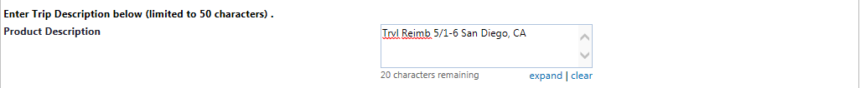
Enter Departure Date as the vendor invoice number
Enter Today’s Date as the invoice Date
Enter amount of Travel Reimbursement/Per Diem Request in amount box
You can enter any additional comments in the additional comments box.
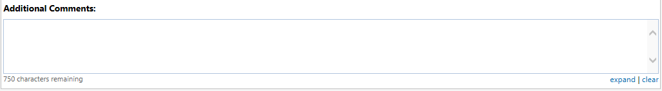
Attach RAT for a per diem request.
Attach TER/RAT with all backup receipts if entering a Travel Expense Report.

