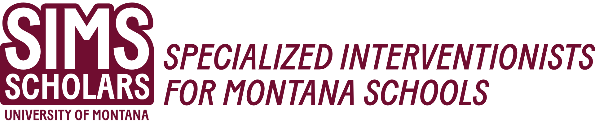
Speech-Language Pathology Required Course Sequence
Course # | Title | Credits | SIMS Scholar Requirement
Fall Semester 1
SLP 560 | Language Assessment and Intervention for School Age Language | 3
SLP 525 | Motor Speech Disorders | 3
SLP 565 | Aphasia | 3
SLP 550 | Language Assessment and Intervention for Children Infants Through Preschool | 3
SLP 570 A | Clinical Processes of Professional Practice I | 1
SLP 571 | Applied Clinic I | 3
SLP 591 (ST) | Cultural Competence in Special Education | 1 | Yes
Spring Semester 2
SLP 520 | Speech Sound Disorders | 3
EDSP 526 | Transition and Community Supports | 3 | Yes
SLP 640 | Swallowing Disorders | 3
SLP 570 B | Clinical Processes of Professional Practice I | 1
SLP 571 | Applied Clinic II | 3
SLP 566 | Cognition | 3
Summer Semester 3
SLP 576 | Advanced Applied Clinic II | 6
SLP 545 | Social Communication Skills, Behavior, and Neurodiversity | 3 | Yes
EDU 518 | Inclusion and Collaboration | 3 | Yes
Fall Semester 4
SLP 530 | Voice & Resonance Disorders | 3
SLP 546 | Augmentative and Alternative Communication | 1
SLP 575 | Advanced Clinical Processes in Professional Practice II | 1
SLP 576 | Advanced Applied Clinic II | 6
SLP 600 | Research Methods | 3
SLP 540 | Fluency Disorders | 2
EDSP 556 | Methods of Low Incidence Disabilities | 3 | Yes
Spring Semester 5
SLP 675 | Clinical Externship/Advanced Practicum | 12
SLP 688 or 699 | MS Capstone/Portfolio-or-  Thesis (6 credits total) | 3 or  1-3 (total of 6)
SLP 591 (ST) | Tele-Intervention and Learning | 1 | Yes
Summer Semester 5
EDSP 591 (ST) | Assistive Technology Practical Application | 2 | Yes

* Students in Cohort 1 (2023-2025) will take CSD 491/SLP 591 Cultural Competence in Special Education during the Spring semester of their first year.

