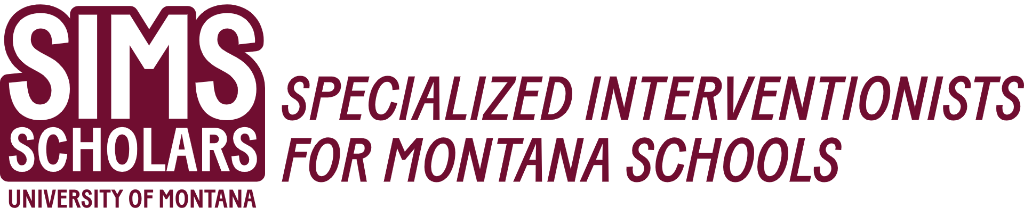
Undergraduate Special Education Required Course Sequence
Course # | Title | Credits | SIMS Scholar Requirement
Fall Semester 1
EDSP 405 | Assessment of Students with Exceptionalities. | 3
EDSP 462 | Special Ed Law, Policy, and Practice | 3
SLP 491 (ST) | Cultural Competence in Special Education | 1 | Yes
Spring Semester 2
EDU 438 | Literacy Assessment, Diagnosis, and Instruction | 3
EDSP 454 | Advanced Academic Interventions | 3
EDSP 426/526 | Transition and Community Supports | 3 | Yes
EDEC 408 | Early Childhood Principles and Practices | 3
Summer Semester 3
EDSP 491 | Inclusion and Collaboration | 3 | Yes
SLP 545 | Social Communication Skills, Behavior, and Neurodiversity | 3 | Yes
Fall Semester 4
EDSP 456/556 | Methods of Low Incidence Disabilities | 3 | Yes
Spring Semester 5
SLP 491 (ST) | Tele-Intervention and Learning | 1 | Yes
EDSP 461 | Positive Behavior Supports | 3
EDSP 495 | Student Teaching: Special Education | 6 or 10
Summer Semester 6
EDSP 491 (ST) | Assistive Technology Practical Application | 2 | Yes

* Students in Cohort 1 (2023-2025) will take CSD 491/SLP 591 Cultural Competence in Special Education during the Spring semester of their first year.

