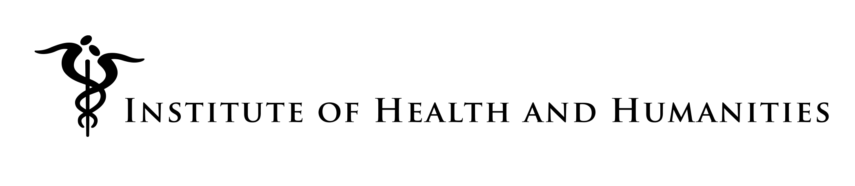

**Ridge Scholarship**

**in**

**Humanities and Health or Healthcare**

**(Application Deadline NOVEMBER 20, 2017)**

**The Institute of Health and Humanities announces $1,000 scholarships for research and creative works on topics at the intersection of health and/or healthcare and the Humanities (including the Arts and Social Sciences). Qualified students are invited to apply.**

Applications related to health equity, social determinants of health, end-of-life care, climate change and health, suicide and community responses to suicide are particularly encouraged. All relevant topics, however, will be considered. There is a general expectation that the research or creative work will be completed or advanced enough in time for the student to present at the Ridge Symposium in April, 2018, although applicants with meritorious projects with a slightly later completion date will be considered for presentation in conjunction with later events.

Visit the IHH website at [hs.um.edu/ihh](http://hs.um.edu/ihh) for more information and an application form.

**Criteria:**

* **Open to undergraduates having completed two years and graduate students and having a cumulative GPA of 3.2 or higher**
* **Utilization of the Ridge Library collection which houses Humanities resources in medical and other health and healthcare-related areas**
* **Other criteria available with application request or by inquiry**

**Application Process:**

* **Request application materials by email at contact info below**
* **Applications will be accepted starting immediately** **and will close on Nov. 20, 2017.** **Applications will be accepted on a rolling basis and reviewed for approval until all awards are made. Early application is encouraged. avoid exhaustion of awards prior to application.**

**CONTACT: Jan VanRiper, Executive Director, Institute for Health and Humanities**

[**ihh@mso.umt.edu**](mailto:ihh@mso.umt.edu)

**406-459-8441**

[**hs.umt.edu/ihh**](http://hs.umt.edu/ihh)

**Or visit website:** [hs.umt.edu/ihh](http://hs.umt.edu/ihh)