General Education Ad Hoc Committee Annual Report, May 5, 2022

Membership
Libby Metcalf, Forestry [Professional School] Co-Chair
Isho Tama-Sweet, Management & Marketing [Professional School] Co-Chair
Steve Schwarz, Comm [Social Science]
Paul Muench, Philosophy [Humanities]
James Randall, Music [Professional School]
Keith Graham, Journalism [Professional School]
Greg Peters, MC Applied Arts & Science [Professional School]
Nicholas Ververis, ASUM [Student]
Hilary Martens, Geosciences [Science]
Kimber McKay, Public Health [ECOS- Senate Chair] spring
Scott Arcenas, History/WLC [ASCRC member]
Coreen Duffy, Music [General Education Committee Chair]
Kelly Webster [Involved with Strategic Planning/ President’s Cabinet]
Jean Loftus, GLI Director

Charge (revised 10/14/21)
The University of Montana is committed to providing a broad-based Liberal Arts education. The General Education Committee is a subcommittee that reports directly to ASCRC. The purpose of this committee is “ongoing evaluation and assessment of the appropriateness and effectiveness of the general education requirements and criteria. The subcommittee shall advocate for general education, propose revisions to the requirements and criteria, review proposals, and ensure that all general education requirements are feasible within campus, Board of Regents and legislative constraints.”
The General Education Ad Hoc Committee (GEAHC), originally created by the Executive Committee of the Faculty Senate (ECOS), is charged by the Academic Standards and Curriculum Committee (ASCRC) with developing and proposing a re-envisioned general education curriculum at UM. To ensure consistency with ECOS procedures, the GEAHC will report to ASCRC in consultation with the General Education Committee. Faculty, students, and the larger campus community should be consulted and given the opportunity to help shape this project. GEAHC will review and incorporate findings from the AY 2018-19 Core Pilot program developed by the General Education Committee, the University Design Team report, and the work of the Academic Planning Group. The GEAHC has three principal tasks for AY22:
- Develop guiding principles for the general education program at UM;
- Develop a General Education structure that improves the student experience;
- Develop a curriculum pathway structure within the General Education program
The GEAHC will help guide the implementation effort in AY22 and further lead this effort in AY23 and AY24 in the following manner:
- Based on the structure and principles, create a detailed general education curriculum
- Create an implementation project plan and timeline
- Work with campus stakeholders, faculty leadership, and UM administration to execute the implementation plan

Guiding Principles
As part of the design of a new General Education program, the General Education Ad Hoc Committee will be guided by the following principles:
- Ensure that the General Education program plays a critical and central role in the education of every UM student.
- Recognize that with respect to curricular matters, the General Education program is the prerogative of the entire faculty of UM; general education curriculum is not solely the prerogative of individual faculty members, departments, or college/schools.
- Recognize that with respect to fiscal and budgetary matters, the General Education program is the prerogative of the administration of UM (President, Provost, Deans, Chairs); fiscal and budgetary matters fall outside the scope of what can be addressed by the General Education Ad Hoc Committee.
- Incorporate strategic planning recommendations that have been developed by the University Design Team (UDT) and the Academic Planning Group (APG), with attention to UM’s Communities of Excellence (CoEx).
- Recognize that there inevitably will have to be trade-offs with respect to the breadth of topics/categories that can be included in the General Education program, the amount of student choice within those topics/categories, and the extent of the program’s alignment with the MUS transfer core.

Meetings with Guests
- The GEAHC met with Jean Loftus, GLI Director and Professor Bar-el, Chair of the GLI Council on July 27th to discuss the possibility of using the global themes as general education pathways.
- Executive Director Mansour and Professor Saldin presented the proposed Civic Knowledge Initiative on September 23rd.
- Co-Chairs met with Academic Deans on Nov 9th and had a follow-up meeting with the H&S Associate Deans on November 30th.
- Co-Chairs met with President Bodnar, Acting Provost Humphrey and Vice Provost Lindsey [mid-December] to discuss a potential management structure and potential help from the administration for a revised general education program. They support creating and funding a temporary presidential faculty fellow position to help steward and eventually implement the innovations and see whether these can be operationalized. Then a more permanent long-term structure / funding mechanism can be discussed.

Deliberations on potential revisions
- The Committee discussed various draft models developed by workgroups. The workgroups clarified the place holder titles (Democracy/Civics, DEI issues, and Information /Media Literacy) for consideration in the core. Professor Arcenas reached out to the Associate Vice Provost Parna Sengupta, Director of Stanford Introductory Studies who shared the syllabus for its course Citizenship in the 21st Century. She was the PI on a Teagle grant. She indicated Teagle would be excited about a core course that engages classics texts. A Workgroup reviewed the syllabi for the existing JRNL 100 American journalism and society and JRNL 102 Calling BS. The courses involve a lot of critical thinking and covers a range of media. Information literacy covered in many disciplines. Thus, graduate students from many programs could assist with breakout sessions. There was considerable discussion regarding a stand-alone DEI course and eventually determined that DEI content should be added to other courses, but not be in the title given the politically charged topic. An oversight committee with experts in the field could develop the framework for these courses and involve the instructors with annual assessment.
The draft model below was presented to three colleges that teach most of the general education courses for feedback. The presentations stressed that the GEAHC still has questions that it hopes the feedback will help to resolve. The placement of the Global Engagement course and the format of the course is still being considered. Should there be 5 versions of the course that introduce students to the different GLI themes/ pathways?

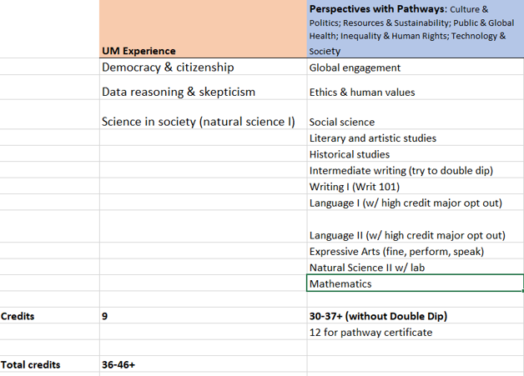
The following sticking issues were noted during the listening sessions.
Language requirements
Lack of specific DEI course
Advanced writing
Total credits
Name of gen ed categories
- The GEAHC reconvened after the stakeholder meetings. Given the feedback the Committee decided to pause on its efforts in order to consult with the new Provost and H&S dean. …….

Stakeholder Meetings -Listening sessions
- Co-Chair Tama-Sweet met with the Writing Committee on February 14th to discuss the GEAHC thoughts regarding its thoughts on revision and how to incorporate writing. The Committee did not support including WRIT 101 Introductory College Writing in a pathway due to various complications with dual enrollment, WRIT 101 plus, and the pedagogy. It did agree, that intermediate Writing could double dip with another general education perspective. There was not a lot of enthusiasm for removing advanced writing from general education.

- Co-Chairs Tama-Sweet and Metcalf presented to the Missoula College Dean Gallagher, Associate Dean Gardner and Department Chairs on March 7th, 2022. Member Peters was also in attendance Since Missoula College is imbedded in the main campus, their students take UM’s general education courses. Missoula College students are not considered transfer students so do not complete the MUS Core [although the most of their gen eds are designed to fulfill both requirements]. Only 12% of Missoula College students transfer to UM. The addition of core courses and pathways will create additional burdens for MC students. According to OCHE it is up to the individual campuses whether or not imbedded two-year campuses can matriculate using the MUS Core.]
- Co-Chair Tama-Sweet presented the draft model to the College of the Arts and Media Dean Baefsky and Department Chairs on March 17, 2022 Members Duffy, Graham, and Randall were also in attendance. The College of the Arts and Media noted that creativity and innovation was missing from the revision. It also would like to see media literacy and news sources as well as some exposure to computer science / technology.
- Co-Chair Tama-Sweet presented the draft model to the College of Humanities and Sciences Associate Deans and Chairs on March 31st. Members Arcenas, and Muench also attended. Other H&S faculty also attended. For the most part the group was supportive of the UM Experience core courses, but not the pathways. The co-chairs sent a follow-up survey to H&S with the following questions.
Thank you all for attending the GenEd feedback session on March 31st. We appreciated the robust discussion and engagement from you! Below you will find the information that was presented in the session. We wanted to follow-up to gather more input from those who were not able to attend or fully voice their opinions. Please fill out the open-ended questions below to help us figure out our next steps on GenEd renewal. All responses will be anonymous. The data will be used to help us revise the proposed model.
The Proposed GenEd model is a combination of a UM Common Experience & Pathways.
Common Experience: 3-4 courses that all UM students take. The proposed courses are Democracy & Citizenship, Data Reasoning & Skepticism, and Science in Society. We envision a small curriculum committee developing syllabi for these courses.
Pathways: A set of 4-5 courses that all relate to the same theme or topic. Pathway courses are across the perspectives. The pathways themes are modeled after the Global Leadership Initiative.
What are the strengths and opportunities with having a Common Experience as part of the GenEd program?
What are the weaknesses and threats that could emerge from a GenEd Common Experience?
What are the strengths and opportunities with having Pathways as part of the GenEd program?
What are the weaknesses and threats that could possibly emerge from GenEd Pathways?

