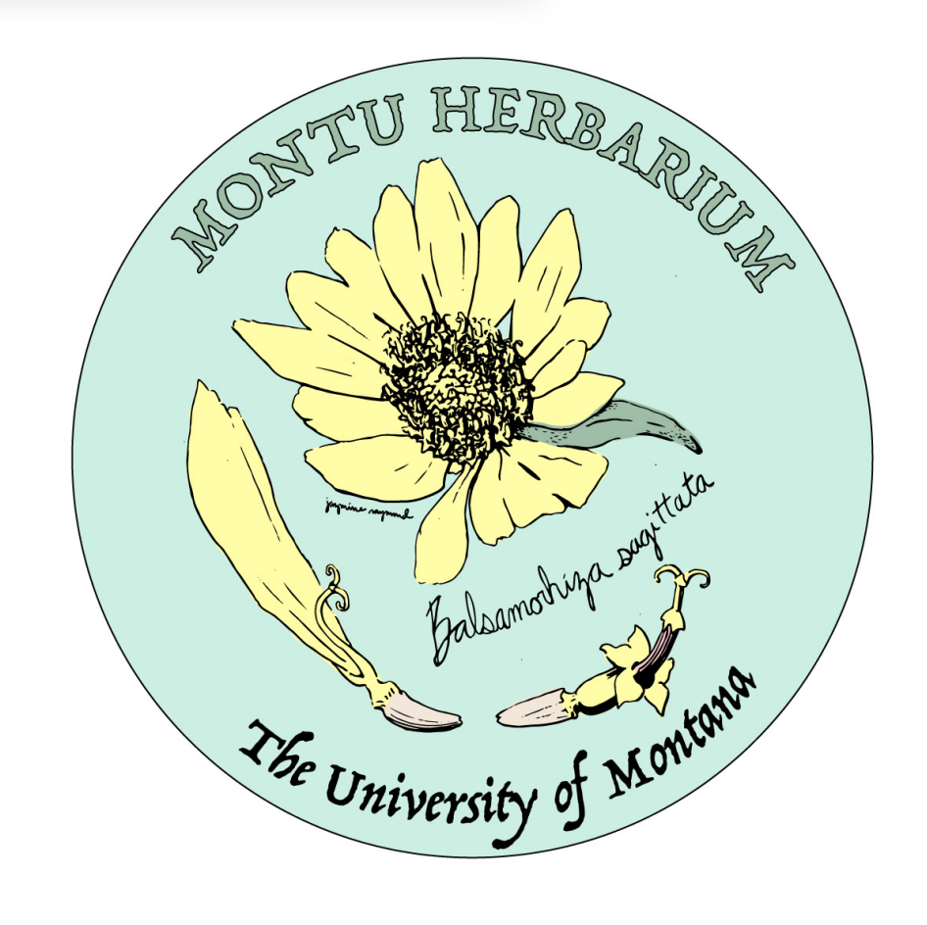
University of Montana Herbarium (MONTU) Strategic Plan Summary
2026 Update by Giovanna Bishop, Curator
(next update/review will be 2031, original plan created in 2021)

Mission: The University of Montana Herbarium (MONTU) strives to preserve and share the botanical and fungal knowledge of Montana and the greater region. MONTU works to create educational programs and build collaborative relationships with partner organizations.

Vision: At MONTU our vision is a Montana that prides itself on educating, acknowledging, and promoting the history of the land and the plant and fungal diversity it has held over time.

Core Values
- Respecting Indigenous and contemporary knowledge of plants and fungi
- Curating and preserving the plant and fungal biodiversity of Montana and the region
- Utilizing methodical and ethical practices for curation and research
- Advancing justice for science and facts
- Encouraging collaborative and interdisciplinary learning
- Promoting discovery of the natural world

Strategic Objectives (3-5yr goals)
- Gain a larger donor for the Herbarium in order to preserve and expand the collection.
- Procure larger space or more space in the current building to enable the expansion of not only the physical collection, but research, education, and outreach programs.
- Re-image all MT vascular plants and image all non-MT vascular plants by 2032.

Annual Goals (1-2yr goals)
- Create a Botany Certificate in collaboration with the Division of Biological Sciences Curriculum Committee to allow students to graduate from UM with formalized botanical training.
- Create paid opportunities for students to gain experience in the Herbarium. Opportunities include two paid interns every semester along with paid student and temp positions created by continued donations.
- Increase FOH membership through outreach events (e.g., Herbarium Night classes, creating more public displays via the Montana Natural History Center, Missoula Public Library, UM campus, and the Missoula Airport).

Key Performance Indicators
- Increased FOH membership year over year.
- Funds raised for future interns, temp employees, and day-to-day operating costs (e.g., supplies, sending packages, and creating content for educational events).
- New public museum displays for MONTU or UMBRC.
- Increased requests for access to MONTU for research or of loan/information requests due to digitizing non-vascular and both MT and non-MT vascular collections.
- Additional UM courses reaching out for tours and educational opportunities to learn more about the herbarium.
- Increased student interest in herbarium opportunities and training.
- Applying for larger grants with other herbaria and UM collections to increase usage, visibility, and outreach.

