Separation From Employment
--Information Form--

Employee Information
Employee ID: ____________________________ |  | Employee Name: ____________________________
Position Number:​ ____________________________ |  | Job Title: ____________________________
Employment Type ​​☐​ Permanent ​​☐​ Temporary |  | Department: ____________________________
FTE ​​☐​ Full-Time ​​☐​ Part-Time

Separation Date & Reason
Last Day Worked: ____________________________
Separation Reason ​​☐​ Resignation ☐​ Termination ​​☐​ Retirement
Separation Reason Code: (If multiple codes apply, select the primary reason)
☐​ BP – Better pay | ☐​ IW – Invol. Sep w/in Probation Period |  | ☐ QT – Quit, no reason
☐​ DE – Death | ☐​ LE – LOA Ended |  | ☐​ RN – Retirement
☐​ FC – Personal Circumstances | ☐​ NR – MUS Contract Non-Renewal |  | ☐​ RS – Return to school
☐​ FE – Layoff | ☐​ NS – No Show |  | ☐​ TE – Temporary Employment Ended
☐​ IA – Invol. Sep after Probation Period | ☐​ PM – Poor Management |  | ☐​ WL – Workload

Final Paycheck
How should the employee’s final paycheck be delivered?
​​☐​ Mailed to the employee’s mailing address ​​☐​ Direct deposited to employee’s direct deposit bank account
Important: The employee’s mailing address is the mailing address listed on the employee’s profile in GrizPortal. The employee’s direct deposit bank account is the bank account marked as active in the employee’s profile in GrizPortal. An employee may review and update their mailing address or direct deposit bank account in GrizPortal (https://www.umt.edu/grizportal/)

Supervisor
I ​attest that the Exit Assessment Checklist contained on Page 2 of this document will be completed on or before the employee’s last day of work.

____________________________ ________________
Supervisor Signature Date

Important: Submit Page 1 of this form to Human Resource Services on or before the employee’s last day of work. You may submit this form electronically through the TeamDynamix web portal or may deliver the form to the Workforce Support Center on the second floor of the Emma Lommasson Building, Rm 229.

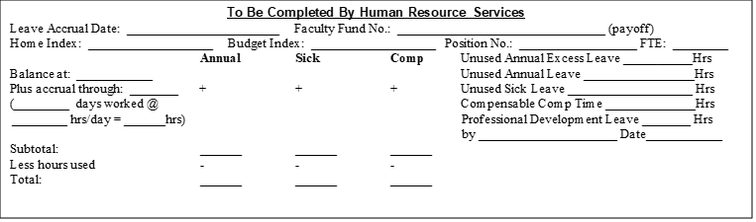

Separation From Employment
--Exit Assessment Checklist--

Employee Information
Employee ID: ____________________________ | Employee Name: ____________________________
Last Day Worked: ____________________________ | Date Checklist Completed: ____________________________
Employee Personal Email Address: _________________________________________________

Each separating employee and their supervisor must review each item listed on this form. If an item does not apply, mark it “N/A”. If a transaction occurs, the employee and the supervisor must initial the transaction upon completion. After completing the checklist, the employee and the supervisor must sign and date the form. The form must be provided to Human Resource Services within 3 days of the employee’s last day worked for inclusion into the exiting employee’s personnel file.

Checklist
Transaction Description | Employee Initials | Supervisor Initials
Information Technology
Banner account closed (email bannerhelp@umontana.edu)
Email account closed (Submit IT Support Ticket in TeamDynamix)
Cell phone, laptop, and other university-owned equipment returned to department
Proxy user set up in Webtime, UApprove, GrizMart, Cayuse, or other requisitioning systems (if the employee has approver permissions) (Contact IT if you require support, ithelpdesk@umontana.edu)
Facilities & Security
Griz Card access to all UM doors revoked (Submit a Griz Card Center Support Ticket in TeamDynamix)
All University keys returned to Facilities Services
Business Services – If Yes To Any Question Below, Send A Copy of Checklist To Business Services.
Does the employee have a Banner Finance Account? ​​☐​ Yes ​​☐​ No
Is the employee a Petty Cash or Change Fund Custodian? ​​☐​ Yes ​​☐​ No
Does the employee have a ProCard or Costco Card? ​​☐​ Yes ​​☐​ No
Employee Information in GrizPortal
Confirm that the employee’s direct deposit bank account information is correct in GrizPortal
Confirm that the employee’s mailing address is correct in GrizPortal
(This is the address to which the employee’s Form W-2 will be mailed unless the employee has elected electronic delivery. Electronic delivery of Form W-2 may be elected within GrizPortal)
Human Resource Services – Benefits Consultation:
At your consultation you will discuss: Long-term care insurance, Faculty/Staff fee waiver reimbursement, Flexible spending account closure, COBRA continuation coverage, and Retirement options.
To schedule your consultation please submit an HRS service ticket in TeamDynamix OR call 406-243-6766.
We acknowledge that all University property has been returned and the exit process completed.

Employee Signature: _________________________________________________Date: __________________

Supervisor Signature: ________________________________________________ Date: __________________

Supervisor Initials: __________ I will return this document to Human Resource Services no later than three days after the Last Day Worked listed on this document.
Please submit this form to Human Resource Services in Lommasson 229.
Questions? Submit an HRS Service Ticket in TeamDynamix or call 406-243-6766

