INCyTE Distributed Experiment: Vertical stoichiometry and flexibility across scales in forest ecosystems

(DRAFT PROPOSAL)

Ecosystem stoichiometry is a key driver of global biogeochemical cycling and will influence the ways carbon (C) and nutrient cycles respond to global change. For example, predicted increases in plant productivity (Hamilton et al. 2002; Norby et al. 2005; Zak et al. 2011) will likely persist under a range of tissue C:N:P values, but the limits to stoichiometric plasticity may govern future vegetation responses as nutrients become increasingly scarce. In addition, multiple lines of evidence suggest that ecosystem stoichiometry may be shifting globally due to a combination of factors, including rising atmospheric CO₂, N deposition, and climate change (McNeil et al. 2007; Fleischer et al. 2013; Du et al. 2019; Wang et al. 2021, Mason et al. 2022). Yet, while stoichiometric flexibility may be a key determinant of future C balance of terrestrial ecosystems, it remains uncertain whether plants exhibit sufficient stoichiometric flexibility to maintain growth despite anticipated imbalances in C, N and P availability from anthropogenically-altered biogeochemical cycling.
Despite evidence of stoichiometric flexibility in terrestrial ecosystems globally, the effects of changing stoichiometry, especially over large temporal and spatial scales, remain largely unknown. In part, uncertainty about stoichiometric controls over ecosystem processes stems from a poor understanding of if and how C:N:P ratios of different ecosystem components are coupled across space and time (Fig. 1). Additional stoichiometric data would enhance our ability to predict how biogeochemical cycling will respond to changing resources and would improve model predictions of Earth’s C sink by establishing stoichiometric boundaries for productivity.
To address this gap, we propose a distributed experiment in which INCyTE participants establish stoichiometric observatories to explore how ecosystem stoichiometry is coupled vertically, from tree canopies into soil, as well as how those relationships vary across environmental gradients. Within the observatories, we propose that participants collect a series of samples along vertical cores in forests across the globe to broadly explore: 1) C:N:P relationships between ecosystem compartments; and 2) potential environmental drivers of stoichiometric flexibility (Fig. 1). Data collected by participants would contribute to a global stoichiometry database used to address some collaboratively developed hypotheses, and we anticipate the initial data collection culminating in 1-2 manuscripts co-authored by all participants.
One hypothesis that could be addressed with the stoichiometric observatories is that stoichiometry of leaves, litter, wood, roots, and associated soil and microbial biomass are strongly correlated (H1, the footprint hypothesis, Fig. 1a), perhaps reflecting the dominant influence of plant foliar stoichiometry on other ecosystem components. Alternatively, vegetation and foliar stoichiometry may be decoupled from other ecosystem components (H2, stoichiometric decoupling, Fig. 1b), possibly reflecting differences between litter and root-driven processes and/or the effects of homogenization of mixed species litter (with varying stoichiometry) on belowground components. The collaboratively-produced database will also allow us to explore broad-scale patterns and drivers of spatial stoichiometric flexibility (e.g., Dynarski et al. 2022, Fig 1c). We envision multiple possible levels of participation in the project depending on level of interest and sampling/analytical capacity of network members. However, we propose to collaboratively discuss and revise all aspects of this proposal in the coming months.
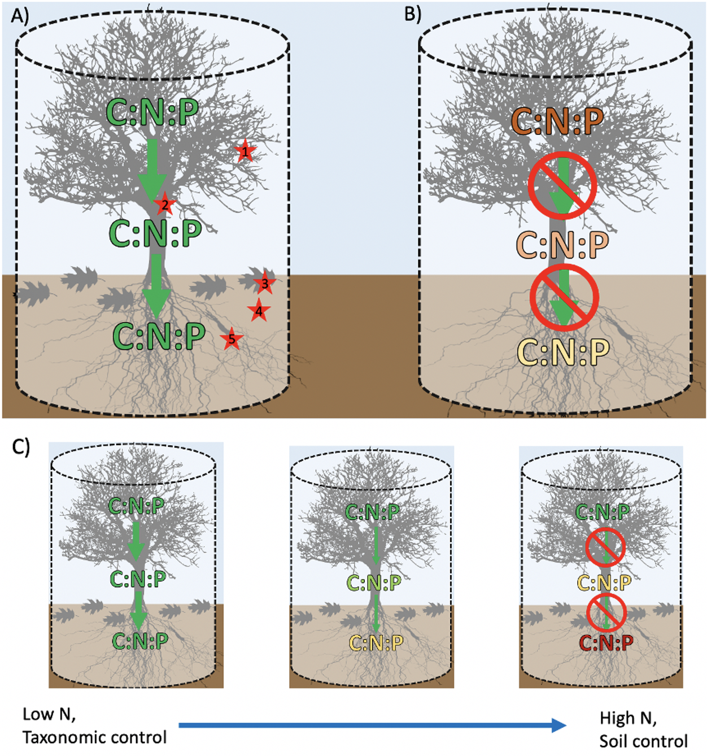
Figure 1. Possible hypotheses for the stoichiometric observatories exploring ecosystem stoichiometric flexibility. We hypothesize that stoichiometric ratios will be coupled across a vertical core (A), including foliage (1), wood (2), litter (3), soil and soil microbial biomass (4) and roots (5), possibly reflecting a footprint of foliage and litter stoichiometries on other ecosystem components. Alternatively, stoichiometry may be decoupled across the profile (B) if root-driven processes or mixing of vegetation with varying stoichiometry produce divergent C:N:P patterns in aboveground versus belowground systems. Over broad spatial scales, we can test drivers of stoichiometric flexibility and connectivity across the vertical core (C).

References

Du, C., Wang, X., Zhang, M., Jing, J., & Gao, Y. (2019). Effects of elevated CO2 on plant C:N:P
Stoichiometry in terrestrial ecosystems: A meta-analysis. Science of the Total Environment,
650, 697-708.

Dynarski, K.A., Soper, F.M., Reed, S.C., Wieder, W.R., Cleveland, C.C. (2022). Patterns and controls of
foliar nutrient stoichiometry and flexibility across United States forests. Ecology. In press.

Fleischer K, Rebel KT, van der Molen MK, Erisman JW, Wassen MJ, van Loon EE, Montagnani L, Gough
CM, Herbst M, Janssens IA et al. 2013. The contribution of nitrogen deposition to the photosynthetic capacity of forests. Global Biogeochemical Cycles 27: 187–199.

Hamilton, J. G., DeLucia, E. H., George, K., Naidu, S. L., Finzi, A. C., & Schlesinger, W. H. (2002). Forest
carbon balance under elevated CO2. Oecologia, 131(2), 250-260.

Mason, R. E., Craine, J. M., Lany, N. K., Jonard, M., Ollinger, S. V., Groffman, P. M., ... & Elmore, A. J.
(2022). Evidence, causes, and consequences of declining nitrogen availability in terrestrial ecosystems. Science, 376(6590), eabh3767.

McNeil BE, Read JM, Driscoll CT. 2007. Foliar nitrogen responses to elevated atmospheric nitrogen
deposition in nine temperate forest canopy species. Environmental Science & Technology 41: 5191–5197.

Norby, R. J., DeLucia, E. H., Gielen, B., Calfapietra, C., Giardina, C. P., King, J. S., ... & Oren, R. (2005).
Forest response to elevated CO2 is conserved across a broad range of productivity. Proceedings of the National Academy of Sciences, 102(50), 18052-18056.

Wang, C., Sun, Y., Chen, H. Y., & Ruan, H. (2021). Effects of elevated CO2 on the C: N stoichiometry of
plants, soils, and microorganisms in terrestrial ecosystems. Catena, 201, 105219.

Zak, D. R., Pregitzer, K. S., Kubiske, M. E., & Burton, A. J. (2011). Forest productivity under elevated CO2
and O3: positive feedbacks to soil N cycling sustain decade‐long net primary productivity enhancement by CO2. Ecology letters, 14(12), 1220-1226.

