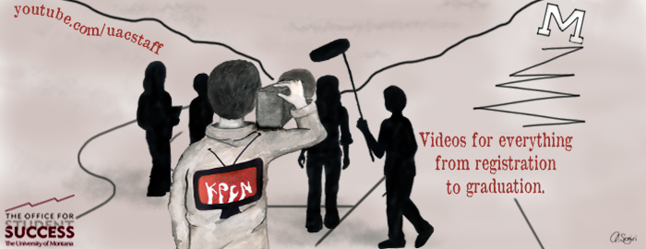

**YouTube:**

* 15,900 views since May 27, 2010 (Before KPCN was *KPCN)*.
* Most Popular Video: “How to Pay and Finalize” (1,600 Views).
* Second: “How to Forward Your UMConnect E-Mail” (1,445 Views).
* KPCN’s favorite video? The comedic mockumentary, “How to Fail a Class.”

**Collaboration:**

* IT
* UMOnline
* Orientations
* The Bookstore
* Convocation

***KPCN: The Peer Connection***

***Network***

* The Writing Center
* Four Bear
* OSS
* GLI: Global Leadership Initiative
* Business Services
* Academic Planner
* Career Services
* First-Year Reading Experience

*Shannon Janssen // KPCN Program Coordinator //* [*Shannon.Janssen@mso.umt.edu*](mailto:Shannon.Janssen@mso.umt.edu)

*Cory Martini // KPCN Intern //* [*Cory.Martini@umontana.edu*](mailto:Cory.Martini@umontana.edu)

**Current:**

This summer, six KPCN videos were integrated into Orientation, meaning that over 2,000 new students and their families viewed KPCN videos. KPCN was selected over a professional video production company to produce this year’s Convocation video that played in front of the freshman class, the President, the band and over 100 faculty members on UM’s Oval Wednesday, August 29th. The *Missoulian* featured KPCN over the summer and shadowed a shoot as research for an article, which also was published in 2012’s *Bear Necessities*. To cap off KPCN, the program was selected as a Certificate of Merit winner by the National Academic Advising Association (NACADA) for achievement in the Advising Technology Innovation category.

Unlike podcasts, blogs, Facebook, Twitter, and traditional email communications from administrators to students, KPCN utilizes and merges peer-to-peer communication models with Gamer generation affinities such as high-quality, engaging videos. Administrative messages delivered in this format by students accomplish select goals of the institution and still appeal to the intended audiences. These means of communication enable students to take more responsibility for understanding the university system and directing their academics.

**History:**

* Funded through the Office for Student Success since January 2011.
* 45 published videos for everything from registration to graduation.
* Students have directed the program from the beginning.
* 58 students have played an important role in KPCN.
* 17 students are participating in KPCN for Fall 2012.

**University Programs**

* “First-Year Reading Experience”
* “GLI: The Global Leadership Initiative”
* Convocation, 2012
* Career Sevices

**Graduation**

* “Graduating from UM - Step by Step”
* "Planning to Graduate"

**General Education**

* “Everything You Need to Know About  
  General Education Requirements”
* “GER Self-Eval”
* “Quick GER Intro”

**Advising**

* "Look up your Advisor"
* “Scheduling an Appointment with a UAC Advisor”
* “How to Prepare for an Advising Appointment”
* “How Advising Works at UM”

**Planning and Registration**

* "Planning and Registering for Your Classes"
* "Academic Planner"
* “Academic Planner for Students”
* “Academic Planner for Faculty & Advisors”
* “How to Pay and Finalize your Registration Bill”
* “UM Catalog”
* “Renting vs. Buying Textbooks”
* “Book Buyback”
* “Buying Your Books”

**Student Success**

* "Tutoring"
* "Study Spots"
* "Professors' Office Hours"
* "Checking Grades"
* “How Pizza and Burritos can Help You Get Started on Your Paper”
* “Preparing for the WPA”

**Parents**

* “The Care and Feeding of a College Freshman”

**Transitioning to College**

* “Time Management"
* “How to Fail a Class” (comedic mockumentary)
* “The Six-Word Sophomore Year Memoir Project”
* “Common Freshman Myths”
* "College is Different”

**Orientation**

* "Fill out your A-IQ"
* “Core Course Registration”
* “GEAR Online”
* "How to Avoid an Identity Crisis"
* "Set Up UMConnect"
* “How to Forward Your UMConnect E-Mail”
* "ALEKS Math Placement"

***All KPCN videos are centrally located at*** [***http://youtube.com/uacstaff***](http://youtube.com/uacstaff)***. Some departments, programs and professors have embedded these videos on webpages, Moodle shells and emails to new and continuing students.***