KPCN: The Peer Connection Network

Administrative Summary
At a foundational level, KPCN records students, instructors, and campus community members sharing their stories of UM, their expertise, their excitement, and their hopes. KPCN produces engaging, professional, informative videos, but we also collect student experiences and bridge people from different disciplines and backgrounds together through exposure and common narrative.
KPCN started in 2010. In the last 7 years, we have collaborated with over 24 clients on 210 videos watched 111,235 times according to YouTube analytics. The Montana University System Office of the Commissioner of Higher Education contracted 17 KPCN productions. Over 100 students have assisted KPCN with some form of the production process for academic credit or paid internship.
In the last academic year, KPCN productions aired 36,126 minutes. To put that number in perspective, you would have had to watch 301 two-hour movies to consume an equal amount of video content. The amount of footage behind those polished productions is triple. It should come to no surprise that KPCN stores over 11 TB of footage.
In the next fiscal year, KPCN plans to continue its role as an option for the campus community to promote academic opportunities and aid students in making the most of their college experiences. We continue to look for new partnerships both within the campus community and within the community of Missoula as a whole.
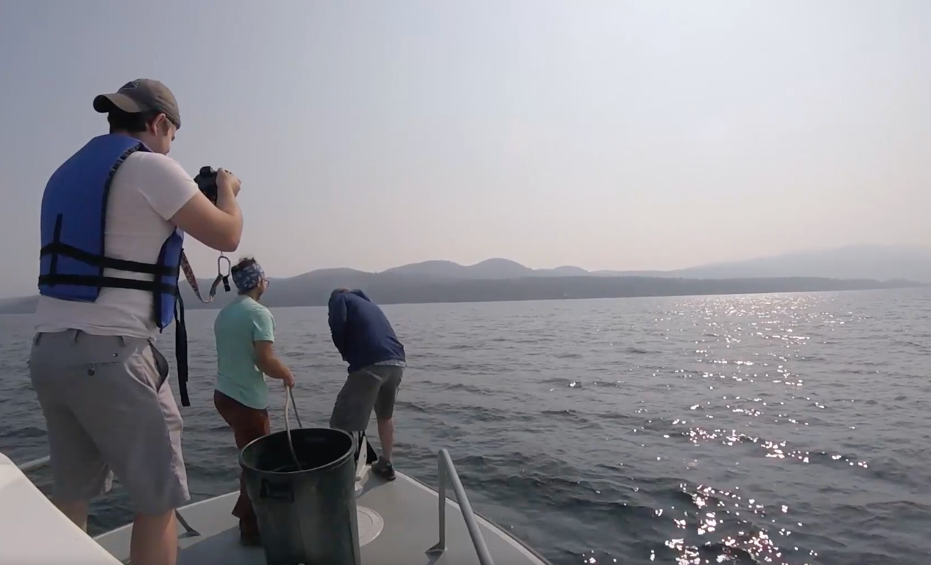
Figure 1: Producer Connor Bryan filming UM students at work aboard the Flathead Lake Biological Station research vessel the Jessie B.

Mission Statement
KPCN: The Peer Connection Network is a student-based video production group creating clear, concise, and engaging video communications for the campus community. Each team member believes in and commits to the necessity and power of film as a way to streamline and demystify educational experiences at the University of Montana. We do this through a collaborative production process that extends classroom learning objectives into field-based experiential learning opportunities for the students behind the camera. We create videos to fill needs, to tell stories, and to aid our community in ways that best support students.

OBJECTIVES
Founded in 2010, KPCN strives to provide a visually engaging form of communication. Collaboration between students, administrators, faculty, and staff ensures a dynamic and interdisciplinary group. KPCN works with departments and student groups across campus to explain complicated business processes, promote academic programs, and highlight unique learning opportunities.

PRIMARY FUNCTIONS
Our multidimensional primary function is to bridge a generational and technological communication gap by:
- Enabling campus communities to meet prospective, new, and continuing students where they are;
- Providing UM students with accurate and helpful information on resource navigation and educational opportunities
- Investing in students through experiential learning and leadership opportunities;

We employ a high-touch collaborative process with our clients. From concept meetings to close captioning the final product, our student staff continuously works with clients to find innovative ways to reach designated audiences. Students exercise leadership, demonstrate professional communication skills, and align production decisions with client’s resources, needs, and wants. We do this by understanding the project, its goal, the budget, and the audience.

Organizational Chart
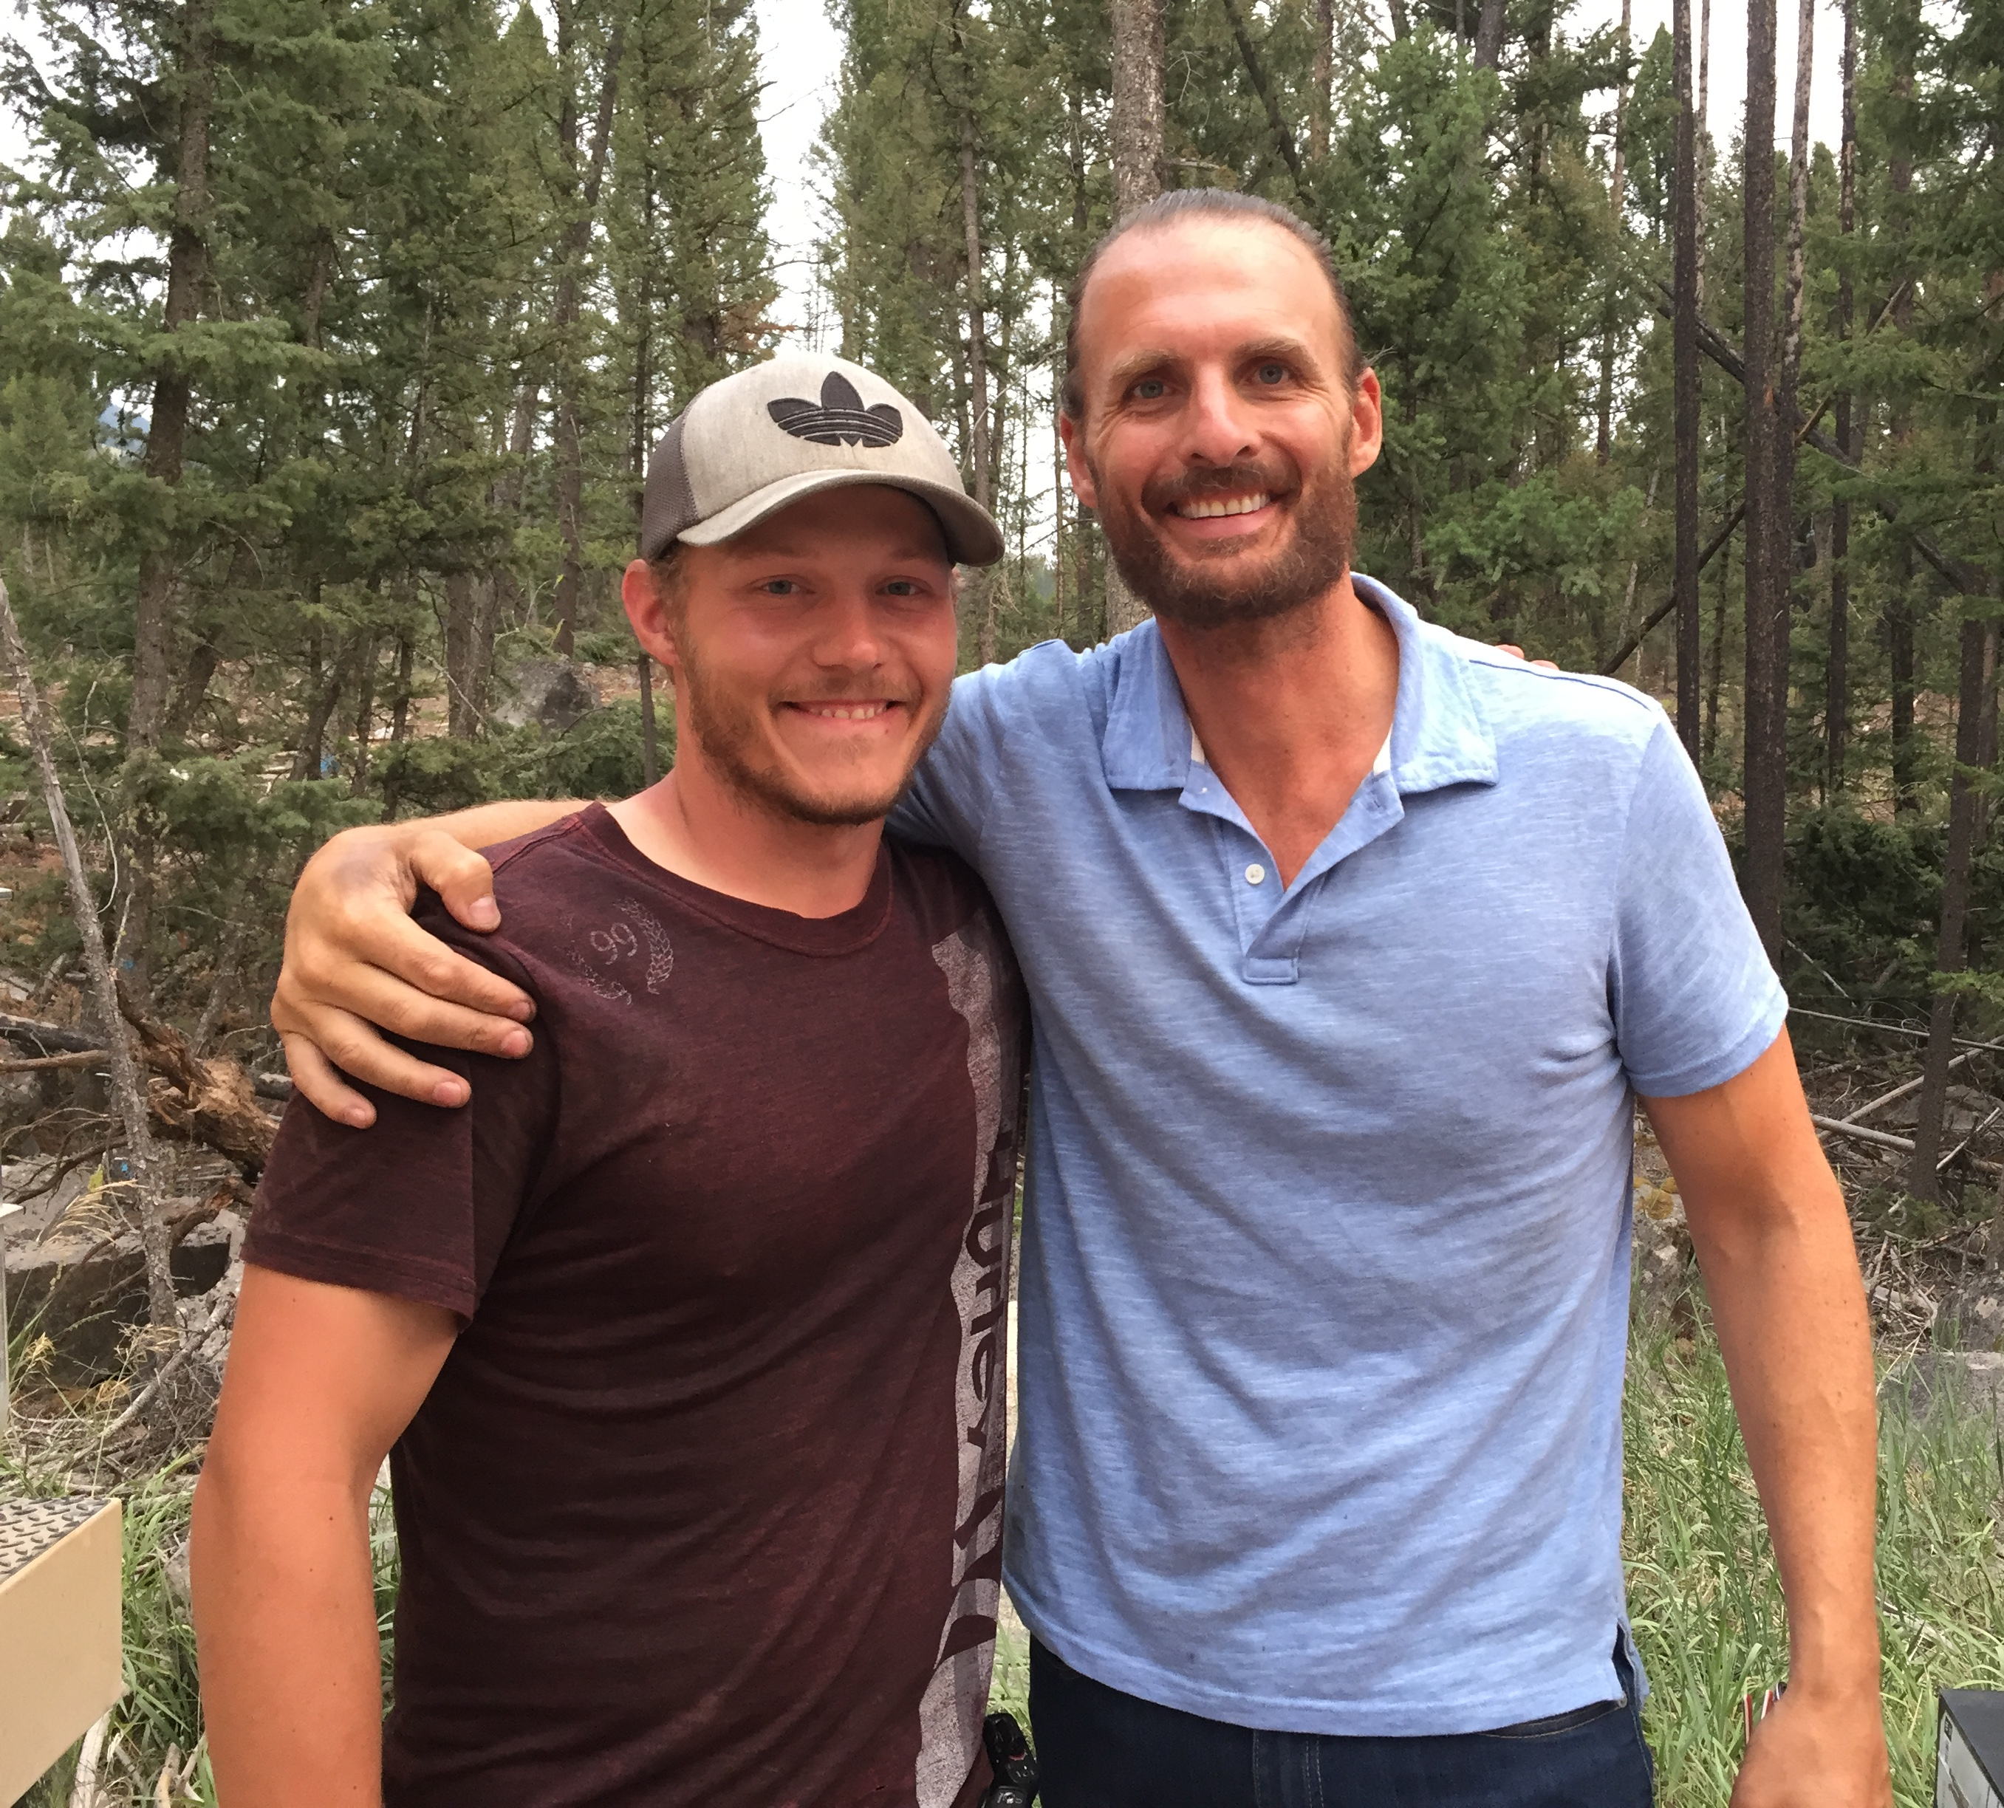
Producer Ryan Graham-Laughlin worked on 15 productions this last academic year in addition to his work with KPCN. Entering the final year of his Media Arts degree, Ryan’s portfolio now includes credits for 10 short films, 2 documentaries, a podcast, a music video, and a graphic design. He continuously works on all aspects of the production process from operating booms, recording sound, set design, filming, editing, acting, and animating. His pinnacle accomplishment this year is his work as a boom operator and sound recordist for the “Far Cry 5” video game promo filmed in Phillipsburg, MT.
Producer Connor Bryan is also entering his final year in Media Arts but is brand new to KPCN. He runs an independent YouTube channel with over 222 videos focusing on the Let’s Play format. Connor also produces a podcast with 22 published episodes.
Figure 2: Producer Ryan Graham-Laughlin and actor Grag Bryk on the set of the "Far Cry 5" promo video.
Animator Gabrielle Tusberg is starting her second year of the Media Arts curriculum and beginning to expand her animation skills. She joined KPCN at the start of summer and, by the end her portfolio will include animations for the Degree Works video series and animations for the 2017 Convocation video.

Program Summary
KPCN’s success is defined by the personal growth of the student staff and their extensive portfolios; the opportunities they have to engage with the campus community and the resulting stories; and through the successful delivery of video-based communication solutions. More recognizable,
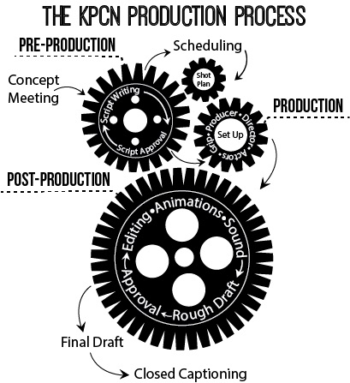
- UM’s official YouTube page lists KPCN as a featured channel.

- Departments post their promo videos to the UM homepage.

- Published in the National Academic Advising Association’s (NACADA) printed monograph for Peer Advising and Mentoring.

- Awarded a national NACADA certificate of merit for an outstanding advising technology innovation.

- One of 9 out of 800 applicants that presented at the Gates Foundation Postsecondary convening.

2016-2017 Videos
- Stories from the College Front Video Series for TRIO research project (continuation)
  - Filmed and produced 70 individual stories, now published on the TRIO YouTube Channel.
  - This project, directed by Janet Zupan, invites members of the campus and Missoula communities to share an anecdote about a time in their college career in which they felt isolated and as if they didn’t belong in college. The gathered vignettes are part of a research project focused on the sense of belonging as it relates to marginalized students.
- Visit Degree Works
  - Part 1 of a video series promoting the newly implemented Degree Works audit system. This production takes a fun approach to informing students of key functionality in Degree Works.
Figure 3: Animator Gabrielle Tusberg's rendering for the Degree Works promo video opening sequence.
- How to Use Degree Works
  - Part 2 of the Degree Works promo series. This video steps students through accessing and using the software to run a degree audit, program a what-if scenario, and run GPA projections.
- JST-Evaluating Your Joint Service Transcript
  - A collaboration between the Montana University System, the Office of the Commissioner of Higher Education, UM’s Veterans Educational and Transitional Services office, and KPCN to produce a comprehensive video for in-person training on adhering to the prior learning agreement while evaluating military joint-service transcripts for college credit.
- W.A. Franke College of Forestry and Conservation Scholarship Video
  - Contracted by CFC to tell the stories of scholarship recipients and to thank donors during their annual awards banquet.
- W.A. Franke College of Forestry and Conservation Promo Video
  - Interviews from the scholarship video allowed for a second cut promoting students’ educational experiences and highlighting strengths of the CFC.
- International Baccalaureate Program
  - KPCN worked with UM’s IB coordinator to edit an informational video promoting the International Baccalaureate Educator Certificate in Teaching & Learning. The video is now housed on the program’s page to welcome interested students with testimonials from those who have completed the program.
- UM’s Environmental Studies Graduate Program
  - This video promotes the graduate program in Environmental Studies by discussing the student experience through the eyes of alumni, current students, and faculty.
- The Writing Center Promo Video (updated information)
  - This update to one of our most popular videos published the Writing Center’s location change and ensured continued use of the production. The Writing Center was then able to deploy the video to all sections of WRIT 101 and C&I 194: Freshman Seminar last year.
- 2016 Academic Convocation
  - Spanning the student experience from orientation to graduation, this video serves as the visual for the official academic welcome to new students on the Oval.

UM Alignment

UM 2020
KPCN’s original structure built upon core values of leadership and engagement as defined in UM 2020. Students run client concept meetings; write scripts; schedule logistics; film; and edit each video. KPCN produced the last six Convocation videos during the seven years UM hosted a formal Academic Convocation. This year, student producers and animators attended the Convocation meetings with the full campus committee. KPCNers hone essential leadership skills through this formalized experiential learning structure.
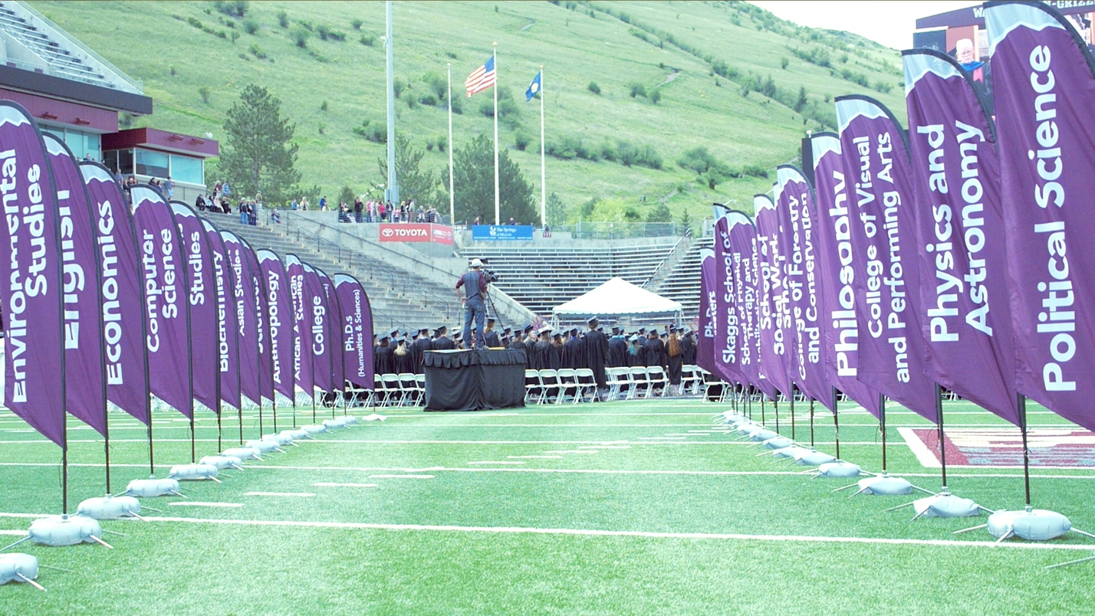
KPCN’s experiential learning focus encourages KPCNers to branch out of their academic disciplines when filming classes, field experiences, labs, events, and programs for stock video. The resulting promotional videos ground current and prospective students with experiences and opportunities by portraying academic discovery, service, and student life.

UM Strategic Vision 1.1
KPCN embodies the opportunities of the UM Strategic Vision 1.1 to engage students where they are and to invest in people. We put students first, one by one, by creating a structured and supportive experience customized by each learner. The learner defines relevant professional development opportunities and we flex to help make the most of those decisions. We adapt, we remain accountable, and we create our best work.
Figure 4: An image from Producer Ryan Graham-Laughlin's KPCN's 2016 graduation footage.
Truly, our student employees are our greatest strength. We work to maintain a high-quality student experience by investing in people through leadership, professional development, and relationships.
KPCN ensures students have paid-positions as they build portfolios and resumes for the post-graduation job market. We invest in leadership opportunities, travel, and high-quality production software and equipment to foster a dynamic set of competencies in our staff. As in the professional realm, we innovate, collaborate, and then rewrite. What sets a KPCN production apart from classroom work, is that we do not simply turn in the assignment and move onto the next project. Our projects are in progress until we have final approval from our clients. Through this, we adapt, we remain accountable, and we create our best work. KPCNers are encouraged and supported in problem-solving and in identifying innovative solutions, one of our primary strengths is the relationships this investment yields. Our students help each other learn complicated processes and new techniques. They push each other to think past what is expected or easy. Our videos are successful and we remain a sought-after resource for the campus community because our production process starts and ends with relationships.
Our services provide materials for 24/7 self-service that can integrate with Moodle, tablets, phones, email, and websites. When utilized, these materials provide standardized procedural information and allow increased time for faculty-student mentorship.

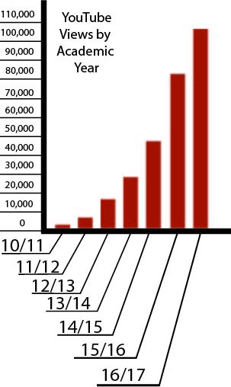
KPCN by the Numbers
KPCN’s YouTube analytics five-year report (September 1, 2012-September 1, 2017) recorded KPCN productions streamed a total of 168,239 minutes or 1,401 full-length movies and our video suite recorded 111,187 views. Our internal, KPCN and TRIO channels show 160,181 minutes watched and 106,298 views over that time period.
KPCN productions were viewed a total of 36,126 minutes in 16/17. That’s the equivalent of 301 full-length movies. In addition, we produced more videos in the 16/17 year than ever before, increasing our output from 20 videos in the 15/16 year to 79 in the 16/17 year.
KPCN currently manages four separate YouTube channels for clients to ensure target audiences have an unrestricted path to content.
- Views: KPCN (22,250), Montana University System Veterans’ Channel (317), Montana University System Financial Literacy Channel (940), TRIO (1,150): Total 24,657
- Videos: KPCN (8), Montana University System Veterans’ Channel (1), Montana University System Financial Literacy Channel (0), TRIO (70): Total 79
- Staff: three students; one administrator

KPCN Channel
- Views
  - 16/17: 22,250
  - All-Time: 105,316
- Videos
  - 16/17: 8
  - All-Time: 122
- Minutes
  - 16/17: 31,908
  - All-Time: 154,715

Montana University System Veterans’ Channel
- Views
  - 16/17: 317
  - All-Time: 720
- Videos
  - 16/17: 1
  - All-Time: 4
- Minutes
  - 16/17: 549
  - All-Time: 1,298

Montana University System Financial Literacy Channel
- Views
  - 16/17: 940
  - All-Time: 4,029
- Videos
  - 16/17: 0
  - All-Time: 13
- Minutes
  - 16/17: 1,853
  - All-Time: 6,626
TRIO
- Views
  - 16/17: 1,150
  - All-Time: 1,170
- Videos
  - 16/17: 70
  - All-Time: 71
- Minutes
  - 16/17: 1,816
  - All-Time: 1,81

AY 17/18 Goals - Looking Forward
Moving into the 2017-2018 academic year, KPCN will produce promotional and tutorial videos for the Office for Student Success to accompany and inform the campus community of major software implementations including the Student Educational Planner functionality of Degree Works and Starfish early alert and scheduling solutions. KPCN will also film and produce an additional 30 interviews for the TRIO research project. In addition, we will look to bolster communication pieces for campus tutoring programs and freshman retention efforts. We will make our debut for the semester by completely revamping our approach to the academic convocation video through visualizing UM’s new strategic vision.

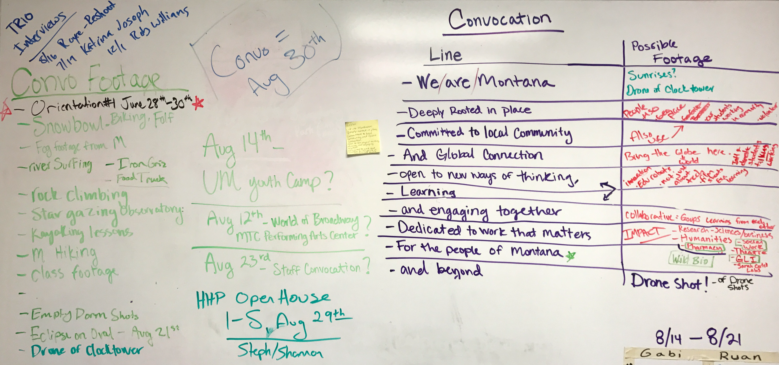
Figure 5: The Convocation planning board in the KPCN office.

