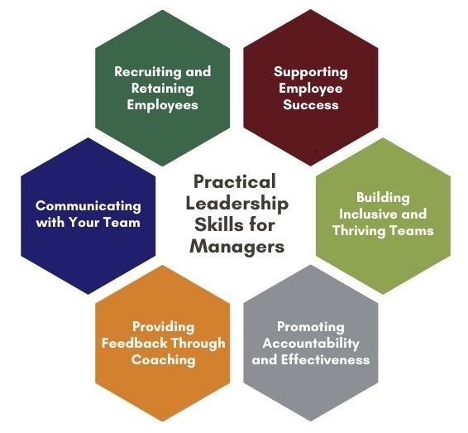
Practical Leadership Skills for Managers
Name of participant: Click or tap here to enter text.

Supporting Employee Success
☐ Watch online learning pathway.
☐ Apply something you’ve learned.
What did you do to apply your knowledge? Click or tap here to enter text.
☐ Attend discussion session with other managers [optional but recommended].
☐ Attend a session attached to this unit.
Name of session: Click or tap here to enter text.

building Inclusive and Thriving Teams
☐ Watch online learning pathway.
☐ Apply something you’ve learned.
What did you do to apply your knowledge? Click or tap here to enter text.
☐ Attend discussion session with other managers [optional but recommended].
☐ Attend a session attached to this unit.
Name of session: Click or tap here to enter text.

Promoting Accountability and Effectiveness
☐ Watch online learning pathway.
☐ Apply something you’ve learned.
What did you do to apply your knowledge? Click or tap here to enter text.
☐ Attend discussion session with other managers [optional but recommended].
☐ Attend a session attached to this unit.
Name of session: Click or tap here to enter text.

Providing Feedback Through Coaching
☐ Watch online learning pathway.
☐ Apply something you’ve learned.
What did you do to apply your knowledge? Click or tap here to enter text.
☐ Attend discussion session with other managers [optional but recommended].
☐ Attend a session attached to this unit.
Name of session: Click or tap here to enter text.

Communicating with Your Team
☐ Watch online learning pathway.
☐ Apply something you’ve learned.
What did you do to apply your knowledge? Click or tap here to enter text.
☐ Attend discussion session with other managers [optional but recommended].
☐ Attend a session attached to this unit.
Name of session: Click or tap here to enter text.

Recruiting and Retaining Employees
☐ Watch online learning pathway.
☐ Apply something you’ve learned.
What did you do to apply your knowledge? Click or tap here to enter text.
☐ Attend discussion session with other managers [optional but recommended].
☐ Attend a session attached to this unit.
Name of session: Click or tap here to enter text.

