Fall 2019 Newsletter of the Department of Mathematical Sciences of the University of Montana

Interview with Marylesa Howard
By John Bardsley
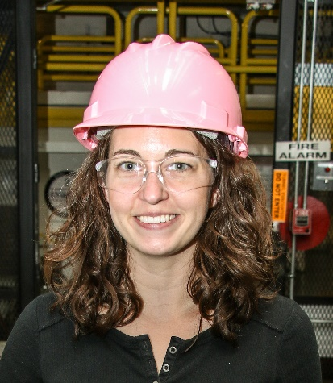
Marylesa Howard
Dr. Marylesa Howard, who earned her Ph.D. in Mathematics from UM in 2013 under the supervision of Professor John Bardsley, was one of the recipients of the Presidential Early Career Award for Scientists and Engineers (PECASE). As the White House Press Release notes, the “PECASE is the highest honor bestowed by the United States Government to outstanding scientists and engineers who are beginning their independent research careers and who show exceptional promise for leadership in science and technology.” John interviewed Marylesa, asking her about the award, her career, and her family.
[John] Congratulations on receiving the PECASE award! UM Math is (and I am) very proud. How does it feel to you?
[Marylesa] To me, I feel as though I’ve just been doing my job these past few years, and to be recognized so widely for my work, well, I’m very honored and very humbled to receive this award.
[John] Please tell us about your trip to Washington, D.C., to receive the award.
[Marylesa] When I received the email informing me of the award, I also learned the ceremony was three weeks away. My mother graciously offered to watch my two girls for us so that my husband could travel with me to receive the award, although I know she would have loved to be there with me. My sister and her fiancé were also able to come and support me in DC. The White House put on the morning ceremony on July 25th, where about three hundred early career scientists and engineers were honored. In the afternoon, the DOE put on a wonderful ceremony for 40 or so of us who were named PECASE winners under DOE. There were 10 of us there from the National Nuclear Security Administration, under which our contract with the Nevada National Security Site falls. This ceremony was terrific, and the speakers really impressed upon us that awardees had been chosen not only for their contributions to science thus far, but, perhaps equally as much, for their potential to develop into powerful leaders in the science community. I was very humbled to consider myself in that category.
[John] You won the award for your work at the Nevada National Security Site (NNSS). Please tell us about NNSS and the work you do there.
[Marylesa] [From our website, nnss.gov] The Nevada National Security Site and its related facilities help ensure the security of the United States and its allies by: supporting the stewardship of the nation’s nuclear deterrent; providing nuclear and radiological emergency response capabilities and training; contributing to key nonproliferation and arms control initiatives; executing national-level experiments in support of the National Laboratories; working with national security customers and other federal agencies on important national security activities; and providing long-term environmental stewardship of the NNSS’s Cold War legacy.
Specifically, I work primarily under the Stockpile Stewardship program at the NNSS. [Again from the website:] Nuclear Weapons Science is experimental support for the Stockpile Stewardship Program to ensure the nation’s remaining nuclear weapons stockpile remains safe, secure, and effective. These activities include breakthrough nuclear experiments, the use of world-class diagnostic measurement systems, high-tech computer simulations, and detailed engineering analysis.
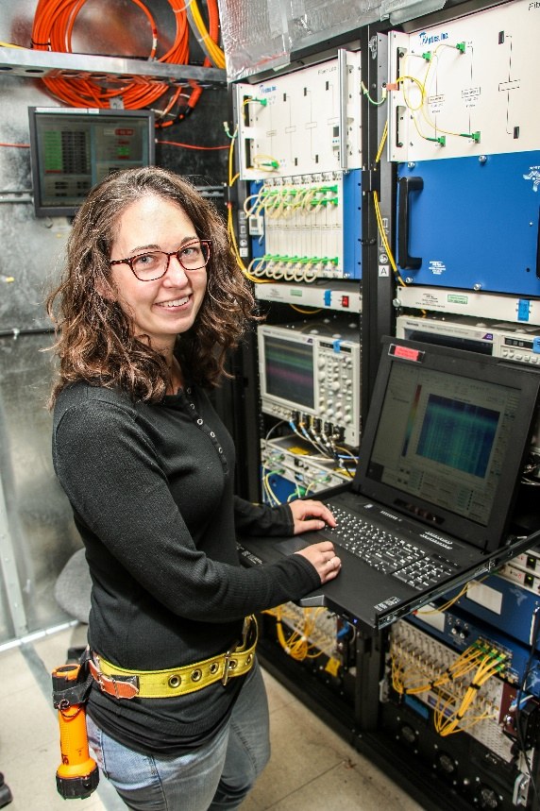
A little more about my work here. I am currently the supervisor for the Signal Processing and Applied Mathematics group, and we are comprised of mathematicians, physicists, computer scientists, and nuclear engineers. A primary role of our group is to support large-scale experiments in conjunction with the National Weapons Laboratories. Much of our work involves data analysis, designing algorithms for said data analysis, and computer programming to deploy said algorithms. We like to get our hands “dirty” and learn the intricate details of diagnostic systems that collect the data by learning how to field them, so we understand the process from beginning to end.
[John] What are your hopes for the future? Will the PECASE award help you realize those hopes?
[Marylesa] I don’t usually plan my life out too far in advance as life always has a funny way of going in its own direction. My biggest dreams have always been to care for my family and to make sure that they don’t ‘need’ for anything. Beyond that, I want to enjoy my job because we spend so much of our life at work and it can have such an effect on how we behave at home. Reflecting here, most of my hopes for my life revolve around my personal life, but the PECASE can have a huge impact on my professional life, which I realize is not mutually exclusive. At this point, the PECASE is probably my ticket anywhere should I choose to look beyond the NNSS for a career. It will likely help me solve the two body problem, especially since my husband works in this field as a technician for the NNSS and it would be easy for us to move together in this field. In the meantime, I want to focus on my time at the NNSS and the impact I can have here. In just a few short months, the PECASE has already bought me authority and notoriety, which also helps the scientific group that I am building here. In addition, the award comes with $50k/year for five years (for work). Currently, I plan to use it for professional training to better develop my skills, and for professional travel, to establish new, and further develop existing, collaborations with leading researchers. I can also use it to purchase materials or to help hire Postdocs or interns, for example. So I think in many ways the PECASE will help me to realize whatever hopes I can dream, probably even in ways of which I haven’t yet thought.
[John] Please tell us about your family and what it’s like to be a woman and mother working at the highest levels of science in the U.S.
[Marylesa] My family is amazing and is what keeps me going most days. Kaleb has always been a perfect pillar of support, never asking me to choose between a career and my family. My oldest daughter is three years old and already brilliant beyond all reason. My youngest is just nine months old and already walking. Being a mother to these girls is more fun, challenging, and ridiculously awesome than I ever dreamed. It’s not always picture perfect as we learn how to grow together, but I cherish the balance my family brings to my life. While being a mother has definitely added a layer of difficulty to my life, my management and my analysis team at work are incredibly supportive of my life as a mom, even when that means missed meetings to take one of my girls to the doctor or cancelled travel to stay at home with a fevering child. I’ve never felt like I need to choose between family and career, and I feel incredibly supported in my choices, which is very freeing.
As a woman in science, it is obvious that we are often the minority, but this also means that there is never a line in the women’s bathroom during meetings or conferences! Only occasionally have I perceived different (negative) treatment for being a woman pursuing a career in mathematics, but those experiences are often isolated and occur rarely. I recognize my experiences may be different from another woman in science, but I appreciate all the opportunities that have been afforded to me over the years and the support that I am fortunate enough to consistently receive from those around me.
[John] Thanks, Marylesa, for taking the time to talk to us. And again, congratulations on your award!

Summer Research: Moves on Higher-Rank Graphs
By Elizabeth Gillaspy
This past summer, three UM students – Kit Fieldhouse, Daniel Gent, and Ian Gonzales – spent 3 months working with me on a mathematics research project. Daniel is a master’s student, and Ian and Kit are undergraduate math majors. Although Daniel and Kit had never done mathematics research before, the three of them produced cutting-edge research this summer. We are currently finalizing a paper based on the summer’s work, and I gave a talk about these results at a conference I attended in Banff (Canada) in September.
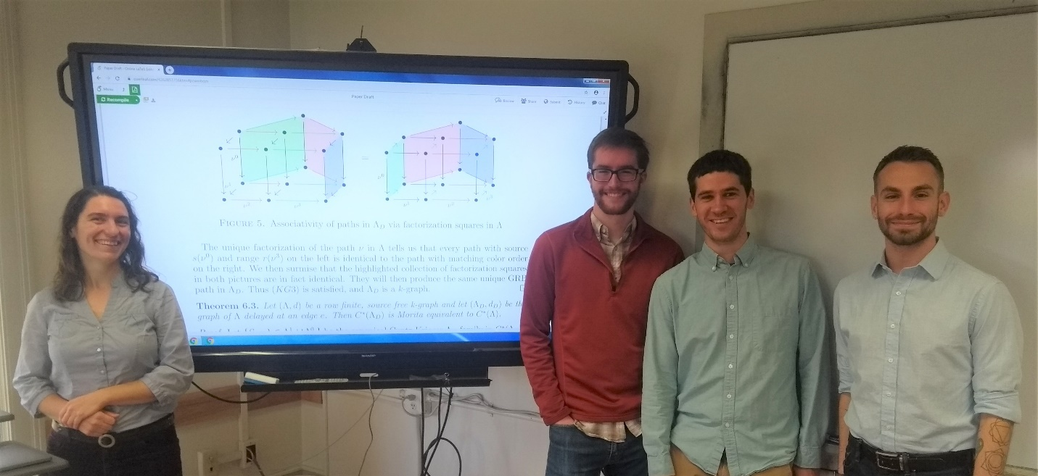
Elizabeth Gillaspy with her research group: Kit Fieldhouse, Daniel Gent, and Ian Gonzales. The monitor shows part of a page of their publication.
The best part about the summer research project was that there was no single “best part”. Daniel, Kit, and Ian worked extremely well together and thoroughly enjoyed all aspects of the research project – the time spent learning background material, the frustration of trying to understand an idea so new that there are no words for it yet, the highs and lows of finding a proof and then finding a flaw in the proof, and especially the collaborative nature of the research process. Plus, we’re getting a paper out of it! When we debriefed in August, none of us could think of any way the summer research experience could have gone better.
Let me give you an indication of the results Kit, Ian, and Daniel proved this summer. My research area is a branch of analysis called C*-algebras; I primarily study the C*-algebras arising from objects called higher-rank graphs, or k-graphs. A k-graph is a k-dimensional generalization of a directed graph, which one can visualize as an edge-colored directed graph with k colors of edges. In many ways, the structure of the C*-algebra associated to the k-graph is visible in the k-graph, so k-graphs provide tractable and informative examples of C*-algebras.
In 2004, Bates and Pask proved (generalizing work of Drinen) that if one “delays” a directed graph, by breaking an edge into two and adding a new vertex in the middle,
the C*-algebra of the resulting graph is stably isomorphic to (i.e., “almost the same as”) the graph C*-algebra we started with.
This summer, Ian, Kit, and Daniel developed a version of this result for k-graphs. It turns out that in a k-graph, it is usually impossible to delay just one edge. In the k- graph pictured on the left below, if one wants to delay the edge f, it turns out that one must also delay all the other vertical edges. Moreover, in a new twist that did not arise for directed graphs, if we delay an edge in a k-graph we also have to add new edges – the horizontal edges labeled α, β, γ, δ in the figure.
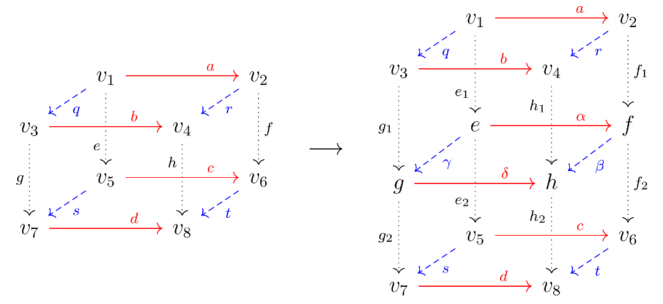
In addition to identifying the right way to think about “delay” for k-graphs, Kit, Ian, and Daniel proved this summer that the C*-algebra of the delayed k-graph is stably isomorphic to the C*-algebra of the original k-graph.
Bates and Pask also identified three other moves on graphs which preserve the stable isomorphism class of the respective C*-algebras. In a 2016 preprint, Eilers, Restorff, Ruiz, and Sorensen identified another 3 moves on graphs, and proved that two graph C*-algebras are stably isomorphic if and only if one can convert one graph to the other by a finite sequence of these 6 moves and their inverses. In addition to the work on “delay” described above, Ian, Daniel, and Kit identified analogues for k-graphs of three of Eilers et al.’s 6 moves, and proved that these k-graph versions also give rise to stably isomorphic C*-algebras.
Curiously, “delay” does not appear in Eilers et al.’s final list of fundamental graph moves. In the graph case, one can achieve the effect of delaying at an edge by combining one of the moves from Eilers et al. with the inverse of another move. It’s not yet clear, however, if delay will also turn out to be redundant in the k-graph setting. Perhaps we’ll find out next summer, when we study how to extend the remainder of Eilers et al.’s moves to k-graphs.
As an aside, the 2019 summer research team met both of the founders of the field of k-graph C*-algebras (Alex Kumjian and David Pask) over the course of this research project. Alex visited me in Missoula in May, and David will be a coauthor on the paper resulting from the summer research. Meeting researchers from other universities, especially such influential ones, was a highlight of the summer for Daniel, Kit, and Ian. In addition to Alex and David, the summer research team worked closely with Caleb Eckhardt from Miami University, and also talked about current problems in C*-algebras with my coauthor Jianchao Wu.
The funding for the summer research project came from the National Science Foundation (NSF). The NSF awards millions of dollars every year in grants to mathematicians and scientists, with the twin goals of advancing the frontiers of knowledge, and benefiting society more broadly. My current NSF grant consequently includes funding for several activities designed to improve the experiences of my students at UM and my colleagues throughout the region, as well as funding to support my own research. What a pleasure when these goals dovetail as neatly as they did in this summer’s research project.

Emma B. Lommasson 1911-2019
We are sad to report that Emma B. Lommasson passed away on November 30. Emma earned bachelor’s and master’s degrees at UM in mathematics, and worked for the math department for a number of years in several roles, from instructor and departmental secretary to assisting Professor N. J. Lennes with editing his mathematics books. After World War II, she moved to the Registrar’s Office. She retired in 1977 as the University’s registrar, after serving UM in varying capacities for 40 years. The building housing the Registrar’s Office and many other student services, was renamed in 2001 in her honor as the Emma B. Lommasson Center (see our Spring 2001 newsletter). You can read more about Emma’s remarkable life in her obituary in the Missoulian.

Notes from the Chair
By Emily Stone
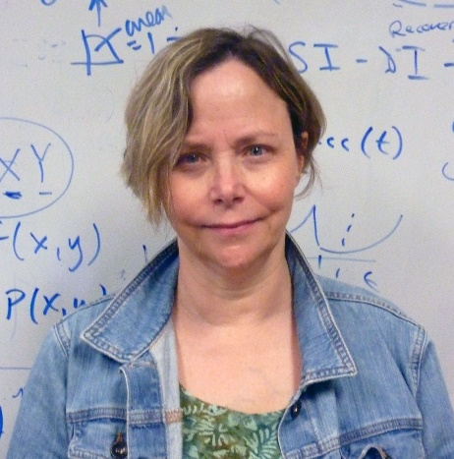
This past semester we have been pursuing excellence on many fronts, illustrating what a wide array of services and activities are housed in the Math Dept.
- We remain committed to student success in the developmental math courses, and led by Lauren Fern have now created “co-req” models for 105, 121 and 115. These special sections fill rapidly and early signs are that they boost success and retention in significant ways.
- We are developing a more “student centered” approach in Calculus I, by offering several hours of additional instruction per week, which review background material (just in time) or work on more difficult concepts. Karel Stroethoff has been the lead on this for the past 3 semesters.
- Undergraduate research is on the rise. Kelly McKinnie and Eric Chesebro have run undergrad research groups on algebra topics (supported by Foundation gifts), and Elizabeth Gillapsy worked with undergrads and grad students on analysis research projects over the summer (supported by an NSF-DMS research grant). We use our newly created “collaborative research space” in the basement (see photos below), for such group work.
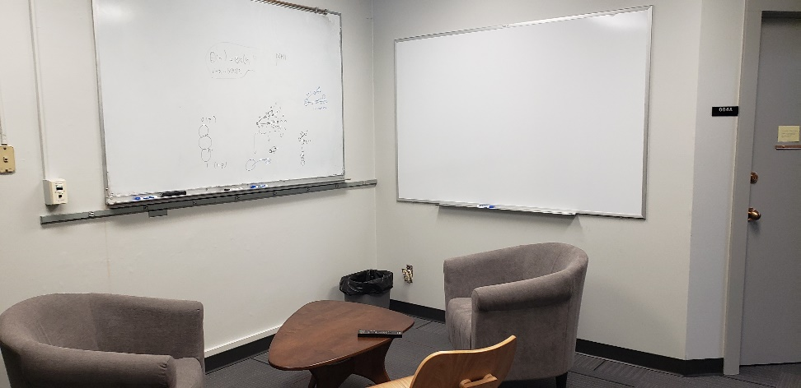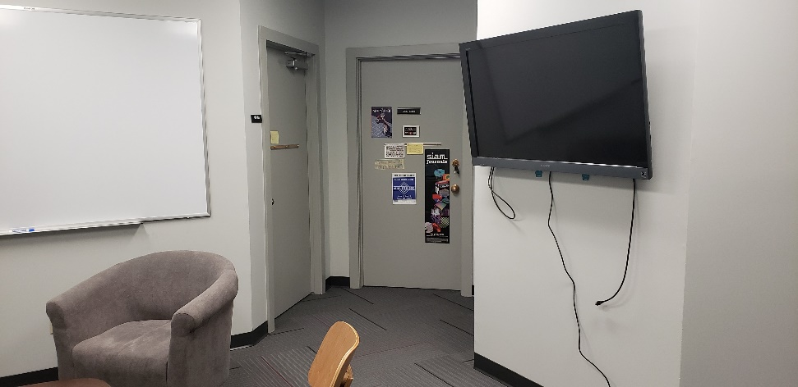
The new Collaborative Research Space, with two whiteboards and a large computer monitor
- Our tutoring center, under the guidance of Rick Darnell, also a math-ed instructor, has become a gathering place for our student-tutors, as well as a tightly run ship of peer assisted learning. Rick’s development of this community in the dept. has spawned the idea of creating learning cohorts for our lower division students, giving them an on-ramp to a lively and exciting community of peers.
- The number of Data Science Masters students went from 2 to 9 this fall, and this without much of any advertising or marketing. We are currently working on an articulation agreement with Carroll College, which has an undergrad data science major in their Math/Physics/CS dept., to allow these students to complete the Master’s degree within 1 year, assuming they meet certain basic requirements. This alone could potentially swell the program to the bursting point, especially with our hands-on approach to developing projects and internships with local companies and other units on campus. We are in conversations with the Provost’s office about plans to increase enrollment in the program, which would certainly require more instructional resources.
- Following the lead of Computer Science, we are actively preparing our students for the expanding opportunities for math majors upon graduation. National companies (such as Fast Enterprises and ATG) are working with us to run mock interview workshops, resume building workshops and more. If you are interested in helping our students connect with the tech sector or other businesses upon graduation, please contact me at stone@mso.umt.edu. Involving our alumni in job search and recruiting is a no-brainer and a lot of fun, we’ve found!
- The end of Fall semester saw the graduation of 2 more PhD students and 1 master’s. Our graduate program is going strong, with many research projects, much conference travel, and plans afoot to build a more diverse slate of graduate courses.
So from all of us here in Math, we wish you a very Happy New Year. Stay tuned for our Spring newsletter, full of awards and graduations and progress reports on the above items, as well as new endeavors!
Emily F. Stone

UM’s Math Learning Center Grows to the Benefit of Students (and Tutors)
By Rick Darnell
The Math Learning Center (MLC), a resource for students needing help in their math classes, has been a fixture of the Math building basement for a long time. But it certainly hasn’t been static, especially over the last four years.
In fall 2016, there were nine dedicated math tutors supporting students in the MLC and Math@Mansfield, our former branch location in the Mansfield Library. UM budget cuts resulted in a cut to hours and wages, but also opened opportunities for program development and a chance to rebuild the MLC into a more comprehensive service. One of these opportunities was for the MLC to become a jointly managed operation of the Math Department and the Office for Student Success (OSS), contributing additional resources and expertise in student support.
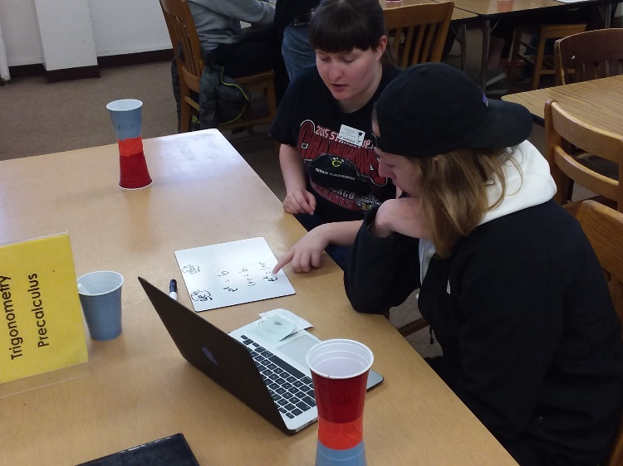
MLC tutor Kathryn Paul helps a pre-calculus student work through and understand exponential growth problems.
With the assistance of mathematics faculty, OSS, and other campus student services, the cohort of MLC tutors has grown to 24 highly qualified undergraduate and graduate students from math and other STEM fields. This academic year, a new UM Student Success Fee has facilitated creation of equitable pay rates for the tutors and increased hours of availability for students. Where the MLC was once on the constant search for tutors with minimum qualifications, well-qualified tutors now seek out the MLC for opportunities to the point of creation of a waiting list of potential tutors. More than half of our current tutors have even voluntarily completed a new UM tutoring internship class developed by OSS and the Phyllis J. Washington College of Education with input from MLC leaders. In addition, all tutors participate in semi-monthly breakfast training sessions on a variety of topics, including course refreshers in key classes, tutoring techniques, working with difficult students, and identifying and dealing with student misconduct.
As a result of the increased depth and breadth of math tutor experience, the MLC is now expanding its offerings to include support for Introduction to Statistics, and guided study sessions for students in Linear Algebra and Multivariable Calculus. MLC tutors are also regularly sought out for private math tutoring for both university students, and middle and high school students from the Missoula area. Even students in classes that are not “officially” covered by the MLC come in for help with calculus-based physics, surveying, and other classes with a heavy math requirement, plus those seeking help with preparation for exams such as the GRE.
When it comes to supporting student success in mathematics, there is always something more to do. The addition of a Griz Card reader for logging MLC users has now made it possible to identify trends in usage for future planning and current training needs. There is also work in progress to explore new ideas for reaching more students, including online tutoring and support, and the possibility for UM students to hire MLC tutors for private instruction at reduced rates to the students.
But, tutoring is not always just about the students – it’s also about what the tutors receive as well. The MLC tutors themselves now constitute another cohort of mutually supporting students in the Math building. Tutors are commonly seen in study groups of classes they’re currently taking, generally with another tutor who has already taken the class offering additional support. As they work with students to deepen and strengthen foundational mathematics, they achieve even more in their own advanced classes. This level of accomplishment does not go unnoticed by others. At the 2018-19 departmental math awards, just under half of the individual awards and recognitions went to current or former tutors.
Keep up-to-date on happenings in the MLC by following them on Instagram or Twitter @Grizzly_Math.

Donation Request Box
The Department of Mathematical Sciences increasingly relies on donations to support its activities. In particular, scholarships are very important for our students. Please consider a gift to the Math Department’s Excellence Fund, to be used where the need is greatest, or to one of the other funds and endowments:
- Endowed Scholarship Funds: The Adams Scholarships, Anderson Mathematics Scholarship, Gloria C. Hewitt Graduate Scholarship in Mathematical Sciences, Joseph Hashisaki Memorial Scholarship, Mac Johnson Family Scholarships, Merle Manis Award, William Myers Mathematics Scholarship
- George and Dorothy Bryan Endowment: Supports undergraduate and graduate students
- Lennes Fund: Provides funds for the Lennes Exam Competition
- Colloquium Fund: Provides funds to bring in visiting speakers
To donate online, please visit the math department home page.
For information on other ways to give, please contact Suann Lloyd: email or by phone at 406-243-2646 (or call toll free 1-800-443-2593).

Math Day 2019
By Fred Peck
Math Day 2019
By Fred Peck
On Friday, October 11, the Department of Mathematical Sciences welcomed 250 high school students from across Montana to campus for the tenth annual UM Math Day. Twenty-one members of the department shared their joy in mathematics, conducting workshops on topics such as knots, two-player games, infinity, and chaos theory. Students also attended a panel in which UM scientists shared how they use mathematics in their careers.
This year we were honored to include University President Seth Bodnar, Provost Jon Harbor, Dean Jenny McNulty of the College of Humanities and Sciences, and Chair Emily Stone of the Department of Mathematical Sciences. Provost Harbor focused on his own research, explaining how his team uses mathematics to understand glacial geology. Chair Stone engaged students in a workshop on chaos theory and hosted a coffee hour for visiting teachers.
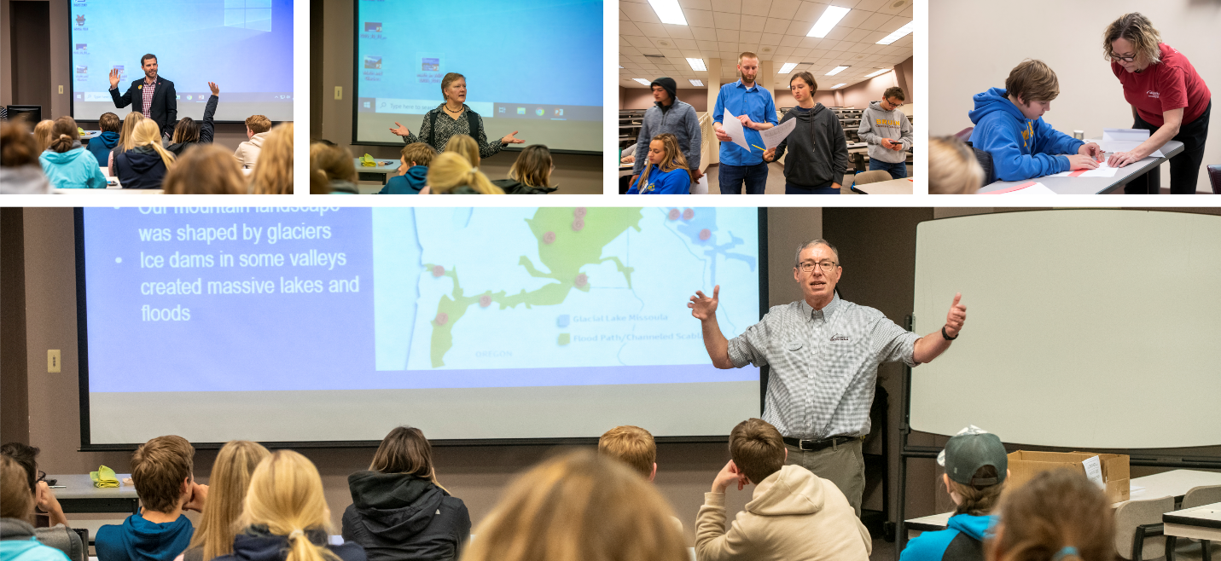
Left to right: President Seth Bodnar, Dean Jenny McNulty, Rick Brown (graduate student), Chair Emily Stone, and Provost Jon Harbor share their joy in mathematics at UM Math Day. UM Photos by Todd Goodrich.
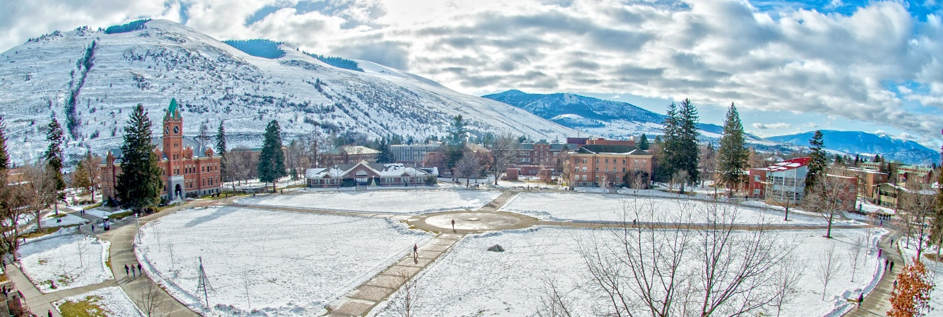
The Oval with Main Hall and the Math Building, on a beautiful winter day a few years ago. UM Photo by Todd Goodrich.

Pizza & Problems
By Daniel Gent
Sometimes the key to unlocking a pattern requires a knowledge of advanced math—but sometimes insight, creativity, and persistence suffice. In Pizza and Problems, a new club that started in Fall 2019, we focus mainly on the latter. This fall we kicked off with the question “How many times, and when, do the minute and hour hand of a clock line up in a day?” Several solutions were presented ranging from pre-calculus methods (listing times, solving a rational or trigonometric equation) to considering a mapping onto a torus. The best liked problems seem to contain difficult patterns which can be collapsed. For instance, did you know
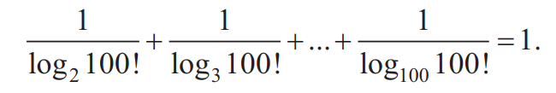
Another favorite variety are problems with some kind of twist. Such as completing the following pattern.
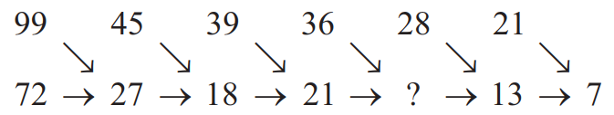
This one can be solved with arithmetic, and no the number 7 is not a typo. (Give this a try; you'll laugh when you get it!)
I have a personal history with Pizza and Problems, dating back to my undergraduate work at College of the Redwoods. Back then, I had intended to go into engineering, but one professor with a knack for creating community around problem solving convinced me that mathematics was “my true love.” One of the tools he used was a weekly problem-solving session called Pizza and Problems. I wanted to share this experience with students at UM. I’m pleased to see the community being built between grad and undergrad students, and I value the friendships I’m developing with students from other departments.
Here is one more problem to go home with. “If the numbers one through one quadrillion were arranged alphabetically, what would be the first and last entry?”
Daniel is a graduate student working towards his MA in Mathematics.

Backmatter

Address
Department of Mathematical Sciences
Mathematics Building (MMAI01)
32 Campus Drive
Missoula, MT 59812-0864
Phone: 406-243-5311
Email
Website

Comments or suggestions?
Please email the newsletter editor, Nikolaus Vonessen.

