Spring 2019 Newsletter of the Department of Mathematical Sciences of the University of Montana

Johnny Lott Receives NCTM Lifetime Achievement Award
By Fred Peck
Professor Emeritus Johnny Lott received the National Council of Teachers of Mathematics’ Lifetime Achievement Award. The award was presented at the group’s annual meeting in San Diego on April 3, 2019.
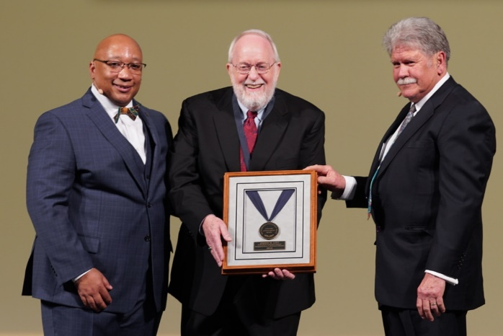
From the left: Robert Barry, president of NCTM, Johnny Lott, and Richard Seitz, Chair of the Mathematics Education Trust Board of Trustees (photo by Raymond Johnson)
The award is generally considered to be the most prestigious award for a mathematics educator in the United States. It is granted to a member of the mathematics education community who has exhibited a lifetime (at least 25 years) of exemplary achievement at the national level. Two awards are granted each year. Professor Lott is the 57th recipient of the award.
Professor Lott was nominated by his UM colleague, Professor Emeritus Rick Billstein. In his nomination letter, Prof. Billstein explained how he and Prof. Lott met at the 1974 NCTM annual meeting. That fall, Prof. Lott was hired as a visiting assistant professor in the Department of Mathematical Sciences. He soon joined the department full time on a tenure-track line, and by 1983 he was promoted to full professor. He served as department chair from 1990 to 1992. In 2005, Prof. Lott was granted Emeritus status after 32 years of service to UM. Throughout his long career, Prof. Lott has been a tireless advocate for “more and better mathematics for students.”
Together, Lott and Billstein helped to make the University of Montana an internationally-renowned institution for mathematics education. They co-authored multiple books, including a ground-breaking textbook for preservice elementary teachers. Now in its 13th edition, the book continues to set the standard for the field.
In the 1990s, Prof. Lott co-directed the Systemic Initiative for Montana Mathematics and Science (SIMMS). This NSF-funded initiative produced a complete curriculum for high school mathematics, which was used nationwide. The curriculum was truly ahead of its time. Two notable features stand out. First, the curriculum deeply incorporated problem solving, mathematical modeling, and proof. Today, these practices form the heart of the Standards for Mathematical Practice in the Common Core State Standards, and nearly every curriculum claims to incorporate them. Second, the SIMMS curriculum involved multiple pathways for students. Traditionally, high school mathematics involves one pathway through Algebra I, Geometry, Algebra II, and Pre-Calculus. Recently, NCTM has called for high schools to rethink this rigidity and instead provide a common 2-year core curriculum, after which students would have choice about which math courses they pursued. This is exactly the model used by the SIMMS curriculum. Because the curriculum incorporated so many elements that would be considered modern or progressive even by today’s standards, it will soon be re-released under an open source license.
Prof. Lott was involved with NCTM throughout his career. He was chair of the editorial panel for the NCTM journal devoted to teaching and learning elementary mathematics. He was the project manager for the Figure this! project, which produced engaging mathematical challenges for families. He served as the editor for an NCTM book series for high school teachers. From 2002-2004, he was the president of NCTM.
Prof. Lott’s commitment to “more and better mathematics for students” was not always easy. During the years of his NCTM presidency, the council was involved in the “math wars,” which pitted defenders of the status quo (traditional instruction with high failure rates that were tolerated in the name of rigor) with reformers who insisted that more students could learn math at high levels through problem solving. In an NCTM news bulletin in 2003, he explained, “NCTM has been a staunch defender of providing mathematics of the highest caliber for all students. Critics have charged that this stance is not realistic. They are wrong. There can be no denying and no apologizing for this position. Anything less is unacceptable for the sake of pre-K–12 students.”
Prof. Lott has donated much to the local community. He and his wife Carolyn endow the Carolyn and Johnny Lott Scholarship, which is given annually to a pre-service teacher candidate at UM. Moreover, Prof. Lott and his SIMMS co-developers wrote the SIMMS curriculum on behalf of the Montana Council of Teachers of Mathematics, the local Montana affiliate of NCTM. This unique and selfless arrangement ensured that all income derived from sales of the curriculum went to MCTM, rather than its authors. The income has funded many statewide initiatives for math education, and continues to support Montana teachers.
Prof. Lott’s lifetime achievement award recognizes his unapologetic conviction that all students can learn mathematics, and his relentless devotion to making this vision a reality.
Congratulations from all of us at UM!

Study Abroad & an Internship: Making the Most of My Degree in Mathematics
By Megan Finley
I have been a part of the UM math department for almost four years now. In those four years, I have accomplished and experienced fantastic things. I graduated in three and a half years, studied abroad for a semester, spent a summer in Oklahoma City with an internship, and most recently began the master’s program in data science.
In the spring of 2017, I was fortunate enough to spend a semester abroad in Cork, Ireland. There, I experienced an alternate approach to teaching and learning mathematics. I took Introduction to Math Modelling, which was wildly different from any mathematics course I had previously studied. This course relied on concepts in physics I had not yet been introduced to, creating a steep learning curve and requiring extra hours of study. Coming from the University of Montana, I was accustomed to seeking help from professors who were eager to lend a helping hand and see their students succeed. I quickly learned most professors spend little time outside of the classroom helping students; their time is primarily focused on research. After experiencing this different style of instruction, I had greater appreciation for UM professors’ abilities to balance their research while meeting the needs of students. My experience in mathematics was different than I expected, but I am grateful for an opportunity that has made me into a well-rounded mathematics student. Not to mention, I got to travel to over 25 cities in 10 countries!
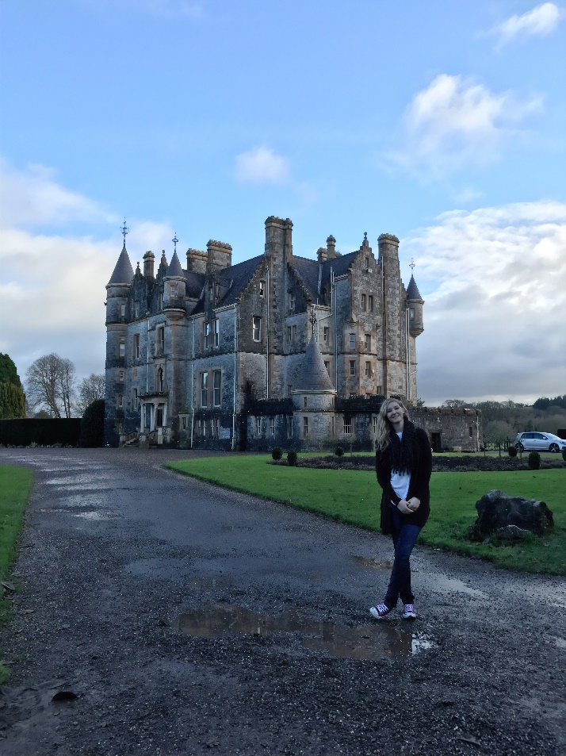
Megan Finley in front of the Blarney House in County Cork, Ireland
Studying abroad was a lot of fun, but once I returned to the States, I had a lot of hard work to put in for the remainder of my undergraduate degree. The fall I returned, I took a rigorous course load and had every intention of landing an internship for the next summer. I studied hard and was eventually presented with an opportunity to intern with a company called FAST Enterprises. FAST specializes in software development and consulting. They receive contracts through state and local governments to implement their software in unemployment insurance, driver and motor vehicle services, and tax services. Even though FAST primarily recruits from a program in the College of Business, the education I have received in the math department made me stand out. I received my offer to work for the company during the fall and the following spring I would have to take a course through the College of Business to learn the language they program in, Visual Basic.
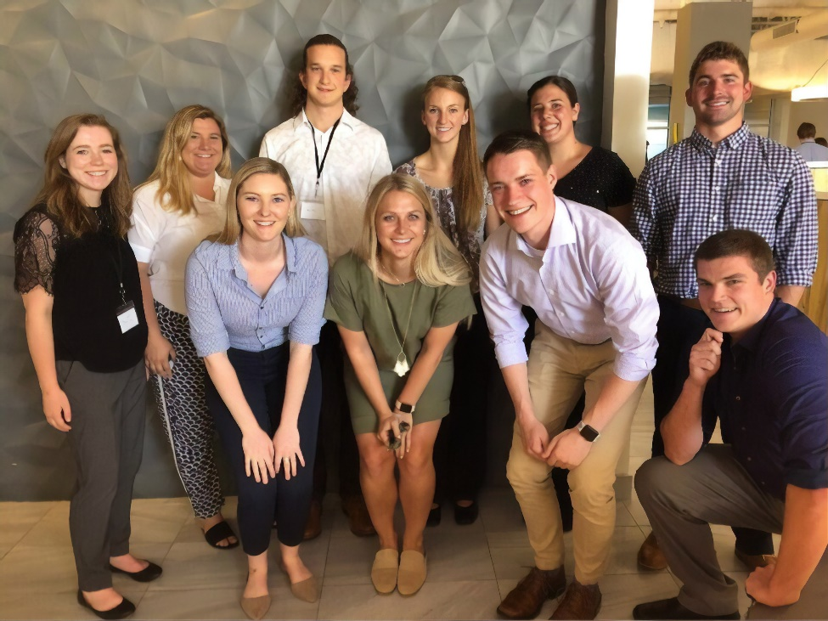
Megan Finley (bottom left) with fellow FAST Interns from UM at Intern Week
Come summer, I was so excited to start my internship and apply what I had been learning. Only a few weeks before the start of the internship I was informed I would be working in Oklahoma City. I was a little shocked to find out I would be spending a summer there. When I thought of Oklahoma City I thought of hot, tornadoes, and flat. After living there for three months, I wasn’t completely wrong, but I still had a wonderful time. FAST is a great company that made sure the interns were learning a lot and having fun in an inclusive environment. As an Implementation Consultant Intern, I was treated just like any employee. I worked on the Motor Vehicle Services software that supports the entire state of Oklahoma’s drivers. I was trusted to make changes to the system, fix problems, and even offer my opinions on how certain aspects of the system should function. As the internship progressed, I was even able to lend a hand to the newly hired, full-time employees. As the only woman on my team, I felt a little disadvantaged at first. I realized I was coming into an environment where I would be outnumbered. However, after meeting my team I knew I wouldn’t have an issue. I fit right in with everyone else. I played on the office’s all-men’s softball team, played volleyball with my coworkers, and even planned outings and activities with everyone. While there was plenty of mistake making and learning the ins and outs of a technical job, I had tons of fun. Throughout the summer, I experienced Oklahoma City’s fantastic cuisine, took a trip to Dallas with my coworkers, spent a week in Denver attending FAST’s Intern Week, and learned how to maintain a system that an entire state relies on every day. My time with FAST was invaluable as I left with lots of memories and the skills to work in a technical position.
As I started my final semester at UM, I was facing the impending responsibility of “real” adulthood. I had received a job offer with FAST, but even as much I enjoyed working for them, I felt there was still more for me to do at UM. So, I decided to apply for grad school. I was accepted into the Master of Science in Data Science program and so far, I am really enjoying it. I am fortunate to be a part of Montana Supports the Mathematicians of Tomorrow, also known as (MT)^2, where I receive funding for my education and have a position as a Teaching Assistant. Grad school is very different from undergrad and I am learning how to manage my schedule with the added rigor of course material.
My time at UM has been terrific, and I am excited to be here for at least another year while I finish my master’s degree. All with the help of my education from UM, I’ve been able to study abroad and experience new perspectives, successfully complete an internship, and pursue a master’s degree.

Notes from the Chair
By Emily Stone
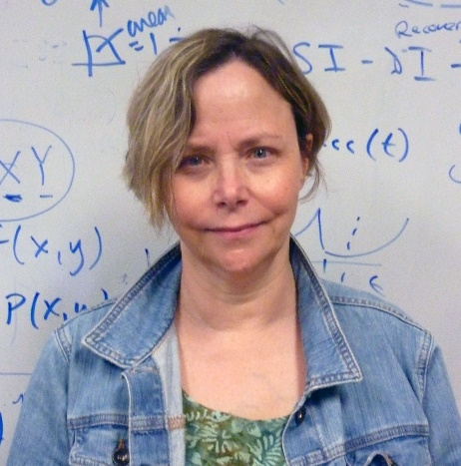
Greetings from Missoula. We are well into summer here, with many of our summer courses already halfway completed. The University has expanded its summer program and upped its marketing game, see the summer-semester website. The new administration is all about what a great place this is to live while you learn, especially in summer. We were able to offer more courses this summer, some on site, some online, which help students pick up the credits they need to graduate in a timely manner. This also gives our graduate students employment opportunities and teaching experience, so it is a win-win situation for our department.
While the transition to a new administration has not been completely smooth, we are relieved to have permanent people in place who are keen to promote the University, and rebuild after a long time spent under a siege mentality. After the dust settled this Fall we had lost three tenure track lines and two lecturer positions, a very large and egregious cut, as well as 1.5 office staff lines. Thanks to our own Linda Azure rising to the occasion, and Zsuzsa Weinhandl stepping in as a part time office worker (she held a similar position at the Alfréd Rényi Institute of Mathematics in Budapest) what could have been a crisis in the front office has been averted. We also made our case to the Provost, and were successful in retaining our most recent hire, and increasing the number of faculty lines by one, by hiring Elizabeth Gillaspy’s partner, Javier Pérez-Álvaro. Javi is a numerical linear algebraist (adding another very active researcher to John Bardsley’s area of expertise) and has taken some of the burden off Brian Steele by teaching in our Data Science program. The next stage in our rebuild is to regain the lost Stat 216 lecturer line, as well as increase our Stats group back up to a functional level. We have an extremely strong case for both hires, and as the fiscal health of the university continues to improve, I will be lobbying and pulling strings to make sure both are filled as soon as possible.
In the meantime our faculty has remained as active as ever in research, service and outreach. We have a very large amount in current grants at the moment (over 3 million dollars), thanks in large part to a big NSF grant in Math Ed to fund outreach to regional tribal colleges (Ke Wu is the PI). Many of our faculty also hold research grants from the NSF and collaboration grants from the Simons foundation. We have been very active in publishing, attending conferences, and have five PhD students graduating this AY; certainly a departmental record!
I must also add, that in spite of austerity measures at the University level, because of the generosity of our many alumni, we have been able to build our programs of undergraduate and graduate research and teaching experiences, fund faculty and student travel, and implement new outreach programs (see the article on our first ever Montana High School Mathematics Awards). Our very committed and energetic faculty and staff make this a great place to do and learn mathematics, and we thank you for your support in making all this possible. Come visit sometime, we would love to have you!
Emily F. Stone

#Latina #UM #Research #Montana #PR #MathEd #Yauco #Boricua
By Ricela Feliciano-Semidei
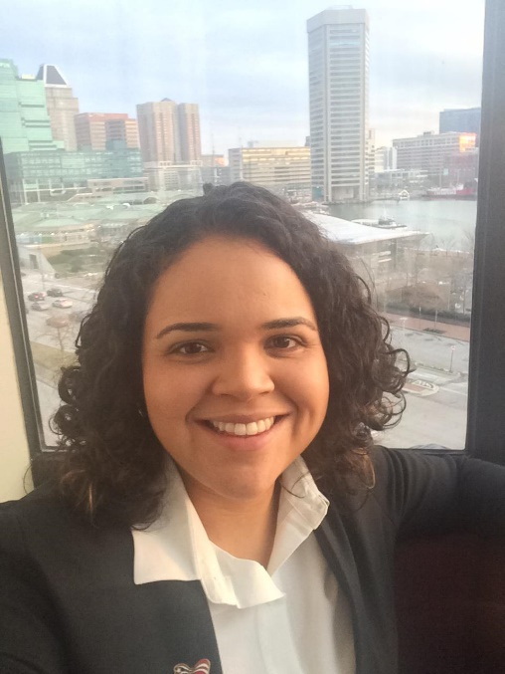
Ricela Feliciano-Semidei at the Joint Mathematics Meetings last January in Baltimore, MD
I started the doctoral program in Mathematics Education at the University of Montana in Fall 2014, supported by a fellowship from the NSF-funded (MT)^2 program. Coming from Puerto Rico, I had a lot of first-time experiences in Missoula, such as skiing and walking on ice. But more importantly, I found that the mathematics department faculty and students became my second family, far from the Caribbean. Missoula has been part of a transformational experience for me—not only in my career, but also in life. I have learned to see life from different perspectives and to love a place far from home. I have truly enjoyed my experiences with each person in Missoula and at UM. For this article, however, I will focus on describing my growth as a researcher in mathematics education.
Over the last five years, faculty at the University of Montana have facilitated valuable research experiences to prepare me for my career. As a doctoral student in mathematics education, I conducted research in student learning, in community formation, and in the mathematics achievement patterns of ethnic minority groups. These research experiences were also tied to independent research courses offered by Drs. Matt Roscoe, Ke Wu and Fred Peck, who helped me build a strong base of general mathematics education research, quantitative research methods and qualitative research methods, respectively.
My research journey in mathematics education started with two projects related to student learning, specifically the development of conceptual understanding. In the first project I worked with Dr. Matt Roscoe to develop a teaching intervention to help pre-service K-8 teachers (PSTs) develop their conceptual understanding of the Fundamental Theorem of Arithmetic. We designed four activities to prompt PSTs’ recognition of the existence and uniqueness of a given integer’s prime factorization. Prior to the intervention, PSTs combined different methods to find the factors of a number, but, after experiencing the intervention, they began to rely more heavily on the Fundamental Theorem of Arithmetic. Results from this project were published in the 2017 Proceedings of the Research Council on Mathematics Learning.
In 2016, I received a Mathematics Department Summer Research Award to work with Dr. Ke Wu on a teaching intervention to help develop students’ understanding of conditional probability. The impact of the teaching module on student learning was examined through pretests and posttests by using the Structure of the Observed Learning Outcome (SOLO) Taxonomy. We found that the teaching intervention improved the learning of conditional probability. We also identified the Law of Large Numbers as a key piece of prior knowledge that our teaching intervention required. Findings from the study had implications for improving the teaching and learning of conditional probability at the undergraduate level. Results from this investigation are under review in the Journal for Statistics Education.
In the Fall of 2016, I joined in a big new research project that strengthened my abilities as a qualitative researcher, as well as exposed me to grant writing experiences and working in a large collaborative team. I worked in collaboration with Drs. Fred Peck, David Erickson, Ian Renga, and Ke Wu. The project is a longitudinal research project studying the Montana Math Teachers’ Circle (MTC), a group of mathematics teachers and mathematicians who meet regularly to work on rich mathematics problems. We collected and analyzed qualitative data including videos, audio recordings and interviews. We explored the ways that participants negotiate various tensions related to their participating in MTCs, including the tension between engaging in a mathematics activity on the one hand, and on improving teaching practice on the other. We showed that, although MTCs are designed as sites for engagement in mathematical activity, participants work to position the community as a hybrid of mathematical activity and professional concerns, and similarly work to develop hybrid identities as teachers and doers of mathematics. We are currently investigating the nature of mathematical activity in MTC gatherings, as well as the longitudinal development of MTC communities. Results have been reported in the Proceedings of the 39th Annual Meeting of the North American Chapter of the International Group for the Psychology of Mathematics Education, the 2018 National Council of Teachers of Mathematics Research Conference, and in a paper in revision for Linguistics and Education.
During the summer of 2018, I received the Mathematics Department Summer Research Award with additional support from an NSF-funded project. For this project, I worked with Dr. Ke Wu to explore the longitudinal performance of transfer students from a Tribal College into UM or other four-year institutions. This project is a work in progress that I am planning to continue for the next few years.
My Ph.D. dissertation investigates the relationship between mathematics achievement of 8th grade students in Puerto Rico and the frequency of using computer software to do mathematics. This is a quantitative study using restricted data from the 2015 Mathematics National Assessment for Educational Progress (NAEP). To model this relationship using multilevel analysis, I received help from Dr. Yukiko Maeda, an expert in this research area from Purdue University. My two visits to Purdue were possible thanks to an NSF-funded grant from Dr. Elizabeth Gillaspy. Findings from this study suggest that students who use computer software to do mathematics with less frequency scored higher in the 2015 Mathematics NAEP. This result is unexpected, because current research generally suggests that use of technology is beneficial for student learning of mathematics. The unexpected result is definitively a great turning point in the formulation of new research questions for my professional career.
In Fall 2019, I will begin my professional career in a tenure-track position in the Department of Mathematical Sciences at Northern Illinois University. At NIU, I plan to continue to explore new research questions including those informed by my dissertation result.
I am grateful to the faculty at the UM Mathematics Department for all of their support. You helped to make my doctorate program a growth experience that prepared me to obtain the job I wanted. To all of you who held my hand to walk this journey with me, ¡gracias!
Ricela graduated this May with her Ph.D. in Mathematics.

Donation Request Box
The Department of Mathematical Sciences increasingly relies on donations to support its activities. In particular, scholarships are very important for our students. Please consider a gift to the Math Department’s Excellence Fund, to be used where the need is greatest, or to one of the other funds and endowments:
- Endowed Scholarship Funds: The Adams Scholarships, Anderson Mathematics Scholarship, Gloria C. Hewitt Graduate Scholarship in Mathematical Sciences, Joseph Hashisaki Memorial Scholarship, Mac Johnson Family Scholarships, Merle Manis Award, William Myers Mathematics Scholarship
- George and Dorothy Bryan Endowment: Supports undergraduate and graduate students
- Lennes Fund: Provides funds for the Lennes Exam Competition
- Colloquium Fund: Provides funds to bring in visiting speakers
To donate online, please visit the math department home page.
For information on other ways to give, please contact Suann Lloyd: email or by phone at 406-243-2646 (or call toll free 1-800-443-2593).

Spring 2019 Scholarship and Award Winners
- Joseph Hashisaki Memorial Scholarship
Kit Fieldhouse
- The Adams Scholarships
Junior: Kenton Ke Senior: Ian Gonzales
- Anderson Mathematics Scholarship
Denise LaFontaine
- Mac Johnson Family Scholarships
Cassidy Alexander Cory Emlen Mielle Hubbard
- Merle Manis Award
Kyra Glidewell
- Undergraduate Research Scholars
Andrew Ammons Cory Emlen Kenton Ke Denise LaFontaine Catherine Rigby
- Undergraduate Teaching Scholars
Ian Gonzales Mielle Hubbard Denise LaFontaine
- N.J. Lennes Competition
Jake Pennington (1st) Haley Wilson (2nd)
- William Myers Mathematics Scholarship
Rick Brown
- Graduate Student Distinguished Teaching Award
Rick Brown
- Graduate Student Summer Research Awards
Rick Brown Quy Cao Anastasia Halfpap Kevin Palencia-Infante Mohsen Tabibian
- Carolyn and Johnny Lott Elementary Education Scholarship
Isabella Clinch
- John A. Peterson Mathematics Education Awards
Rachael Blackman Elizabeth DeReu Jennifer Powers
- President’s Senior Recognition Awards
Elizabeth DeReu Megan Finley Matthew Kingston Joseph Newman-Hudelson Glen Woodworth
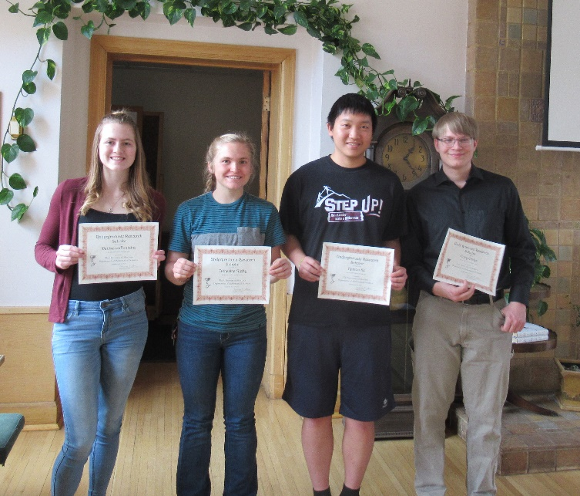
Our Undergraduate Research Scholars: Denise LaFontaine, Catherine Rigby, Kenton Ke and Cory Emlen. Missing: Andrew Ammons

Honor Roll of Donors
Duane Adams
Thomas & Kathryn Anderson
Joseph Apaloo
Linda Azure
Robert Bastasz
Anthony Beltramo
Anh-Thy Boyd
Ruth Brocklebank
Graham Carter
Ming-Chun Chang
Denny Culbertson
Loren Doyle & Linda Baugher
Matthew Edmonds
Carey Eyer
Lewis Frain
Frank Gilfeather
Francis Hannick
Eric Hartse
Geraldine Hashisaki
Mary Hashisaki
Patrick & Bobbi Heaney
Gloria Hewitt
Gregory & Sydney Hulla
Herbert Kasube
Richard Kitchen
Johnny & Carolyn Lott
Nicholas Miller
Todd Oberg
Robert O'Donnell
Oracle Corporation
Champak & Meena Panchal
David Patterson
Robert Lynn Turnquist Living Trust
Sharon Robertson
Gregory & Jan St. George
Schwab Fund for Charitable Giving
David Sherry & Jeanne Ambruster Sherry
Jack & Janice Thompson
R. Lynn Turnquist
Vanguard Charitable Endowment Program
Nikolaus Vonessen & Regina Souza
Richard & Carla Welter
James Williamson
Jefferey & Samantha Wright
Yong Zhao

Degree Recipients 2018-19

Bachelor Degrees
- Jared Dean Berkram
- Rachael Blackman
- Amelia Cantwell
- Victor Casadevall Gras
- Elizabeth P. DeReu
- Caleb M. U. Douglas
- Emily Engstrom
- Eric D. Fevold
- Megan Finley
- Nicholas C. Grasseschi
- Luke Hilmes
- Heather Nicole Kelly
- Matthew L. Kingston
- Dallas Alexander Lebel
- Dillon Travis May
- Joseph Newman-Hudelson
- Jakob Oetinger
- Jake Rooster Pennington
- Jennifer Brook Powers
- Jared T. Rutherford
- Evrard Sinarinzi
- Doranda Ann Standing Rock
- Kristie Nicole Weeks
- Glen Horace Woodworth
- Rilee Ann Zilkey

Master’s Degrees
- Anna R. Gasner
- Omid Khormali
- Sarah Leipheimer
- Ben Stark

Doctoral Degrees
- Ricela Feliciano-Semidei - Advisor: Ke Wu
Use of Computer Software to Do Mathematics and the Mathematics Achievement of Students in Puerto Rico Using Restricted 2015 NAEP Data
- Omid Khormali - Advisor: Cory Palmer
Extremal Problems for Forests in Graphs and Hypergraphs
- Esmaeil Parsa - Advisor: P. Mark Kayll
Aspects of Unique D-Colorability for Digraphs
- Denis Mikhailovich Shchepakin - Advisor: Leonid Kalachev
Applications of Asymptotic Methods: Analyzing Mathematical Models in Neuroscience and Describing Fast Dynamics of a Trajectory in the Vicinity of a Chaotic Attractor

First Annual Montana High School Mathematics Awards
By Emily Stone
On Thursday, April 11th, 2019, we welcomed our first group of Montana High School Mathematics Award recipients at a banquet dinner in the UC. Awardees were given a certificate, and a T-shirt and coffee mug with our famous “head” logo. After the dinner several faculty provided some light mathematical entertainment: I had made a pair of very stretchy clown pants that allowed me to demonstrate some “trouser topology”, Fred Peck made some very cool soap bubbles using ball-and-stick geometry frames, and Eric Chesebro delighted the audience by guiding two groups of four students through Conway’s Rational Tangle Dance.
We developed the Montana High School Mathematics Award to celebrate high school mathematicians in Western Montana, specifically targeting juniors, who could put the accolade on their college applications. We asked educators in all the high schools from Darby to Whitefish, Butte to Superior, to select students who demonstrated the following qualities:
- Mathematical curiosity: Mathematics comes from questions. We want to celebrate inquisitive students who ask interesting and insightful questions.
- Mathematical creativity: Creating new mathematics is a creative process. We want to celebrate students who think outside of the box.
- Mathematical persistence: Doing mathematics is often difficult. We want to celebrate students who persevere when “the going gets tough.”
- Mathematical understanding: The beauty of mathematics can be found in the connections between concepts. We want to celebrate students who understand mathematics as a connected web.
- Mathematical joy: Above all, mathematics should bring joy. We want to celebrate students who take delight in doing mathematics.
The teachers were the judges, whomever they selected were honored. Honorees could be students who had been traditionally high-achieving in math, but this was not the only—or even the primary—criterion. We were keen to celebrate students who had demonstrated the qualities listed above.
Everyone had a great time at this event and was pleased to have their achievements formally recognized. Thanks to the generous donations of our alumni, we hope to make this a long-standing tradition of community outreach in our region.
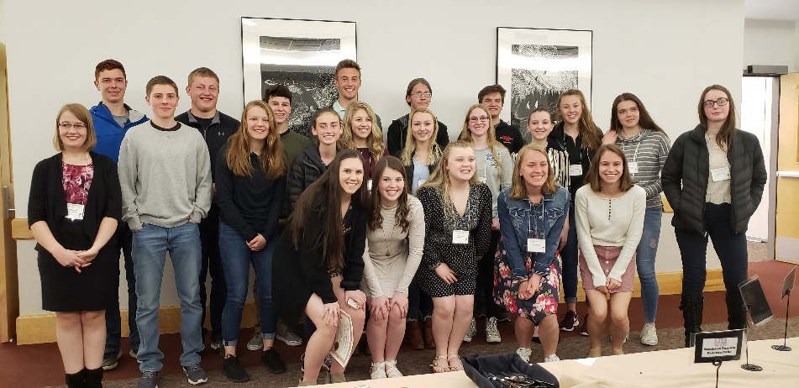
The proud recipients of the Montana High School Mathematics Awards, being photographed by their
even prouder parents and friends:
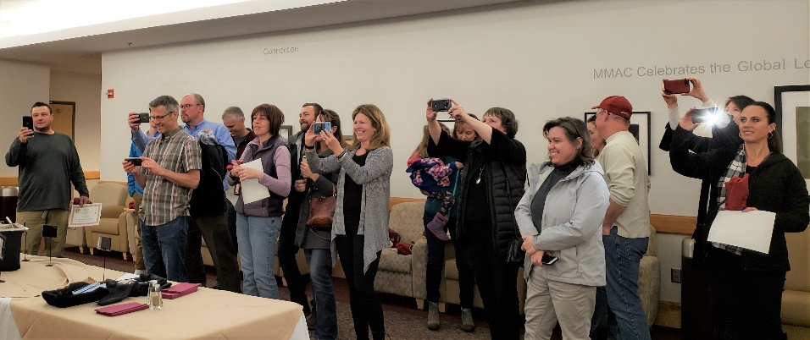

Backmatter

Address
Department of Mathematical Sciences
Mathematics Building (MMAI01)
32 Campus Drive
Missoula, MT 59812-0864
Phone: 406-243-5311
Email
Website

Comments or suggestions?
Please email the newsletter editor, Nikolaus Vonessen.

