Spring 2020 Newsletter of the Department of Mathematical Sciences of the University of Montana

Professor Matt Roscoe Receives Prize from the Museum of Mathematics
By Fred Peck
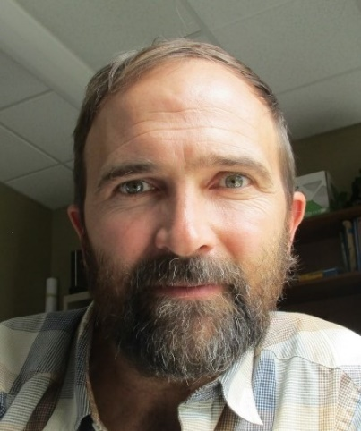
Matt Roscoe
Professor Matt Roscoe was awarded first runner-up in the 2019 Rosenthal Prize for Innovation and Inspiration in Math Teaching. The prestigious prize is awarded by the Museum of Mathematics in New York City, following an international competition. The prize celebrates innovative math lessons for elementary and middle school students. Prof. Roscoe accepted the award with his family at a ceremony at the Museum on January 7, 2020.
Prof. Roscoe’s lesson is titled, “Building the City of Numbers: An Exploration of Unique Prime Factorization.” Prime factorization is traditionally taught using symbols. Roscoe’s lesson turns prime factorization into a construction project. He explains: “Students collectively build the prime factorizations of each whole number 1-100 as a tower of blocks, each block representing a prime. These towers are then placed on a 10-by-10 grid numbered from 1 to 100.”
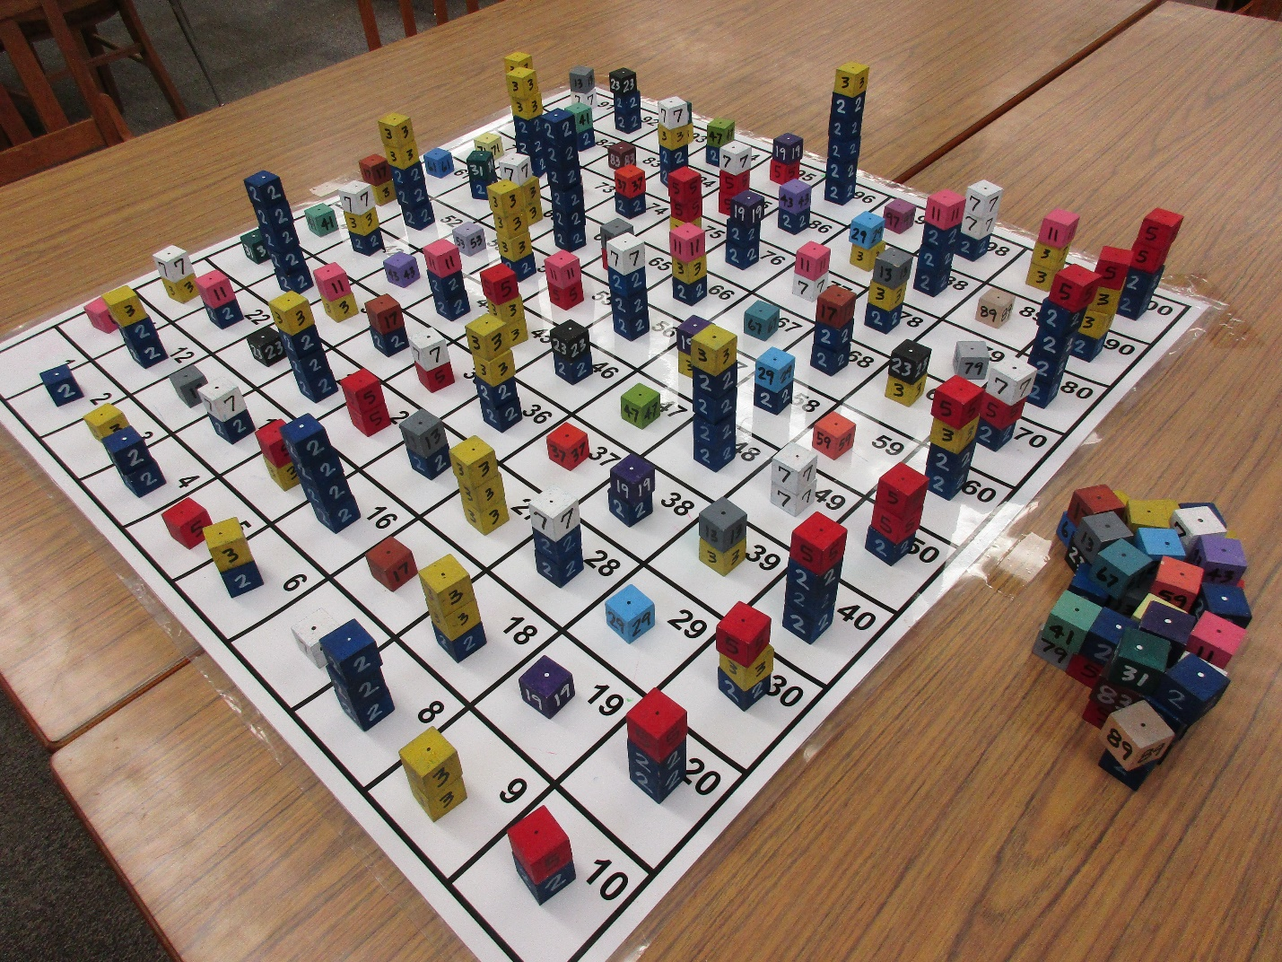
Matt Roscoe’s City of Numbers. (Building it requires lots of computations, not an easy task for many of the students. If one looks closely, one can see that a few of the towers are not built correctly. Can you find them?)
Roscoe describes the resulting “city of numbers” (pictured on page 3) as a “pedagogically inviting object.” The bright colors and physical design are simply begging to be explored, and students joyfully comply by finding patterns in the arrangement. For example, students have discovered and explored the following patterns:
- The 2’s and 5’s are arranged in columns.
- The tallest towers tend to have 2’s.
- 2’s, 3’s, 5’s and 7’s are only factors that ever appear more than once in a given number. 2’s and 3’s are the only factors to appear more than twice in a given number.
- The 3’s and the 11’s are arranged diagonally.
- The 7’s are arranged like a knight’s move in chess.
Each time a pattern is discovered, Roscoe asks, “I wonder why?” Here is where the real power of the lesson is revealed. As students explore and explain their patterns, they gain a deep appreciation for the multiplicative structure of the integers.
Sometimes, the students’ patterns surprise Prof. Roscoe. Recently, a student made this observation: “The 2’s go in waves.” The student explained that if one looks at consecutive even numbers, the factors of 2 follow a peculiar pattern. Every-other even number has only one 2 in it, and the others all have multiple 2’s. The “wave” pattern is: one 2, multiple 2’s, one 2, multiple 2’s.
“I wonder why.”
Professor Roscoe has taught the lesson to students and teachers across the state. Often, teachers explain that this is the first time they have truly understood prime factorization, beyond a symbol manipulation procedure. Teachers have been so taken with the lesson that they have produced their own sets to use.
Professor Roscoe is known throughout the department and the state of Montana for developing lessons like The City of Numbers, which use innovative material design to produce pedagogically inviting objects that reveal deep mathematical structure. For example, he designed a set of quilt squares that lead students to understand symmetry groups, and a set of triangles that enable what he terms, “a constructive approach to trigonometry.”
Professor Roscoe’s innovative methods have earned him multiple teaching awards, including the Helen and Winston Cox Educational Excellence Award and the William Stannard Award for the Teaching of Undergraduate Mathematics in Montana. The Cox Award is awarded by the College of Humanities and Sciences at UM, and is the College’s longest-standing award. The Stannard Award is given by the Department of Mathematical Sciences at Montana State University, to recognize exemplary contributions to the teaching of mathematics across the state.
Roscoe explains, “I hope that my contributions to the field will be characterized by moving mathematics instruction toward a future where students experience mathematics as a venue for the expression of creativity, exploration and discovery.”
For students at UM and across the state, that future is here today. The department is proud to have such an inspiring and innovative educator on the faculty. Congratulations Professor Roscoe!
For more information about the Rosenthal Prize and Prof. Roscoe’s “City of Numbers” lesson, see: the Rosenthal Prize website.

UM Math Faculty Authors: Steele and Bardsley
By Mark Kayll
Continuing a legacy stretching back to the era of long-time department Chair N.J. Lennes (1874-1951), the last few years witnessed the appearance of two new math books by UM faculty. In 2016, Springer published Algorithms for Data Science, by Brian Steele, John Chandler, and Swarna Reddy. The lead author is a professor in our department while the coauthors are both former UM students. 2018 saw the publication of Computational Uncertainty Quantification for Inverse Problems by Professor John Bardsley. This monograph appeared in the Computational Science and Engineering series of SIAM, the Society for Industrial & Applied Mathematics.
Both works fall in the broad realm of applied mathematics, and both touch on stochastic themes, i.e., on probabilistic ideas. Another common thread is the high prominence of algorithms in the authors’ approaches. In the earlier book, these are conveyed through the Python programming language and the statistical package R; Dr. Bardsley turns to the programming platform MATLAB as his computing environment of choice. Many of the actual computer codes in both books are easily available for their readers, either in-text or, in Prof. Bardsley’s case, as downloadable text-files on SIAM’s support website.
Perhaps a testament to the high value placed on quality math teaching at UM, both Steele and Bardsley had pedagogical motivations. In the first, we find the quote “The text is eminently suitable for self-study…”, while the second’s Preface asserts, “… I wrote the book to be learned from.”
With the first book now having been published for sufficient time, several reviews are available. But its highest honor to date is no doubt the seven-page treatment it garnered in the Bulletin of the American Mathematical Society [Vol. 56 (2019), 143-149, by Richard and Nicholas De Veaux]. Here is a brief snippet from their favorable review: “What the book does deliver is a broad set of hands-on tutorials on topical data sets that will give students needed practice in the process of data science. The breadth of the algorithms and examples, such as the real-time analysis of twitter feeds, the large-scale American health survey, and the look at PAC political spending, will be of interest to students of data science.”
Congratulations to Professors Bardsley and Steele (and coauthors, Drs. Chandler and Reddy) for their new and substantial contributions to the mathematical literature.
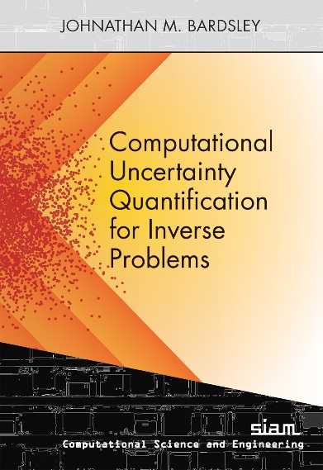

Vera Myers 1926-2020
We are sad to report that Vera Myers passed away on February 23. She was a long-time adjunct faculty member in the department. She earned a bachelor’s degree in mathematics from Bryn Mawr College and a Master’s from Ohio State University. In 1952, she and her husband, Bill Myers, moved to Missoula, where he had been hired as an assistant professor. Vera Myers taught in the department intermittently over many years as an adjunct faculty member, before she and her husband retired in the late eighties. You can read more about her impressive life in the obituary in the Missoulian, and in a profile of Bill Myers that appeared in the Fall 2000 Newsletter.

Chair’s Notes
By Emily Stone
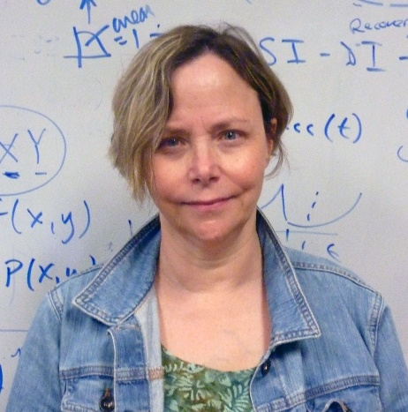
Greetings from Missoula! I hope everyone has survived the COVID shutdown okay, so far. We had a very interesting semester, what with switching to remote learning at Spring break. I am really proud of how our faculty and students rose to the occasion. We were able to make the transition during the week of Spring break, which I think sets a record compared to some higher ed institutions. After the first week of fumbling with cameras and problems with internet access in some of our more remote locations, we were off and running, more or less seamlessly. We did everything remotely, from classes, office hours, advising, testing and group meetings. We all got very used to joining Zoom meetings with a checkerboard of faces on our screens, seeing everyone’s living room, or what background they had chosen, and watch cats, dogs and kids wander in and out of the shot. I can’t thank everyone enough for making my job so easy during this difficult time. Students, faculty and staff were reliably cheerful and ready to make all kinds of adjustments, on the fly most of the time! Just goes to show how Montana folks really shine in adversity.
What about good things that happened? Well, we completed our 7 year “self study” this year, and received glowing reviews from our outside evaluator, Professor Phil Kutzko. In his report he says, “First and foremost, this Department is an absolute gem. It could serve as a model for what [a] math sciences department at a public university of its size should look like.” Our faculty won awards: Fred Peck won the College Cox award for teaching, Lauren Fern was honored as a Montana University System Teaching Scholar, and Matt Roscoe was 1st runner up for the 2019 Rosenthal Prize for Innovation and Inspiration in Math Teaching. Ke Wu and Fred Peck are submitting a new NSF-STEM proposal, which brings together UM, Salish Kootenai College, Montana Technological University (formerly Montana Tech), and Blackfeet Community College.
This last reminds me of our role as agents of change in the world. The Black Lives Matter movement has brought this to the forefront of our minds, but it has always been there as part of our mission in higher education. Success in school, and success in math, in particular, is a strong predictor of success in life in general. Bringing that success to a wider and wider audience, is a critical step to bringing equity to marginalized groups in our society. Education is the key to freedom, a freedom where the worth and dignity of every human life is respected and celebrated.
Best wishes for a safe and productive summer!
Emily F. Stone

Honor Roll of Donors
Duane & Kathleen Adams
Joseph Apaloo
Gordon Bahen
Robert Bastasz
Rodney & Mary Jean Brod
Ming-Chun Chang
Arthur & Shirley Clarkson
James & Kay Coghlan
Susan Cole
Scott Jones & Elizabeth Cummings
Loren Doyle & Linda Baugher
James Elander
Lewis Frain
Frank Gilfeather
Bill & Jeannette Gregg
Mary Hashisaki
William Heider
Gloria Hewitt
Lawrence & Charlotte Kaber
Herbert Kasube
Nicholas Miller
Frank Nelson
Mark & Kathleen Netland
Todd Oberg
Robert O’Donnell
Oracle Corporation
Champak & Meena Panchal
David Patterson
Carolyn Riggs
Robert Lynn Turnquist Living Trust
Gregory & Jan St. George
Jamie Small
Ekaterina Smirnova
Schwab Fund for Charitable Giving
R. Lynn Turnquist
UBS Donor Advised Fund
Vanguard Funds
Nikolaus Vonessen & Regina Souza
Michelle Wieler
Marshall Wylder
Rebekah Yates
Yong Zhao

Spring 2020 Scholarship and Award Winners
- Joseph Hashisaki Memorial Scholarship
Kenton Ke
- The Adams Scholarships
Junior: Burkleigh Yost Senior: Kenton Ke
- Anderson Mathematics Scholarship
Cory Emlen
- Mac Johnson Family Scholarships
Esther Lyon Delsordo Michael McKelligott Jethro Thorne
- Merle Manis Award
George Glidden-Handgis
- Undergraduate Research Scholars
Natalie Cole Cory Emlen George Glidden-Handgis Kenton Ke Martín Romero Andi Wainwright Burleigh Yost
- Undergraduate Tutorial Scholar
Martín Romero
- N.J. Lennes Competition
Alex Shepherd (1st) Haley Wilson (2nd)

Donation Request Box
The Department of Mathematical Sciences increasingly relies on donations to support its activities. In particular, scholarships are very important for our students. Please consider a gift to the Math Department’s Excellence Fund, to be used where the need is greatest, or to one of the other funds and endowments:
- Endowed Scholarship Funds: The Adams Scholarships, Anderson Mathematics Scholarship, Gloria C. Hewitt Graduate Scholarship in Mathematical Sciences, Joseph Hashisaki Memorial Scholarship, Mac Johnson Family Scholarships, Merle Manis Award, William Myers Mathematics Scholarship
- George and Dorothy Bryan Endowment: Supports undergraduate and graduate students
- Lennes Fund: Provides funds for the Lennes Exam Competition
- Colloquium Fund: Provides funds to bring in visiting speakers
To donate online, please visit the math department home page.
For information on other ways to give, please contact Suann Lloyd: email or by phone at 406-243-2646 (or call toll free 1-800-443-2593).

Degree Recipients

Bachelor Degrees
- Cassidy Alexander
- Andrew Bedunah
- Kit Fieldhouse
- Ian Gonzales
- Mielle Hubbard
- Ian Jedd
- Denise LaFontaine
- Juyeon Lyu
- Matthew Malloy
- Kyra Mycroft
- Songyue Qiu
- David Rich
- Catherine Rigby
- Witley Sampson
- Makayla Sanders

MA in Mathematics
- Daniel Gent
- Dakota Gray
- Caleb Huber
- Ian Kit Nicolas

MA in Teaching School Mathematics
- Shunteal Jessop
- Cara Lokken-Frandsen

MS in Data Science
- Megan Finley
- Tony Mayer
- Van Tran

Doctoral Degrees
- Rick Brown - Advisor: John Bardsley
Semivariogram Methods for Modeling Whittle-Matérn Priors in Bayesian Inverse Problems
- Quy Cao - Advisor: Katia Smirnova
Methods for Analyzing High Dimensional Data with Applications to the
Wearable and Microbiome Data Analysiss
- Jacob Downs - Advisor: Jesse Johnson
The Application of Contemporary Numerical Methods to the Modeling, Analysis, and Uncertainty Quantification of Glacier Dynamics
- Kevin Palencia-Infante - Advisor: Jen Brooks
A Natural Rank Problem for Homogeneous Polynomials and Connections with the Theory of Functions of Several Complex Variables

Lauren Fern Honored as a Montana University System Teaching Scholar
By Nikolaus Vonessen
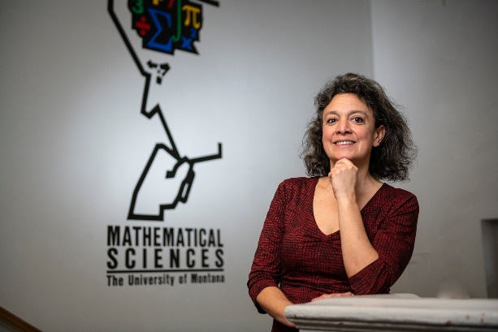
Lauren Fern in the main entrance staircase of the Math Building, posing with our “Math Thinker”
Math Department Lecturer Lauren Fern, who also works for UM’s Office for Student Success as the Student Success Coordinator for Mathematics, earned a high honor from Montana’s Office of the Commissioner of Higher Education: She was named a Montana University System (MUS) Teaching Scholar! She belongs to the inaugural class of this new program, one of only twelve faculty from across the entire MUS (and one of only three from UM).
This new program recognizes faculty members who have made exemplary contributions to teaching and learning at an MUS campus. While it involves a small award for outstanding past performance, it is really meant to encourage recipients to share their pedagogical knowledge and expertise with other faculty members. When the awards were announced in late November, each MUS Teaching Scholar was asked to organize during the Spring 2020 semester a Faculty Learning Community to develop high-impact teaching practices to increase student success.
Lauren gathered a group of interested faculty teaching introductory math classes, from our department, Missoula College, and Bitterroot College. They met throughout the semester, first in person and then via Zoom. One of the questions they discussed was how to design “low threshold high ceiling activities” that are on one hand accessible to students with a weak background and help them develop their skills, but that are also meaningful and challenging for better-prepared students, helping everyone in the class to get ahead.
Congratulations, Lauren! And thanks for doing this important work!

Backmatter

Address
Department of Mathematical Sciences
Mathematics Building (MMAI01)
32 Campus Drive
Missoula, MT 59812-0864
Phone: 406-243-5311
Email
Website

Comments or suggestions?
Please email the newsletter editor, Nikolaus Vonessen.

