Spring 2021 Newsletter of the Department of Mathematical Sciences of the University of Montana
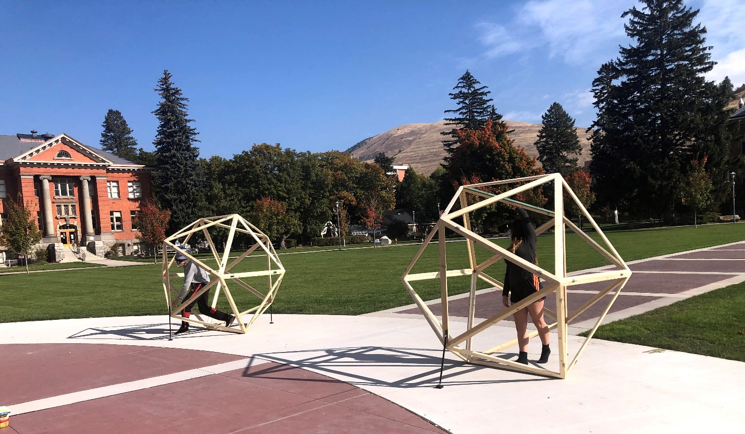

Icosahedrons on the Oval?!
If you visited UM last fall, you might have encountered large, human-sized icosahedrons on the Oval. Matt Roscoe investigated, and found their creator, math and theatre double-major Ryan Longdon. Here is Matt's report:
Ryan Longdon remembers that it was in second grade that he fell in love with mathematics. He was lucky to have a teacher that “made it a lot of fun”. He grew to enjoy mathematics. So much so, that he asked for more homework. His teacher enthusiastically complied. From that point onward, he says, mathematics has always been something he was good at, something, as he puts it, “That I have had a lot of fun with.”
Ryan took advantage of Advanced Placement (AP) Courses at Helena High School, where he passed both the Calculus AB and BC exams. While at it, he also became involved in theater and discovered a new love: the stage. When it came time to pick a college, Ryan chose Montana State and enrolled in civil engineering. However, after a couple of semesters, he felt unsure and unfulfilled with his choices. He had a friend from high school who was studying theater at UM and convinced him to transfer. He says, “It was the best decision I ever made.”
Ryan is now a senior with a double major in Math and Theater. As a theater major he is heavily involved in the production of plays here at UM. He has served as prop director, assistant technical director, technical director and assistant scenic director for a number of shows. He especially enjoys applying his mathematical knowhow to the design and construction of sets. Not surprisingly, his favorite math class in our department has been M439 Euclidean and Non-Euclidean Geometry.
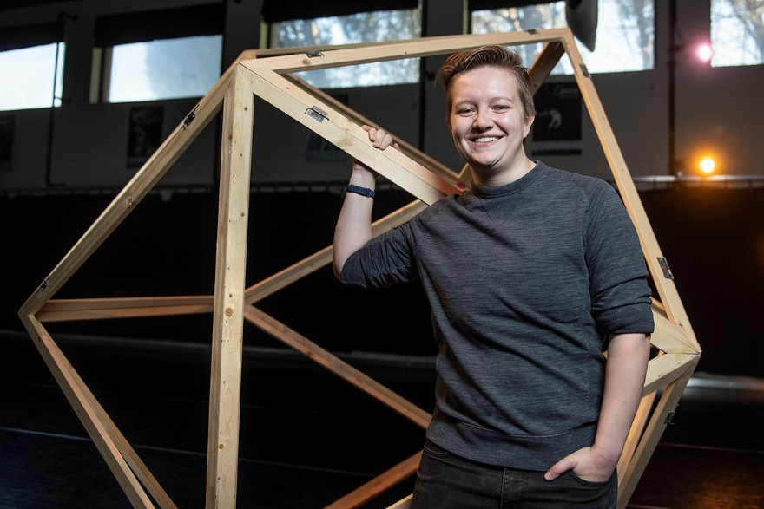
Ryan Longdon with one of his icosahedrons
In the spring of 2020, UM planned to produce a show entitled, “She Kills Monsters”. The show heavily references the popular board game “Dungeons and Dragons”. Being very familiar with the game, Ryan lobbied the scenic designer to include large scale models of the Platonic solids in the set – a nod to the five dice that are used in playing the game. Unfortunately, the show was never produced in front of a live audience due to the pandemic. But, through a strange coincidence, shortly thereafter a request was made to the theater shop for a set of “human sized icosahedrons” for use in Visiting Assistant Professor Brooklyn Draper’s dance courses in UM’s Drama and Dance Department. Recognizing the project as the perfect intersection of his two great loves, Ryan happily took charge.
In designing the objects, Ryan decided to make the 20-sided figure out of 20 identically constructed equilateral triangles. The approach would essentially double every edge in the icosahedron, meaning that 60 identical pieces of wood would be used to construct the figure. There were three cuts required for each piece. Wood was first “ripped” length-wise to insure that each doubled edge would fit together. Here, the important number was 138 degrees, the angle in which adjacent planes meet on the icosahedron. To achieve the angle, the defect, 42 degrees, was divided by two and each board was ripped at 21 degrees. This left the long edge of each board beveled to 69 degrees. When two of these boards were put together along an edge, the angle achieved was the desired 69+69=138. Once every board was ripped, he chose a constant length and cut each end at 30 degrees so that any two ends meeting end-to-end would create a 60-degree angle, insuring that each triangle created would be equilateral.
His first “proof of concept” was a ½ scale model, which, he reports, “Fit together on the first try.” Once he knew his approach would work, he scaled up the model to “human sized”…about 7 feet tall. He also had to consider the fact that the models needed to be easily transported, assembled, disassembled and stored. This led him to rigidly build each icosahedron as a set of three pentagonal pyramids (15 faces) that mate together with a flower-like arrangement of 4 equilateral triangles (4 faces) and a single “lonely” equilateral triangle (1 face) – see the picture of the scale model for a more visual explanation. The three models that he completed are color coded so that sets are easily identified, and, they use loose-pin hinges for attachment.
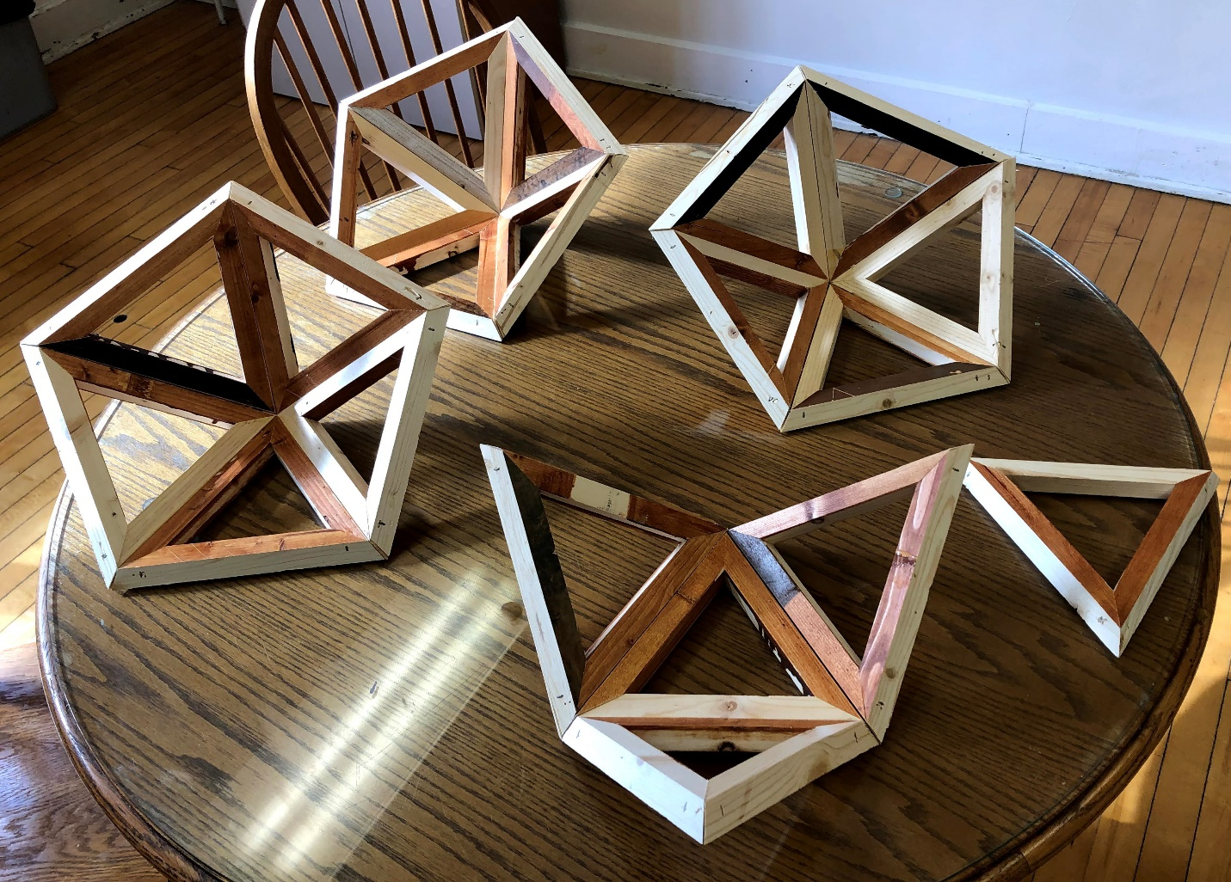
A disassembled ¼ scale model of the icosahedron
Brooklyn Draper reports that she uses the icosahedrons in her dance classes to teach her students about Laban’s space harmony theories. Students dance inside the structure to learn about body connectivity, spatial awareness, and creativity. For example, students learn about the vertical, sagittal, and horizontal planes, which provide dancers with clarity about their own movement through space. These planes are found in the icosahedron as three sets of 4 vertices that define 3 orthogonal planes.
Ryan is graduating this May and plans to continue to follow his heart using his head. That is, he plans on continuing to use his skills in mathematics to support theater through set design and construction. He is hopeful to gain employment in this field based on his unique set of talents. He happily looks forward to graduation to see, “where the wind will blow me”. We look forward to hearing all about it, Ryan, and we wish you luck in your application of mathematics to the world of theater.

Professor William Derrick 1938 – 2020
By Leonid Kalachev
Professor Emeritus William Derrick was born on May 18, 1938, in Oklahoma City, Oklahoma. He passed away on Oct. 8, 2020, in Missoula. Since Bill’s father worked for the State Department, Bill mostly grew up in Mexico and Ecuador, where his father was assigned. After finishing High School in Ecuador, Bill entered Oklahoma State University from which he graduated with a major in Mathematics. In 1958 he started teaching Mathematics at Fort Lee, Virginia, after being commissioned in the US Army in the Quartermaster Corps and then spent several years working at IBM in Endicott, New York. Bill received his Ph.D. in Mathematics from Indiana University in Bloomington in 1966. He held positions in the Math Departments at the University of Utah and at Arizona State University before becoming an Associate Professor at the University of Montana’s Mathematical Sciences Department in 1972. Bill was promoted to the rank of Full Professor in 1975; he served as Department chair twice, from 1979 to 1981 and then, again, from 1987 to 1990.
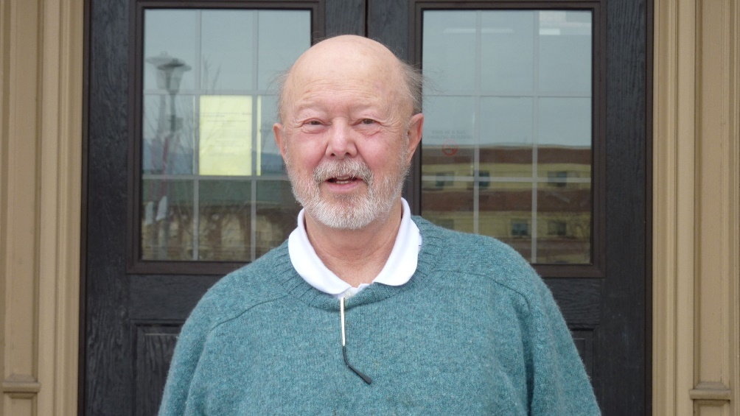
Bill Derrick in February 2012, in front of the Mathematics Building
Throughout Bill’s career his research interests lay in the areas of Complex Analysis, Differential Equations, Applied Mathematics and Mathematical Modeling. He was the thesis adviser of six doctoral students who successfully finished under his direction; he wrote a large number of impactful research papers and took part in international research collaborations and the popularization of science. Bill was actively involved in undergraduate and graduate teaching, and in the development of new courses; he was an author / co-author of 10 mathematics textbooks (including such titles as Complex Analysis and Applications, College Algebra and Trigonometry, Advanced Engineering Mathematics, and many others). At various stages of his career Bill was a Fulbright Fellow and an NSF Faculty Science Fellow. He also conducted research at Lawrence Livermore National Laboratory in California. Bill won the University of Montana Distinguished Scholar Award and the Teacher of the Year Award.
I first got acquainted with the work of Bill Derrick through the textbooks which he co-authored, long before I met him personally during my first interview for a position at the University of Montana in San Antonio in winter of 1993. For the course that I was assigned to teach at the University of Washington, out of many textbooks on Ordinary Differential Equations, I chose the one written by Bill Derrick and Stan Grossman because of its clarity and multitude of applied examples. During our meeting at San Antonio, and later, during my interview for a position in Missoula, Bill expressed keen interest in my research, and we found a large number of topics for potential future collaboration. Over the years we had a great time working together, and with our numerous colleagues from the US and other countries, on the problems related to nonlinear partial differential equations (watershed solutions and domains of attractions of stationary solutions of parabolic equations, moving fronts, maxima of solutions of nonlinear elliptic equations in bounded domains), on bifurcations of nonlinear ordinary differential equation systems and their oscillatory solutions in chemical kinetics applications, and others. For many years Bill served as an informal leader of our Applied Mathematics group within the department. I very much enjoyed his short courses on fixed point theory and on applied problems in Mathematical Biology which he taught as a part of an Applied Math seminar series. A number of times Bill and I visited Toyo University in Tokyo, Japan, where we took part in the Bio-Nano Symposium, and where we presented papers and participated in panel discussions. I saw firsthand how Bill was highly regarded and respected by the international scientific community.
At the end of this short note, I would like to say that Bill Derick was a great scientist who made an impact on several important areas of mathematics, a great educator who influenced numerous students at the University of Montana and in many universities all over the US and abroad, and a great man who will be missed by his family, friends, and colleagues.

Notes from the Chair
By Emily Stone
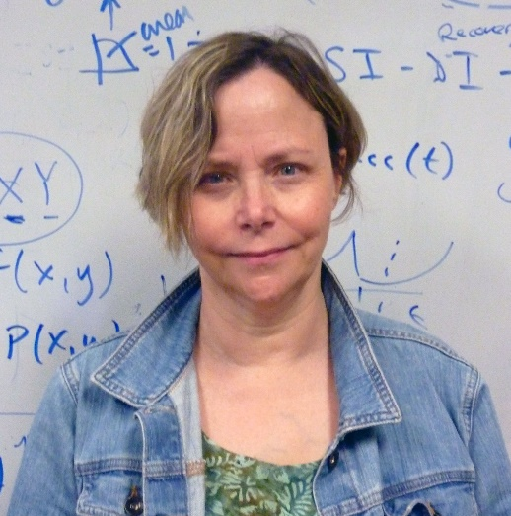
Greetings from Missoula!
I write to you on a Spring day when the trees are shimmering with the first light green glow, birds are everywhere carrying on in an insane manner, and it was reported that a hiker on the M trail scared off a bear heading toward him by yelling and waving his arms. Spring in Missoula! This is my last note to you as chair, as I am stepping down from the post at the end of June. It has been 6 years for me, and I have enjoyed my work with the Best Little Math Dept. in the West. Johnathan Bardsley will be taking over July 1, please see the article about him on p. 3 for an introduction. I am confident that with his guidance the department will continue to master new challenges and grow. I will be continuing my work with our University of Montana High School Math Awards and Data Science program. And now for more dept. news!
Last summer we initiated our data science industrial collaboration course, with the help of Capsource, a sourcing and design company for experiential learning. There were 5 students, both Data Science and Computer Science masters students, working with faculty mentor Javier Pérez Álvaro. They analyzed website hits for the marketing team of Crayon, an international software development company. More information can be found at the project’s website. The University then fell in line to expand experiential learning by adopting a UM capsource platform. Here we can post future courses, and interested parties from the private sector can propose a project for collaboration. If you are in a position to engage with the University community in this way, please have a look at this page; I would be happy to discuss it with you anytime!
This is all part of our plan to build career readiness into our major. Gone are the days when the only obvious career choices for math majors were teaching, being an actuary, or moving into computer science. Companies have sought us out to recruit our students (Fast Enterprises, ATG and Submittable), and we are working on developing collaborative programs with them to train future employees in industry specific software (e.g. Microsoft Power BI, Salesforce). We are also seeking alumni who would like to meet with our seniors to discuss career opportunities from their own areas. Contact me at stone@mso.umt.edu for more information.
This past year, in addition to supervising masters and PhD students, we have had an active group of faculty working with undergraduates, some of whom are supported by our undergraduate research awards. Eric Chesebro recently received a grant to continue this important work; you can read about his undergraduate research group on p. 6. This year also saw the promotion of Kelly McKinnie and Eric Chesebro to Full Professor and the promotion and tenure of Fred Peck (now Associate Professor). Greg St. George retired, and we thank him for all his contributions to the Dept. over his long career. See page 4 for an article about Greg. We sadly lost Bill Derrick, an emeritus faculty member.
Lastly, I would like to thank Nikolaus Vonessen for tirelessly creating this newsletter year after year, and our office manager Linda Azure for her devotion to the Math Dept., its students, emeriti and alums. Her interest in the history of the department has kept it alive for the rest of us, and has been greatly appreciated.
Best wishes to all of you from all of us!
Emily F. Stone

Introducing our Next Chair: Professor John Bardsley
By Nikolaus Vonessen
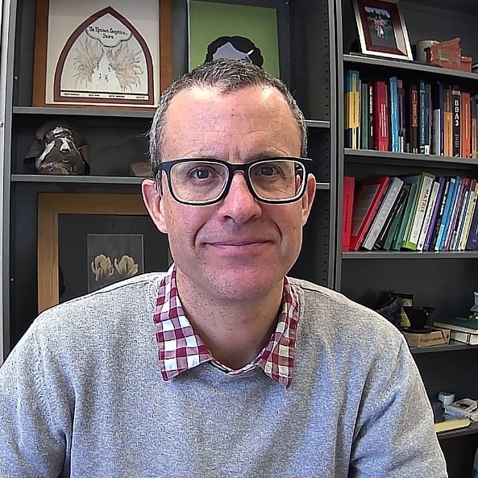
John Bardsley
For the past six years, Professor Emily Stone has successfully led the Department of Mathematical Sciences through difficult and unusual times. This summer, after serving for two terms as chair, she’ll hand over the leadership role in the department to Professor John Bardsley. We are grateful to both of them: Emily for her hard work on our behalf, and John for taking on this demanding task!
John is a native Montanan. He grew up in Butte, and attended Montana Tech, where he majored in mathematics. He earned master’s degrees in mathematics both from Montana State and Oregon State University, before completing his Ph.D. at MSU in 2002. He joined our faculty the next year, and has been a tenured full professor since 2013.
John is a very accomplished researcher in applied mathematics: He has published over fifty articles in refereed journals, as well as an advanced textbook that was published by SIAM, the Society for Industrial and Applied Mathematics. He has supervised and co-supervised six Ph.D. students, earned numerous grants, and organized many conferences and workshops. In 2017, he was honored with the Chancellor’s Medallion from Montana Tech, for excellence in his educational and professional career, and for significant contributions to his academic discipline.
Best wishes, John, for your new job as department chair!

Rural Montana Sheds Light on Productive Problem Solving
By Sara Killeen
Sara graduated this month with an MA in Mathematics. Here she reports on her research in mathematics education, which she completed under the supervision of Professor Fred Peck.
During my time as a graduate student in the department, I have worked on an NSF-funded research project called Montana Models. The project is a collaboration between MSU, UM, and Montana 4H in which we worked with teams of youth from rural towns to address issues in their communities, using a combination of local and mathematical practices.
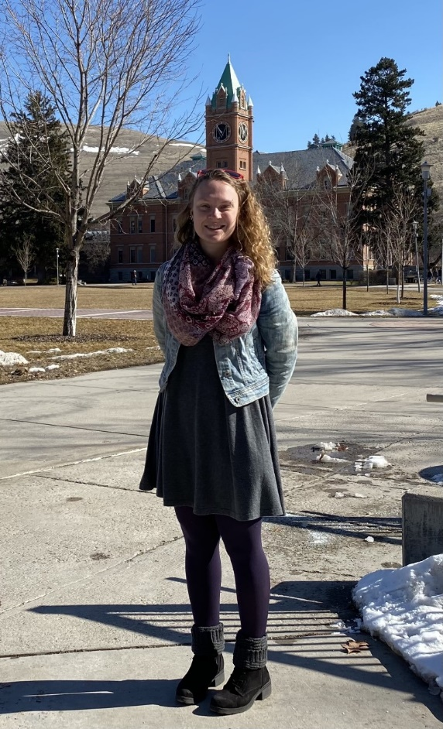
Sara Killeen on the Oval
The first phase of the project involved an ethnographic approach. We used interviews and observations of community events as a way to learn as much as we could about the communities and the natural problem solving habits they engage in while working on problems in their day to day lives. During this phase I got the pleasure of meeting adolescents and adults involved in 4H and was able to observe events like pig-tagging and a flea market fundraising booth, as well as participating in events like setting up for the county fair.
A key focus of this research was to understand how community members approached and solved problems. Through the research, we identified 5 “community problem solving practices.” For example, we noticed that community members were inclined to get right into a problem, and make adjustments to the strategy if/when they reached a barrier. We called this practice “try something and adjust.”
The next phase was to run a summer camp at MSU. In the summer camp, the youth participated in several different mathematical modeling tasks, were exposed to campus life and had the opportunity to work on their community projects. We focused on bringing together mathematical and the community problem solving practices in our work with 4H groups, such that they came to see both as powerful tools that can aid them in accomplishing their goals.
I specifically spent time with a group who wanted to help improve a highly trafficked, dysfunctional intersection in their town. During camp they were exposed to agent based modeling. They used what they learned to attempt to model different solutions to their problem. Each time they learned something new, they would incorporate it into their model—an example of how they used “try something and adjust” in conjunction with mathematical modeling. I was also able to work with this group to begin to develop a survey that could be used to gather information from their community about their knowledge and opinion of the intersection.
From the data we collected both from the communities and from camp we began to create different mathematical modeling modules. Our goal here was to incorporate the community problem solving practices into activities that could be used in schools as a way to help mathematics be more approachable and relevant.
I worked to create a survey module that will help youth design, administer and analyze the results of a survey in a variety of different settings (classrooms, youth groups, etc.). Through this module they will learn about things like survey and question bias and how to interpret data naturally rather than through a lecture based form. This module was also designed to allow adolescents to engage in the community problem solving practices that we identified.
My hopes going forward are that the work we’ve done can help youth more easily involve themselves in mathematical thinking and develop a stronger personal mathematical identity.

Greg St. George Retires
By Seth Braver
In January 1978, having recently completed his bachelor’s degree in math at Rutgers University, Greg St. George took a cross-country bus trip to California to join his brother, who had been traveling the U.S. in a bread truck fitted out as a camper, complete with a wood-burning ice fishing stove. After working for a while in Fresno picking oranges, the brothers rented an apartment just outside of San Francisco’s Tenderloin district and began to pursue less acidic employment. Greg soon had two offers, one from an insurance company as a computer programmer (this was largely before the dawn of microcomputers) and another at Rocket Messenger, the fastest and hairiest of San Francisco’s many bike messenger firms. Characteristically, Greg chose the latter job. After half a year of riding bicycles 11 hour a day, he decided to return to New Jersey – via bicycle.
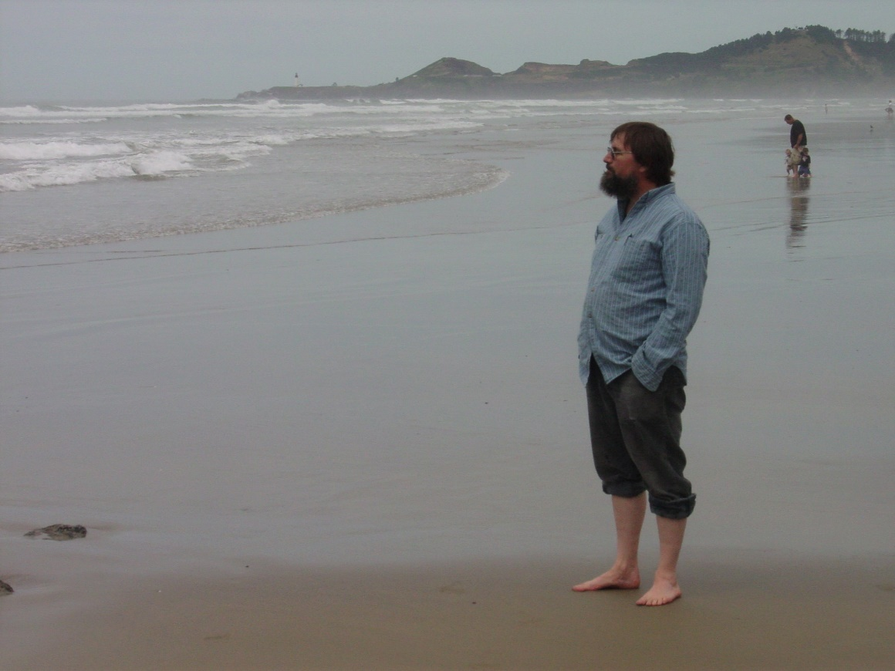
Greg St. George at the Oregon Coast
Greg followed the coastal highway north to Astoria, Oregon, one endpoint of the TransAmerica Bicycle Trail. The cross-country trail eventually took him through Missoula, where he stopped long enough to drop by UM’s Math Department. It was summer, but Dr. Rudy Gideon happened to be in his office. They talked and Rudy wrote down Greg’s name. After departing Missoula, Greg eventually veered off the bike trail to visit the Black Hills, where he ended his trek; it was getting too cold and he had run out of mountains.
When a graduate student quit UM’s math program later that year, Don Loftsgaarden, the department chair, called Greg in New Jersey. He didn't come then, but he did apply, which ultimately led to Greg’s enrollment in UM’s graduate program in Fall 1979. After earning his Master’s degree (in group theory), Greg took a job teaching at Ithaca College, but soon found he’d need a PhD to be treated seriously. Accordingly, he returned to UM, where he earned a PhD in functional analysis under what he describes as Keith Yale’s “magnificent guidance”. While pursuing his doctorate, he also became increasingly occupied with computer programming and poetry, taking seminars in machine learning from Alden Wright and poetry from William Pitt Root.
Not long after, UM’s math department conducted a national search for a faculty member willing to specialize in undergraduate education. Greg applied for this position and was duly selected. Thus, 15 years after first setting (bike-weary) foot in UM’s math department, Greg had become the department’s newest professor. In the nearly three decades that followed, he spent many years coordinating and teaching the department’s Precalculus and Applied Calculus courses, even writing his own innovative Applied Calculus textbook that attempted to restore some luster to the neglected topic of difference equations.
Greg named three highlights of his career at UM, all of which were extended collaborations with others. One was a two-year project with two undergraduates, Kit Fieldhouse and Soren Ormseth, on what turned out to be the number theory of 3x3 matrices of determinant one over the non-negative integers. Another was serving as a co-PhD advisor (along with Karel Stroethoff) to a peculiar grad student whose name I have somehow misplaced. At any rate, this student’s dissertation became the basis for a book, Lobachevski Illuminated, published by the American Mathematical Society. Finally, Greg mentions his collaboration with Jim Sears of UM’s geology department, for whom he wrote a long computer program that computed parametric and non-parametric statistics on the sphere so as to investigate an idea relating the locations of volcanic hotspots to truncated icosahedra.
Greg lives in the Bitterroot with his wife Jan. His son, Aaron, also a UM alumnus, lives in Missoula and programs for Workiva. Greg currently enjoys using multiple programs and a mashup of Linear Algebra, Statistics, and Applied Math to attempt to extract money from the stock market. He paints, writes and records music and is enjoying retirement with Jan. He doesn't miss the commute, but does miss the daily interaction with students and faculty, the sheer joy of teaching and helping students learn, which he continues to think is the best job in the world.
Seth Braver is a professor at South Puget Sound Community College; he earned his Ph.D. in Mathematics at UM in 2007, under the supervision of Professors Greg St. George and Karel Stroethoff. You can learn more about him and his books at his website, Braver New Math. (Take a look – it’s interesting!)

Fred Peck Wins Cox Award
By Matt Roscoe
In the spring of 2020, Fred Peck was recognized as the recipient of the Helen and Winston Cox Award for Educational Excellence. Each year, this award recognizes a single tenure-line, junior faculty member at the University of Montana who demonstrates superior teaching and mentoring. Nominees must also demonstrate accomplishment in scholarly and professional activities and engagement in campus and community service.
Fred’s nomination letters speak highly of his firm commitment to excellence in education. When Jodi Marmaro first walked into his classroom as an elementary education major with a strong mathematics background, she assumed that his course could not possibly challenge her. In her own words, “How very wrong I was.” She characterized Fred’s influence as “life altering”. Indeed it was. Jodi made the change from elementary education to secondary mathematics largely because Fred’s class transformed her view of mathematics from one of “procedure to a deeper, richer understanding rife with creativity”. Jodi, now a practicing teacher, strives to live up to Fred’s example by inspiring her students to “see the wonder that is mathematics”.
Sarah Piper characterized Fred’s teaching as “transformative”. She took his graduate course while teaching AP Statistics in a high school setting. Recognizing her strong content knowledge in the area, Fred provided extra readings and activities that, she says, “truly changed how I approached the teaching of statistics, as well as making me a stronger statistician.” She also noted Fred’s enthusiasm for learning which he shares through a variety of non-traditional venues. One such venue is Fred’s monthly “Mathy Hours”, where interested teachers gather at an area brewpub to engage in recreational mathematics. These gatherings, Sarah notes, give teachers the opportunity to build professional comradery while expanding mathematical knowledge and they “remind us that we truly love mathematics.”
Fred Peck
Department members Ke Wu and Emily Stone drew attention to Fred’s other contributions that support mathematics education. He is the statewide coordinator for the Montana Math Teachers’ Circle, an effort that has engaged over 300 Montana teachers of mathematics. He regularly promotes our institution in outreach efforts at Montana tribal colleges. He is an active advocate for inclusion and diversity. He publishes regularly in flagship journals. He also is successful in procuring external funding, some $1.2 million in grant-funded projects during the six years he has been with the department. However, it is Fred’s teaching that stands out. His classes simply “look different”. Small groups of students stand at vertical whiteboards reasoning through one of the well-sequenced problems that he has chosen for the day. At key moments, Fred pauses student investigation and draws attention to the ideas that have proved fruitful for one group or another. Students are clearly in charge of their mathematical learning in his courses. They are empowered and taught to reason and think on their own. Not surprisingly, Fred earns universally high reviews from his students in teaching evaluations.
Fred sees his efforts in the classroom as part of a larger picture of change in the landscape of teaching mathematics. New research has led the field away from traditional instruction, characterized by passive processes like note taking, and drill-and-practice, towards more active learning, characterized by argumentation, problem solving, and reasoning. It is clear that he sees himself as an agent of change in this setting. His efforts, writ large, are designed to foster student agency and identity as mathematical problem solvers, which is often achieved through collaborative action and communication. To quote one student, his classes are, “Like no other math class I have ever taken.” We could not agree more, Fred, congratulations on this well-earned recognition!

UM Undergraduates Study the Geometry of Hyperbolic Knots and Links
By Eric Chesebro
In spite of the sacrifices we’ve all had to make this last year, my hardworking group of undergraduate researchers have managed to closely collaborate and make concrete contributions towards understanding relationships amongst the geometries of an important class of hyperbolic knots and links. They are almost finished with a web application which will allow users to investigate the patterns and beautiful images which arise when studying these relationships.
Every rational number determines a loop or pair of loops in 3-dimensional space. These loops are the 2-bridge links and are obtained by drawing the slope p/q arcs emanating from the corners of a square pillowcase and connecting the left corners of the pillow with one arc and the right corners with another.
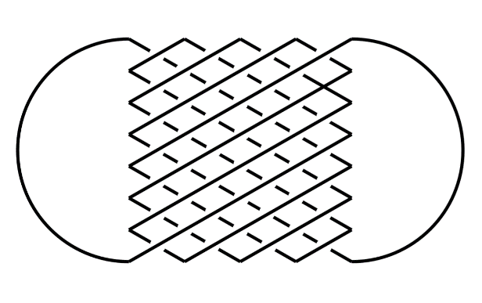
The 2-bridge link for 4/7
This rich class of links have been long studied by mathematicians especially after Horst Schubert, in 1956, described a connection between 2-bridge links, continued fractions, and a classical diagram of the rational numbers called the Farey graph.
It follows from the celebrated work of William Thurston done in the 1970’s that nearly all of the complements of 2-bridge knots and links admit geometries that are modeled on 3-dimensional hyperbolic space. This set of links continues to provide an important class of examples and an invaluable testing ground for the general theory of 3-dimensional hyperbolic spaces.
Thurston’s approach to these spaces includes aspects which are quite accessible to computer calculations. In fact, his 1985 PhD student Jeffery Weeks was especially interested in this and built the computer program Snappea to efficiently compute the hyperbolic geometries of knot and link complements. This continues to be a critical program – now called Snappy – and is used by nearly everyone in the field. Notably, Jim Hoste, Morwen Thistlewaite, and Weeks used Snappea to tabulate all 1,701,935 knots through 16 crossings in 1988.
Following the computational traditions in the field, our goal is to leverage new computer calculations to better understand and describe the patterns and differences between the different geometries of all hyperbolic 2-bridge knots and links.
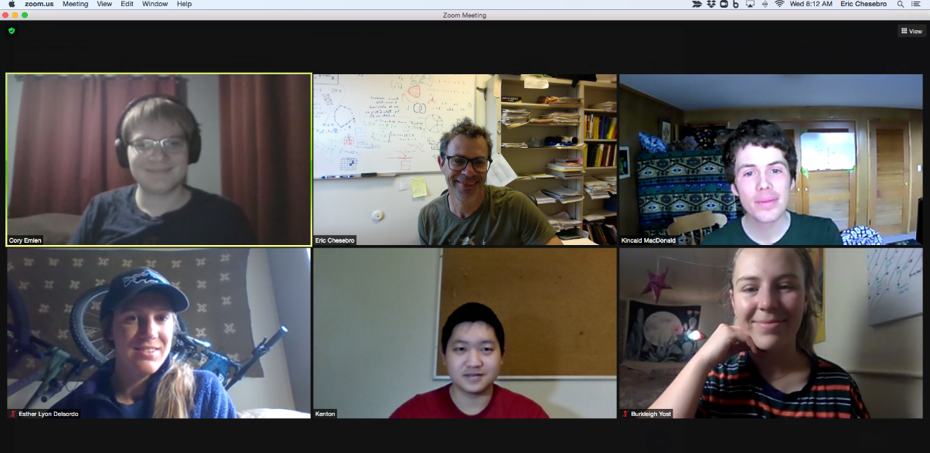
Pictured in this Zoom screen shot are Cory Emlen, Eric Chesebro, Kincaid Macdonald, Esther Lyon-Delsordo, Kenton Ke, and Burkleigh Yost. Missing: George Glidden-Handgis, who is also involved in this work. Four of the six students were supported by two-semester Undergraduate Research Scholar Awards (with most of the funding coming from the George and Dorothy Bryan Endowment.
In recent work, our group has drawn new connections between the Farey graph and solutions to the ‘gluing equations’ for hyperbolic 2-bridge links. These connections allow us to efficiently use the computer to compute a collection of one variable polynomials whose complex roots determine the geometric structures for the corresponding links. When these roots are plotted together in the complex plane as in the figure to the right, the results are both beautiful and mysterious.
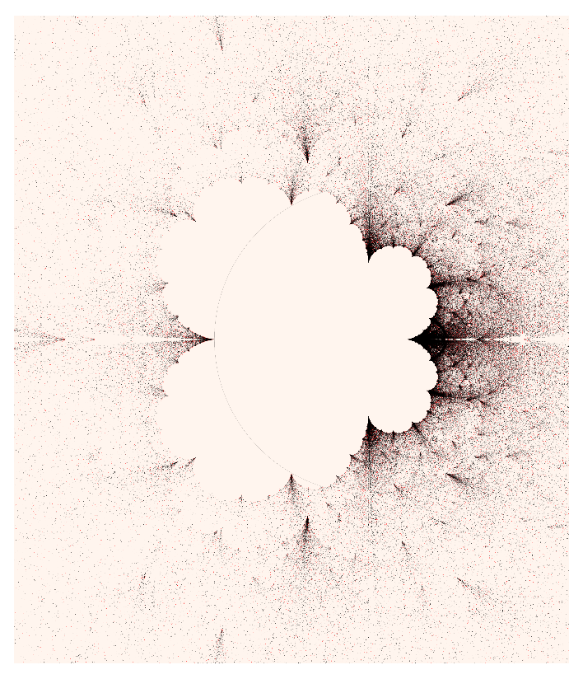
To compute this image of over 400,000 points, we’ve calculated the complex roots of over 12,000 polynomials. These points describe the geometry of the 2-bridge links that correspond to the rational numbers p/q with 0 < p/q < 1 and 1 < q < 250.
Our final project for the spring semester combines interactive scripts, graphics, and technical explanations which explore these root images and describe the associated theory. Ultimately, our work will be publicly hosted and accessible to the general public.
Professor Eric Chesebro has been leading undergraduate research groups in topology for several years. Based on his accomplishments, he was recently awarded a grant from the Center for Undergraduate Research in Mathematics to support the research efforts of his students for the coming academic year.

Honor Roll of Donors
In addition to funding scholarships and awards, donations have made many other things possible over the past couple of years: Memberships to the American Mathematical Society for graduate students, bringing colloquium speakers to campus, conference registrations for students, capsource projects for data science students, the basement workspace renovation, the High School Math Achievement Awards, Math Day outreach activities, and more! We are grateful for your support – we couldn’t have done it without you!
Ross Abraham
Thomas & Kathryn Anderson
Bill & Sandy Atkins
Jody Brewster
Rodney & Mary Jean Brod
Ming-Chun Chang
Arthur & Shirley Clarkson
James & Kay Coghlan
Susan Cole
Kendra Eyer
Eric Fevold
Lewis Frain
Frank Gilfeather
Edray Goins
Eric Hartse
Mary Hashisaki
Lesley Herrmann
Gloria Hewitt
Wendy Houston
Gregory & Sydney Hulla
Severt & Mary Kvamme
Fat Lam
Johnny & Carolyn Lott
National Philanthropic Trust
Todd Oberg
Robert O'Donnell
Oracle Corporation
Pepper Pallante
Champak & Meena Panchal
Marc Quilici
Jeffrey Raber
Sandy Ryan
Karen Schroder
Schwab Fund for Charitable Giving
David Sherry & Jeanne Ambruster Sherry
Jamie Small
TIAA, FSB
Danika Van Niel
Vanguard Charitable Endowment Program
Jon & Karen Wahrenberger
Richard & Carla Welter
Yong Zhao

Spring 2021 Scholarship & Award Winners
- Joseph Hashisaki Memorial Scholarship
Kenton Ke
- The Adams Scholarships
Junior: Vivian Cummins Senior: Burkleigh Yost
- Mac Johnson Family Scholarships
Jonah Britton Cory Emlen Kayla Irish
- Carolyn and Johnny Lott Elementary Education Scholarships
Kari Inabnit Faith Sullivan
- Undergraduate Research Scholars
Kayla Irish Jordan Jarrell Esther Lyon Delsordo Emily Morison Andi Wainwright Luke Wyman
- Undergraduate Teaching Scholars
Kenton Ke Jethro Thorne
- John A. Peterson Mathematics Education Awards
Ross Coleman Rebecca Hasenyager
- William Myers Mathematics Scholarships
Ian Gonzales José Martinez
- Gloria C. Hewitt Graduate Scholarship in Mathematical Sciences
To be awarded in Fall 2021
- Bertha Morton Scholarship
José Martinez
- Graduate Student Distinguished Teaching Awards
Michael Morris Cameron Raber
- Graduate Student Summer Research Awards
Dakota Gray Anna Halfpap José Martinez Ryan Wood
- President’s Senior Recognition Awards
Brock Adkins Tucker Day Rebecca Hasenyager Alex Shepherd Haley Wilson

Degree Recipients 2020-2021

Bachelor Degrees
- Brock Adkins
- Cordell Appel
- Amanda G. Brennan
- Ross M. Coleman
- Tucker Day
- George Dowson
- Ellen Etrheim
- Shane Fancler
- William J. Griffin
- Rebecca Ngari Hasenyager
- Jasper Palmer Knutson
- Ryan Longdon
- Michael McKelligott Jr.
- Marcus Tucker Richlie
- Max August Riedl
- Alexander John Sampson
- Alex Shepherd
- SueAnne Marie Stewart
- Joseph David Stockdill
- Nat Warford
- Haley Wilson

MA in Mathematics
- Sara Killeen
- Michael Morris
- Scott Payne
- Cameron Raber

MA in Teaching School Mathematics
- Amanda Stoltz

MS in Data Science
- Brenden Connors
- Parto Mahmoudi
- Loren Meyer
- Mohsen Tabibian

Doctoral Degrees
- Ted Owen - Advisor: David Patterson
Variance Approximation Approaches for the Local Pivotal Method
- Mohsen Tabibian - Advisor: Brian Steele
Extending Bootstrap Aggregation of Neural Networks for Prediction with an Application to COVID-19 Forecasting

Math Major is Top-Ranked Chess Player in Montana
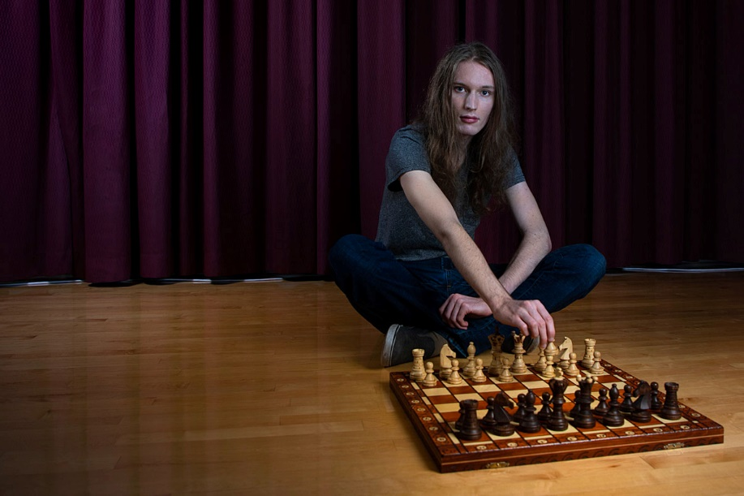
Math major Dorje McPherron is the Montana state chess champion, a title he’s held for the past two years, and is the top-ranked tournament player in the state. According to Dorje, math and chess require many of the same skills. Learn more about him in this article.

Welcome to Factor City
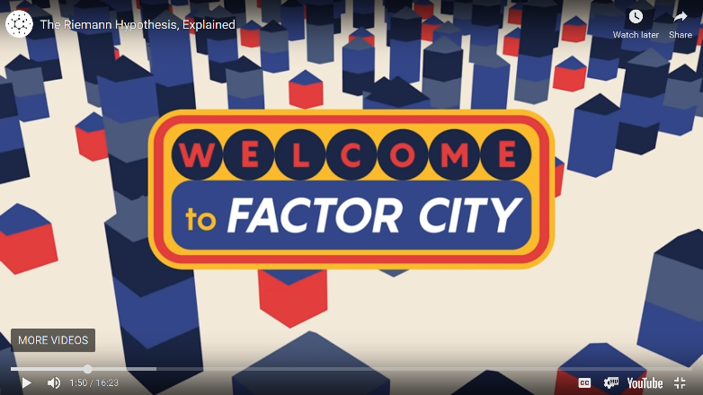
Professor Matt Roscoe’s award-winning teaching game involving the City of Numbers (see the Spring 2020 Newsletter) found its way into a nationally-released short film about the Riemann Hypothesis. The video, by Rutgers Math Professor Alex Kontorovich, is a really enjoyable take on this infamous math problem. Kontorovich also posted an animated GIF of the Factor City on Twitter. And congratulations again to Dr. Roscoe!
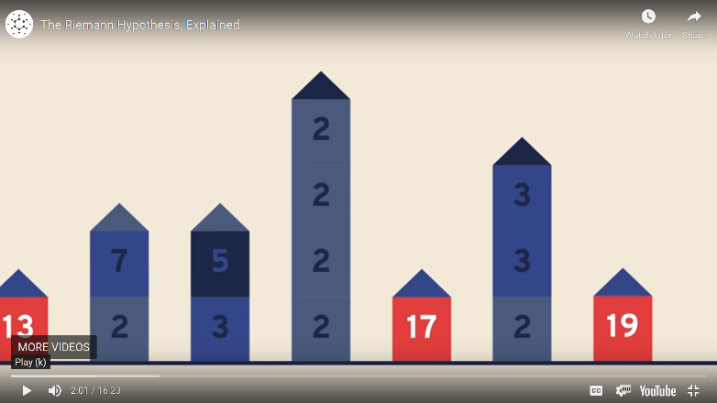

Donation Request Box
The Department of Mathematical Sciences increasingly relies on donations to support its activities. In particular, scholarships are very important for our students. Please consider a gift to the Math Department’s Excellence Fund, to be used where the need is greatest, or to one of the other funds and endowments:
- Endowed Scholarship Funds: The Adams Scholarships, Anderson Mathematics Scholarship, Gloria C. Hewitt Graduate Scholarship in Mathematical Sciences, Joseph Hashisaki Memorial Scholarship, Mac Johnson Family Scholarships, Merle Manis Award, William Myers Mathematics Scholarship
- George and Dorothy Bryan Endowment: Supports undergraduate and graduate students
- Lennes Fund: Provides funds for the Lennes Exam Competition
- Colloquium Fund: Provides funds to bring in visiting speakers
To donate online, please visit http://hs.umt.edu/math.
For information on other ways to give, please contact Suann Lloyd: suann.lloyd@supportum.org or by phone at 406-243-2646 (or call toll free 1-800-443-2593).

The Reinhardt Peony Garden
This May and June will be the third time you can enjoy the blooming peonies in the Howard and ChinWon Reinhardt Peony Garden, located on the UM campus next to the beginning of the M-Trail. It will be worth stopping by – more than 200 plants are expected to bloom!
Professor Emeritus Howard Reinhardt was a faculty member in the math department, who also served as Dean of the College of Arts and Sciences. You can read more about the Reinhardts’ impressive accomplishments, and the founding of the peony garden named in their honor, in our Fall 2018 newsletter. The garden’s Facebook page has lots of additional information and many beautiful photos. Contributions to support the on-going needs of the garden can be made through the UM Foundation (please specify the Reinhardt Peony Garden in the Comments Box).
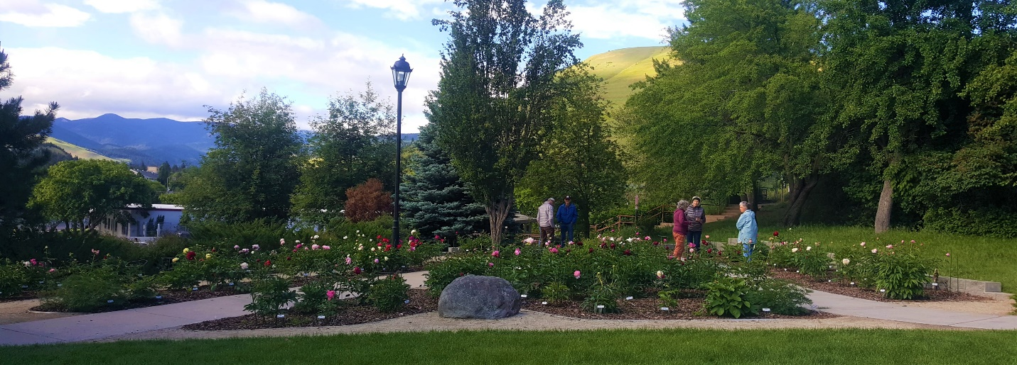
The Reinhardt Peony Garden in bloom during its second season, in June 2020 (Photo by Ron Scholl)

Backmatter

Address
Department of Mathematical Sciences
Mathematics Building (MMAI01)
32 Campus Drive
Missoula, MT 59812-0864
Phone: 406-243-5311
Email
Website

Comments or suggestions?
Please email the newsletter editor, Nikolaus Vonessen.

