Spring 2022 Newsletter of the Department of Mathematical Sciences of the University of Montana

Jack Finlay: a “Mathematical Singularity”
By Mark Kayll
Long after earning a ‘D’ in math as a high school senior, Jack Finlay was awarded a different sort of ‘D’. At UM’s Spring commencement ceremony, where he “marched” in May, Jack was awarded his mathematics Doctorate.
That’s not the most amazing thing about Jack. Not even close. In 2010, while still an undergraduate, now Dr. Finlay learned that he has ALS (Lou Gehrig’s disease). This diagnosis led him to change majors, from microbiology—he’d been on a pre-med track—to a field where he wouldn’t need to rely on his hands. He chose mathematics and in 2013 completed his BA with a Combinatorics & Optimization concentration.
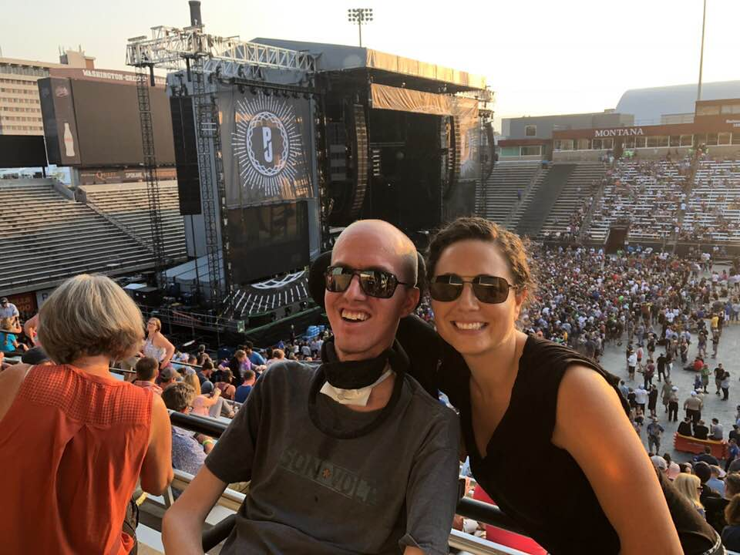
Jack and his wife Abby at the Pearl Jam concert at UM in 2018
As it happens, during the preceding fall (2012), another UM PhD, Mary Riegel, was teaching our senior-level graph theory course. Taking this course cemented the field as the one for Jack’s graduate school emphasis. His 2022 dissertation, entitled “Randomly Perturbed Graphs and Rainbow Connectivity”, was co-supervised by professors Cory Palmer and Mark Kayll.
Jack’s a pure mathematician, through and through; other mathematical areas that inspired him include Abstract Algebra and Number Theory. And other influential professors have included Kelly McKinnie, Nikolaus Vonessen, George McRae (now emeritus), and Jen Brooks (formerly Halfpap; now at BYU).
Jack’s path from bachelor’s to doctoral degrees took longer than average (nine years compared to five or six), partly due to ALS but partly not. In 2017, he took a two-year leave from his doctoral studies to complete his undergraduate Microbiology degree, which he did in 2019. Considering this, Mr. Finlay’s time in graduate school was only seven years, clearly within the ballpark of a ‘typical’ student (more on ballparks below).
But advanced ALS is mighty far from typical. Try to conceive of doing all your typing using an eye-gaze computer. That’s a device that accesses computer input (keyboard, mouse, Alexa queries, etc.) by scanning a user’s eye movements. Jack has become strikingly proficient at this through eight or nine hours of daily practice. After that, eye fatigue interferes with the scanner’s functionality.
Another vital piece of technology has been a ‘V-Go Robot’, available through UM’s Office of Disability Equity (ODE). The robot attends class in Jack’s stead (wheeled in by the instructor) and is controlled remotely by him (yes, through his eye-gaze computer). It sports a two-way camera, a microphone, a small screen, and—wait for it—two-wheel drive! These all combine to bring Jack virtually to the classroom—and vice versa—his beaming face smiling on-screen the entire time. Jack and his inner circle are quick to credit UM, ODE, and his Math instructors for “being great” in helping him make this system substitute for his physical presence during the past four years.
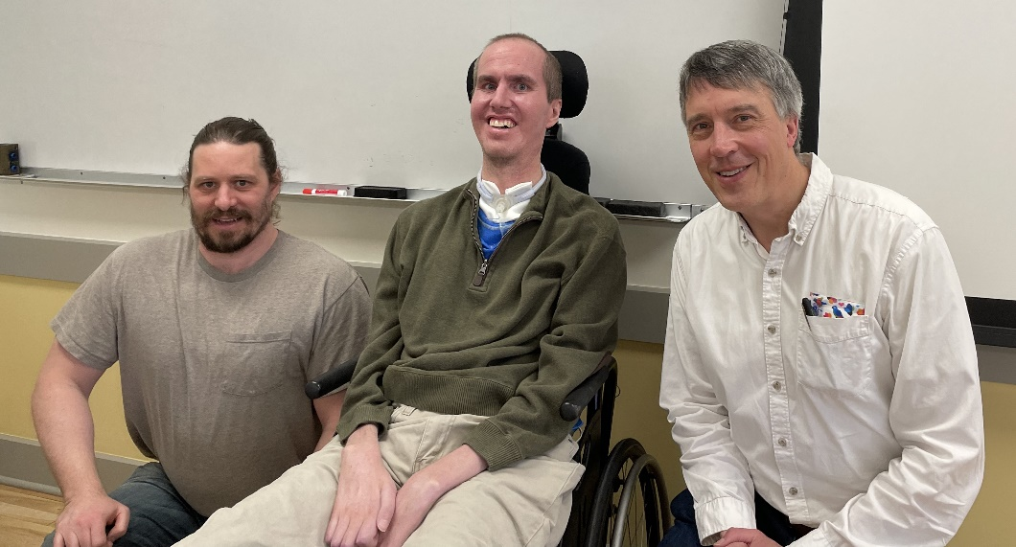
Jack Finlay, with his two Ph.D. advisors, Professors Cory Palmer (left) and Mark Kayll (right)
Jack’s life outside of mathematics may surprise some readers through its richness. In 2016, he married his long-time sweetheart, Abby (nee Habein), who has a degree in Math and Philosophy from Concordia College in Minnesota. During the interview for this piece, the couple shared a head-spinning coincidence. Abby’s great-grandfather was Harold Habein, the very doctor who diagnosed Lou Gehrig with ALS in the 1930s. (Abby and Jack met before Jack’s own diagnosis.) That’s a name one can Google for further details.
When COVID hit, Jack took a deep dive into learning chess. Of course he formerly knew the basics, but Abby would consistently win their matches. That’s now reversed, and the couple regularly travel to regional tournaments, where Jack competes—with communication help from Abby. The chess world makes precious few disability accommodations, so Jack sometimes has to forfeit matches through exhausting his game clock.
Jack’s other hobbies include music and baseball fandom. Before his diagnosis, he was an award-winning bass player (in high school), both electric and upright. Now he’s exclusively on the listening end but still very active. Back to ballparks: seven years ago, he and one of his eight siblings traveled the country visiting as many Major League Baseball parks as they could: they hit 20 that summer.
But Jack’s main hobby is unequivocally mathematics. To many in UM’s Math Department, Dr. Finlay’s dedication to our field is humbling to the hundredth power. MORE: it really defies any attempt at description. Given the physical challenges imposed by ALS, how many of us would continue our mathematical careers with even a modicum of Jack’s commitment? Try to imagine what it would take to complete a doctoral degree, start-to-finish, all the while coping with this progressively debilitating condition. I, personally, have found Jack Finlay’s determination, persistence, and love for mathematics to be deeply inspiring. So I count myself lucky to know him.

Howard Reinhardt 1927 – 2021: In Memoriam
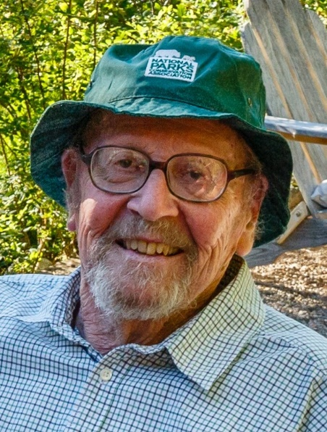
We are sad to report that Emeritus Professor Howard Reinhardt passed away in November 2021. He had earned his Ph.D. at the University of Michigan at Ann Arbor, and had been a faculty member of the Department of Mathematical Sciences for over three decades, from 1957 until his retirement in 1988. He served the department and university in many roles, including as department chair, dean of the College of Arts and Sciences, chair of the Faculty Senate, and president of the University Teachers’ Union. Honoring him and his wife ChinWon, friends of the Reinhardts established the Howard and ChinWon Reinhardt Peony Garden, located on the UM campus next to the beginning of the M-trail. You can learn more about the impressive life of Howard Reinhardt in his obituary in the Missoulian, and in newsletter articles from Spring 2000 and Fall 2018. A memorial reception will be held at his home in the East Rattlesnake between 5 and dusk on Wednesday June 29. For details call 406-370-1546.

Notes from the Chair
By John Bardsley
It is finals week as I write these Chair’s Notes. Looking out my office window onto the Oval, campus is quiet. Things are settling down after a year like no other. What made this year so unique is that we watched COVID restrictions gradually slacken and then go away during spring semester. It was wonderful to return to mask-free teaching and conversations in the faculty lounge, but it will take some time for the cumulative effects of COVID to dissipate. Despite the return to normalcy, both my students and I showed the signs of exhaustion from the challenges of the past two years.
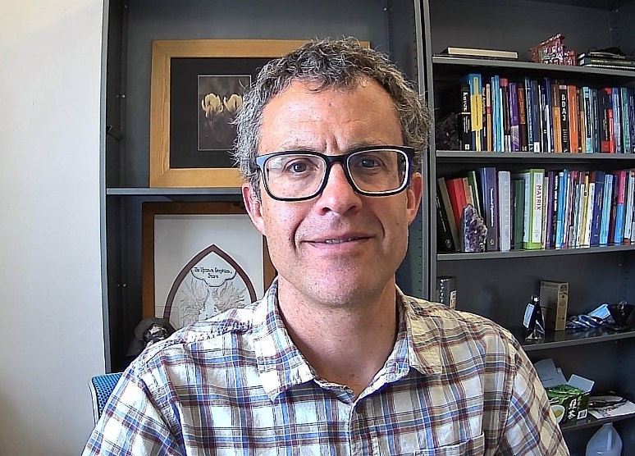
John Bardsley
This is the end of my first year as Chair, and as I look back, I realize how much I have learned, first about the nuts-and-bolts of running the department, and second about leading a group of twenty people. Prior to this year, my work-life has centered around research and teaching, and I have been quite isolated. The isolation gave me the time and energy to be a productive researcher, but it also left me inexperienced in the realm of leadership. As a result, there have been growing pains as I’ve learned the job, and there will undoubtedly be more. Nonetheless, I am grateful for the opportunity to serve this department.
Graduation will occur this coming weekend, and we are able to return to having our annual departmental “celebration for graduates” after a two-year hiatus. I am always uplifted by this event and am grateful for its return. One inspiring story from among our graduates this year is that of our sole PhD graduate, Jack Finlay. If you haven’t already, I encourage you to read the story about him, written by Professor Mark Kayll, which begins on the cover.
One of the biggest news items of the year for our department is the retirement of two of our Statistics Professors, David Patterson and Brian Steele. Dave and Brian have served our department excellently for a combined 62 years; please see the individual articles on them contained in this newsletter. This year also saw the passing of two former members of our department, Howard Reinhardt and Carol Ulsafer; please see the accompanying articles. It strikes me how people give their careers to this department – much of their lives, really – retire, grow old, and pass on, while the department keeps on going. Our department is bigger than each of us individually and will outlive us all. We are grateful to Dave, Brian, Howard and Carol for what they have contributed to our department and to UM.
Two of our Professors, Mark Kayll and Jon Graham, were awarded sabbaticals for next year. Mark will home-base out of Missoula, but he plans to visit collaborators in Hawaii, New York, Virginia and Iran. Jon will also stay in Missoula and will be working with his long-term collaborators in UM’s Public Health Department. We wish them both a restful and productive sabbatical year.
In other faculty news, Ke Wu was interviewed for the Confluence podcast; see the accompanying article by Fred Peck. Fred and Ke collaborate on more than just newsletter articles: they were recently awarded a $4.2 million NSF grant titled, “Supporting Talent with Aligned Resources for STEM students (STARS).” The grant is a collaboration between three institutions: UM, Salish-Kootenai College, and Montana Tech; UM’s portion of the grant is $1.7 million. The grant will provide multiple forms of support for STEM students with financial need, including scholarships of up to $10k per year, academic support, first-year seminars, a “math boot camp” over the summer, and career transition support. The research component of the grant focuses on how participating students develop STEM identities, and how those identities become integrated with their existing sense of self.
Finally, I would like to thank those of you who have donated to our department over the past year. Your donations help us do important projects and outreach that we would not be able to do otherwise. Our outreach over the past year includes the University of Montana High School Math Awards, which are administered by Professor Emily Stone, and the Montana Science Fair. Within our department, we used your donations to support research-related travel by faculty, graduate students, and visiting speakers. We also used it to fund our spring and fall Department Picnics and to cover the publishing costs for this newsletter. And finally, we used your donations for the pursuit of innovative opportunities, such as an internship program in data science this past summer – see the accompanying article by Emily Stone.
Best wishes to you all, and have a great summer! You are important to us, so don’t hesitate to reach out if you are so inclined.
John Bardsley

Statistics Professors Brian Steele & Dave Patterson Retire
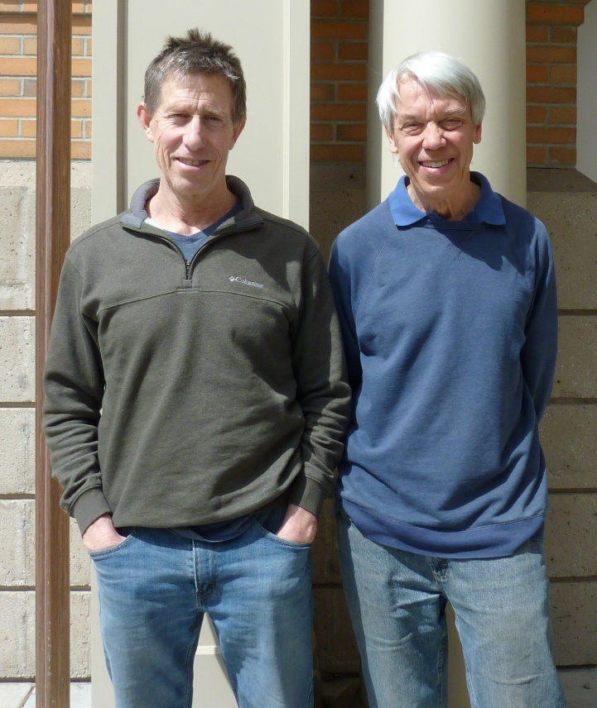
Brian Steele and Dave Patterson outside the Math Building

Brian Steele
By Dave Patterson
Professor Brian Steele is retiring in May, after 25 years as a faculty member in the Department. Brian started as a full-time statistician, but led the development of the data science program about 10 years ago and split his time between the two fields from then on. He will be missed for his expertise in both fields and the new courses he developed.
Brian grew up in State College, Pennsylvania, and obtained his undergraduate degree in biology at Cornell University. He says he took no mathematics courses as an undergraduate. He then moved to Missoula to do seasonal field work with the Forest Service and began to take undergraduate math courses part-time at UM. He started in calculus with Keith Yale and took additional courses from Bill Derrick and Stanley Grossman. He also took his first statistics courses with Don Loftsgaarden with computer labs taught by Dick Lane. After six years in Missoula, he entered the graduate statistics program at Oregon State where he received a Master’s degree.
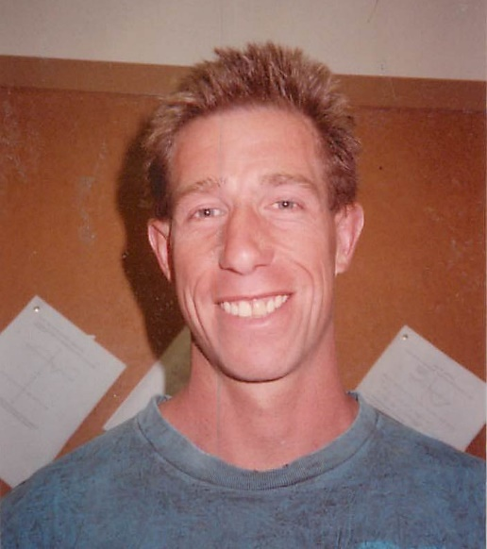
Brian Steele around 2000
He then returned to Missoula, again working part-time for the Forest Service, and started taking more advanced mathematics courses, including advanced calculus from Charles Bryan and algebra courses from Merle Manis and Gloria Hewitt. He says his favorite course was topology from Gloria. He then entered our PhD program, part-time at first, and received a PhD in statistics in 1995. Although his thesis was nominally under the supervision of Rudy Gideon and Dave Patterson, Brian came up with the topic, using the EM algorithm for estimation in generalized linear mixed models, completely on his own after 6 months of reading the statistics literature to find open problems. He also solved the problem almost completely on his own. He says he got a key piece of help from Leonid Kalachev to overcome one sticking point. He published his work in Biometrics, a premier journal in statistics, and received the 1996 outstanding student paper award from the Biometrics Section of the American Statistical Association.
After a year as an adjunct assistant professor at UM, the department hired Brian for a tenure-track position starting in fall 1997. With his background in both biology and statistics, Brian was a natural for interdisciplinary work. He soon started working with Rollie Redmond, who had started the UM Wildlife Spatial Analysis Lab, on using remote sensing data for land cover classification. This work resulted in a series of papers in remote sensing and statistics journals, several of which have been cited more than 150 times. He also worked on a variety of other projects with biologists relating to wildlife population trends, genetics, and responses to wildfire, among others.
Around 2012, then Chair Leonid Kalachev asked Brian to co-teach a class with Eric Tangedahl in the College of Business on the emerging field of Big Data, which eventually morphed into the more general field of Data Science. The problem they addressed early on was analyzing, in real-time, large volumes (terabytes) of streaming data coming at high speed, such as from sensors on self-driving cars or from intruder detection sensors around military facilities. The volumes of data are too large to be stored and analyzed with conventional methods and, in addition, it is often desired to immediately detect anomalous data. After co-teaching this course two or three times, Brian led the development of the Data Science program, starting first with a Certificate in Big Data joint with Business in 2014, and, eventually, a Master’s in Data Science in our department. One of the courses Brian developed for this program was M467/567 Data Science Projects where students work in small teams on projects from local and national businesses or from other campus departments. He said a particularly interesting project was developing a model for forecasting flu case numbers county by county and week by week in Montana.
Shortly after starting to teach data science courses, Brian realized there wasn’t a good introductory textbook so he started to write one along with his wife, Swarna Reddy, an applied mathematician, and John Chandler, who received his PhD in statistics from our department in 2010. John is a Clinical Professor of Marketing teaching part-time in the UM College of Business while also running a marketing analytics consulting business. The result of their collaboration was “Algorithms for Data Science” published by Springer in 2016 which received excellent reviews.
Brian is happy that the Data Science program will now be in the hands of Assistant Professor Javier Pérez Álvaro, who has quickly proved to be a capable and popular teacher. Brian’s retirement plans include puttering in the garden and becoming a musician. He intends to exploit his son’s (Rohan) very substantial knowledge of music for that purpose. Rohan is completing his freshman year at UC Boulder as a mathematics major.
Brian says he will most miss the interactions with students and in working on projects. He says that good students and good projects make a great combination.

Dave Patterson
By Jon Graham
After 37 years of dedicated and passionate service to the department as a statistician, Dave Patterson is retiring this spring. Dave is originally from Boston but took several family trips west as a kid that developed his love for the area. After majoring in math at Carleton College, he worked for two years doing water rights surveys for the state of Oregon. He decided during that time he was more interested in statistics than pure math and entered the statistics program at the University of Iowa. He enjoyed the life of a graduate student, especially being part of the volleyball and running communities and meeting his future wife, Marjorie, while playing softball. He spent two summers working at Los Alamos National Laboratory which ultimately led to his PhD work in discriminant analysis. He received his PhD in the fall of 1984 and after interviews with both industry and academia, he decided he liked the atmosphere of the academic world and entered the Department of Mathematical Sciences here at UM in the fall of 1985.
In Dave’s early years in the department, he spent much time developing courses that he was teaching for the first time and commented how appreciative he was to both Don Loftsgaarden and Rudy Gideon for their support and encouragement. In the late 1980’s, he met a young economist, John Duffield, who worked on non-market valuation surveys using logistic regression. Dave and John initially collaborated on an important paper on optimal bid design for these surveys, a paper that Dave said is probably the most cited paper on which he worked. That began a lifetime research collaboration on a variety of projects with John including the Exxon Valdez oil spill in Alaska where they worked to fairly value losses suffered by Alaska Natives as a result of the disaster. In addition to this research collaboration, Dave spent sabbaticals at Penn State and then at Glacier National Park working with bear biologists under the former Sabbatical in the Parks Program. He commented that his children, Alec and Gilia, still have fond memories of the 45-student West Glacier Elementary School and the mountains of snow they experienced that winter.
One reason Dave went into statistics is because the theory and methods mostly come from real-world problems and he worked hard to incorporate that into his teaching. While he never had a formal sampling course during his graduate studies, he recognized early in his career through interactions with researchers in other fields, particularly biology, the importance of sampling, and so developed a sampling course. Put simply, he explained to me “I thought Horvitz-Thompson estimators were so cool.” To improve the learning experience for students in introductory statistics, Dave introduced a workshop approach to teaching the summer course in 1996 where students spent class time doing activities and working on data analysis in small groups. Students have genuinely appreciated this approach. The summer course continues to be taught in this format and the large-lecture course has adopted many of its activities.
Dave’s most recent PhD student, Ted Owen, perhaps best summarized what makes Dave such a great teacher in saying: “The two most admirable Dave traits are his sense of wonder and his willingness to try new things”. Dave is relentlessly curious and prides himself on keeping his courses fresh with new ideas and exploring new ways to bring those ideas to life. In more recent years, he developed an affinity for teaching probability from a simulation (rather than set theoretic) perspective and is happily teaching that course in his final semester this spring.
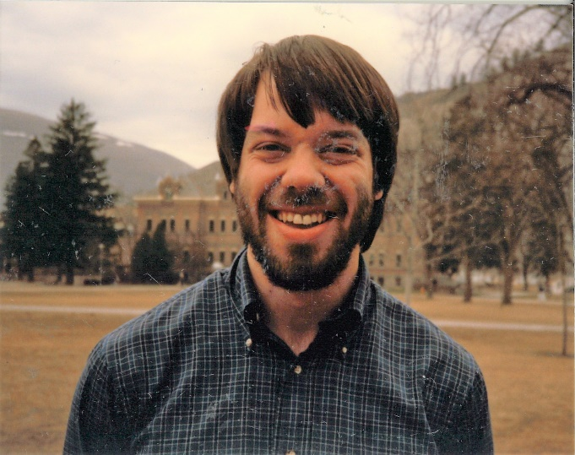
Dave Patterson in 1985, at the start of his career at UM
From 2005-2009, Dave served as the department chair, a time during which an elevator and the new addition to the Math Building was constructed. Although Dave attempts to credit seemingly everyone but himself for this change, he was instrumental in this process. In addition to improving accessibility, the addition brought several new offices and much needed bathrooms. Other than helping plan the addition, Dave says he “didn’t do much else as chair except make sure we had enough adjuncts.” He credits Michelle Johnsen with being the one who ran the department (a statement not far from the truth!), but anyone who has worked with Dave knows how much he cares about the department and how much he has contributed during his time as chair and as a faculty member.
From my perspective, Dave is the one of the primary reasons I chose to come here in 1995 and is certainly the person who has had the greatest impact on my career as an example and as a mentor. I have tried to model his enthusiasm for statistics and mathematics in general, his willingness to help students, and his dedication to teaching. To highlight one of Dave’s impacts on me and the greater Missoula community, Dave has been integral to the success of the middle school Mathcounts program in the Missoula area. While serving as a volunteer coach while his own children participated in this program from 2004-2009, Dave got the idea to organize Saturday Mathcounts sessions to serve all interested middle school kids in the greater Missoula area. He later brought the local chapter competition to UM and has helped organize this competition up to the present time. His dedication to promoting mathematics in the middle schools inspired me to become a Mathcounts coach and earned him the State Mathcounts Champion award in 2015.
To finish this recognition of Dave’s service to the department and impact on so many students and researchers, it seems appropriate to share the sentiments of former students and colleagues, and a little roasting. First the sentiments:
- “Tears of gratitude come to my eyes as I consider a future department without him.”
- “Early in my career, I was trying to compute the probability of an event related to bootstrap sampling. After a week, I gave up and asked Dave. He wrote out the formula in about half an hour with a little (very little) help from me.”
- “The first thing that pops into my head was Dave’s smile and willingness to always talk, listen, and rant. He was always very kind and wanted the best for us.”
- “Dave not only taught me a lot about statistics but he also taught me a lot about teaching. One thing in particular I learned from Dave is that teaching is not just about delivering the material to your students but also showing excitement about the subject.”
- “He is one of the sharpest & thoughtful people I know, and while he is extremely kind & generous, he’s never afraid to name what he sees. He seems to have a fierce love for the savvy presentation of truth, education & clarity, and works to show his students and colleagues the importance of cutting the fluff and to strive for high-level science.”
Now for the roasting: I asked many former students for memories about Dave. There were a few consistent themes that cannot go unmentioned. First, many commented on Dave’s vertical or horizontal organizational skills. Until the past few years when Dave cleaned up his office, Dave possessed a masterful organizational technique of somehow knowing where to find almost anything in his office. I say “almost anything” because my FEC file once disappeared in his office never to make a reappearance. Second, Dave had a reputation for going into a deep trance-like time of focus during seminars and colloquia. As one former student put it: “In every seminar and colloquium, I saw Dave’s eyes close at some point, yet, at the end of each presentation, he could ask the most thoughtful and profound questions of the speaker, like he had been absorbing everything deep in thought.” Third, several students brought up Dave’s passion for the Red Sox and requisite angst toward “that team that shall not be named”, love of baseball and sabermetrics in general, and some level of trash-talking during faculty student softball games. I suppose Dave earned that right since the faculty did manage to beat the students virtually every time we played them!
As a final thought, I would like to share a quote from Dave’s long-time research colleague, John Duffield, which I think says a lot about who Dave is and the impact he has had: “Dave is not only an excellent mathematician and teacher, but also very personable. I remember several years ago one of Dave’s students, Rachel, was from the tiny community of Sunburst, located up in the high-line. Speaking at her graduation ceremony, Dave surprised and honored her with a quiz he had developed on obscure little known facts about Sunburst. This generated a lot of smiles in the assembled. This also is a data point for the observation that Dave has in fact taught generations of students. Back in the 1980s one of my first MA thesis candidates in economics was also from Sunburst, and Dave was on her committee. That was Susan, Rachel’s mother!

Experiential Learning in Data Science
By Emily Stone
As Dept chair, I became interested in how we could make our majors more “career ready” upon graduation. With more students able to attend college, and with the cost of a college degree on a steep incline, it behooves us now to examine the ROI for our students, financially, as well as developing a well‐informed electorate, and increasing life satisfaction.
For our math majors, it amounts to making sure they take advantage of the opportunities that are out there for them, and understand the skill set that they bring to the job market. One approach to this is “experiential learning” engagements with external organizations.
We have struggled with keeping this program going for our data science students, where the connection with the job market is obvious, and want to extend down to lower division majors, but have lacked the time, energy and expertise. In April of 2020, in the middle of the COVID lockdown in MT, I received a marketing email from a company called “Capsource” about its sourcing and design services for collaborative capstone courses. This seemed to be just what we were looking for to help bring more work‐based experience to our data science students.
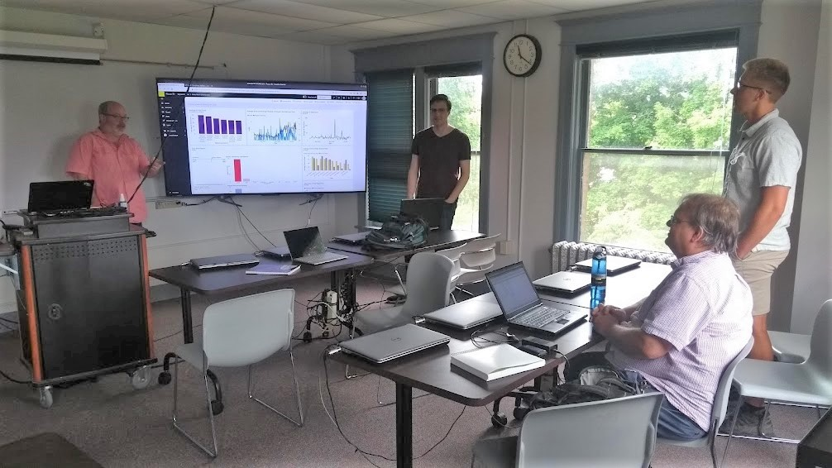
Summer 2020 Virtual Internship: The students rehearse their final presentation to Crayon.
We entered into a contract with Capsource for one course, to be conducted remotely during the summer 2020 term, targeting data science and CS masters students. Capsource rounded up interviews for me with four different companies who were interested in working with our students on a data science project. They coordinated and guided the interviews, and helped us to choose the best partner, an international company called “Crayon” (no relation to Crayola).
We spent another week having meetings with the Crayon representative and Capsource to set up the timeline and benchmarks for the course. In June the course commenced in meetings with the instructor, Assistant Professor Javier Pérez Álvaro, Lesly Kenney, Crayon’s VP for Marketing, and the 4 students enrolled. Students and the instructor met twice weekly, with several group meetings with Crayon. Crayon employees also helped in getting the students up to speed using Google Analytics, Microsoft Dynamics and Power BI. The students presented their results to Lesly and her staff in July, and collectively brainstormed uses for the new information they had gleaned.
The students learned new software and data visualization tools, gained experience interacting with marketing teams from the company, and discussed career options with Crayon’s Head of AI. It was a dream project, and Capsource was the key to this, helping us to avoid the pitfalls we had encountered when running other data science consulting project courses. We run at least one such course a year as part of our data science program, and hope to extend these opportunities to our undergraduate math majors, again using Capsource to help us find non‐academic partners and design an effective experience.
UM’s Experiential Learn­ing and Career Success program, under the guidance of Andrea Vernon, has brought UM its own instance of Capsource, branded with the UM logo (https://umt.capsource.io/). In addition to Math, also the College of Business has successfully used the platform. On page 6 is the list of our projects so far, completed and ongoing. If you are interested in learning more, or contributing to our experiential learning effort, please contact me at stone@mso.umt.edu.

Our Data Science Project Portfolio with Capsource
- Summer 2020 Forecasting organic website lead generation: Crayon
- Spring 2021 Help build the open source prediction network: Micropredictions
- Summer 2021 Incorporating machine learning into cloud based HVAC monitoring systems: EcoEnterprises and PowerTron Global
- Spring 2022 Select machine learning framework for analyzing data in order to optimize HVAC systems: EcoEnterprises and PowerTron Global
- Spring 2022 Prediction of racial bias in sentencing length in Montana state courts: JustFair and Qside

Handbook of the Mathematics of the Arts and Sciences
Over the past five years, Professor Bharath Sriraman spent much of his time editing a new reference work, the Handbook of the Mathematics of the Arts and Sciences. The handbook, recently published by a major academic publishing company, is impressive even if one were to just look at its physical properties, from the number of pages (2,853), to its weight (12.64 pounds), to its sticker-shock-inducing list price ($1,099, reduced on Amazon to a mere $745). Those of us not quite ready to spend that much can still see the three volumes: they are on display in the bookcase in Main Hall.
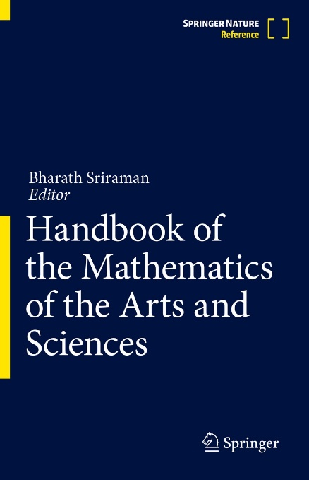
The goal of the handbook is to be an authoritative source that shows the origins, unification, and points of similarity between many different disciplines and mathematics. A quick glance at the list of contents will show you the vast breadth of topics covered. In the words of Harry R. Lewis, a professor at Harvard University, as quoted by Springer: “What do figure skating, invasive species, medieval cathedrals, ropes, poems, wines, metaphors, rhythms, climate change, and origami have in common? Mathematics! The Handbook of the Mathematics of the Arts and Sciences is a stunning compendium of essays on these and scores of other unlikely subjects to which the mathematical imagination has been brought. … It is a breathtaking work, for its ambitious scope and for its endless stimulation of the reader’s curiosity.” NV

Dr. Carol Ulsafer 1940-2021
We are sad to report that retired lecturer Carol Ulsafer passed away in July 2021. After earning her Bachelor’s and Master’s degrees in mathematics at Creighton University, she taught at North Central College in Naperville, Illinois. Leaving her position as a tenured associate professor, she came to UM for her doctoral studies which she completed in 1984. For the next decade, she worked at the high-tech firm Education Logistics, Inc., where she rose to the position of Vice President. In the mid-nineties, Carol decided to return to her first passion, teaching mathematics, and taught at UM until her retirement in 2007. Her obituary was published in the Missoulian.

Professor Ke Wu featured on the Confluence podcast
By Fred Peck
Professor Ke Wu was featured in the Confluence podcast, produced by the UM Graduate School. Professor Wu is the featured guest of Episode 38, from September 12, 2021. You can listen to the podcast by searching for “Confluence” in your preferred podcast app, or by visiting https://www.umt.edu/grad/telling-our-story/stories-folder/ke-wu.php.
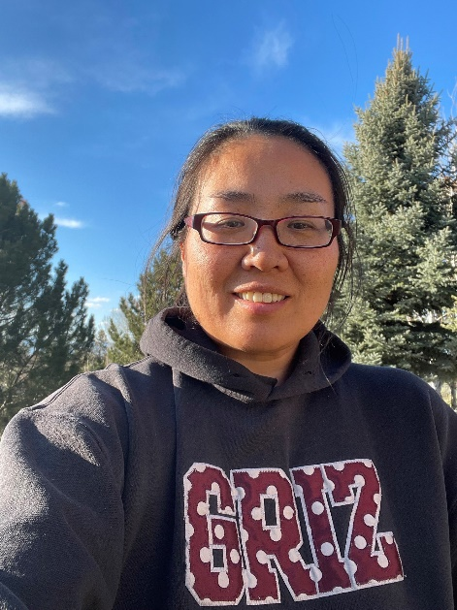
Professor Ke Wu
The podcast is a conversation between Professor Wu and Professor Ashby Kinch, Dean of the Graduate School. The episode starts with voices of Professor Wu’s students: “She encouraged me to step out of my comfort zone and take another step forward.” “She cared a lot about me as a person, as a human being.” “If somebody believes in my like that, I definitely want to live up to that belief.” “She is one of the women I look to the most.”
As these voices attest, Professor Wu is a profoundly impactful educator. Her care for students is well-known in the department, and it comes through clearly in the podcast as Professor Wu shares her philosophy for mentoring students. Mentoring is a key aspect of Professor Wu’s scholarship as well, and she explains her scholarly inquiry into how mentoring can broaden access to, and humanize, the mathematical sciences. Finally, Professor Wu shares more about her trajectory from “a small town in China to a big city in Montana,” earning degrees in policy, psychology, mathematics, and mathematics education along the way.
It’s well worth a listen to learn more about an esteemed faculty member!

Honor Roll of Donors
In addition to funding scholarships and awards, donations have made many other important activities possible over the past year: The High School Math Achievement Awards, the summer internship program for data science students through CapSource, research-related travel by faculty, graduate students, and visiting speakers, our Department Picnics at the beginning and end of the academic year, publishing and mailing this newsletter, and more! We are grateful for your support – we couldn’t have done it without you!
- Ross Peder Abraham, PhD
- Gordon Bahen
- James A Barta
- Robert Bastasz
- Ruth Rollins Brocklebank
- Mary Jean Brod
- Dr. Ming-Chun Chang
- Michael Wayne Decker
- Dr. Frank L Gilfeather
- Edray Herber Goins
- Bill Gregg
- Dr. Gloria C Hewitt
- Wendy R Houston
- Lt Col Gregory G Hulla
- Kristin Marie Jakobson
- Dr. Herbert E Kasube, PhD
- Dr. Fat C Lam
- Mark J Netland
- Todd D Oberg
- Robert Terrence O’Donnell
- Dr. David A Patterson
- Dr. Howard Earl Reinhardt
- Carolyn Riggs
- Dr. David M Sherry
- Carla Ingebo Welter
- Ke Wu
- Rebekah Bernice Johnson Yates

Student Interview: Kenton Ke
By Kelly McKinnie
Kenton Ke is a senior mathematics major who graduated this May. His time at UM involved many outstanding achievements in the classroom, in undergraduate teaching and in research. Kenton won all the math department’s top awards and scholarships. This includes the Adams Scholarship (junior and senior year), the Hashisaki Scholarship which he won twice, and multiple teaching and undergraduate research scholarships. He also co-authored one paper with his undergrad research group and Professors Eric Chesebro and Kelly McKinnie on Farey Recursion in the Stern Brocot Diagram, and has another paper in preparation.
In addition to the mathematical achievements mentioned above, Kenton has developed his talents as a ceramicist during his time at UM, leading to a proliferation of beautiful, often mathematically themed ceramic pieces both in the department and in the homes of multiple faculty members. His gifts of ceramics will be missed upon his graduation! You can see a photo of one of his pieces below. Here is an edited interview with Kenton:
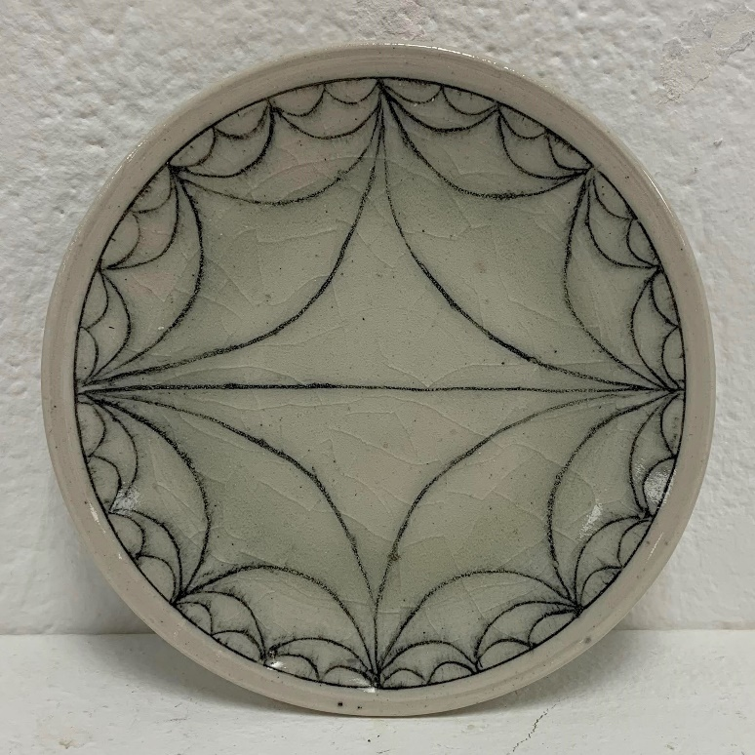
A plate made by Kenton. Google the keywords “hyperbolic farey” to learn more about the mathematics behind this beautiful design.
Q: How did you become interested in math?
Kenton: Math has always been my favorite subject in elementary, middle, and high school. When I took Intro to Abstract Mathematics during my first semester in college, Dr. Chesebro opened my eyes to the fascinating world of pure mathematics. Proving theorems using a given set of tools (definitions and other theorems) helped improve my intuitive problem solving abilities.
Q: How did you become interested in ceramics?
Kenton: I had always been interested in crafting things with my hands — from origami to paracord projects (I prefer to use Chinese knots though) to sewing. During my first semester in college, I decided to take the course “Intro to 3D Foundations”. I really enjoyed that class. During my fourth semester, I took “Ceramics 1,” which covered both hand building and wheel throwing, but due to the pandemic, classes were moved online, and I wasn’t able to have as much fun with ceramics as I had hoped. I continued taking ceramics during my junior year, and got the opportunity to become a student of the world-famous potter Julia Galloway. Her classes were incredibly inspiring and I realized that I wanted ceramics to be a part of me for the rest of my life.
Q: Are you interested in exploring the realm of mathematical art? Or do you prefer to keep math and art somewhat separate in your life?
Kenton: I am undoubtedly interested in exploring mathematical art. For the past year in ceramics, I have been playing around with making difficult forms on the wheel. I saw pictures of bowls with two walls, and the outer wall is pierced; that is, the wall on the outside cannot hold liquid, but the inner wall still holds liquid. I’ve seen people craft these by making two separate pieces, then combining them. I wanted to find a way to make them that is more efficient. Implementing my problem-solving abilities from mathematics, I came up with a way to make these bowls in one piece!
Q: You’ve been a learning assistant in several upper division classes. Has this experience changed the way you view teaching and learning math?
Kenton: These experiences were quite rewarding to me. I didn’t do much teaching Fall 2021 because I mainly hosted homework discussions and office hours. Sharing something I love with others is always an enjoyable experience, and I found it especially rewarding when the students would tell me that they’re looking forward to my discussion sessions. Currently, I am leading 50-minute recitations every week. I go over questions on the homework, the notes from class, and related examples. My experience last semester definitely helped prepare me for this. Teaching for 50 minutes helps give me a taste of what being a professor in the future might be like and I look forward to teaching more.
Q: What do you plan to do after graduating from UM?
Kenton: I plan on continuing to study mathematics in a PhD program, though I haven’t decided where yet.
Since he was interviewed, Kenton graduated and decided to enter the PhD program in mathematics at the University of California at Davis. Congratulations and best wishes!

Donation Request Box
The Department of Mathematical Sciences increasingly relies on donations to support its activities. In particular, scholarships are very important for our students. Please consider a gift to the Math Department’s Excellence Fund, to be used where the need is greatest, or to one of the other funds and endowments:
- Endowed Scholarship Funds: The Adams Scholarships, Anderson Mathematics Scholarship, Gloria C. Hewitt Graduate Scholarship in Mathematical Sciences, Joseph Hashisaki Memorial Scholarship, Mac Johnson Family Scholarships, William Myers Mathematics Scholarship
- George and Dorothy Bryan Endowment: Supports undergraduate and graduate students
- Lennes Fund: Provides funds for the Lennes Exam Competition
- Colloquium Fund: Provides funds to bring in visiting speakers
To donate online, please visit https://supportum.org/give/. Please specify in the Comments box that the donation is for the Dept. of Mathematical Sciences. For information on other ways to give, please contact Dan Minor: dan.minor@supportum.org or by phone at 406-243-2646 (or call toll free 1-800-443-2593).

Degree Recipients 2021-2022

Bachelor Degrees
- Adlin Fisher Abell Ball
- Alex Carey
- Kevin Christensen
- Grant Collins
- Mitchel E. Contreras
- George Dowson
- Trevor Wade Duvall
- Cory Emlen
- George Glidden-Handgis
- Kayla Ann Irish
- Kenton Ke
- Shannara McDunn
- Jethro Emmerson Thorne
- Andi Wainwright
- Burkleigh Yost

MA in Mathematics
- Luke A. Davis
- Baleigh Doyle
- Howard Grotts
- Jake Rooster Pennington

MA in Teaching School Mathematics
- Bethany Cooney
- Wendy Killebrew

MS in Data Science
- John Williams

PhD in Mathematics
- John Finlay — Advisors: Mark Kayll and Cory Palmer
Randomly Perturbed Graphs and Rainbow Connectivity

Spring 2022 Scholarships & Awards
Made possible by our generous donors - Thank you very much! Starred awards are funded primarily (*) or completely (**) by the George and Dorothy Bryan Endowment.
Because of privacy considerations, we no longer publish the names of the scholarship and award winners.
- Joseph Hashisaki Memorial Scholarship
- The Adams Scholarships (2)
- Anderson Mathematics Scholarship
- Mac Johnson Family Scholarships (3)
- Carolyn and Johnny Lott Elementary Education Scholarship
- Undergraduate Research Scholar Awards* (5)
- Undergraduate Tutorial Scholar Award*
- N. J. Lennes Competition Awards (2)
- John A. Peterson Mathematics Education Award
- William Myers Mathematics Scholarships (3)
- Gloria C. Hewitt Graduate Scholarship in Mathematical Sciences
- Graduate Student Outstanding MA Award
- Graduate Student Distinguished Teaching Award**
- Graduate Student Summer Research Awards** (5)
- Bertha Morton Scholarship
(from the Graduate School)
- President's Outstanding Student Awards (5)
(from the President's Office)

Backmatter

Address
Department of Mathematical Sciences
Mathematics Building (MMAI01)
32 Campus Drive
Missoula, MT 59812-0864
Phone: 406-243-5311
Email
Website

Comments or suggestions?
Please email the newsletter editor, Nikolaus Vonessen.

