Spring 2023 Newsletter of the Department of Mathematical Sciences of the University of Montana

Nontraditional Math Majors
By Elizabeth Gillaspy
Last fall, I was surprised to discover that every student in my Advanced Calculus class (M 381) was a nontraditional student, taking a second crack at college in their mid-to-late-twenties. It turns out that we have attracted quite a number of older or nontraditional students to the math department at UM. As I myself had taken a straight-line path from high school to college, I was curious about the experience of being a nontraditional math major at UM. Four of my current and former undergraduate students – Ian Gonzales (’20), Ian Oberbillig (’25), Zachary Taylor (’23), and Adam Viray (’22) – were kind enough to share some of their stories with me for the newsletter.
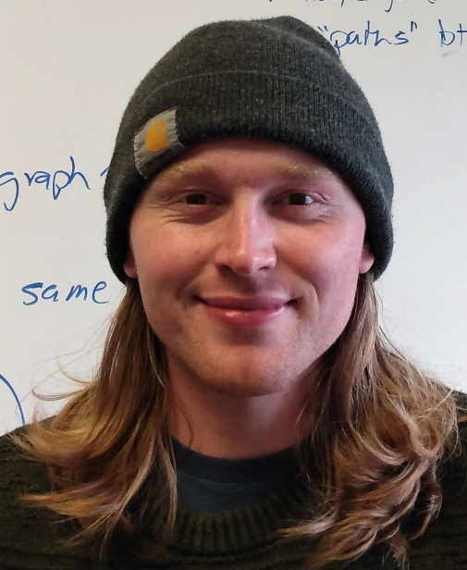
Ian Oberbillig
Why did you choose UM when deciding to come back to school? For all of the students, the support network available at UM was crucial. Ian O. and Adam both had family in the Missoula area, and a close friend of Ian G.’s, also a nontraditional student, had recently joined the Wildlife Biology program. In Zach’s case, he chose the city of Missoula rather than the university: “I wanted to live in a city with less than 100,000 people, that had a Best Buy, and a few other requirements.”
When did you decide to major in math? Ian G. knew that he wanted to major in math from the beginning. He had liked math in high school, and liked helping people; a math education major and a career in teaching sounded perfect. Ian O., Zach, and Adam came to math through their other interests (physics for Ian and Zach, geosciences for Adam). For Adam and both Ians, their calculus professors – Omid Khormali (PhD ’19), Kelly McKinnie, Greg St. George, and Nikolaus Vonessen – were instrumental in convincing them that the UM math department was a good academic home.
What have been some of the challenges you’ve faced as a nontraditional student? What helped you overcome them? While all of the students mentioned feeling some initial embarrassment about being older than the stereotypical college student, it faded as they met other nontraditional students and settled into the academic routine. About other nontraditional students, Ian G. said “We found each other because we needed each other.”
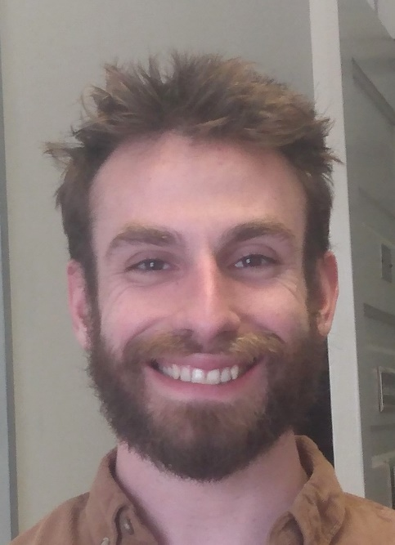
Ian Gonzales
Although I asked the students about challenges they faced, they were unanimous that college was actually easier as a nontraditional student than when they first attended college. For Adam, switching from working to studying was easy: “Instead of spending all my energy at a job that I didn’t really care for, I got to focus my efforts on something I value and enjoy.” Ian O. and Adam mentioned that the extra years of maturity had made them more honest with themselves about their needs and limitations. The work ethic that came from having years of work experience also improved their ability to focus on their studies: Ian G. “treated school like a job, like I had five bosses.” At the same time, being a few years older made the professors less intimidating, and made the students less concerned with the potentially awkward social dynamics around speaking up in class, for example, or forming study groups.
Ian G. and Adam also valued the peer-to-peer connection they built with younger students. Adam in particular felt that returning to college later in life gave him a unique opportunity to build these connections. For his part, Ian G. appreciates how much energy and passion the younger students have, even if they haven’t figured out how to channel it yet.
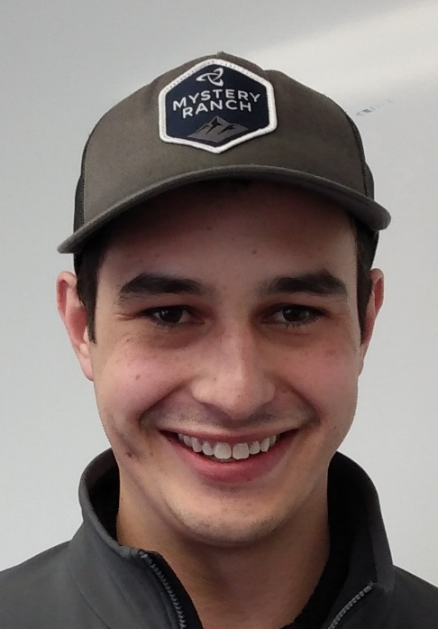
Zach Taylor
Are you glad you chose to study math at UM? “Yes,” said all four of my interviewees. Zach said that his heavy course load, as a physics & math double major, has ensured that he’s always using all of the math he’s learned. “There’s no chance to forget any of it!” Adam and Ian O. also mentioned how friendly, intelligent, and supportive they found the UM math professors. In the same vein, Ian G. said “It feels great when you treat your professors like your bosses, and they respond like mentors.” Both Ians gave a shout-out to the Math Learning Center and its community of tutors, which has fostered their love of teaching and mathematics.
For my part, I am also very glad that these students, and others, have chosen to study math at UM as nontraditional students. Their love for mathematics and their passion for learning have enriched the life of the department. Thanks to Ian G., Ian O., Zach, and Adam for your enthusiasm, and for sharing your story with us.

George F. Votruba 1934 - 2023
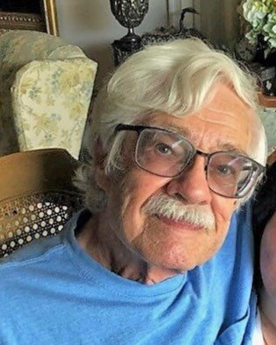
We are sad to report that Emeritus Professor George F. Votruba passed away on April 17, 2023. Professor Votruba earned his Ph.D. at the University of Michigan in 1964. His research area was functional analysis. He joined UM’s math department in 1968, and worked here for 32 years until his retirement in 2000. You can read more about him in https://www.gardencityfh.com/obituaries/george-votruba. In lieu of flowers, the family requests donations be made to the George F. Votruba Memorial Scholarship at the University of Montana.

From Crayons to Co-Degree
By Cory Palmer
Anastasia Halfpap—Anna as she is known to my colleagues and me—graduates this May with her doctorate in mathematics. This signals the close of a nearly 10-year chapter of undergraduate and graduate study in our department.
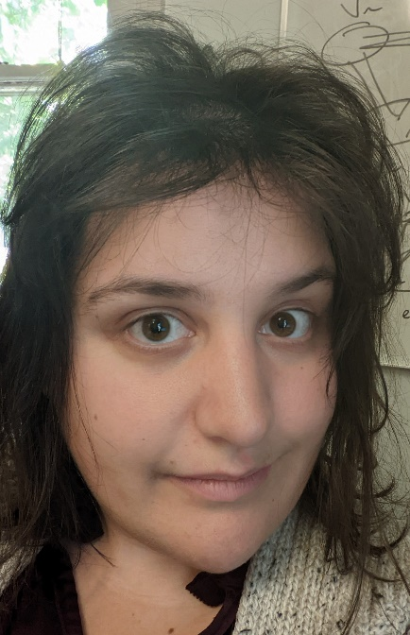
Anna Halfpap
I first got to know Anna during my second semester on the faculty in Spring 2014. Anna, then a precocious 15-year-old, enrolled in my graduate topics course: Extremal Combinatorics. Let me set the stage. This is a course for advanced graduate students. Most of those enrolled were at least a decade older than Anna with many courses under their belt. I have to admit, at the time I had some trepidation about her ability to keep up with the course material. However, this worry turned out to be wildly unfounded. With her first homework set it was clear that she belonged—even more, would excel—in my class.
Anna grew up in a mathematical household. Her mother Jen Brooks was a professor in our department (now at BYU) and her father Brad Halfpap is a colleague in the physics department. One of her earliest mathematical memories at age 6 or 7 occurs at a restaurant with her parents. Anna was given a paper placemat and crayons for doodling. Instead of drawing, she asked her parents to tell her something about the work they do. So, as an example, they gave her an introduction to Fibonacci numbers—pretty heady stuff for a kindergarten-aged kid! In a fun prophetic coincidence one of Anna’s current research projects closely involves that popular sequence. Perhaps it’s no surprise that she developed a passion for mathematics in such an environment.
Let me give a mini-CV of Anna’s academic achievements at UM. As best as I can tell, Anna only received a single A- among straight As during her entire time at Montana—both graduate and undergraduate. Moreover, she won essentially every undergraduate and graduate award available in the math department and a prestigious campus-wide Bertha Morton Scholarship. After graduation in 2018, Anna had PhD TA offers at several institutions and was an Honorable Mention for a (very prestigious) NSF Graduate Research Fellowship. Ultimately, she decided to return to U. Montana for graduate study.
I’ve had the great pleasure of serving as Anna’s undergraduate and doctoral advisor at UM. We’ve written three papers together (with several more on the way). It’s self-evident that a supervisor will have a great deal of influence on their student, but one of the highlights of working together has been how much I’ve learned from Anna!
Early on our meetings followed a pretty standard advisee-advisor arrangement. I posed questions and suggested approaches to problems for Anna to pursue between meetings. More recently, I’m more of a sounding board for Anna’s new ideas. An anecdote: recently Anna realized that a technical result called the hypergraph regularity lemma could be applied nicely to a problem we were working on, but I was not familiar enough with the details. So Anna taught them to me!
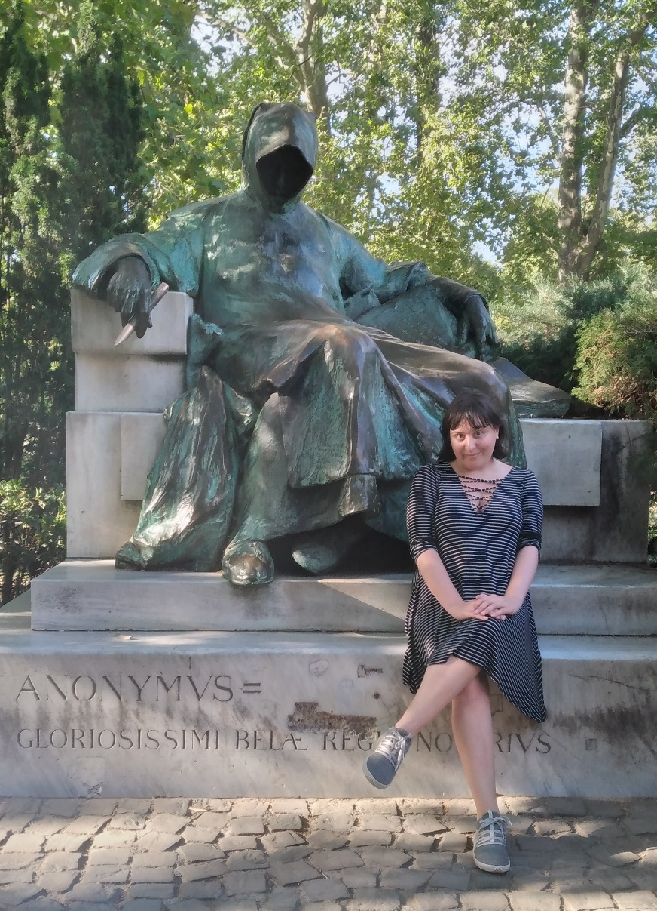
Anna in front of the Anonymous statue in Budapest. In the winter of ’32-’33 Paul Erdős often met here to discuss mathematics with his fellow students.
Anna’s primary research is in the field of graph theory. A graph is a collection of points (called vertices) and lines between pairs of vertices (called edges). Graphs are often used to model network-like structures. For example, a graph can be used to model the US highway system in the following way: major cities are represented by vertices, and we connect two vertices (cities) by an edge, if there is a highway between those two cities. Social networks are also often modeled by graphs where individuals are vertices and “friendships” are represented by edges. Modelling networks as graphs allows us to solve real-world problems via theorems in graph theory. For instance, when your car’s GPS gives you an optimal route to a destination, it’s just solving the so-called “shortest path problem” on the corresponding graph.
Anna works specifically in the subfield of extremal graph theory. This subject was initiated in the 1940s by a seminal theorem of Pál Turán. In the following decades, Turán’s theorem has been generalized extensively and examined in other combinatorial objects beyond graphs. The standard pursuit in this field is to determine the “extremal number” for a fixed graph F, i.e., what is the maximum possible number of edges in an n-vertex graph that does not contain F as a subgraph. The prototypical result is due to Mantel who showed that a graph on n vertices with no triangle subgraph has at most n²/4 edges.
Anna’s dissertation titled “On Three Generalizations of the Turán Problem” concerns generalizations and extensions of the classical extremal number question. These three generalizations are “subgraph-counting,” “rainbow Turán,” and “positive co-degree.” It is based on the work of 6 manuscripts she’s produced while at UM. An impressive output for a graduate student!
The positive co-degree problem was introduced by Anna and her coauthors in 2022 as an alternative to “ordinary” co-degree. This initial manuscript quickly drew interest from the extremal combinatorics community. A number of researchers reached out to Anna and her coauthors with interest in the paper’s results. Anna was invited to present the paper at a (virtual) seminar at Umeå University in Sweden. Anna points to this project as her proudest grad school accomplishment. As mathematicians we often worry that only the journal reviewers will read our articles, so it’s gratifying when peers are excited about our work.
Much of Anna’s grad experience was during the pandemic. This made productive research tough. Most mathematics research is done collaboratively and working over Zoom is a poor substitute for meeting in person. Among other things, Zoom misses the body language, coffee breaks, and “working” lunches that are so often valuable in a collaboration. Despite this, Anna successfully developed the positive co-degree ideas over weekly Zoom meetings.
Once travel became viable again Anna spent productive research trips at other institutions—Spring 2022 at U. Illinois and shorter trips to Hungary in Summer 2022 and Iowa State in Fall 2022. During each of these visits Anna met new collaborators and wrote new articles. Anna has truly embraced the Hungarian mathematical tradition characterized by problem-solving and inveterate collaboration.
Besides research, Anna served (like many grads do) as a TA. Anna did important work here teaching two different 300-level standalones: Linear Optimization and Intro to Probability & Stats. She’s been awarded an Outstanding Teaching Award this semester for her efforts.
Anna credits a supportive group of friends and fellow grad student as essential to her success. She’s told me that a focus on mental health is key in grad school. Indeed, her first advice to new grad students: do not underestimate its importance. Be sure to make an effort to find a place (geographically, emotionally, etc.) where you can thrive and the math will follow.
Outside of mathematical research Anna’s hobbies include singing—she’s been taking classical voice lessons for ten years—as well as bridge (a popular pastime also among my Hungarian combinatorialist colleagues). Anna also enjoys movies—including bad movies. We’ve spent many a Friday afternoon discussing Star Wars or the merits (rather demerits) of a stinker like Troll 2.
After nearly a decade in our department, Anna will be moving this fall to Iowa State University in Ames to begin a postdoc appointment under Professor Lidický. This is a premier department in combinatorics and the natural next step in her journey to become a professor.
I’m so proud of Anna’s accomplishments at U. Montana and I’m eager to see how she makes her mark on the next department!

Podcast with Anna Halfpap and Cory Palmer
As part of his Confluence Podcast, the Dean of UM’s Graduate School had very interesting conversations with Anna Halfpap and her advisor Cory Palmer. Listen online at https://scholarworks.umt.edu/confluence_podcast/. (Search “in this collection” for “Halfpap” to find both podcasts.)

Notes from the Chair
As I write this, we are nearing the end of June and of our academic year. The Math Building and the UM campus are quiet. I have started to think about next year, when the two Math faculty who have been on sabbatical return to our ranks. It will be good to have them back. As they come in, we have four faculty leaving on sabbatical. We will miss them as they collectively travel the globe.
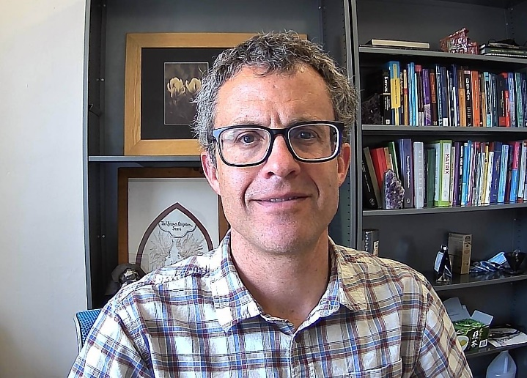
John Bardsley
The academic year that is now ending has been productive for UM-Math on many fronts, but particularly in our training of graduate students. Three PhD students, four MA-Math students, three students with an MA in Teaching School Mathematics, and two MS in Data Science students completed their degrees. In addition, two of our graduate students received the Bertha Morton Scholarship, which is UM’s premier scholarship for graduate students. See the first page article on one of our graduating PhD students, Anna Halfpap, who has been a student in our department since she was 15 years old.
Also thirteen undergraduate Math majors graduated this year. One of our department’s most successful former graduates, Diana Thomas, BA ’91, is a permanent faculty member in Math at West Point, and she recently won an award from the American Mathematical Society for her research. See the accompanying article on Diana beginning on the last page.
Our faculty were also productive in research related activities. One highlight was Elizabeth Gilaspy’s hosting, at UM, of the 2022 Groundwork for Operator Algebras Lecture Series (GOALS). GOALS took place here at UM-Math over two weeks last summer. Most of the attendees were graduate students getting foundational training in operator algebras, preparing them to move into research in that and related areas. See the accompanying story focused on last summer’s GOALS.
Another highlight from the year was Cory Palmer’s Pi Day 24-hour marathon math lecture. Cory and his three PhD students presented an entire one-semester Discrete Mathematics course (our Math 225) in a 24-hour continuous lecture, beginning on Pi Day, March 14.
This issue of the newsletter also highlights Jon Graham’s service as a coach for Mathcounts at Washington Middle School, which he has done since 2011. Jon has been an extremely successful coach, earning the title of Montana’s National Team Coach for nine out of thirteen years.
Lastly on the faculty front, we recently lost one of our former colleagues, George Votruba, who was a faculty member in our analysis group from 1968 to 2000; see the accompanying notice on page one.
Finally, I would like to thank those of you who have donated to our department over the past year. We have used the money well. In addition to funding scholarships and awards for our students, donations have made many other important things possible over the past year: the High School Math Achievement Awards, the Montana Science Fair, undergraduate summer research, research-related travel by faculty, graduate students, and visiting speakers, Colloquium talks and dinners, Math Department social gatherings, publishing and mailing this newsletter, the 24-hour math lecture on Pi Day, and more.
Best wishes to you all. Have a great summer, and please don’t hesitate to reach out if you are so inclined.
John Bardsley

GOALS 2022 at UM: Report on an International Workshop for Graduate Students
By Patrick Kreitzberg, Ph.D. student at UM
In the summer of 2022, the University of Montana hosted the 3rd annual Groundwork for Operator Algebras Lecture Series (GOALS), welcoming twenty graduate students, including myself, and eight guest speakers. Our very own Dr. Elizabeth Gillaspy organized the event alongside Dr. Rolando de Santiago (Purdue), Dr. Brent Nelson (Michigan State), and Dr. Kristin Courtney (University of Münster).
Operator algebras first came about as a mathematical formulation of quantum mechanics and remains a highly active area of research in modern mathematics. GOALS focuses on teaching early-career graduate students about two branches of operator algebras: C*-algebras and Von Neumann algebras. Much like this author and his identical twin brother, C*-algebras and Von Neumann algebras are very similar, almost identical, but they are still unique and special in their own way.
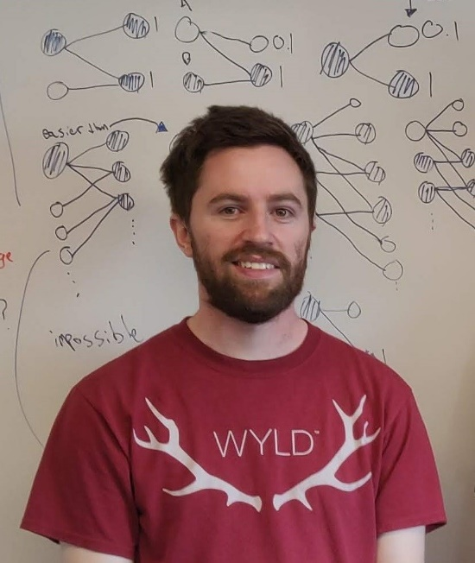
Patrick Kreitzberg
While most students (or GOALies as we have come to call ourselves) who attended are currently graduate students in America, they come from diverse backgrounds. We hosted students originally from India, South Korea, Spain, Puerto Rico, Nepal, Greece, Ireland and even lands as foreign and mysterious as Nebraska. For two weeks us GOALies spent six hours per day attending lectures and working on solving homework exercises together in the problem sessions. Along with learning and working on the materials, the GOALies were also introduced to several experts in the field of operator algebras in the form of both the organizers and guest lecturers and speakers.
During the first few days, we were introduced to the material at an accelerated pace. By the end of the first week, we were already tackling more complex and fascinating mathematical results. As a result, we became more comfortable with the material overall, which was crucial for the second week of the program. Throughout the second week, we had the privilege of having four experts each spend a day lecturing and aiding us during the problem sessions. In the evenings, these experts would often join us for some food and drinks, providing us with valuable opportunities to socialize and network.
Alongside lectures and problem sessions, GOALies participated in a few evening workshops aimed at improving our lives as graduate students. This included an almost therapeutic workshop wherein the students split into four groups, each led by an organizer to discuss the stress of our workload and our unique experiences with imposter syndrome. It was reassuring to us all to learn that the other students struggled with self-doubt and a sense of not belonging to the mathematics world, and our organizers battled these issues too. The group discussions also included a discussion on how to promote diversity in mathematics and how to challenge and overcome our implicit biases. For the final evening event we hosted a career panel with several guests who have done research in operator algebras and who discussed their current careers while answering questions from the students. The guests included two academics but also a scientist at Los Alamos National Laboratory, a finance manager at American Express, and an insurance actuary.
On the final Saturday, a culminating workshop was held where experts in the field, including all four organizers, one professor, and two graduate students, presented their research on operator algebras. It was enlightening to hear about the diverse range of work being done in the field, and it was clear that the other students were captivated and engrossed in the guests’ research presentations. It was especially fascinating to see a presentation about quantum information theory, one of the largest areas of operator algebras which was not covered in the lectures, and its interactions with graph theory. The workshop concluded with a final dinner, followed by drinks, pool, and dancing at the Union Club Bar, which is known as Missoula’s quintessential college dive bar.
Now, everyone knows that when you visit Japan you get sushi, when you visit Italy you get a Neapolitan pizza, and when you visit Missoula, you get yourself outdoors and into nature. In the evenings, the students had several options for activities, such as hiking up Mount Sentinel, walking around campus, or playing volleyball and basketball on campus. One of the students who took part in these activities was Adriana Fernandez Quero, who came to America on a basketball scholarship. Adriana put on an absolute clinic on the court.
During the weekends, GOALies had the opportunity to go on longer hikes and float down the river on inner tubes. This was especially enjoyable as the GOALS program took place during a two-week heatwave with temperatures in the high nineties. Fortunately, Georgios Baziotis, who spent time as a white-water rafting guide in his home country of Greece, was part of the program. Along with eight other GOALies, we rented a raft and paddles from the University and spent several hours white-water rafting down the Clark Fork hitting some great rapids along the way.
Even after the students have left, the spirit of GOALS is not fading because GOALS is more than just a two-week lecture series; it’s a community-building event. We GOALies have worked hard to keep the community together outside of the annual two-week lecture series. We hold monthly Zoom seminars where we share our work and other interesting topics in operator algebras with each other. We congregate at conferences such as the Great Plains Operator Theory Symposium where there is a planned meetup the night before the symposium starts to review preliminary topics for talks, discuss how to get the most out of the conference, and then go out for a group dinner. The Young Mathematicians in C*-Algebras (YMC*A) conference has historical ties with GOALS and is focused on bringing together junior researchers in the operator algebras field. Please, do not worry, YMC*A also covers Von Neumann algebras, so no GOALie is left behind! If, in 1978, the Village People released a hit entitled “YMVNCA” which would later become immortalized as number seven on VH1’s list of The 100 Greatest Dance Songs of the 20th Century, then I’m sure the conference would have been named the Young Mathematicians in Von Neumann and C*-Algebras, but we are not so fortunate.
The GOALS community has an active Discord channel where we post information about upcoming events and available job positions. In addition, members of the community engage in casual discussions about various topics such as their favorite music or anime, share memes, search for potential roommates for future conferences, or share pictures of their pets.
Thanks to GOALS, I now have confidence that I can go to any relevant conference and most likely find some GOALie peers. Even if they did not attend the same year as me, we still have that connection and likely know some of the same people. This is an incredible advantage in a field where networking is vital to landing great jobs, finding great collaborators, and just having fascinating discussions about research and mathematics in general.

Funding for GOALS 2022 was provided by National Science Foundation Grant DMS-2154574 and the University of Montana Department of Mathematical Sciences.

Gloria Hewitt Featured on EvenQuads Card
The Association for Women in Mathematics published in 2021 a new card game called EvenQuads that honors notable women mathematicians. Among the honorees is Emeritus Professor Gloria Hewitt who taught at the University of Montana for 38 years, from 1961 to 1999. Below is an image of the profile side of the card featuring her; the impressive portrait was created by the artist Mila Matney. You can read more about Gloria Hewitt at https://awm-math.org/publications/playing-cards/deck1/#hewitt. For information about EvenQuads and the other amazing women mathematicians it honors, visit https://awm-math.org/publications/playing-cards.
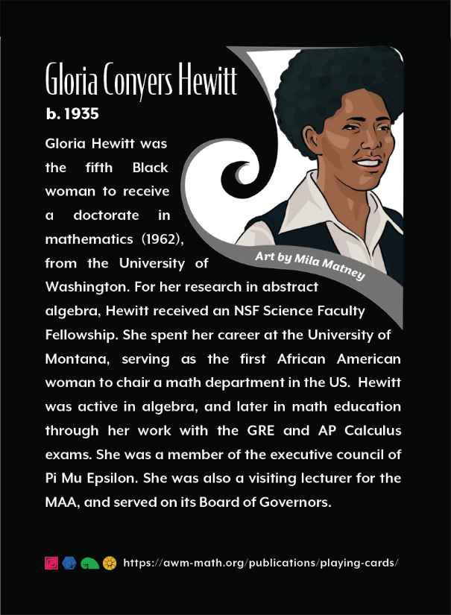

Jon Graham’s Other Job: Mathcounts Coach & Mentor
By Matt Roscoe
Jon Graham was first introduced to the middle school mathematics competition Mathcounts by fellow statistician Dave Patterson. At the time, Dave’s son Alec was participating. Interesting problems from the competition became a regular subject of discussion between the two of them. Once Jon’s oldest daughter grew to middle school age, he started volunteering as an assistant coach for her team at Sussex School where the school’s founder, Bente Winston, had established a long tradition of excellence. In 2011 his second daughter enrolled in middle school at Washington Middle School (WMS). Jon volunteered to coach together with Kari Boucher, an 8th grade math teacher there, and has been serving in this capacity ever since.
A typical season for these mathletes starts the first week in October. Students meet for an hour and a half after school once a week. Jon directs the first part of the season to introducing students to Mathcounts problems which, he says, they often find more interesting, more challenging and more fun than the problems that they get in their middle school math classes.
Towards the middle of the season, Jon makes an effort to introduce students to mathematical concepts and ideas that are common to the competition: prime number theory, Pythagorean triples and combinatorial counting are examples. There is time for fun as well. One gathering that has become a tradition is the annual Mathcounts geocache scavenger hunt. Jon, an avid geocacher himself, organizes mathletes into teams and prepares a unique circuit for each. Teams use the solution to a math problem to fill in a missing digit in a latitude or longitude coordinate. A GPS unit then takes the team to the next station in the circuit where another math problem awaits. Teams race to the final clue and a prize is earned at the end, “Kids always love it,” Jon says.
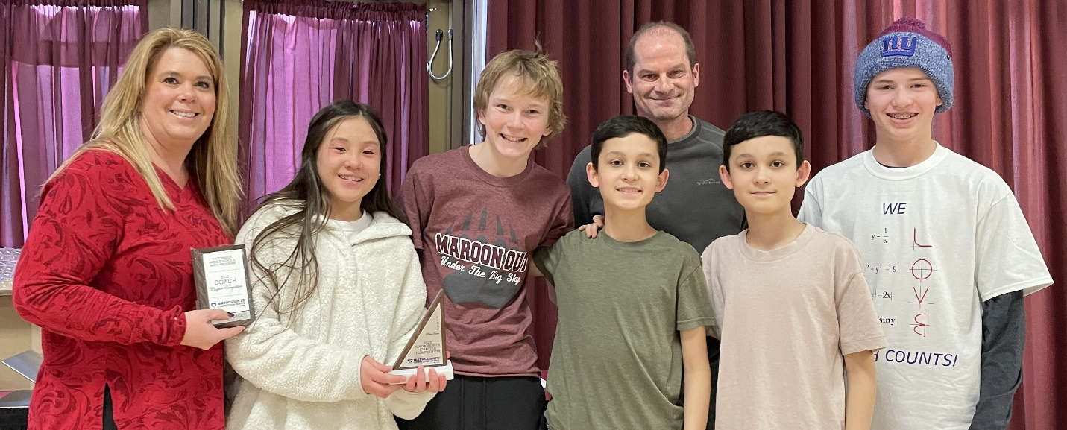
Coaches Kari Boucher and Jon Graham with their team at the regional competition in February. The mathletes are (from left) Bonnie Groenenboom, Gabe Hammitt, Kieran Alviar, Jasper Alviar, and Isaac Lukacs.
As the competition in February approaches, Jon’s coaching grows more focused. Practice is offered twice a week, with one gathering held on campus in the Math Department. Jon helps his competitors prepare for each of the components of the competition: Sprint, Target, Team and Countdown. Once every season, parents of competitors are invited to also participate in a “kids against parents” competition – which is almost always won by the young mathletes.
Jon’s dedication to this effort has certainly helped many young mathematicians compete successfully. In every year that Jon has coached, his team has qualified for the state competition by placing among the top three or four teams competing in the Western Montana regional competition. At state, the mathletes Jon coaches have also done remarkably well. Usually one and sometimes two members of Washington’s team place in the top four, earning these individuals an all-expense paid trip to the national competition. Nine times in 13 years Washington’s team has done well enough in the state-wide competition to designate the WMS coaching staff as the state’s national team coaches, earning Jon and Kari a trip to the nation-wide competition. Of course, these years there are more practices to organize, stretching Jon’s commitment to this effort well into May, when the last competition is held.
It clear that Jon’s efforts are truly appreciated by these kids and their parents. Tarl Briggs was coached by Jon as a WMS mathlete. He’s now a Missoula CPA. He remarked, “Jon’s passion for math helped me understand new topics and inspired me to pursue math further after I was out of middle school...even getting a degree in applied math.” Finn Westenfelder, who earned an undergraduate degree in Computer Science and is now pursuing graduate studies, comments, “Jon taught us problem solving skills...this was the most valuable aspect of the program for me...these skills have benefited me far beyond middle school.” Magnolia Chinn also gave a glowing review. She attributes her decision to study engineering at MIT to her early exposure to STEM via Mathcounts. She applauded Jon’s commitment on weeknights and weekends and providing detailed solution sets for home study. In her words, “Jon fostered a collaborative team environment, applauded our successes and encouraged us through challenges with genuine and unwavering support no matter how competitions went.” She went on to say, “I think it’s quite rare to get to work with such an accomplished math professor like Jon as early as middle school and I feel incredibly lucky to have had Jon as a mentor.”
Finally, parents are impressed with Jon’s efforts as well. Amy Kinch, whose son Griffin competed as a WMS mathlete, says, “I am sure that Jon commits hundreds of hours of service to the Washington team each year...he expects greatness, much like an athletic coach might, and he cultivates strong engagement and interest...students, including my own [son], grow to truly love math through Jon’s mentorship.” She also spoke highly of his efforts to involve parents and teachers which, she says, created a sense of community and celebration.
This year, the WMS Mathcounts team once again posted impressive results. The team won both the regional and state competition – designating Jon and Kari as the national team coaches. Two of the WMS mathletes earned a right to represent Montana as members of their 4-person team. Jon, Kari and the team will travel to Orlando, FL for the national competition in May. After more than 18 years being involved with the program, Jon does not show any sign of slowing down. “It’s really the highlight of my week...the kids are just thirsty for learning...and excited about mathematics,” he says.
After she retired from teaching, Jon once asked his mentor, Bente Winston, when she might suspend involvement with Mathcounts, her answer was, “When I die.” Jon says, “That has always stuck with me...I have come to feel the same.” The anecdote demonstrates that Jon’s commitment to the development and support of young mathematicians through Mathcounts rises above mere community service. It has become a calling, a vocation – a component of his life’s work. As Jon puts it, “It’s something that I want to continue for the rest of my life, it’s just so much fun...to work with the kids and these problems.”

Would you like to try a Mathcounts Problem?
Jon’s all-time favorite Mathcounts problem appeared in the 2005 National Competition. This problem and more recent ones from the 2023 Chapter Competition are provided as a challenge to readers. The answers are on page 8.
- A gecko is in a room that is 12 feet long, 10 feet wide and 8 feet tall. The gecko is currently on a side wall (10’ by 8’), one foot from the ceiling and one foot from the back wall (12’ by 8’). The gecko spots a fly on the opposite side wall, one foot from the floor and one foot from the front wall. What is the length of the shortest path the gecko can take to reach the fly assuming it does not jump and can only walk across the ceiling and the walls? Express your answer in simplest radical form.
- Each face of a right square pyramid has a perimeter of 24 cm. What is the volume of the pyramid? Express your answer in simplest radical form.
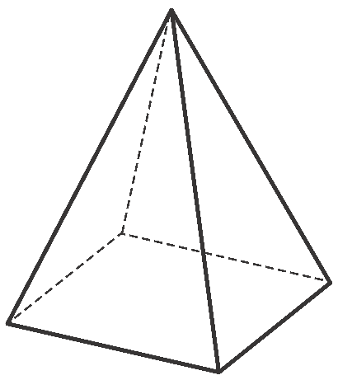
- Suppose that 4 letters are chosen at random without replacement from the phrase “MAZAMORRA MORADA.” What is the probability that the four letters chosen can be arranged to spell AMOR? Express your answer as a common fraction.
- Two parallel planes a distance of 8 meters apart intersect a sphere. Each of the circles where the planes intersect the sphere has an area of 128 π m2. What is the surface area of the sphere? Express your answer in terms of π.
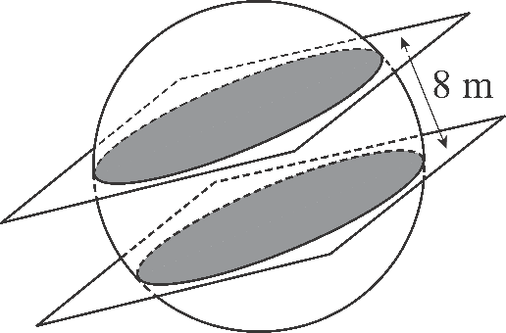
Answers at the end of the newsletter (under Backmatter). Problems © 2005-2023 by MATHCOUNTS.

Donation Request Box
The Department of Mathematical Sciences increasingly relies on donations to support its activities. In particular, scholarships are very important for our students. Please consider a gift to the Math Department’s Excellence Fund, to be used where the need is greatest, or to one of the other funds and endowments:
- Endowed Scholarship Funds: The Adams Scholarships, Anderson Mathematics Scholarship, Gloria C. Hewitt Graduate Scholarship in Mathematical Sciences, Joseph Hashisaki Memorial Scholarship, Mac Johnson Family Scholarships, William Myers Mathematics Scholarship
- George and Dorothy Bryan Endowment: Supports undergraduate and graduate students
- Lennes Fund: Provides funds for the Lennes Exam Competition
- Colloquium Fund: Provides funds to bring in visiting speakers
To donate online, please visit https://supportum.org/give/. Please specify in the Comments box that the donation is for the Dept. of Mathematical Sciences. For information on other ways to give, please contact Dan Minor: dan.minor@supportum.org or by phone at 406-243-2646 (or call toll free 1-800-443-2593).

Update on the Honor Roll of Donors
We always enjoyed acknowledging your donations in the Honor Roll of Donors, which had been a regular feature in this newsletter for over two decades. But this spring, the University of Montana Foundation advised us against including it in future newsletters, to protect the privacy of donors who have not given explicit permission to recognize them.
While we can no longer list you by name, we still thank you for your generous support!
In addition to funding scholarships and awards for our students, donations have made many other important things possible over the past year: the High School Math Achievement Awards, undergraduate summer research, research-related travel by faculty, graduate students, and visiting speakers, Colloquium talks, our Department Picnics at the beginning and end of the academic year, publishing and mailing this newsletter, a 24-hour marathon lecture on Pi Day, and more! We are grateful for your support – we couldn’t have done it without you!

Diana M. Thomas, BA '91, Wins Math Research Prize
By John Bardsley
I recently spoke with UM Math alum Diana M. Thomas on the occasion of her receiving the 2023 Mary P. Dolciani Prize for Excellence in Research from the American Mathematical Society. The Dolciani Prize recognizes a mathematician with a distinguished record of scholarship from a department that does not grant a PhD and who has had success mentoring undergraduate students in research. Diana mentioned that she thought her research outside of mathematics (see below) was an important factor in her receiving the prize, as well as her mentorship of several undergraduates who worked full time while in school. Diana is one of only four permanent civilian Math faculty members at West Point, a position she has held since 2016. The remaining approximately 66 Math faculty at West Point are postdocs or military officers on two-to-three-year appointments. Diana held the postdoc position from 1996 to 1998.
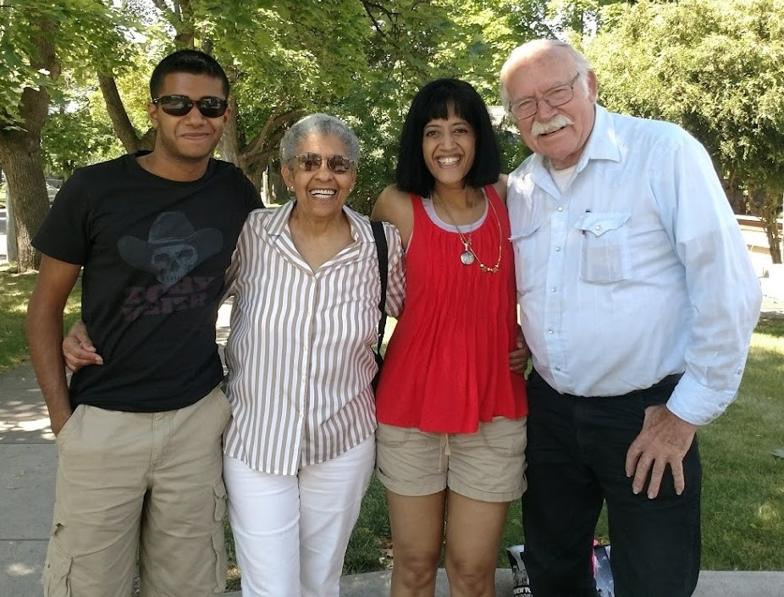
Diana (third from left) with her son Ajay and retired math faculty Gloria Hewitt and George McRae
Diana grew up in a family of six in Glendive, Montana. Her father was a doctor, who traveled around eastern Montana serving patients in remote locations. She graduated from Dawson County High School in 1987 and came to UM that fall. She said that she chose UM over MSU because it was the liberal arts university, and although she chose to study mathematics, she pursued a passion for playing guitar throughout her time at UM and had many fond memories of playing on campus and in student groups. She was also in two formal groups that played together, one specializing in country and the other in heavy metal. When I pointed out the discrepancy in musical styles, she said it makes sense because those were the two most popular types of music in Glendive at the time. She was also a tutor in the Math Learning Center, which taught her that she did not want to become a high school teacher, so she set her sights on academia. From our discussion, it is evident that Diana looks back very fondly at her time at UM, in our department, and in Missoula.
When I asked her about memorable professors, she mentioned Bill Ballard, Bill Derrick, Gloria Hewitt, George McRae (her advisor), George Votruba, and Keith Yale. The three professors who made the biggest impact on her were Gloria Hewitt, Bill Derrick and George McRae. She said she took every course she could from Bill Derrick – remembering fondly the ODEs/PDEs book by Derrick and Grossman – and she did a thesis with Professor Derrick in PDEs, studying Burger’s equation. She said that George McRae was a ‘wonderful mentor.’ He encouraged her to apply for one of the first research experiences for undergraduates (REUs) in the country, which she attended. She asked George what she should do to best her chances of being able to get a faculty position in the Math Department at UM, and he told her to get her PhD as far from Montana as possible. So, she applied for the PhD program at Georgia Tech and was accepted. There, she worked under Professor Shui-Nee Chow, receiving her PhD in 1996 with a dissertation on Lattice Dynamics.
Diana’s first position following her PhD was a postdoc at West Point from 1996 to 1998. The position was ½ research with the U.S. Army, where she studied ‘the use of voting theory to combine classifiers,’ and ½ teaching at West Point. For the following two years, from 1998 to 2000, she had a position in the Math Department at New Jersey City University, where she wrote an applied math paper on West Nile virus. From there, she moved to a permanent position at Montclair State University – across the river from Manhattan – where should would be for the next 17 years. At Montclair State, she said that she ‘taught everything,’ including graduate level pure mathematics courses, and through a very demanding seminar at NYU led by Dennis Sullivan, she slowly became a pure mathematician, moving her research into the fields of algebraic and topological dynamics.
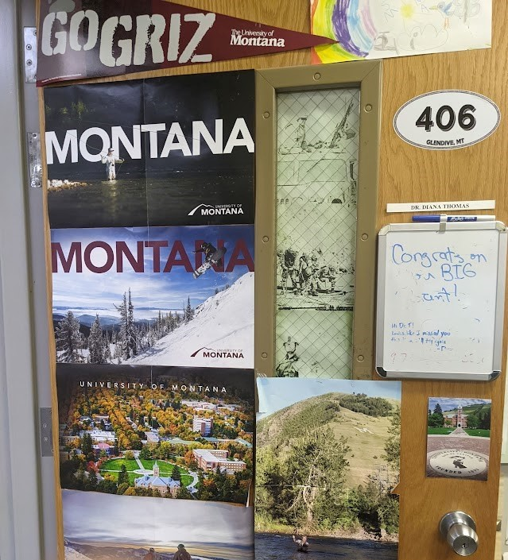
Diana’s office door shows true Griz spirit!
Later in her time at Montclair State, Diana moved her research back toward more applied topics, with collaborators in health and medicine. This move began with an undergraduate research project that she led in Biology. She worked together with an OBGYN, looking at the dynamics of fetal growth. Then, after attending an NIH conference where she began asking and learning how to conduct medical studies, she began shifting her attention toward research in nutrition and obesity. She eventually obtained three NIH grants and established the Center for Quantitative Obesity at Montclair State. Associated with this work, she co-developed the cell phone app called SmartLoss, which monitors energy balance versus weight, an important factor for obesity. In a separate research project, she did a pilot study to get data for an NIH grant studying placental shape in pregnant women.
I had heard that West Point has a unique pedagogical approach for training its students, and when I asked Diana about it, she mentioned that the cadets are required to come to class and do not work outside of the college, which is different from a state school, such as Montclair State and UM. For example, she mentioned that one of her undergraduate research students at New Jersey City State University worked full time as a tollbooth operator on the New Jersey Turnpike. However, she also said that (as at UM) the best students at Montclair State are as good as anywhere, including West Point. At West Point, the Thayer method is used, which puts responsibility on the students for learning. Students study material prior to attending class, and the class time is spent discussing that material. In our department, we call this the ‘flipped classroom’ approach, which several of our faculty use.
Finally, Diana has three children, two in high school (Anjali and Aishwarya) and one in the Army (Ajay). Her husband, Anand, is an Associate Vice President at LTI Mindtree. Although as an undergraduate she had dreamed of returning to Montana, and to UM as a Math Professor, in particular, her entire family now lives back east, including her mother. Thus, she no longer has family ties in Montana, but she remains Montanan through-and-through, with a clear connection to the state, to Missoula, to UM, and to our department.
It was a pleasure to speak with Diana and to learn of her impressive accomplishments. Congratulations, Diana, on receiving the Dolciani Prize. We are proud of you!

Degree Recipients 2022-2023

Bachelor Degrees
- Jonah Britton
- Rebecca Elise Bryan
- Sarah Evans
- Jordan Ashley Jarrell
- Esther Lyon Delsordo
- Alivia Dawn Milyko
- Daniel Kennedy Ryan
- Jack Schwaiger
- Zachary Adam Taylor
- Adam P. Viray
- Anthony Warren
- Aiden Watson
- Luke Daniel Wyman

MA in Mathematics
- Marcelo Alonso Almora Rios
- Bergen Dolan
- Jake Oetinger
- Eric Wagner

MA in Teaching School Mathematics
- Caitlin Elder
- Keyleigh Hennessy
- Samuel Richard Parke

MS in Data Science
- Sebastian Brahm Coombs
- Ian G. Derickson

PhD in Mathematics
- Ian G. Derickson — Advisor: Dr. Leonid Kalachev
Analysis of COVID-19 in Rural America
- Anastasia Halfpap — Advisor: Dr. Cory Palmer
On Three Generalizations of the Turán Problem
- S. Joseph Lippert — Advisor: Dr. Elizabeth Gillaspy
Persistent Structure of Higher-Rank Graphs and Their C*-Algebras: A Path Towards Geometric Classification

Spring 2023 Scholarships & Awards
Made possible by our generous donors - Thank you very much! Starred awards are funded primarily (*) or completely (**) by the George and Dorothy Bryan Endowment.
Because of privacy considerations, we no longer publish the names of the scholarship and award winners.
- Joseph Hashisaki Memorial Scholarship
- The Adams Scholarships (2)
- Anderson Mathematics Scholarship
- Mac Johnson Family Scholarships (3)
- Carolyn and Johnny Lott Elementary Education Scholarship
- Merle Manis Award
- Undergraduate Teaching Scholar Awards* (2)
- Undergraduate Tutorial Scholar Award*
- N. J. Lennes Competition Award
- William Myers Mathematics Scholarships (3)
- Gloria C. Hewitt Graduate Scholarship in Mathematical Sciences
- Graduate Student Distinguished Teaching Awards** (2)
- Graduate Student Summer Research Awards** (4)
- John A. Peterson Mathematics Education Awards (2)
- President’s Outstanding Student Awards (5) (from the President's Office)

Backmatter

Answers to the Mathcounts Problems
- $2 \sqrt{113}$
- 36$\sqrt{7}$
- 6/91
- 576 π

Address
Department of Mathematical Sciences
Mathematics Building (MMAI01)
32 Campus Drive
Missoula, MT 59812-0864
Phone: 406-243-5311
Email
Website

Comments or suggestions?
Please email the newsletter editor, Nikolaus Vonessen.

