Fire Suppression Repair Plan

For the

Mendocino Complex Incident – Ranch Fire

Mendocino National Forest Lands

CA-MEU-008674

Mendocino National Forest

Pacific Southwest Region

August 17, 2018

Prepared by: ________________________________________________________
Japhia Huhndorf, Resource Advisor, MNF

Prepared by: ________________________________________________________
Devin Quintana, Resource Advisor, CNNF

Reviewed by: ________________________________________________________
Gary Urdahl, Lead Resource Advisor, MNF

Approved by: ________________________________________________________
Ann Carlson, Forest Supervisor, MNF

Approved by: ________________________________________________________
Ken Heffner, Agency Administrator

Approved by: ________________________________________________________
Jerry Mcowan, Incident Commander

Table of Contents
Overview 1
Objectives 1
General Repair Objectives 1
Guidelines 2
General Repair Guidelines 2
Wilderness Repair Guidelines 5
Site Specific Management Items 6
Appendix A: Effective Water bars 7
Appendix B: Suppression Repair Data 9

Overview

The implementation of this fire suppression repair plan will be in compliance with all pertinent rules and regulations regarding fire suppression activities and is to comply with management direction and standards and guidelines in the Mendocino National Forest Land and Resource Management Plan. Guidelines for the repair of the various fire suppression activities, as well as the responsibilities for implementation are indicated in the following narrative.

The Mendocino Complex consists of two separate fires: the Ranch Fire and the River Fire. The River fire burned 48,920 acres, none of which was Forest Service land. The Ranch Fire is still actively burning along the northern edge as of the signing of this document, so the acres listed below are as of 16 August 2018, and will likely increase. Ownership of the land involved in the Ranch Fire Incident is as follows:

Mendocino National Forest: 245,744 Acres

Other (Private, BLM): 81,726 Acres

Total: 327,470 Acres

Implementation of suppression repair will be the responsibility of the Incident Management Team (IMT). This will be accomplished in cooperation with the Mendocino National Forest (MNF). Suppression repair will commence once the Suppression Repair Plan is in place and there is no danger of the fire burning into, or across, the repaired fireline. The assigned Resource Advisors will develop a list of needed repairs. Implementation of some suppression repair activities may take place after the incident has transitioned from the IMT to the home unit; these activities will be determined and monitored by Resource Advisors. This plan has been approved by the National Forest Agency Administrator and the Incident Commander of the IMT. Any additions or clarification of guidelines will be incorporated by addendum.

Objectives

The overall objective is to repair damage caused by the fire suppression activities, and to return the affected area to pre-existing conditions as nearly as possible. Repairs for the Ranch Fire incident will occur on roads, fire lines, drop points, staging areas, safety zones, spike camps, helispots, water drafting locations and all other facilities used by suppression resources.

General Repair Objectives
- Safety: ensure all supression repair is done in a safe and efficient manner.
- Minimize surface and gully erosion by preventing concentrated water flow
  - Minimize sediment delivery to stream channels to maintain water quality
  - Restore conditions to pre-fire drainage patterns
  - Return road drainage elements to functioning stable condition.
- Minimize loss of soil productivity due to potential erosion in cleared areas.
- Minimize vegetation damage and utilize seeding for revegetation where appropriate.
- Minimize the introduction or spread of noxious weed infestations.
- Protect cultural resource sites that were impacted and repair destabilized areas that threaten sites.
- Minimize impact to anadromous fish habitat by repairing fireline water crossings and water drafting sites.
- Identify infrastructure (fences, gates, etc.) that were damaged and repair/restore as needed.
- Restrict undesired motor vehicle access to newly constructed fireline: re-establish road closures, road widths, and block junctions between roads and firelines.
- Cleanup: remove all suppression-related material, including debris, flagging, signage, fire hoses, etc.
- Adhere to wilderness suppression repair standards within wilderness areas.

Guidelines
Assessments will be ongoing, based on operations and events as they occur within the fire area, especially the area that is still actively burning. Additional suppression area disturbances will be recorded and mapped as they are discovered. Suppression damage discovered in these ongoing assessments will be repaired to the standards and guidelines described in this Suppression Repair Plan.
Prior to suppression repair on private lands within the National Forest administrative boundary, coordinate with Resource Advisors. Resource Advisors will supervise suppression repair work on these private lands. Private landowners will be notified of planned repair work whenever possible. Communication with private landowners may require coordination with an Agency Administrator or IMT Liaison. If a private landowner refuses access or suppression repair, it must be documented in writing.
Equipment used for suppression repair will be thoroughly cleaned of any plant materials prior to entering work areas. All incident vehicles will be cleaned prior to demob to reduce the risk of transporting invasive noxious weeds to other areas.
Repair guidelines for Wilderness areas are found after the section on general repair guidelines.

General Repair Guidelines
- Archaeology
No repair work shall commence at known heritage and archeological resource sites without consultation with the archaeologist and lead Resource Advisor to the fire.
- Fire lines
- Pull back berms and piles (logs, topsoil, and available slash) onto the fireline to blend with adjacent natural contour. Leave a roughened surface to promote infiltration, erosion control, and recovery of native plants. Where available, scatter brush over the fireline.
- Water bars will be constructed on all fire lines where surface erosion is a concern and access is no longer needed. See Appendix A for instructions on water bar construction and placement.
- Heavy equipment is needed for repair of dozer lines, and it is highly preferred that this work is done by an excavator. In specific locations Resource Advisors may require that repair is done with an excavator.
- Where a fireline crossed a natural drainage, any soil, debris, and woody material added to the water course channel needs to be removed to at least above high water line, and preferably above slope break into the stream. The natural contour of the channel will be restored.
- Where equipment disturbed perennial streambanks or wetland areas, the damage may have to be repaired by hand to prevent further erosion and allow vegetative recovery. Consult with a Resource Advisor or specialist for this repair.
- Lines going straight downhill (perpendicular to contour), where water will simply run downhill parallel to the fireline, may cause excessive erosion. Back-blading is particularly preferred. Alternate the drain direction of water bars so they drain water off both sides of line (herringbone pattern).
- Seeding is only needed on firelines when unburned litter, duff, and soil are unavailable or insufficient to spread over the disturbed soil. Hand line will rarely be seeded; dozer lines of many blade widths are higher priority for seeding. The seed mixture applied should be approved by a Forest Service botanist (see guideline D4 below).
- Roads and Roadways
Roads used to support fire suppression activities will be repaired to a condition that is as close to pre-fire conditions as reasonably possible. This includes any spur roads and turnouts. This will include treatments designed to provide water drainage, to prevent surface erosion, to reduce compaction within identified areas, to minimize noxious weed spread, and to repair road surface damage.
  - Restore road ditches, side drains, rolling dips and other road drainage features that were damaged by fire suppression activities. If inslope culverts are partially or wholly blocked, they will need to be cleaned out to allow unobstructed water flow.
  - Roads and spurs will be returned (graded) to their pre-existing condition. Refer to a Mendocino National Forest roads map for road levels.
  - Where rolling dips are installed or repaired, divert water onto vegetation, rocks, and/or slash. Drain water into natural channels where possible.
  - Any earthen berms, rock barricades, or other types of road closure features removed during reopening of roads should be replaced. The Mendocino National Forest will address long-term motorized access issues.
- Drop Points, Staging Areas, Helispots, Safety Zones
Most open or cleared sites used for suppression activities will be restored. Sites that are most likely to be needed to support future suppression activities, such as helispots, can be stabilized in a condition available for future suppression activities.
  - Large cleared areas should have berms spread out to contour, and vegetation pulled back over the area.
  - Where heavy vehicle traffic has compacted soils away from road prisms, scarify or deep rip (2”-6”) the area as appropriate to reduce compaction.
  - Inventory and monitor disturbed areas used for suppression activities for the spread of noxious weeds.
  - Because these large areas generally do not have sufficient unburned litter, duff, and soil to cover the area, they should be seeded with a native seed mix approved by a Forest Service botanist. Seed should be broadcast with a hand operated seed spreader that has been properly calibrated. Seeded areas may be mulched with straw after planting to reduce seed predation and erosion. All seed and straw used in suppression repair shall be certified weed-free.
The table below describes the proposed seed mixture, which contains perennial grasses (PG), an annual grass (AG), an annual forb (AF) that is also a nitrogen fixer to improve soil quality, and a long-flowering perennial forb (PF) for pollinators. Some species, especially the forbs, may vary depending on availability. All seed will be obtained from genetically appropriate local sources.
Species | Common name | Lifeform | lb/acre
Bromus carinatus | California brome | PG | 5
Elymus glaucus | blue wildrye | PG | 5
Hordeum brachyantherum | meadow barley | PG | 2
Festuca microstachys | three weeks fescue | AG | 3
Elymus trachycaulus | slender wheatgrass | PG | 3
Trifolium willdenovii | tomcat clover | AF | 1.5
Grindelia camporum | common gumplant | PF | 1.5
TOTAL |  |  | 21

- Felled Trees and Other Vegetation
Merchantable trees in excess of those needed for rehab will be moved to the nearest landing site. Non-merchantable trees and other cut vegetation may be machine piled for future burning. Leaving this cut vegetation in place will create excessive fuel conditions and future fire hazard.
- Trails
  - Where a designated National Forest System recreation trail was used for fire line, reconstruct the trail tread to 24”.
  - Any use trails created during fire suppression activities will be blended into the landscape and restored to pre-fire conditions. Block and visually obscure the junction where the trail connects to any road.
- Litter and Garbage Removal
Litter, garbage, flagging, and discarded hose stockpiled and dispersed by fire personnel will be removed from all suppression sites. Fire crews are to police their areas of responsibility. All equipment and supplies associated with fire suppression will be removed from fire lines and dispersal sites, such as drop points.
- Fences and Gates
Repair any fences or gates cut or damaged by fire suppression activities.

Wilderness Repair Guidelines

The Ranch Fire has burned a large portion of the Snow Mountain Wilderness. The overall goal of fire suppression rehabilitation in wilderness coincides with the intentions of the Wilderness Act, which states: “....wilderness is an area effected primarily by nature, with human activity substantially unnoticeable....” The appearance of the adjacent unburned/undamaged area should be used as a guide for wilderness suppression repair activities.
A Resource Advisor should be present to oversee all suppression repair in Wilderness.
- Archaeology
No repair work shall commence at known heritage and archeological resource sites without consultation with the archaeologist and lead Resource Advisor to the fire.
- Firelines
  - Replace mineral soil, duff, litter, and recoverable rocks that were removed during fireline construction. Obliterate any berms and leave as natural appearing.
  - The above materials must be mounded in the fireline 4-6" higher than original contour to compensate for settling. Add supplemental organic matter, if necessary, to accomplish the above.
  - Provide some means for drainage to prevent erosion in sloped areas. Water bars/check dams should not be too large, take extra care when placing these in wilderness. Place check dams and drainage ditches as needed using the suggested guidelines given in the table below:
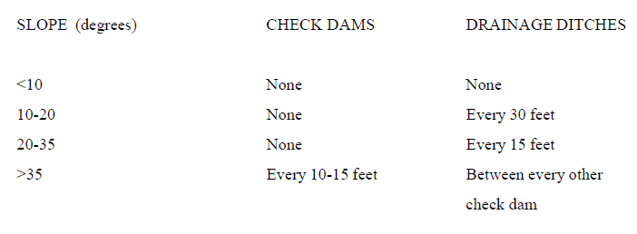
  - Where the dozer or hand line meets a trail or road; vegetation, windrow, and any other native materials should be used to visually obscure these entry/exit points so that they look natural for the full length of sight distance from the road or trail.
  - Cup trenches should be filled in and restored to natural reference condition.
  - Replace dead and downed material (i.e. logs) that was previously on the fireline.
  - Scatter some cut brush/limbs onto the fireline – one layer thick only – so it blends with the natural appearing landscape.
  - Seeding should not be necessary on repaired hand line in wilderness, provided that unburned soil, duff, and litter was returned to the fireline. If unburned material is not available, consult with a Resource Advisor.
- Staging Areas, Drop Points, Safety Zones, Spike Camps
Large disturbed areas such as these should be minimal in Wilderness. Suppression repair should focus on making the area look as natural as possible. These areas should be assessed for repair needs by a Resource Advisor. If these sites have large areas of soil disturbance, they should be seeded with a native seed mix as described in section D4 of the General Repair Guidelines above.
- Helispots
There is currently one designated helispot in the Wilderness area. All wilderness helispots should be assessed for repair needs by a Resource Advisor.
- Felled Trees and Other Vegetation
  - All cut stumps need to be flush cut and obscured with soil or vegetation along line. Naturalize and obscure evidence of chainsaw use. Ensure cut log rounds are placed away from trail corridors. Spread dirt by hand on the cut part of logs and branches.
  - Position cut logs and stumps in a manner that is least noticeable to visitors.
  - Scatter obvious, excess accumulations of cut limbs/seedlings/saplings into a more natural arrangement
  - Use a variety of means to camouflage cut faces of stumps and bolewood: rocks, dead woody material, fragments of stumps, bolewood and/or limbs, soil, and fallen/broken green branches.
- Trails
  - Where a designated National Forest System recreation trail was used for fire line, reconstruct the trail tread to 24”.
  - Any use trails created during fire suppression activities will be blended into the landscape and restored to pre-fire conditions. Block and visually obscure the junction where the trail connects to any road.
- Litter and Garbage Removal
All litter, garbage, flagging, and equipment used by fire personnel will be removed from all suppression sites and trails. Fire crews are to police their areas of responsibility. In camps all human refuse is to be buried.

Site Specific Management Items
Due to the fact that the fire is still active and active suppression is ongoing, site-specific suppression repair will be addressed in one or more addenda to this plan.

This fire suppression repair plan is subject to changes and amendments as the situation changes and additional rehabilitation needs are identified. The Resource Advisors are currently conducting field inspections and will pass on any site-specific needs as soon as possible.

Appendix A: Effective Water bars
When locating and building water bars, place them the right distance apart, at a diagonal to the fireline, so that they divert, then discharge, then dissipate the energy of the flowing water. Be sure to make them deep enough so they'll be durable, and that soil does not block the water bar outlet. Waterbars should be dug as dips, not constructed from fill.

Recommended spacing for waterbars on firelines.
Waterbars constructed by hand on hand line should be at least two Pulaski widths (4-6 inches) wide and 6-12 inches high.
Waterbars constructed by heavy equipment on dozer lines should be at least 12 inches wide and 12-18 inches high.
Fireline slope  % |  | Maximum Distance Apart (feet)
1– 5 | ……………………. | 200
6 – 20 | ……………………. | 125
21 – 40 | ……………………. | 60
41 – 60 | ……………………. | 40
>60 | ……………………. | 25
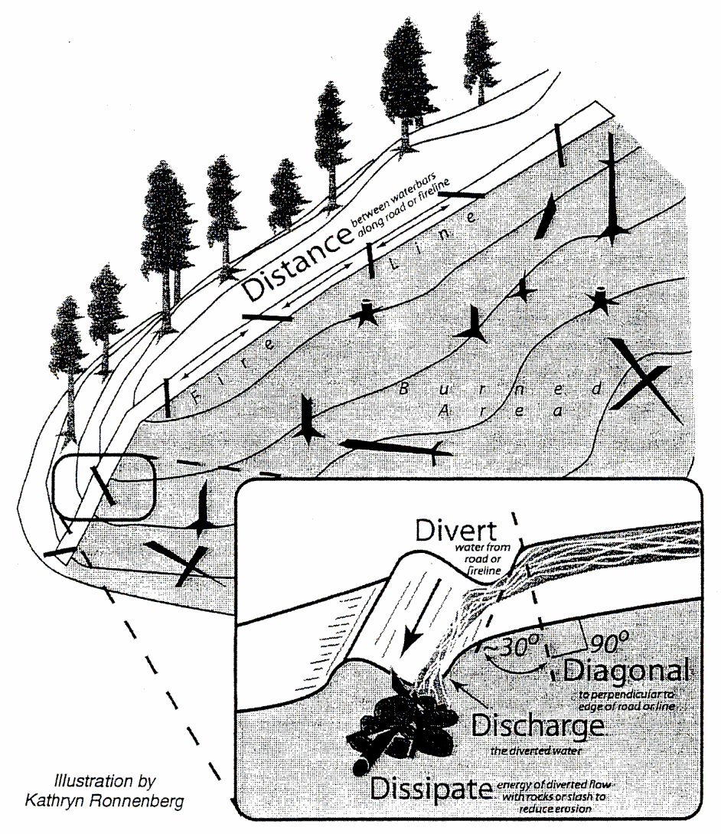

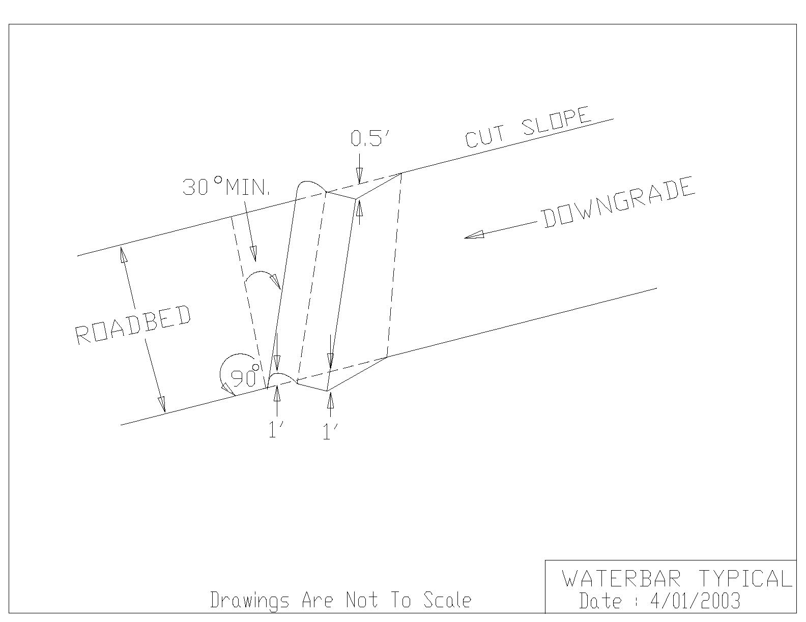

Water bar construction
  - Space water bars based on gradient, following the chart above.
  - Build water bars at a 30-45˚ relative to perpendicular to the fireline.
  - The outlet of the water bar must be cleared and open ensure proper drainage and prevent ponding or pooling of water. The outlet must extend beyond the edge of the fireline.
  - Water bars should be located so they drain onto vegetative cover, slash, rocks, duff, or other less erodible material. Water bars should not drain directly into drainages or unstable areas.
  - Excavate water bars as dips into firm soil instead of building as dikes from fill material.
  - Wherever possible, water bars should drain onto the unburned side of the line. On ridges, alternate direction of water bars (herringbone pattern) to prevent concentrating water on one side of the fireline.

Appendix B: Suppression Repair Data

This appendix will be provided separately as a spreadsheet from the Suppression Repair GIS Database along with a Map Product. Additionally, the GISS for the incident can add individuals with a NIFC ArcGIS Online account to the “view” group for the suppression repair map for use in the ArcGIS Collector Application. See the Situation Unit Leader or Plans Section Chief for more information.

The most up-to-date Appendix B data will be provided to the IMT in a timely manner by the Lead READ, typically on a daily basis during the full suppression repair phase (Stage 2). It is a ‘living’ document, subject to change; however, once repair recommendations have been developed for individual features, those recommendations will not change without approval from the Incident Commander and Agency Administrator or their Representative. The final version of this appendix will be submitted to the Incident Business Advisor, the signatory Incident Commander, and the Agency Administrator as necessary.

How to read Appendix B:
Individual repair features may be identified by a Repair ID number as well as a general label and location information. READs, ARCHs, and Heritage Consultants will inspect suppression damages and develop recommendations for suppression repair. Once recommendations have been developed, the features will be coded red and given a level of priority; low, medium or high. When suppression repair is initiated on individual features, they will be coded yellow. When suppression repair is complete, it will be inspected by a READ and, if necessary, an ARCH and/or Heritage Consultant. If suppression repair work acceptable and in a final state, the individual feature will be coded green.

