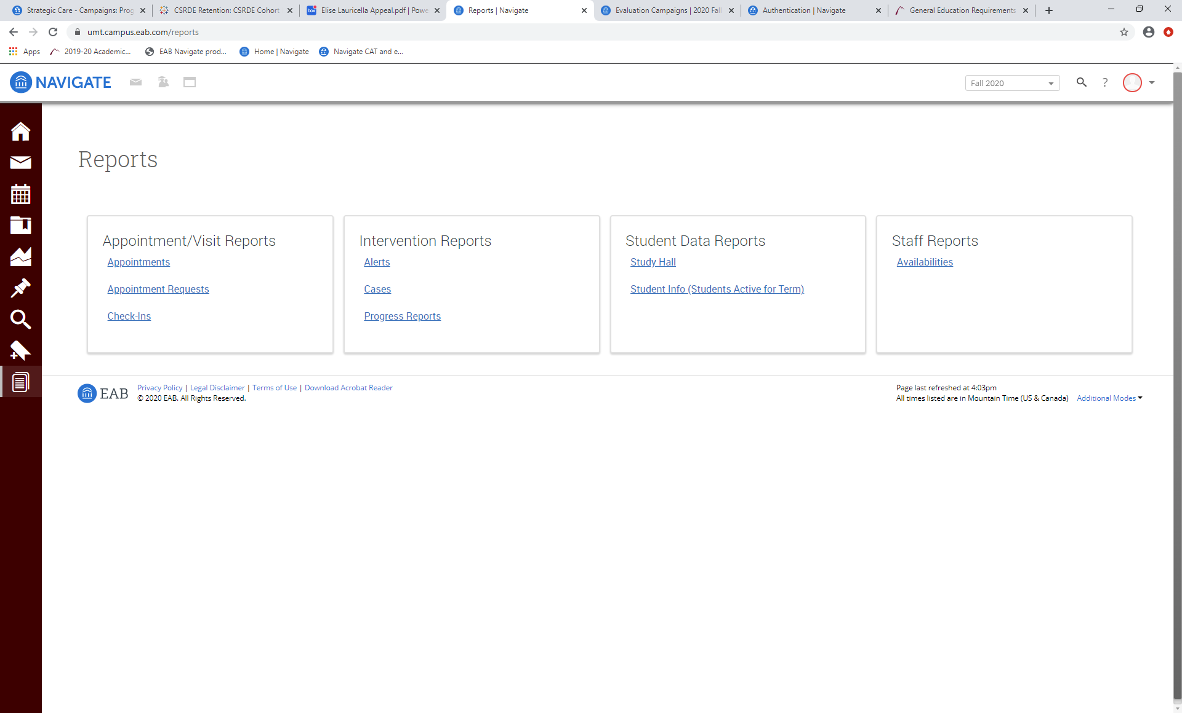

**Step 1 – click “Reporting” icon on left menu column from home page**

**Step 2 – click “Alerts”**

**Under “Intervention**

**Reports”**

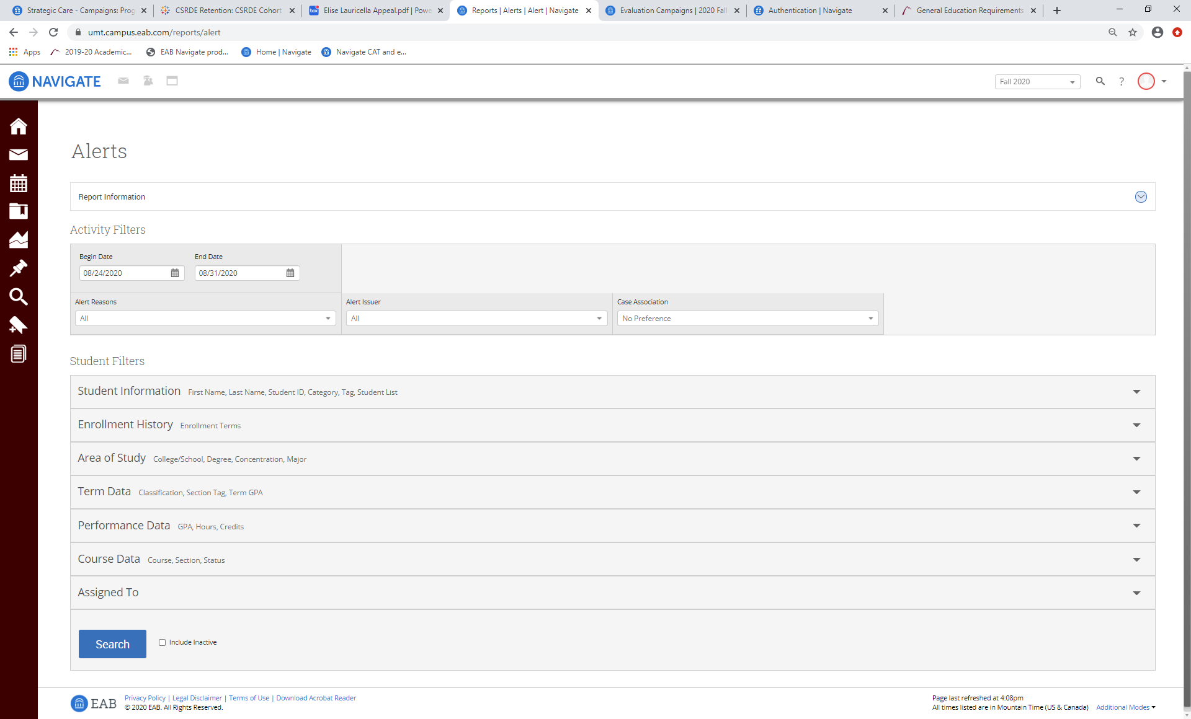

**Step 3 – enter date range and leave “alert reasons” and “alert issuer” set to “all”**

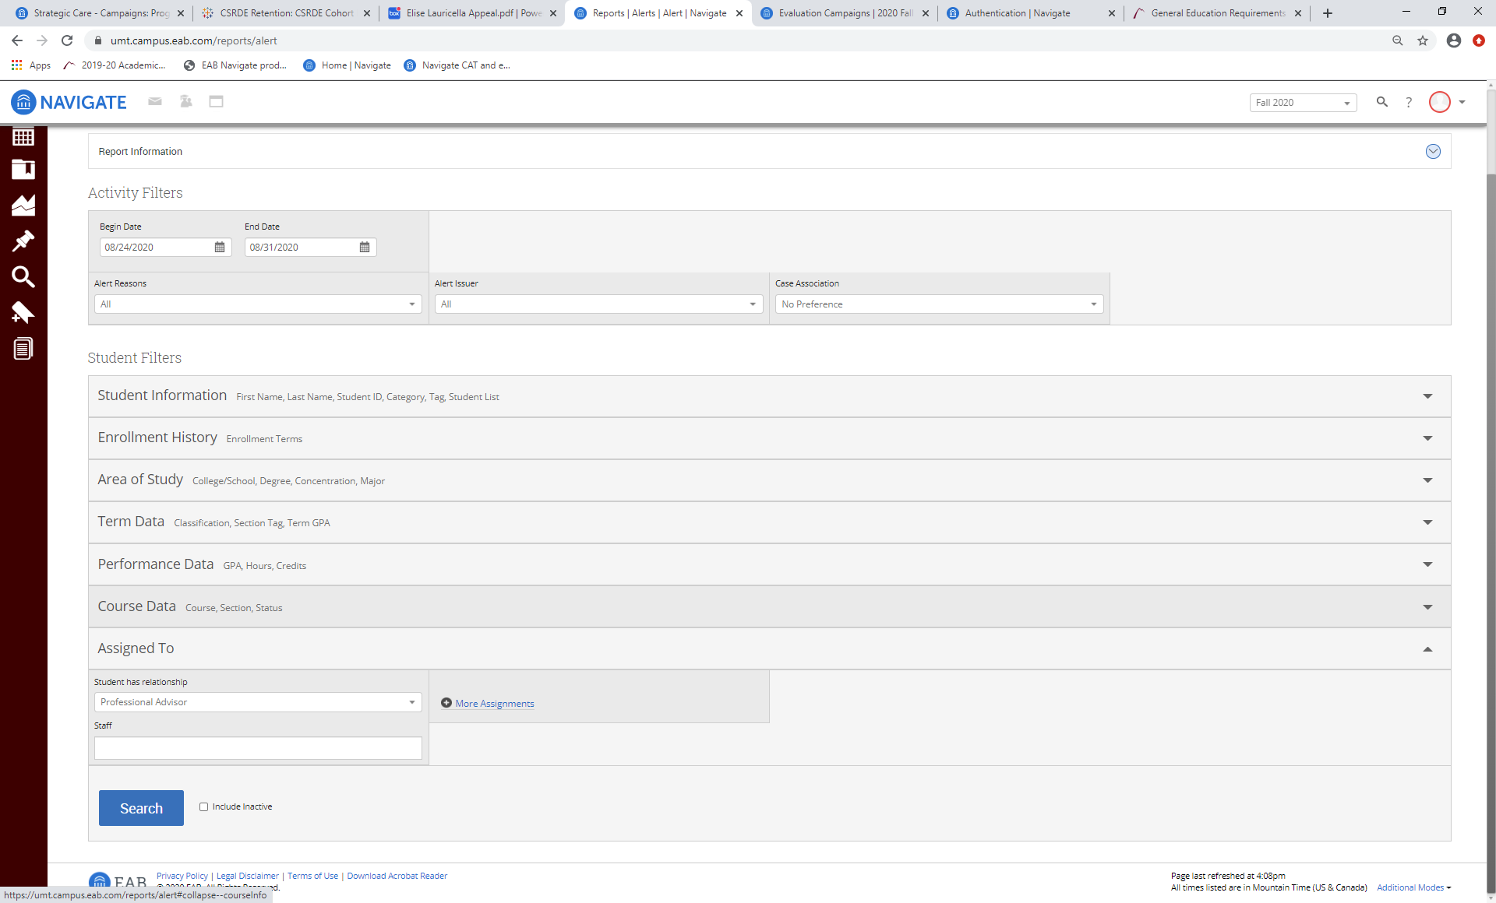

**Step 5 – Click “Search” – a listing of your advisees who have been issued alerts should appear on the screen. You can then select multiple actions for the student(s) (e.g. send message, create appointment campaign, enter notes, add to student list, etc.)**

**Step 4 – within the “Assigned To” portion of the “Student Filters” section, select the relationship between you and the student. The vast majority of primary role advisors will be listed as either “Advisor” or “Professional Advisor” within the “Student has relationship” drop-down menu. Most faculty advisors will be listed as “Faculty Advisor” or “Faculty Mentor”. After making your selection, enter your name in the “Staff” field or select your name from the alphabetical listing of campus advisors.**

**If you don’t see your name in the “Staff” field, try changing the selection in the “Student has relationship” drop-down menu to one of the other selections until you can find and select your name.**