Faculty/Advisor/Staff Access to Online Advising Tools
Banner XE-Advisor, Registration Planner, Degree Works & Starfish

Overview:
Several new online advising and communication tools are now available for faculty, advisors, staff and administrators.
Degree Works is an academic advising, transfer articulation and degree audit solution that allows students and their advisors successfully navigate degree requirements. The system also provides academic audits of compliance with federal financial aid and NCAA regulations.
Student Educational Planner is a degree planning tool within Degree Works which contains 2-year and 4-year degree templates by major. The templates can be used by students and advisors to plan and subsequently track degree progress.
Starfish is a student success platform and advising portal that provides students and their advisors the resources and communication tools they need to ensure the successful completion of their degree.
Banner XE Advisor Profile is the latest web self-service architecture delivered within the main student information system and provides the advisor a more user-friendly, comprehensive view of Banner student data and the ability to enter advising notes.
Banner XE Registration is a new web self-service module which combines the degree planning and registration planning process with course registration.
Banner Workflow is an application which automates business processes and directs information and notifications generated from the steps within a business process to users or user roles associated with the process. For example, automatically changing the advisor assignment when the student declares a new major and notifying the student, previous advisor and new advisor after the change is made.
Access to these new online advising tools is based on the role and relationship an employee has to the students.

Security Requirements
The Registrar is the custodian of student academic data and sets the guidelines and procedures for protecting the data and ensuring it is used appropriately. The Registrar is also responsible, along with Legal Counsel, for ensuring UM is in compliance with FERPA regulations.
The Registrar requires that access to student academic data is only granted to those that have a teaching or advising relationship with the student. In the case of academic leaders and academic program & support services directors who are University officials with legitimate educational interests, access is restricted to students in the respective college, department or program.
The Registrar further requires that access to student academic data must be consistent between all of the advising technologies listed above.
The remainder of this document defines the faculty/advisor coding structure (maintained jointly by the Registrar’s Office and the Office for Student Success) and the processes that ensure compliance with the Registrar’s security requirements.

Staff Types
Employees needing access to one or more of the online advising tools will be classified into one of the staff types listed below. The employee’s classification (code) is entered into Banner and is used by a series of extract programs which load the user accounts into the various software tools and set the appropriate security classes or profiles which allow access to the tools and associated student data. Please see Appendix A – Code Matrix for Advising Staff Types for more details.
It should be noted that these Staff Types may also be used to facilitate Banner Workflow processes and for messages sent from the Banner Communication Manager.

List of Staff Types and Definitions

FACULTY Associated with students as an assigned instructor for a course in the current or scheduled term. Access limited to students on their assigned course roster(s). Maintained on Faculty Assignment form (SIAASGN).
ADVISOR Assigned to a student as an academic, professional or program advisor. Access limited to their list of assigned advisees. Maintained on Multiple Advisors form (SGAADVR).
PEER ADVISOR Student worker who has trained and approved to provide basic academic advising information to other students within an academic department, advising center or program office. Access limited to assigned advisees or students within their College or Department.
ADVISING COORDINATOR Primary advising coordinator for an academic department, college or school. Access limited to students within their College, Department or Program.

DEAN Official/acting dean of one of the eight academic colleges and schools. Also included in this category are the Deans of the Graduate School, Honors College and Bitterroot College. Access limited to students within their College.
ASSOCIATE DEAN Official/acting associate dean of one of the eight academic colleges and schools. Access limited to students within their College.
DEPARTMENT CHAIR Official/acting department chair (or assistant chair) of an academic department within one of the eight colleges and schools. Access limited to students within their Department.
ACADEMIC/MAJOR PROGRAM DIRECTOR Official/acting chair of a program within an academic department. Access limited to students within their Department.
COLLEGE/DEPARTMENT ADMIN Primary administrative contact for an academic department, college or school. Access limited to students within their College or Department.
ACADEMIC SUPPORT PROGRAM DIRECTOR Director of an academic student services program reporting to Academic Affairs. Access to all students.
ADMINISTRATIVE DIRECTOR/STAFF Director or staff of a non-academic student services program or office reporting to units other than Academic Affairs who are required to maintain student data or who need student data to process transactions for the student. Access to all students.
TUTOR Staff who have been trained and approved to provide academic tutoring to other students. Access to student information is limited to only those data elements required for tutoring (i.e. contact and appointment information, registration data, ability to enter meeting notes and make referrals to other academic support services).

Quick Reference of Staff Types and Security Access to Advising Technologies
SIAINST Staff Type (Role) | Security Access (SGAADVR Advisor Type Code)
Faculty | Students on assigned course roster
Faculty Advisor | Assigned advisees
Advisor | Assigned advisees
PEER (Peer Advisor) | Assigned advisees or College or Department Level as needed based on advising model (COLL or DEPT)*
ADVC (Advising Coordinator) | College or Department Level as needed based on advising model (COLL or DEPT)
DEAN (Dean) | College Level (COLL)
ASOC (Associate Dean) | College Level (COLL)
DPCH (Department Chair) | Department Level (DEPT)
DIR (Program Director-Major) | Department Level (DEPT)
ADMN (Department Admin) | Department Level (DEPT)
COAD (College/Dean’s Office Admin) | College Level (COLL)*
PGM (Academic Support Program Director) | All Students*
STAF (Administrative Director or Staff) | All Students*
TUTR (Tutor) | Restricted access – requires Registrar’s approval

Summary of Security Control Methods
Banner Forms | Banner XE | Degree Works/SEP | Starfish
Oracle security classes  *NOTE*  College/Department level security is NOT available so access is restricted to transactional users only and requires approval by the Registrar. Approved users will be granted access to all students in the related advising technologies. | Based on Staff Type. College/Department level security uses a combination of:  - Faculty/Advisor Information form (SIAINST),  - Faculty Assignment form (SIAASGN) and  - Multiple Advisors form (SGAADVR)  *NOTE*  College/Department level security requires additional advisor assignments which will not display to the students and will require custom automation to configure and maintain. | Advisor extract scripts use the SIAINST Faculty Attribute value | Advisor extract scripts use a combination of SIAASGN, SGAADVR and the SIAINST Faculty Attribute and Faulty Comment sequence 1 values

Requesting Access
Campus users will request access to the various advising technologies via a web form located on the OSS Advising web page.
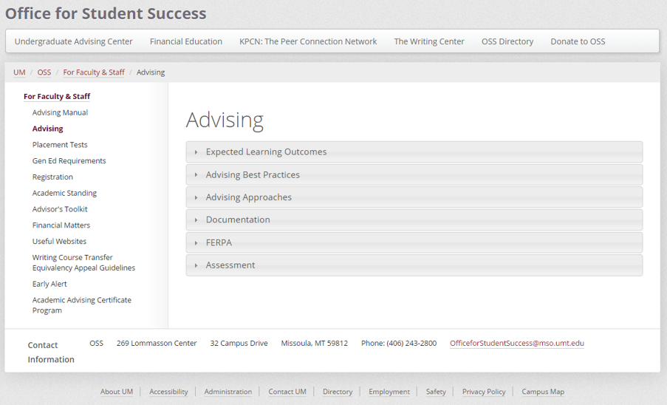
Request Access to Advising Technologies
The responses to the questions on the web form (see sample below) will be used to determine the appropriate Staff Type and related coding in Banner, which in turn controls the assigned security profiles in Banner XE, Degree Works and Starfish. Refer to Appendix B for the Faculty/Advisor Information (SIAINST) data entry instructions.
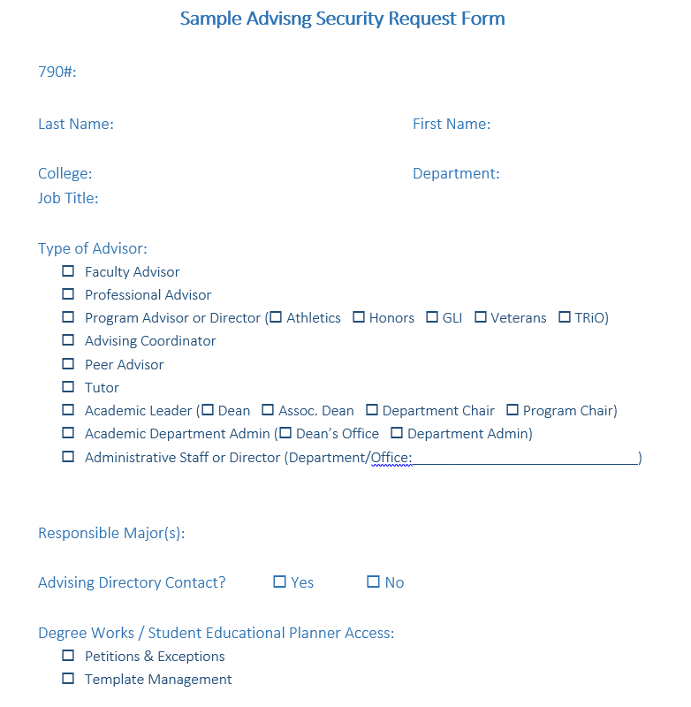

APPENDIX A – Banner (SIAINST) Coding Matrix for Advising Staff Types
Staff Type | SIAINST Code | DegreeWorks  User Class | Starfish  Security Role | Starfish  Coll/Major(s)/Cohort | CommMgr  College | CommMgr  Department | CommMgr/Advr  Major(s) | CommMgr/Advr  Advisor Type
Faculty | Faculty checkbox | ADVX | Instructor (no attributes) | None | College | Department | None | FAC
Faculty Advisor | Faculty checkbox  &  Advisor checkbox | ADVX | Primary Advisor | None | College | Department | Major(s) | FAC
Professional Advisor | Advisor checkbox | ADV | SFGA  General Advisor | None | ‘*’ or College | ‘*’ or Department | ‘*’ | PROF or  Cohort Advr Type
Program Advisor | Advisor checkbox | ADV | SFGR  Group Advisor | Coll/Major(s)/Cohort | ‘*’ or College | ‘*’ or Department | ‘*’ | PROF or  Cohort Advr Type
Peer Advisor | Advisor checkbox | ADV/ADVX | SFPA *if ADV, else None | Coll/Major(s)/Cohort *if SFPA, else None | ‘*’ or College | ‘*’ or Department | ‘*’ | PEER
Advising Coordinator | Advisor checkbox  &  Staff Type=ADVC | ADV | SFGR  Group Advisor | Coll/Major(s)/Cohort | College | Department | ‘*’ | PROF
Dean | Staff Type=DEAN | ADV | SFAL  Academic Leadership | College | College | ‘*’ | ‘*’ | FAC?
Associate Dean | Staff Type=ASOC | ADV | SFAL  Academic Leadership | College | College | ‘*’ | ‘*’ | FAC?
Department Chair | Staff Type=DPCH | ADV | SFAL  Academic Leadership | Major(s) | College | Department | Major(s) | FAC?
Academic/Major Program Director | Staff Type=DIR | ADV | SFAL  Academic Leadership | Major(s) | College | Department | Major(s) | FAC?
College/Department Admin | Staff Type=ADMN | DEPT | SFAL  Academic Leadership | Coll/Major(s)/Cohort | College | Department | Major(s) | PROF  *if listed in Advising Directory, else None
Academic Support Program Director | Staff Type=PGM | ADV | SFAD  Administrative Leadership | None | 00 | 0000 | None | None
Administrative Director/Staff | Staff Type=STAF | DEPT | SFSS  Student Services Support | None | 00 | 0000 | None | None
Tutor | Staff Type=TUTR | None | SFTU  Tutor | None | ‘00’ or College | ‘0000’ or Department | None | None
APPENDIX A (continued) – Code Matrix for Other Staff Types

Staff Type | SIAINST Code | DegreeWorks  User Class | Starfish  Security Role | Starfish  Coll/Major(s)/Cohort | CommMgr  College | CommMgr  Department | CommMgr/Advr  Major(s) | CommMgr/Advr  Advisor Type
Registrar’s Office Staff | Staff Type=STAF | REGX | SFSS  Student Services Support | None | 00 | 0000 | None | None
Registrar’s Office Power User | Staff Type=STAF | REG | SFAD  Administrative Leadership | None | 00 | 0000 | None | None
Advising Office Power User | Staff Type=STAF | ADVP | SFSA | None | 00 | 0000 | None | None
SEP Template Manager | *same as original Staff Type value | ADVT  will replace original DegW user class value | *same as original  Starfish Security Role value | *same as original value | *same as original value | *same as original value | *same as original value | *same as original value
Financial Education Staff | Staff Type=STAF | ADV | SFFC  Financial Educator | None | 00 | 0000 | None | None

APPENDIX B
Faculty/Advisor Information form (SIAINST) Data Entry Instructions

- After logging into Banner, go to the SIAINST form

- Enter or find the 790 number for the faculty/advisor

  - To find the 790 number, leave the ID field blank and tab to the next field and enter the last name, first name. The ‘ % ‘ symbol is the wildcard if you need to search on a portion of the last name or first name

- Make sure the current term code is in the Term field and then Control-Page Down to the next block/section

- If the From Term in the block is not equal to the current term, click on the Maintenance icon (this copies the old information and allows you to update the fields to the new values we need)

- Update the following fields as needed:
  - Status
  - Faculty checkbox
  - Advisor checkbox
  - Staff Type

- Control-Page Down to the next page

- Do not change or add anything to the Faculty Contract block

- Control-Page Down to the next block – Faculty College and Department

  - If the College and/or Department fields are correct, do not make any other changes

  - If the College and/or Department fields are blank or are different than the request form, the new code will need to be added/changed.
    - If the From Term is the same as the current term, you can just type over the old value with the new values.

    - If the From Term is less than current term, click on the Maintenance icon and then click on the Record menu option at the top of the screen and select Remove. Once the record is removed, enter the new College and/or Department code.

- Control-Page Down to the next block – Faculty Attributes

  - Do not remove any existing codes

  - If the attribute field is blank, the new code will need to be added.

    - If the From Term is the same as the current term, you can just type over the old value with the new values.

    - If the From Term is less than current term, click on the Maintenance icon, select Copy Faculty Attributes and then enter the new attribute codes.

- Control-Page Down to the next block – Faculty Comments

  - Row 1 = Starfish Organization (major code or cohort code) Use ‘ ~ ‘ in between multiple codes
  - Row 2 = Banner Communication Manager Primary College code
  - Row 3 = Banner Communication Manager Primary Department code
  - Row 4 = Banner Workflow Auto Advisor Assignment Major code Use ‘ ~ ‘ in between multiple codes
  - Row 5 = Banner Workflow Auto Advisor Assignment Advisor Type code

