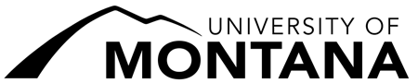
UNIT STANDARDS REVIEW SIGNATURE FORM

Department of:

Effective Date: _
This field will be completed by the Office of the Provost.

1) Department Chair:

Signature Date

2) Dean:

Signature Date

3) Chair, UM Unit Standards Committee:

Signature Date

4) Provost and Vice President for Academic Affairs:

Signature Date

