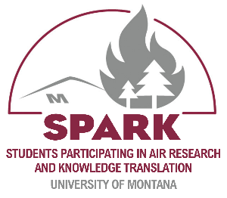
Name:
Date:

Public Health and Translational Research

Part 1: Bridging Science and Society
- What features of public health research make it unique from other types of research?

- Define “translational research.”

- The research arc from initial studies to real-world solutions involves four basic steps. Provide the examples of this process related to wildfire smoke below.
Basic Research
Applied Research
Implementation
Evaluation

Research to People: Making a Difference
- Read through the examples provided of how research has influenced people and practice, resulting in real-world changes that help protect public health during wildfire events. Which of these examples have you seen in your community or on the news? Describe one example.

The Role of Community Engagement
- Public health is most effective when the community is involved in the solution(s). How can you, as a member of your community, help to contribute to public health efforts regarding air quality? Read through the four example ways communities can actively contribute to public health efforts. Then, share in the space below how you could help with one of these efforts.

Part 2: Designing and Conducting Authentic Science Research Projects
- Using your own words, describe “authentic science research.”

- Authentic science research involves essential characteristics that distinguish it from basic classroom activities. Fill in the characteristic associated with each description below:
_________________________________: Presenting findings to classmates, teachers, or the broader community to communicate the significance of your research.
_________________________________: Gathering information through direct observations, hands-on experiments, or engaging with community sources for authentic research.
_________________________________: Selecting topics and formulating questions that genuinely interest you to guide your research project effectively.
_________________________________: Focusing on issues impacting your school, neighborhood, or local environment to ensure meaningful and applicable research outcomes.

- List the common steps of the scientific research process that are bolded in the lesson:

Developing a Research Question and Hypothesis
- Now that you know what makes a strong research question, list two possible research questions you might like to investigate in your SPARK project.

- A hypothesis is a tentative explanation to your research question. Choose one of your research questions and generate a hypothesis.

Collecting and Analyzing Data
- There are several methods available for collecting data in air quality projects. Which of the methods listed might you consider for your project? If none of these methods will apply, what will your approach be for collecting data? If you are struggling to answer this question, you may want to reconsider your research question.

Research Ethics and Responsible Conduct
- Which of the four best practices for conducting ethical research might apply to your project? How will you go about ensuring that you are adhering to ethical standards?

Communicating Your Research Findings
- Strategies to help you best communicate your science research include: knowing your audience, using visuals, telling a story, highlighting importance, and practicing presenting. As you begin your SPARK research project, what are some things you can do from the beginning to ensure you are able to communicate your findings effectively?

