FACT SHEET ON FLAMMABLE LIQUID STORAGE
- Storage of flammable liquids must occur in either the original container from the manufacturer, or in approved containers as illustrated in Table 1 of this fact sheet.

- "Flammable liquid" means any liquid having a flashpoint at or below 199.4 °F (93 °C). Flammable liquids are divided into four categories as follows:

Flammable Liquids
Category | Criteria
1 | Flash point < 23°C and initial boiling point ≤ 35°C (95°F)
2 | Flash point < 23°C and initial boiling point > 35°C (95°F)
3 | Flash point ≥ 23°C and ≤ 60°C (140°F)
4 | Flash point ≥ 60°C (140°F) and ≤ 93°C (200°F)

- When liquid with a flashpoint greater than 199.4 °F (93 °C) is heated for use to within 30 °F (16.7 °C) of its flashpoint, it shall be handled in accordance with the requirements for a Category 4 flammable liquid.

Maximum Capacity of Containers for Flammable Liquids
TABLE 1
Container Liquids Type | Flammable Liquids
Container Type | Category 1 | Category 2 | Category 3 | Category 4
Glass or approved plastic* | 1 pt | 1 qt | 1 gal | 1 gal
Metal | 1 gal | 5 gal | 5 gal | 5 gal
Safety Cans | 2 gal | 5 gal | 5 gal | 5 gal
*Approved means approved or listed by either Underwriter's Laboratories or Factory Mutual Engineering Corporation.
Storage Cabinets: "Maximum capacity." Not more than 60 gallons of Category 1, 2, or 3 flammable liquids, nor more than 120 gallons of Category 4 flammable liquids may be stored in a storage cabinet.
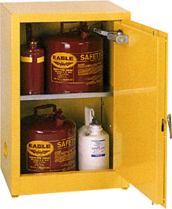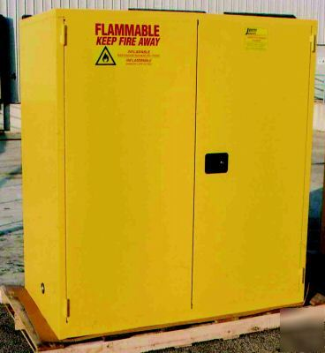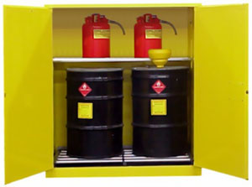
Number of Storage Cabinets: The number of storage cabinets allowed in a Fire Area is listed below:
Maximum Number of Flammable Storage Cabinets allowed in any one Fire Area
Non-sprinklered Area | 3 per fire area
Cabinets separated by 100 feet | 3 per each 100 feet of travel distance
Automatic Sprinkler System | 6 per fire area
Fire Area: A "fire area" is an area of a building separated from the remainder of the building by special construction. This area has a fire resistance of at least 1 hour and has all communicating openings properly protected by an assembly that also has a fire resistance rating of at least 1 hour.
Flammable Liquid Storage Outside of a Flammable Storage Cabinet: The maximum quantities of flammable liquids that can be stored outside of a flammable storage cabinet are listed in the Table below:
Maximum Quantities Outside of a Flammable Storage Cabinet or Inside Storage Room
Class and Container Type | Quantity
Category 1 Liquids in Containers | 25 Gallons
Category 2, 3 or 4 Liquids in  Containers | 120 Gallons

