FACT SHEET ON SAFETY CANS
In an effort to prevent flammable and combustible liquid fires and personal injury, requirements have been set forth by the National Fire Protection Association (NFPA), the Uniform Fire Code (UFC), the Uniform Building Code (UBC), the Code of Federal Regulations (CFR - OSHA), the International Fire Code (IFC) and others.
Plastic gas cans for example cannot be used in the work environment for storage of flammable/combustible liquids due to the absence of certain safety features that approved safety cans have. Safety Cans serve several critical functions:
- Safely contain hazardous liquids and control vapors to reduce the risk of fire, protecting both personnel and facilities
- Offer compliance with federal OSHA regulations and state and local fire codes
- Improve efficiency with ease-of-use features to enhance pouring and filling operations
NFPA and OSHA Definition of a Safety Can: OSHA 29 CFR 1910.106(a)(29):
Safety Can shall mean an approved container, of not more than 5 gallons capacity, having a spring-closing lid and spout cover and so designed that it will safely relieve internal pressure when subjected to fire exposure.
This definition allows a wide variety of containers to be considered safety cans. However, many local laws and insurance carriers require safety cans to be Factory Mutual (FM) or Underwriter Laboratory (UL) approved. These two organizations are nationally recognized independent testing laboratories to which manufacturers submit products for evaluation of their ability to meet safety requirements under intended use. Products that meet the requirements are given either a UL product or FM approved. Both laboratories are also recognized by OSHA.
Metal Can Typical Features:
Chemical resistant stainless steel flame arrester that stops flashback ignition, A self-venting, self-closing leakproof lid prevents ruptures from pressure build-up and controls vapors and spills
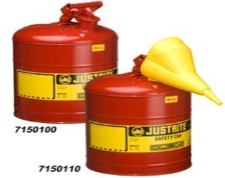
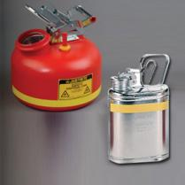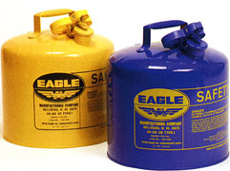

Poly Can Typical Features:
Poly Safety Cans are constructed of high density polyethylene. They are inert so they standup to tough acids and corrosives, as well as heat. Poly cans are dent, puncture and chip resistant – and their color is integral to the can. Nonmetallic cans are designed and manufactured with a unique conductive current-carrying carbon insert imbedded into rib of the container, completing a ground path between the cover assembly and the flame arrester in the spout. When used with a grounding strip, this provides proper grounding and prevents the creation of an arc during filling or pouring. The self-close cap, pressure relief mechanism and dual-density flame arrester work together to prevent ignition sources from entering without restricting liquid flow in or out of the can.
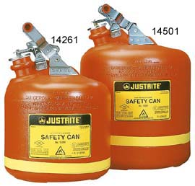
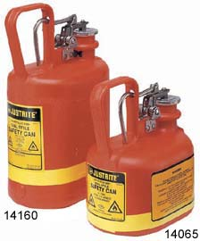
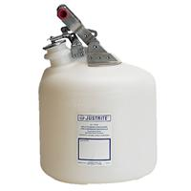

University of Montana Requirement:
Safety cans are to be used to store flammable liquids such as gasoline, gas/oil mixtures or other flammable/combustible liquids instead of plastic gas cans. All departments are to use either UL or FM approved metal or polyethylene safety cans meeting the NFPA and OSHA definition. If the cans are going to be used to transport flammables or combustible liquids over the road, they must meet Department of Transportation (DOT) specifications.

