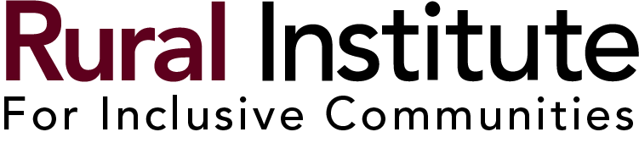

Community Investment Fund
Mini-Grant Application

Please note: Community Investment Funds are to be used for inclusive projects or programs that help people with disabilities live, learn, work, and/or play in their communities. “Inclusive” means people with disabilities participating together alongside people without disabilities. (Merely having staff or volunteers without disabilities does not make a project inclusive.) People with disabilities should be included from the earliest stages of proposal development. Activities in segregated settings (people with disabilities separated from people without disabilities) will not be considered for funding. The Rural Institute reserves the right to re-open the application process if no proposals meeting the funding criteria are received.

Prospective applicants are strongly encouraged to view the CIF YouTube video at https://www.youtube.com/watch?v=vrm9B1tqEqQ, as well as the March 1, 2016 “What’s the Buzz about Inclusion?” (https://www.youtube.com/watch?v=7eV7CXieUVA) and/or the January 24, 2017 “Inclusion: We All Benefit” (https://www.youtube.com/watch?v=yMrwmK8F-4Q) archived webinars prior to applying for the Community Investment Fund.

Applications must be received by May 15, 2024. Applicants will receive notice of funding decisions by July 15, 2024. Successful applicants will receive half of their award amount up front and the other half once their project is completed and their final report submitted and approved. Community Investment Funds must be spent by December 15, 2024.

Important application instructions: Please do not change the application format, add pictures or other graphics, or include additional materials.

Describe how people with disabilities were involved in preparing this proposal. (50 words maximum):

Who?
- Name of project contact person:

- Name of another project contact person:

- Organization name:

- Address (street address, city, state, zip code):

- Email address:

- Phone number:

- Organization’s website (if applicable):

- Brief description of your organization (number of employees and volunteers, what you do and who you usually serve, etc.) (75 words maximum):
- How does your organization’s mission relate to the proposed activity for people with disabilities? (75 words maximum):
- How do you plan to continue promoting inclusion outside of this project? What tools or skills do you need to make this happen? (75 words maximum):
- What previous experience has your organization had with grants? (No previous experience is necessary.)

What?
- Project or program title:

- Who are your intended participants/who will your project serve?

- How many people with disabilities do you expect to participate?

- How many people without disabilities do you expect to participate?

- Amount requested (up to $4000.00):
- Will your project proceed if you only receive part of the Community Investment Fund support you are requesting?

Where?
- Where will the project or program take place? (Please note: locations must be accessible to people with disabilities.)

When?
- Expected start and end date:

Why?
- Explain why you think the project or program is needed (75 words maximum):
- Explain why you believe your project is inclusive (reminder – watch the videos listed at the top of the application) (75 words maximum):

How?
- Write a detailed description of the project or program. Explain the purpose, what you will do, and how you will do it. (250 words maximum):
- How does this project or program promote people with disabilities to live, learn, work and/or play in inclusive ways in their community?

Budget
- What is the full cost of your inclusive project or program?

- What other funding sources do you plan to use?

- Please complete the detailed budget below for the Community Investment Fund money you are requesting. (For example, if the full cost of your project will be $8000 but you are only applying for $2000 from the Community Investment Fund, only include details for the $2000 in the section below.)

Please note: The “category” listings in the following section are suggestions. Not all projects or programs will have expenses in every category.

Category | Amount | Description
Staffing | $
Supplies/  Materials | $
Printing/  Advertising | $
Travel and  Lodging | $
Speaker  Stipends | $
Scholarships | $
Project  Evaluation | $
Other Project  Costs | $
Other Project Costs | $
Total Requested Budget Amount | $

Applications must be received by 5:00 PM on May 15, 2024. Please submit the completed application by email, mail or fax to:
Kim Brown
University of Montana Rural Institute, 253 Corbin Hall
Missoula, Montana 59812
Email: brown@ruralinstitute.umt.edu
Fax: (406) 243-2349
Applicants will be notified of funding decisions by July 15, 2024.

