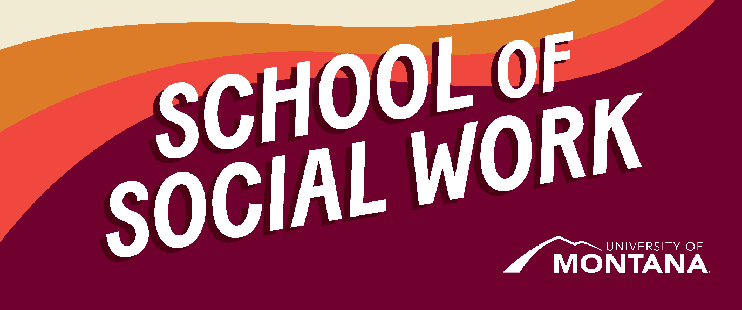
What's Up – A Newsletter from the UM School of Social Work
Online MSW Students Meet In-Person in Missoula
By Kimmie Garner
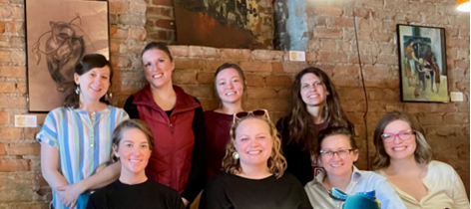
On Tuesday, April 2nd, 7 Online MSW students from Generalist and Specialization Years met at Break Espresso in Missoula while Field Liaison Kimmie Garner was visiting Missoula from North Carolina. They came from as far away as Wyoming to connect! The group reflected on their current and future practicum placements, coursework, and post-graduation plans. It was a lively gathering, and it was wonderful to see students relate in real time to the successes, challenges, and possibilities of completing the MSW Program.
The following students were in attendance: Lindsay Fischer (Class of 2024), Alexis Whitlow (Class of 2024), Sara Lippy (Class of 2025), Christina Bucarey (Class of 2025), Katy McMahon (Class of 2025), Sarah Hilbert Krumm (Class of 2025), and Laura Curry (Class of 2025)
Thank you, all, so much for joining in such a vibrant, supportive discussion!
If you are an online student and would like to schedule a time to visit us on campus, please contact Amanda!
Global Social Work Joint Conference 2024 in Panama
By Dr. Phyllis Ngai
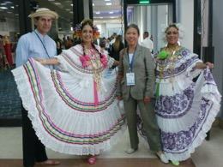
Photo: Panamanian performers welcomed conference participants on the opening day.
Dr. Phyllis Ngai, Clinical Associate Professor, presented a paper at the World Social Work & Social Development Conference jointly organized by the International Association of Schools of Social Work, the International Federation of Social Workers, and the International Council on Social Welfare. Fueled by the exchange of ideas and a shared vision of promoting social justice for all under the theme of Respecting Diversity through Joint Social Action, the conference brought together over 1500 social work educators, researchers, and practitioners. Dr. Ngai’s well-received presentation was entitled Social Work’s Roles in Advancing Indigenous Peoples’ Rights. While all UN member nations endorsed the UN Declaration of the Rights of Indigenous Peoples (UNDRIP) by 2008, Indigenous peoples’ rights continue to be violated in many parts of the world. The field of social work must help advance Indigenous rights by supporting the full implementation of UNDRIP at all levels. Dr. Ngai’s presentation stimulated discussion among conference participants about (1) global, national, and local advocacy of Indigenous peoples’ rights, (2) implementation gaps of UNDRIP in Indigenous communities, (3) past successes, current challenges, and future possibilities of drawing on glocal connections for advancing Indigenous Peoples’ rights, and (4) the role of social work in helping to fill implementation gaps through global, national, and local advocacy and actions.
UMSSW Student Spotlight
Students find their way to the UM School of Social Work for various reasons and from a wide range of backgrounds. Students are doing critical social justice work in urban, rural, and indigenous communities and the broader United States, either in employment or practicum settings. The UMSSW Student Spotlight is an opportunity to hear from our students across all of our programs – BSW, MSW, in person and online – and learn about their important roles in creating change.
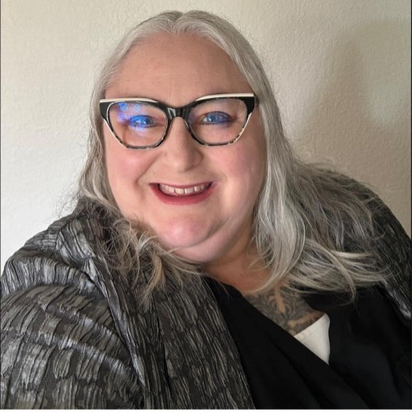
Student Name & Program:
Dione Griffith, online MSW student (third year)
Community of Practice:
Seattle, WA
Social Work Area of Practice:
I have primarily focused on using the guidance of my instructors to conduct research and writing through the lens of my lived experience. Some of the topics that I have explored are reproductive justice, homelessness, historical trauma, and especially neuroplasticity in adolescents and young adults as a protective factor for criminogenic thinking.
Tell us a little about yourself and why you chose the UM School of Social Work for your degree.
I left home at the age of twelve years old and lived homeless for the next six years. During that time, I had the opportunity to be encouraged by many social service providers at youth shelters, day, and detention facilities. Following receiving my GED, I attended Ohio University’s Honors Tutorial College for chemistry pre-medicine as a reflection of my passion for health sciences and due to my commitment to the helping mission. When I was in my third year, I developed a significant disability and subsequently lived homeless for another nearly four years. Following being treated for my disability, I attended Evergreen State College. I completed my degree in General Science Pre-Medicine with a focus on mathematical and scientific modeling with computer programming, with a minor in chemistry and a minor in Spanish. It was during the recession when I graduated, and I could not find a job, so I returned to school for paralegal studies. That is when I became familiar with social justice and advocating for Civil Rights such as police brutality cases.
Eventually, I wanted to return to school to pursue a master’s, but I was confused about my direction. I started thinking about what intervention was effective with me that caused me to be a success and decided it was the effects that abstract learning had on my brain when I was a young adult. This led me to present to the Seattle Public Schools my interest in teaching mathematical and scientific modeling with computer programming to at-risk youth. As a result, I worked for Seattle Schools in special education for four years. During that time, I wanted to further my commitment to at-risk youth and young adults by pursuing a career in social sciences as an MSW student.
Where are you doing your practicum this year?
I am doing my practicum with the Washington State Department of Commerce for the Statewide Reentry Council. We serve the public by advocating for best practices that are human-centered, which lead to a reduction in recidivism and efficacy for those who have been formerly incarcerated.
What have been the most challenging and rewarding aspects of your practicum?
The most challenging aspect of my practicum has been juggling work and school. I have also learned a lot about interpersonal communication and how best to present myself to others in a professional context. Initially, I struggled with communicating with one of my colleagues, but we had a listening circle as an intervention for our inability to communicate effectively. Although it required vulnerability from everyone involved, it was a very effective way to work out our kinks and move forward in a positive direction.
What are your future plans and/or job interests after completing your social work degree and practicum?
Last week, I was offered a job with the Washington State Department of Commerce as a community engagement and policy coordinator for the housing division, and I accepted. I intend to use this venue to advocate for those the furthest away from social justice. It is my hope that I will continue working in policy and eventually work towards leadership in policy. I have also considered working for some time in policy and then returning to academia for a PhD and/or to teach. I am passionate about teaching as a result of my experience with Seattle Schools and would love to teach online courses in social work studies. I also have an interest in research. I enjoy research and writing. This journey with Commerce will direct my future plans regarding what direction I go with research, but I intend to integrate my passion for research in writing in all my future endeavors.
Restorative Justice Workshop
By Dr. Jen Molloy
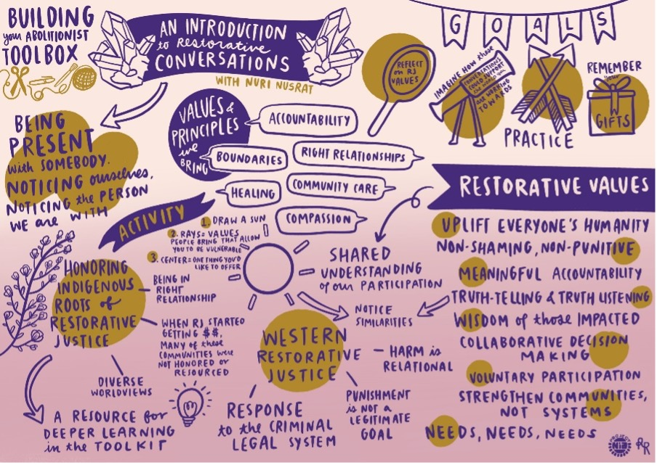
Intro to Restorative Conversations & Graphic Notes by Laura Chow Reeve
Want to learn more about restorative justice? Come to a virtual workshop offered by Jen and Jessika Eiskant (2021 MSW Graduate) on Monday, May 6th, from 12 to 1 p.m. To sign up and receive a Zoom link, email jen.molloy@umontana.edu. I hope to see you there!
You're receiving this update because you're part of the UM School of Social Work community.
University of Montana – School of Social Work • Jeanette Rankin Hall • Missoula, MT

