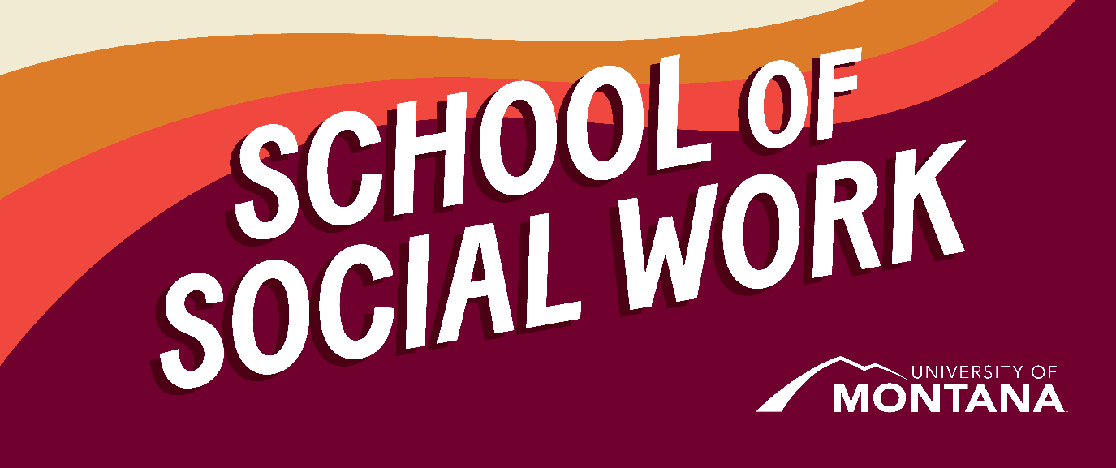
What's Up – A Newsletter from the UM School of Social Work
Congratulations!
A huge congratulations to Deanna Cooper, Jen Molloy, Ashley Trautman, and Kat Werner on their recent promotions!
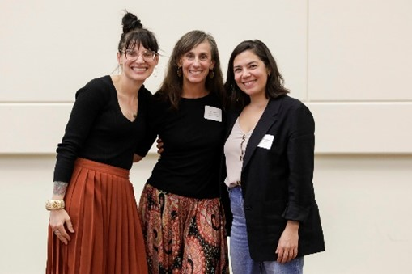
Kat Werner, Jen Molloy, and Ashley Trautman (not pictured: Deanna Cooper)
- Kat Werner, Director of Field Education, has been promoted to Clinical Associate Professor
- Jen Molloy, Ph.D., has been promoted to Associate Professor
- Deanna Cooper, BSW Director, has been promoted to Clinical Associate Professor
- Ashley Trautman, Chair of the School of Social Work, has been awarded tenure.
These promotions take many years to achieve and are a testament to incredible hard work and dedication to our program.
CSWE Interview
As we mentioned in November, seven UM faculty members had the opportunity to attend The Council on Social Work Education conference in Atlanta, Georgia, on October 26-29. The Council on Social Work Education's (CSWE) Annual Program Meeting (APM) is where social work education professionals collaborate, learn, teach, and grow. This year's APM theme is "It's Time to Act: Defining and Reckoning With Anti-Racist Social Work Education" and featured social work education presentations, an exhibit hall, and networking opportunities (CSWE.org, 2023).
Kimmie Garner, LCSW, Field Liaison
- Favorite Key Learning: Social work educators across the country think critically about students' intersectional identities and cultural humility in supervision as they support their field education experiences to ensure these are mutually beneficial for students and their community partners.
- Favorite Presentation Attended: My favorite presentation was "Call for Social Work Educators to Teach Asian American Oppression." This was a very interactive session about the missing presence of Asian Americans in both social work history and the profession currently. The presenters called upon social work educators to actively seek out and include the history of Asian American oppression and resiliency in coursework moving forward and offered the attached resources for further reading and learning.
Social Work Students – Advocate!
The social work profession has a long history of promoting policy change to serve better individuals and communities facing oppression. We also have a call to participate in political advocacy within our Code of Ethics. We hope all students find their advocacy niche and work to pursue social change with and on behalf of oppressed individuals and populations.
Quick Examples of advocacy you can start with:
- Take the time to learn about what's happening in your city/town. All city council meetings are recorded. See if you can find the most recent one and see what folks are working on locally.
- Build and share knowledge - Get educated about an issue you care about. This is an excellent place to start if you're wondering what might align with social work values: NASW Action Center.
Policy Leadership Institute
By Kat Werner

Montana Women Vote is hosting its annual Policy Leadership Institute the second weekend of February, Friday 2/9/24 and Saturday 2/10/24. IN PERSON!
This two-day conference is an amazing opportunity to get hands on experience at the capitol in Helena, meet and engage with legislators, and learn about relevant and pressing social justice and policy issues affecting Montanans, including rural and indigenous communities. The Policy Institute is an excellent addition to your Social Policy & Social Services coursework and your existing advocacy skills. Detailed agenda to follow once registration opens!
For In-Person MSW students and all BSW students, this course can be taken for one credit- registration information below. Online MSW students are not able to receive the one credit for attendance but are encouraged to attend if able and will be offered a benefit in their SW 531 course- talk to Amanda Cahill for more information on that.
For In-Person MSW Students, and all BSW students, this is a 400-level course for social work students attending the conference (students must be present for both days, arriving late or leaving early is not an option). Graduate students needing a 500-level credit have the option of completing a brief reflection essay about their conference experience.
This course is now available for registration:
Women's Policy Leadership Institute - SW480.01 - CRN: 34399
Please know that this is UM registration only and does not include the actual registration to the Institute itself which will open in the coming weeks – students wishing to receive a UM credit must register for both the course AND the conference. Scholarship applications will also be available at the end of the conference registration process (offered by Montana Women Vote, not UM). Full and partial scholarships including food and lodging are available and are on a first-come-first-serve basis once registration opens.
Student Spotlight

Online MSW student Katarina (Kati) Keeler is doing her first-year practicum at Dartmouth Hitchcock Medical Center in Lebanon, New Hampshire. For her practicum, Kati works closely with a licensed clinical social worker who supports patients in the Norris Cotton Cancer Center struggling to meet their basic and overall well-being needs.
In December, Kati attended the National Association of Social Work (NASW) Chapter of New Hampshire JEDI (Justice, Equity, Diversity, and Inclusion) conference and had the opportunity to present her research on the importance of incorporating cultural awareness and respect into the healthcare community. This research looked specifically into how other cultures and religions around the world view healthcare, death & dying, gender & dignity, diets, and other topics. It further captured how cultural differences influence individual choices, which sometimes do not fully align with Western medicine.
You're receiving this update because you're part of the UM School of Social Work community.
University of Montana – School of Social Work • Jeanette Rankin Hall • Missoula, MT

