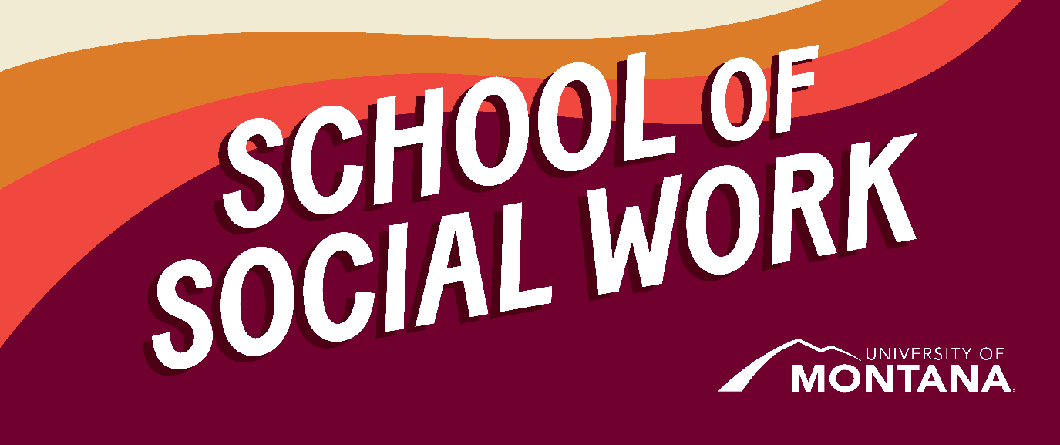
What's Up – A Newsletter from the UM School of Social Work
Enjoy Winter Break
This newsletter is a little late in getting out- par for the course for ending a busy Fall semester. I hope you all take some time to rest and recharge during the Winter break!
Online MSW Graduates!
By Amanda Cahill
Cohorts 1 and 2 of our Online MSW program have graduated! The Online MSW Program began in August of 2021 with the vision of serving students in rural and tribal communities. We are extremely proud and excited to have more than 60 new professional MSWs across Montana and the greater US. We know that their commitment to excellence and social justice will serve their communities well. Congratulations!
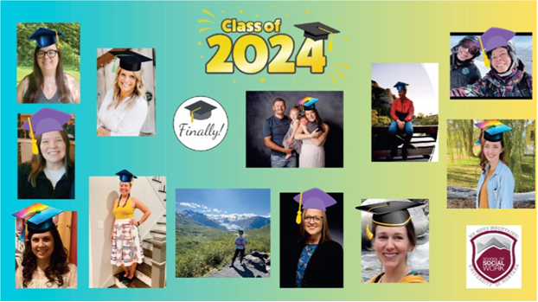
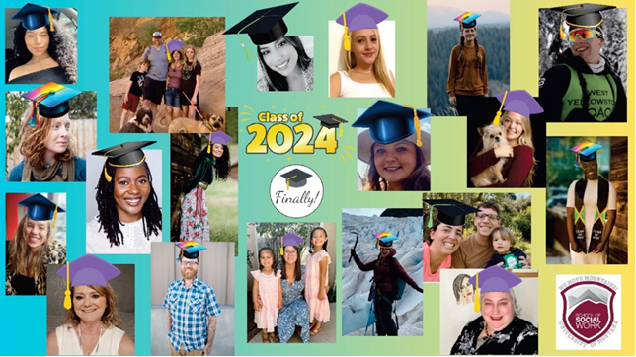
Climate Emotions Support Group
By Melody Irvine

I am a senior majoring in social work, environmental science and sustainability. I am currently working with Climate Smart Missoula for my practicum and have been afforded a fantastic opportunity to bring my social work knowledge and skills to aid in climate action for our community. With this opportunity, I have been working on my senior capstone project to create and implement a climate emotions support group. I have found a way to include my social work skills in climate action through working on and implementing this group next semester. Recently, Katie Karas and I held a listening session where students shared how climate impacts their well-being. Members shared that having a space to unpack the weight of this crisis would be most beneficial, as when you reflect on this crisis alone, it can be isolating or cause distress. While I welcome allowing ourselves to experience these reactions, as it means you are paying attention, we are more effective if we support each other. The main purpose of my group is to give people a space to express how climate change impacts their mental health and to walk away with skills to cope with those emotional reactions. I know that when internalizing the weight of all of this I felt very hopeless and in distress, I could have used a space to gain support, this is why I am passionate to bring this to our campus!
Climate change affects all of us in many ways, from extreme weather events to changes in our surroundings. While we often focus on its physical impacts, we overlook its effects on our mental health. In a recent survey of U.S. young adults, it was found that 85% of the respondents were worried about climate change, and almost half were experiencing mental health issues related to the climate crisis. As social workers think about this crisis, it is very important to note that there are many ways we can utilize our skills to support climate action. This may include supporting clients through these emotional responses or bringing in the perspective that our climate is changing in how we think about managing other social justice issues. Our social work values instill in us that we will work in service to those who are most vulnerable in our systems; this includes those most vulnerable to climate change. As the world changes, those who already face the brunt of challenges will be greatly affected by these physical climate changes. By incorporating this perspective into your work, you can ensure our clients are effectively advocated for as we navigate the systemic changes needed to sustain life on this planet.
If you are interested in joining this group next semester, please fill out this Google form so I can reach out when we are closer to starting up! If you have any questions or comments, please reach out. I would love to chat!
You're receiving this update because you're part of the UM School of Social Work community.
University of Montana – School of Social Work • Jeanette Rankin Hall • Missoula, MT

