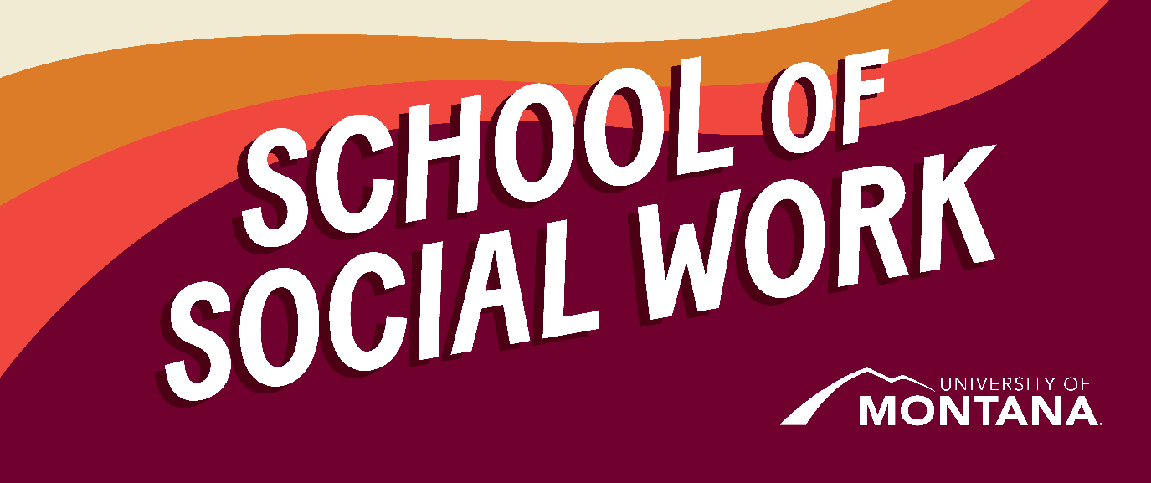
What's Up – A Newsletter from the UM School of Social Work
Faculty Changes
The University of Montana School of Social Work (UMSSW) wants to take a moment and introduce Amanda Cahill to the new role of MSW Program Director. In this new role, Amanda will oversee the administrative leadership of the grounded and online MSW programs and ensure rich learning experiences and student support across all program modalities. Many of you already know Amanda from her initial role as an adjunct instructor with UMSSW and, for the past 1.5 as a clinical assistant professor supporting the implementation of our new online MSW program.
Amanda comes to the MSW Program Director role with extensive social service, leadership, and program management experience and a passion for social justice work and accessible education. After graduating with her BSW from the University of Montana and then receiving her MSW for California State University in Long Beach, she was a social worker for more than 15 years and started her career in one of Montana’s largest hospitals before working as a hospice social worker. Amanda spent the last nine years as a government relations director (aka, a lobbyist) fighting for policies that protect Montanans. Her policy practice and advocacy areas are food security, healthcare, tobacco-related disease and prevention, public health, and protecting local democracy. Amanda currently serves as the Chair of the Montana Food Security Council, which addresses food security across the state. She has also served on her local Aging Services board and as a liaison with the school district to work on nutrition policy. Amanda believes that civil discourse is the only viable path forward on many social justice issues and policy solutions. Thus, much of her teaching focuses on empowering social workers to be deep listeners in their communities and developing the ability to work with diverse stakeholders. In the classroom, her goal is to ignite students’ interests and ability to engage thoughtfully in social justice work. She will push you to think critically about the policies that are a part of our day-to-day lives and work towards more equitable solutions.
As a born and raised Montanan, Amanda couldn’t be more excited to serve in this important role and support the development of future social workers serving Montana, the Rocky Mountain West, and communities beyond. In her free time, you can find her reading, traveling, and spending time with her partner Paul (also a social worker!) and their two children, Bridger and Anamarie.
Please help us welcome Amanda in her new role and send her an email or stop by her office to say hi. Amanda, we are lucky to have you and know you will fiercely support our students and their learning!
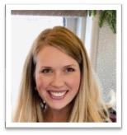
Research Corner
Our own Dr. Jessica Liddell recently published the following two research articles:
Liddell, J. L., *Sheffield, S., Johnson, K.M., & Lederer, A.M. (2022). College Students’ Perceptions of the Root Causes of Sexual Violence Before and After a Curricular Intervention. Violence Against Women.
https://doi.org/10.1177/10778012221132300
Liddell, J. L., *Kington, S. G., & McKinley, C. E. (2022). “You Got to Drive 30 Miles to Get an Apple”: Indigenous Food Sovereignty, Food Deserts, and Changing Subsistence Practices in the Gulf Coast. SN Social Science, 2 (10), 1-22 https://doi.org/10.1007/s43545-022-00530-5
In honor of Black History Month enjoy this article from the Journal of Social Work Education: Black History Month; Black Social Workers Matter: Using Parallel Narratives to Discuss Social Work History
Women’s Policy and Leadership Institute
On Feb 10th and 11th more than 30 students from the UM School of Social Work attended the Women’s Policy and Leadership Institute in Helena. Pictured below, first-year MSW student Mallory Phillips presents about her organization Shelter Whitefish.
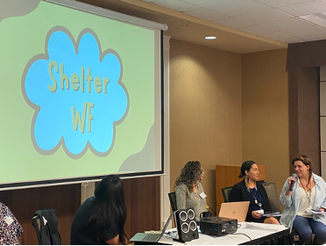
Shelter WF is a 501(c)4 membership organization focused on building grassroots power around housing for everyone in our communities. We work to empower those most impacted by the housing crisis to get involved, run for office, and be a part of creating housing solutions in Montana.
BSW Distance Students: UMSSW Faculty and Staff Road Trip to You!
Our BSW and MSW distance options are expanding. As our travel to partnering communities commences this Spring, please save the dates for scheduled trips and share them with those interested in either BSW or MSW distance learning opportunities. We love to see graduates as well!
Staff and Faculty from UM School of Social Work will be on campus to meet with current students and those interested in learning more about distance learning options through UMSSW BSW and MSW programs.
Feb. 13-14th Helena College (done- we enjoyed our time with our Helena folks!)
March 14th Flathead Valley Community College
March 22nd Great Falls College
March 27th Blackfeet Community College
TBD Miles City (partnering colleges included ANC, FPCC, CDKC, Stone Child)
Here are links to the programs we will be sharing more about:
- 2+2 BSW Distance program
- LAC Pathway within Social Work Program (Licensed Addiction Counseling)
- MSW Online (Distance Learning) and Campus MSW
- Advanced Standing Distance MSW, to begin Summer, 2024
Practicum Education Key Dates
Practicum Orientation (campus students): March 8th, 2 pm - 4 pm via Zoom
Practicum Orientation (2+2 Students): March 14th, 11 am - 1 pm at FCC and via Zoom
BSW Practicum Panel: March 27th, 11 am - 12 pm on campus (location TBD) and via Zoom
Nominate your Outstanding AFI!
The UM School of Social Work recognizes the importance of the Agency Field Instructor's (AFI) role in preparing social workers. AFIs provide the hands-on support, mentorship, and teaching necessary for students' professional growth and readiness to practice as social workers.
A committee of faculty will review nominations and select one BSW-nominated, one 2+2 nominated, one in-person MSW - nominated, and one online MSW - nominated field supervisor. Outstanding AFIs will be honored at an Agency Appreciation Event via social media and the UMSSW website.
Nominations are due by Friday, March 17th, and can be submitted via this link, AFI Nominations.
You're receiving this update because you're part of the UM School of Social Work community.
University of Montana – School of Social Work • Jeanette Rankin Hall • Missoula, MT

