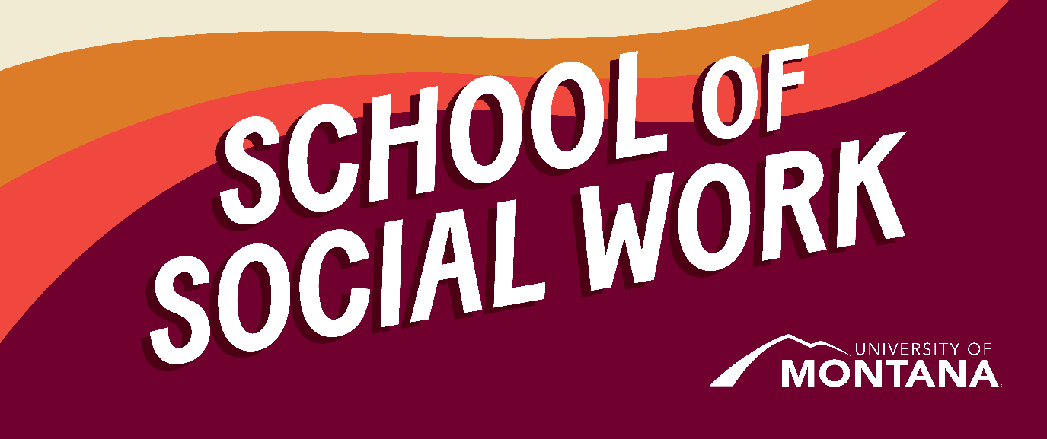
What's Up – A Newsletter from the UM School of Social Work
UM Students Are Considering Creating a Phi Alpha Honor Society Chapter - Your input is needed!
Established in 1962, Phi Alpha is a National Honor Society for Social Work students with over 450 chapters nationwide. The mission is to create a tighter community among social work enthusiasts, champion humanitarian goals, and uphold high standards of education. The University of Montana is exploring interest in establishing a chapter for eligible Social Work students. Please consider taking this 14-question survey, which will provide valuable information about your interests and what chapter activities would be most valuable to you. The survey is anonymous and takes approximately 4 minutes to complete. Your input is crucial in shaping the future of Phi Alpha at UM!
Spend Spring Break Volunteering in Seattle!
Embark on adventure and make a difference this March. Join UM's Alternative Breaks Program March 17 - 23, 2024, and explore youth homelessness, its root causes, and how organizations like YouthCare fight to end it while engaging in meaningful direct service and discussion in the beautiful Pacific Northwest. Volunteer opportunities may include renovating transitional housing, serving meals, and facilitating one-on-one resume workshops for homeless young adults.
Seattle is steeped in natural beauty and world-class attractions from the Sound to the Northern Cascades. On our community immersion day, we will explore Seattle through team-organized activities, including visiting Pike Place Market, hiking in Mount Rainier National Park, whale watching on San Juan Island, or touring the Seattle Aquarium.
You'll return inspired and empowered to create positive change in your community. Visit the Alternative Breaks Website to learn more. Application Deadline: February 26, 2024.
Research Highlights
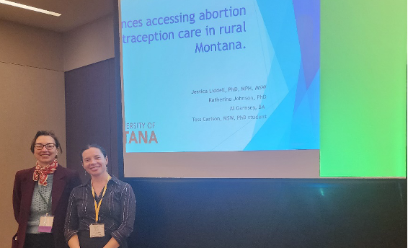
UM Social Work Faculty Dr. Jessica Liddell, Dr. Govind Dhaske, and former MSW student Tess Carlson all had presentations accepted at the Society for Social Work Conference (SSWR) in Washington, DC, in January.
Dr. Govind Dhaske, an Assistant clinical professor at the University of Montana's Online MSW Program, convened a Special Interest Group (SIG) at the Society for Social Work and Research's 28th Annual Conference in Washington, DC. The SIG entitled 'Spiritual Competencies Training in Clinical Social Work' examined a wide range of subjects, including religion and spiritual diversity, the differences between the definitions of religion and spirituality (R/S), spiritual assessment, understanding different types of spiritual resources, how clients can use these resources effectively, understanding spiritual problems, and formulating solutions. As a co-convener, Dr. Dhaske was vital in steering the group's exploration of the competencies necessary for the spiritually oriented practice of clinical social work. The Special Interest Group (SIG) was co-convened by Pious Malliar Bellian, MSW, and Vincent R. Starnino, PhD of IUSSW.
Dr. Liddell co-led the Reproductive Justice special interest group at the conference and gave the following presentations:
Liddell, J. L. & Glover, A. "Recovery doulas as a way to improve substance use disorder and maternal and infant health outcomes in rural Montana." SSWR. Washington, D.C. (January, 2024).
Liddell, J. L. & Johnson, K., & Carlson, T. "Experiences Accessing Contraception and Barriers to Care in Rural Montana." SSWR. Washington, D.C. (January, 2024).
Doria, C., Liddell, J. L. "Using a Reproductive Justice Lens to Explore Contraceptive Barriers for Abortion Fund Applicants in the Rocky Mountain West" SSWR. Washington, D.C. (January, 2024).
Poehling, C., Liddell, J. L. & Singh, M.“The Impact of Disasters on Sexual and Reproductive Health Needs: A Qualitative Analysis from Providers and Responders in Louisiana" SSWR. Washington, D.C. (January, 2024).
Carlson, T., Liddell, J. L. & Reese, S. "Perinatal Mental Health Screening: Investigating the Perspectives and Experiences of Those Who Have Given Birth." SSWR. Washington, D.C. (January, 2024).
Additional Publications:
Dr. Sarah Reese, Dr. Jessica Liddell, and Deanna Cooper were recently published in The Journal of Teaching in Social Work, Volume 44, 2024- Issue 1.
Abstract: Over the past two decades, online and distance social work programs have grown rapidly. The COVID-19 pandemic has further highlighted interest in online options from both students and instructors. As programs grow, it is important to recognize the need for retention strategies, especially for students with marginalized identities. This study aimed to identify strengths and areas for growth in an online BSW program designed to meet the needs of students living in rural and Tribal communities. To that end, we conducted a cross-sectional survey with current students. Based on their responses, we have identified several recommendations for similar programs: offering employment-based practice, extensive onboarding and practicum support, prioritizing goodness-of-fit when recruiting and retaining program instructors, and supporting students in their pursuit of further education.
Restorative Justice
By Dr. Jen Molloy
Restorative Justice is a philosophy with associated practices rooted in Indigenous teachings that emphasize our interconnection by repairing relationships when harm occurs while proactively building and maintaining relationships to prevent future harm. Restorative Justice can be practiced in education, criminal legal, and community settings.
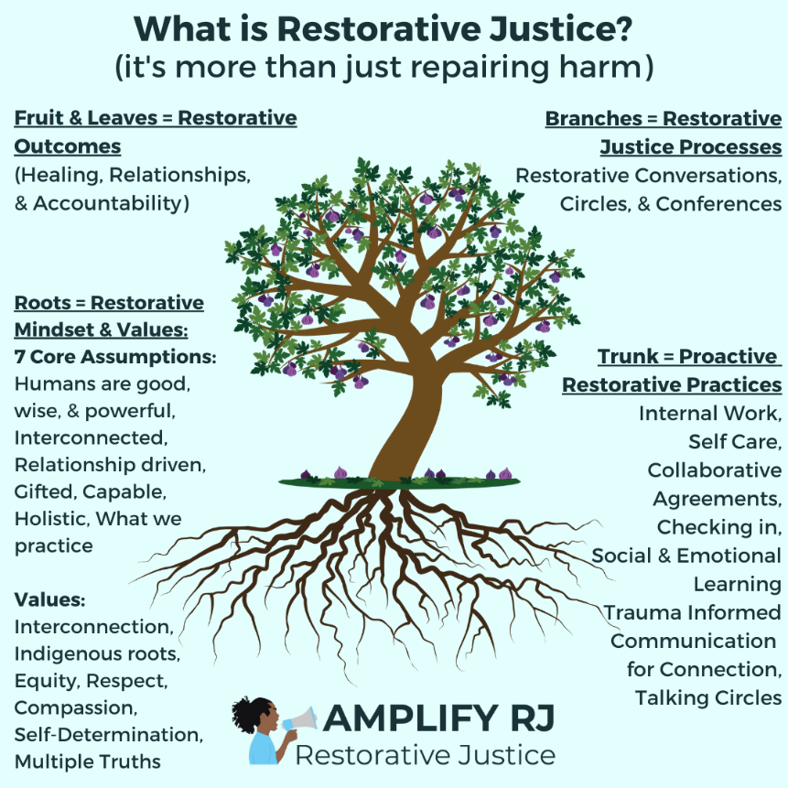
To learn more about the tensions and possibilities of implementing restorative justice in education, check out these articles by UM faculty:
Dr. Jen Molloy, SSW Chair Ashley Trautman, and Dr. Sarah Reese collaborated with colleagues from around the country to understand how state-level policies inform and promote the implementation of restorative justice in education (RJE). Findings supported the need for laws to clearly define the paradigm shift underlying RJE and provide sustained support to promote a realignment of policies and practices with attention to incorporating measures of accountability to larger values surrounding equity and justice. To learn more about RJE and how policies can support the systematic implementation of RJE and potentially prevent the misuse of RJE as an alternative system of punishment, read the article here.
In Healing Schools, Jen collaborated with colleagues from the University of Utah to share an integrated framework for whole school reform draw from literature and practice experience with trauma-informed care, restorative justice, and multicultural education. To address the need for healing in schools, a framework is promoted based on four key values: relationships, safety, belonging, and agency. These values are embedded within an ecological perspective, exploring how they manifest at the internal, student, school, and community/society levels.
In the News
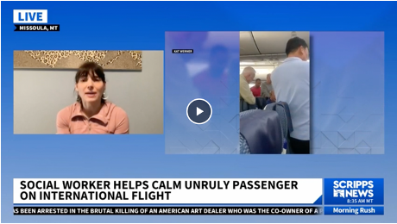
Our own Kat Werner, herself a UMSSW MSW Program alumna and current Field Education Director, put her social work and crisis intervention skills to good use on a recent flight from Tokyo to Seattle. She was featured on this Scripps Morning News segment recounting her experience with a passenger in crisis. See the interview here.
BSW Corner
By Meghan Intermill
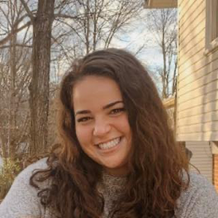
Hello, all! My name is Meghan, and I am the BSW Graduate Assistant! I am a first-year MSW student, and my current practicum is working as a Wellbeing Support Coordinator in the College of Education. I grew up in Northern Virginia and graduated from Virginia Tech in 2020 with a BS in Human Development and Family Studies. After graduation, my plans to volunteer abroad got flipped upside down (thank you, Covid). After some contemplation, I eventually decided to volunteer for Jesuit Volunteer Corps NW/AmeriCorps, where I was placed in Ashland, Montana. There, I taught in the elementary school in various capacities and fell in love with the state of Montana. After some time living in Billings, MT, working for Big Brothers Big Sisters, I decided it was time to go back to school to pursue my MSW, and here I am! I love baking, getting outside, spending time with friends, and hanging out with my dog in my free time. I am so excited to be in this role and look forward to all that is to come!"
Faculty International Engagement
Dr. Phyllis Ngai, Clinical Associate Professor, is the U.S. member of an international panel of researchers from Finland, China, France, Spain, the U.K., S. Korea, and Saudi Arabia who are collaborating on a project led by scholars at the University of Helsinki in Finland and Minzu (Ethnic Minority) University in China. The project includes virtual lectures and a book. Dr. Ngai's contribution focuses on Internationalization and Indigenization in U.S. Higher Education: 21st Century Social Justice Education.
Professor Ngai presented (virtually) at the Global Studies Conference hosted by Oxford Brookes University, UK, in July 2023. The conference focused on "Agency in an Era of Displacement and Social Change." Dr. Ngai's contribution covered Indigenous NGOs' Agency in Advancing Indigenous Peoples' Rights.
Dr. Ngai recently published an article entitled "Indigenous Peoples Organizations' Approaches to Social and Community Development in Cambodia" in the International Journal of Social and Community Development, Volume 5, Issue 4, 2023
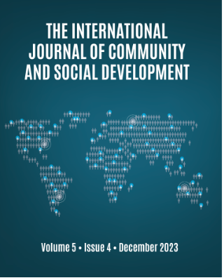
Faculty Training- Indigenous Paradigm
In January, Jen Molloy, Katie Karas, Laura Guay, Phyllis Ngai, and Amanda Cahill attended an excellent training on Indigenous Paradigm. This training was provided by Lona Running Wolf and Wendy Bremner of the Blackfeet (Siksikaitsitapi) people. This training created the opportunity to understand better the Indigenous experience of moving through policies that shape Indian Country today.
You're receiving this update because you're part of the UM School of Social Work community.
University of Montana – School of Social Work • Jeanette Rankin Hall • Missoula, MT

