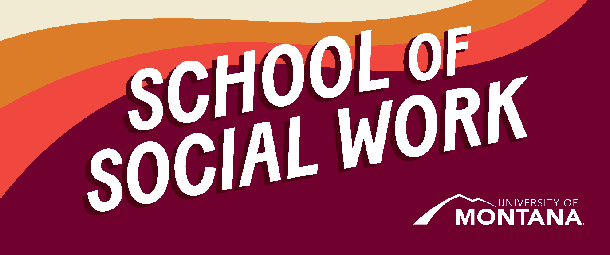
What's Up – A Newsletter from the UM School of Social Work
Maternal Mortality Report
By Sarah Reese
Dr. Sarah Reese, Associate Professor and Co-Chair of the SSW would like to share the first report from the Montana Maternal Mortality Review Committee (see attached). The goal of this interdisciplinary committee is to prevent deaths in the perinatal period and has been funded by HRSA and the CDC. Dr. Reese initially served as facilitator of the MMRC and has served in the role of Interim Chair of the committee since 2022.
MSW Student Helps Connect the Local to the Global
By Akemi Nakagawa
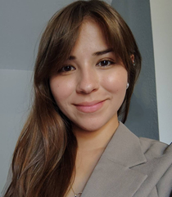
Akemi Nakagawa
My name is Akemi Nakagawa, and I am a first year MSW student with the UM School of Social Work. This semester, I am completing an internship with the International Development Studies Program (IDS) affiliated with the School of Social Work. I would like to take this opportunity to introduce myself to the social work student community! In this role, I focus on advocating for global justice and motivating young people to engage with glocal issues - the interconnected challenges that span global and local contexts, such as sustainable development, economic inequalities, gender oppression, migration, climate change, and public health.
My work with IDS also includes encouraging undergraduate students to minor IDS, which offers an interdisciplinary experience for students to gain knowledge and skills useful for helping to solve glocal problems. Additionally, I am helping to organize and promote events that support student learning and professional development in the field of social and community development. You may see me presenting in some of your classes! One of the key goals of this internship is to foster a community of students committed to tackling global challenges through collaboration and partnership across disciplines. I look forward to connecting with many of you as we work toward advancing global justice together.
Montana NASW Advocacy
Find out what NASW Montana is working on during this legislative session!
Student Feedback Wanted!
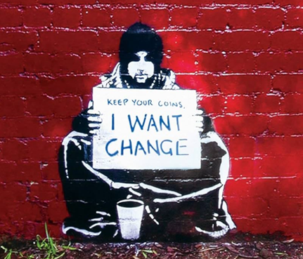
Keep Your Coins, I Want Change
Many of you have had discussions with your instructors, students, and other colleagues about the challenges of navigating your roles as students and social workers in this rapidly evolving political climate. We have been having discussions about the best way for our department to collaborate in supporting students, and we want to know what makes the most sense to you all. Please take a minute to complete this brief Qualtrics survey to let us know your preferences by 02/12.
Practicum and Student Spotlight: Crisis Text Line
By Kimmie Garner
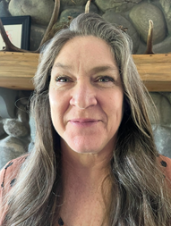
Amy Sanders Karri Cossabone
The School of Social Work has begun a new partnership with Crisis Text Line for the 2024-25 academic year. The Crisis Text Line provides 24/7 mental health support to participants via text through a dedicated group of trained volunteers across the country. Their Student Learning Practicum Program is designed to support students in the development of crisis intervention skills in a remote practicum setting with consistent group and individual supervision. Over 20 universities partner with Crisis Text Line's Student Learning Practicum Program; UM currently has four students placed with CTL.
Three students, Tanner Bailey, Karri Cossabone, and Amy Sanders all made the Fall Honors List, which means they successfully achieved all program requirements for the Fall 2024 semester, including consistent daytime and overnight hours on the CTL texting platform. Congratulations to these students and thank you for your commitment to supporting people in crisis!
Please contact the Field Education Team if you would like to learn more about this practicum site for next year! If you are a rising Generalist student in the Online MSW Program, you can reach out to Kimmie Garner (kimberly.garner@mso.umt.edu). If you are a rising Specialization Year student in the Online MSW Program, you can reach out to Sarah Fielding (sarah.fielding@mso.umt.edu). For Grounded MSW and Advanced Standing students, you can reach out to Jen Barlie at jen.barile@mso.umt.edu.
Opportunity to be in a video for Cindy Garthwait’s e-textbook on Human Behavior in the Social Environment
Cindy Garthwait, retired faculty member in the School of Social Work, is completing a new textbook for BSW and MSW Human Behavior in the Social Environment courses. She is looking for volunteers (students and/or faculty members) to do role plays between a social worker and client for the online portion of the book to be published by Pearson Education. The scripts for the videos have been written, and each video is about three minutes long. Pearson Education will send a videographer to Missoula to record the videos sometime this semester. There may be a modest honorarium, and this would be a chance to participate in social work education for students who appreciate watching meaningful videos.
You can contact Cindy at 406-207-6036 or at cynthia.garthwait@umontana.edu. She would appreciate hearing from you right away if you are interested or have questions. She can provide information on what this would require.
Examples of the practice topics for these videos include brain injury, miscarriage, identity development, anger management, unhoused veteran, and end of life.
SSW Faculty Published a New Book!
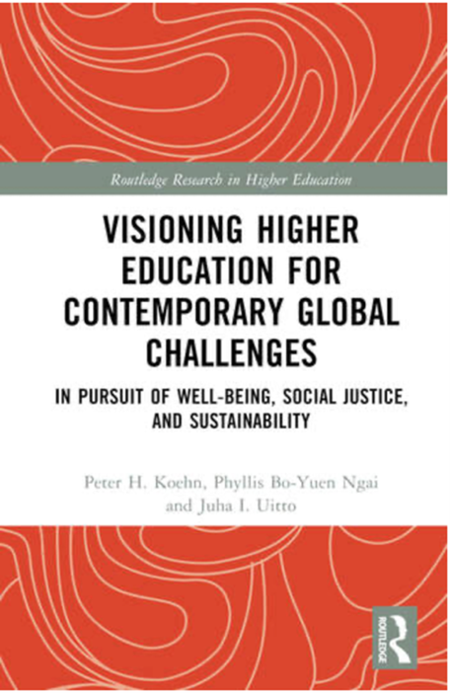
Visioning Higher Education for Contemporary Global Challenges: In Pursuit of Well-being, Social Justice, and Sustainability
Clinical Associate Professor, Dr. Phyllis Ngai published a co-authored book, Visioning Higher Education for Contemporary Global Challenges: In Pursuit of Well-being, Social Justice, and Sustainability in Routledge's Research in Higher Education series, that advocates for higher-education institutions worldwide to step up to equip students to advance global justice and contribute to social change. Visioning presents a roadmap for university leaders to vitalize higher education in response to five urgent and interconnected global challenges (Sustainable Development, Climate Change, Migration, Global Health, and Social Justice). The book elaborates detailed and feasible pathways for (1) promising educational approaches to higher learning that specifically and effectively address the interconnected drivers of contemporary global challenges and (2) promising transnationally collaborative higher-education arrangements and initiatives aimed at making the most of research, learning, and policy-shaping opportunities. The book includes educational approaches that incorporate just practices utilizing Janet Finn’s Just Practice framework. The authors argue that universities around the world offer humanity one of our most hopeful long-term prospects for tackling such global crises.
In her book endorsement, Lynne M. Healy, Distinguished Professor Emerita, University of Connecticut School of Social Work and main representative to the UN, International Association of Schools of Social Work wrote: “This important book encourages institutions of higher education to embrace a leadership role in addressing key global challenges. The authors lay out a transformative action agenda to move us toward the university of the future.”
Visioning is available in the Mansfield Library.
Celebrate Black History Month

(Image representing Black History Month with themes of activism and social work. Photo includes prominent Black individuals throughout US history, the Statue of Liberty, the American flag, and a Black man standing up raising a fist.)
Black History Month: Honoring Legacy, Advancing Justice
February is Black History Month! Black History Month is a time to recognize and celebrate the profound contributions of Black individuals and communities throughout history. In social work, this month holds particular significance as we strive to uphold values of social justice, dignity, and the pursuit of equity. The social work profession has a responsibility to acknowledge the impact of systemic racism and work toward dismantling barriers that continue to affect Black communities. By learning from the past and amplifying Black voices, we reaffirm our commitment to anti-racist practice and the ongoing fight for justice, inclusion, and empowerment.
For those located in and around Missoula, you may be interested in attending the Black Solidarity Summit, hosted by UM’s Black Student Union (BSU). Save the Date for February 27-28! You can find more information on the BSU Instagram page or RSVP here.
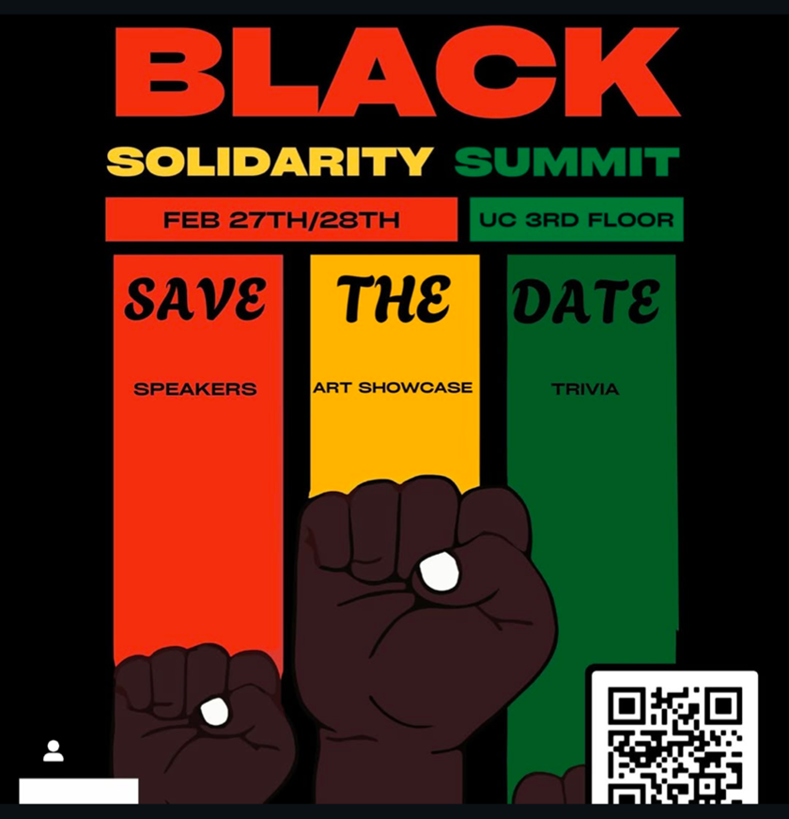
UM’s Black Student Union (BSU) Black Solidarity Summit
You're receiving this update because you're part of the UM School of Social Work community.
University of Montana – School of Social Work • Jeanette Rankin Hall • Missoula, MT

