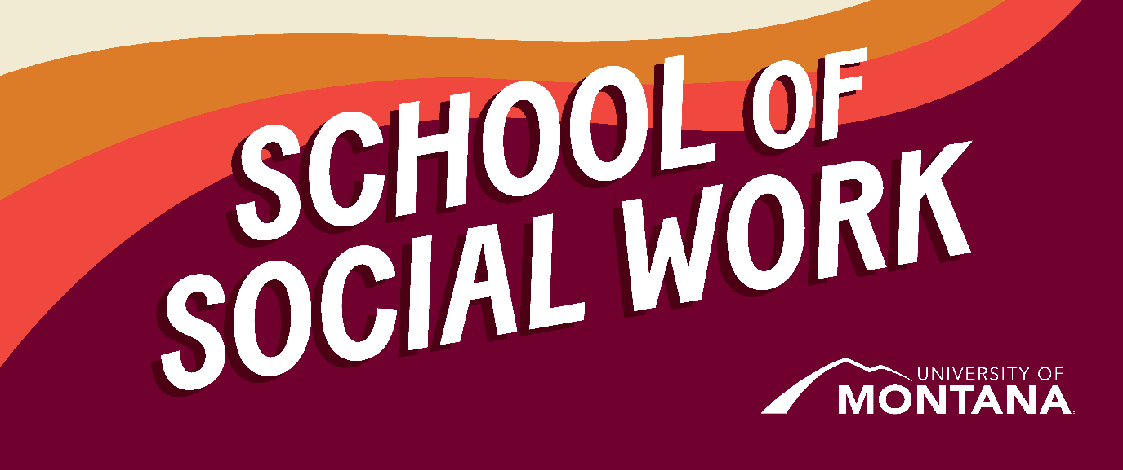
What's Up – A Newsletter from the UM School of Social Work
Celebrate Black History Month

By Amanda Cahill, MSW Director
We ask students, alumni, and colleagues to join us in celebrating Black History Month by taking time to recognize and reflect on the contributions of Black Americans to social work. Several important historical figures are discussed in this powerful article from The Massachusetts Society for the Prevention of Cruelty to Children. Additionally, the theme of this year’s Black History Month, A Century of Black Commemorations, as proclaimed by ASALH- the Founders of Black History Month.
UM Social Work Professor Advocates for LGBTQ Youth
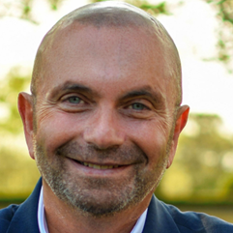
UM School of Social Work Clinical Assistant Professor Dr. David Kilmnick was featured on PIX11 News discussing the Bellmore-Merrick School District’s decision to comply with New York State law protecting transgender students, as well as the district’s current federal investigation by the U.S. Department of Education. Dr. Kilmnick addressed the legal, ethical, and social implications for schools and emphasized the importance of safeguarding student dignity, safety, and civil rights.
▶️ Watch the segment here: https://www.youtube.com/watch?v=4OS82dVQOfU
MSW Online Students Now Eligible for the Student Health Insurance Plan (SHIP)
By Kinsey Webb
MSW Online students are now eligible for the Student Health Insurance Plan (SHIP).
Please learn more about the plan, and what it covers by following this link: 2026: Insurance Accepted at Medical | University of Montana
The Student Health Fee is a fee that all other UM students have been able to opt in to, to access the full range of Curry services. Starting in January, MSW Online students should be able to opt in as well. The Student Health Fee is currently $303.
We are still gathering information about the opt-in Student Health fee for Online students. If you'd be interested in opting into this fee, and are an MSW Online student, please send an email to kinsey.webb@mso.umt.edu.
Additionally, if you are local and have other insurance, Curry Health Center will begin billing insurance in January, for visits to the medical clinic (including psychiatric care).
Counseling Services will remain at the current rate (first session free, $20/session thereafter), if you pay the Student Health Fee.
As always, all students are eligible to see Wellness Coordinators, regardless of program.
Wellbeing Support Coaches | University of Montana
More information via the QR code, or phone number:
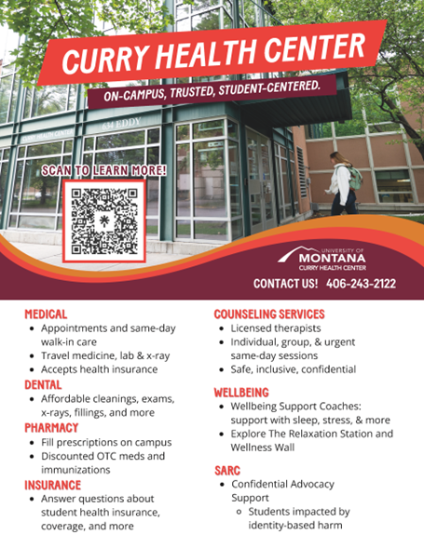

Student Spotlight: Emily Curtis
Why Studying Abroad Changed How I See Social Work
By Emily Curtis, Online MSW Specialization Year Student

As students, we are deliberately putting ourselves in a humbling position to learn, adapt new skills, and challenge ourselves to grow. I believe the underlying factor of choosing to become a student in social work is the innate desire to learn how to best help people in a genuine way. After joining the UMSSW MSW program, I realized quickly how complex a social work degree truly is. Reading about intersectionality, trauma-informed care, family and group dynamics, research methods, and ethical dilemmas, it was clear that I looked at the world through western-model lenses. I began to seriously reflect on the magnitude of how our environment shapes us.
I became infatuated with the holistic model of care and was shown how each micro, mezzo, and macro level impacts who we are as humans. I applied this to people living in different countries, speaking different languages, and growing up with different values and ways of life. I knew that to help others in a broad sense, I could not generalize to one group. After traveling abroad for the first time at 22, I became humbled in realization that I have so much to learn about the ways of the world and that if I can become a student again and again in a disparate country from a diverse culture, I can compile more humility and knowledge on how to better serve people. My international experiences have changed my conception of social work as a global, culturally grounded profession and challenged me to reflect on ethical practice, positionality, and responsibilities as a future practitioner.
My international work began at 24 with a 3-credit study abroad course to Berlin, facilitated by Clinical Associate Professor Kat Werner, focused on refugee resettlement and immigration. During my time in Berlin, I attended meetings with legislative representatives, spoke with German social workers, listened to refugees’ firsthand stories, and visited refugee camps. Being there gave me a deep understanding of the complexity of life for people everywhere and showed me how social work can impact lives on a human and policy level. Within the refugee camps, I witnessed extreme trauma, grief, and uncertainty, as well as care, organization, and a genuine passion for helping those in need.
After spending the remainder of the summer abroad, I returned to the USA with a clear sense that I needed to continue international work. I am currently completing a six-month practicum in New Zealand at a nurse-led clinic providing cervical health services to Māori and Pasifika women. Here, I am learning about cervical health, New Zealand healthcare, Māori culture, and how colonization, historical trauma, and systemic inequalities continue to shape Indigenous communities. Across both experiences, I recognize that while social issues manifest differently across countries, themes of dignity, equity, and justice remain universal. As I prepare for graduation, I carry with me the lessons to listen first, remain humble, and approach all communities with respect and curiosity.
My advice to UM students: GO! Seek out opportunities that will push you out of your comfort zone and challenge your biases. I would encourage students across all programs to participate in the Berlin class (offered again in the spring of 2027!), even if international social work isn’t your focus. It completely changed how I approach my work, my relationships, and my own growth; from empathy and cultural humility to understanding systems and policy. The lessons go far beyond international work; it makes you see the world, and your place in it, in a completely new way.

Spring Visits to Partnering Colleges
This spring faculty and staff will travel throughout the state to visit with current and prospective social work students and partnering colleges in the 2+2 program. This is a great time to connect in-person after spending much of the year connecting virtually. We hope to see some of you again and meet many of you for the first time! For more information contact Distance Education Support Specialist, Hailey Michelson @ Hailey.michelson@mso.umt.edu
- March 17th – Great Falls Community College
- March 18th – Stone Child College
- March 23rd – Little Big Horn College
- March 23rd – Chief Dull Knife College
- March 24th – Fort Peck Community College
You're receiving this update because you're part of the UM School of Social Work community.
University of Montana – School of Social Work • Jeanette Rankin Hall • Missoula, MT

