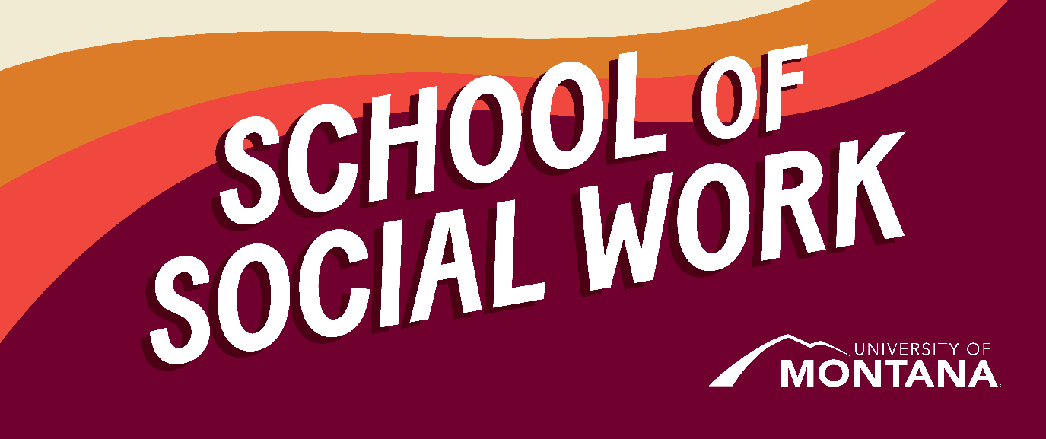
What's Up – A Newsletter from the UM School of Social Work
Welcome to Spring Semester
By Amanda Cahill, MSW Director
We hope you were able to enjoy a nice winter break over the last weeks. We recognize that many of you are experiencing extreme stress regarding the state of the world and what is happening in the U.S. Please remember the UM resources available that can be found here. Wellbeing support coaches are available to all UM students. As always, please reach out to us to let us know what you need and how we can best support you.
MLK JR Lecture: Resistance, Resilience, and Radical Love
The School of Social Work is proud to co-sponsor this lecture on February 4th. Please mark your calendars. This is an in-person event, should an online option become available, we will email the information.
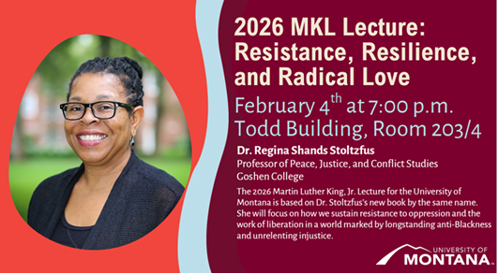

Experiencing Severe Financial Hardship? The School of Social Work May Be Able to Help
The School of Social Work was gifted a fund from the legacy of Jerry Nagel Jr. to “assist students experiencing financial hardship impacting their education”. This fund is to be used when students are having severe financial difficulty that could result in them dropping out of classes. The fund can be used by BSW and MSW students. If you are experiencing financial hardship, reach out to Dr. Sarah Reese to access the application for this funding. Please note that we are still figuring out the process for the funding and that funds are typically going to take up to two weeks to become available.
Submit an Article to the NASW Montana Newsletter
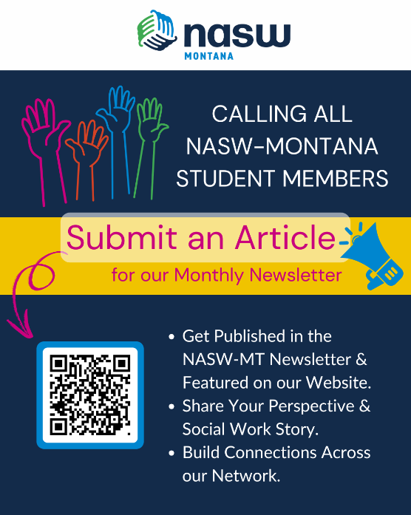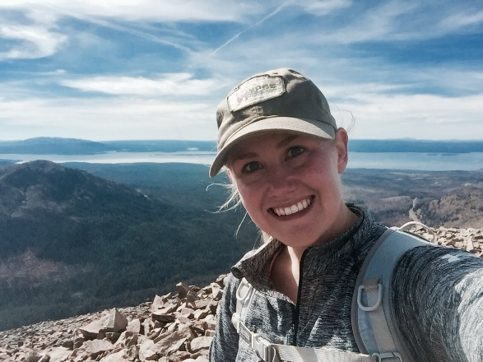
Hi everyone! My name is Katy Melton, and I’m an MSW student at UM completing my practicum with NASW–Montana. In this role, I work closely with the director, board members, and committees on projects related to professional development, ethics, policy, and member engagement.
One project I’m especially excited about is expanding student and member voices within NASW–MT. We’re inviting students to submit short articles (250-500 words) for our monthly newsletter that share experiences, perspectives, passions, or reflections related to social work. This is a great opportunity to get published, build your professional presence, and contribute to our statewide social work community.
To learn more, submit an article, and see where submissions are featured on our website, please visit our Member Voices page: https://naswmt.socialworkers.org/Membership/Member-Voices.
If you have any questions or want to talk through an idea, feel free to email me at intern.naswmt@socialworkers.org. I’d love to connect!
Thanks so much and I am excited to hear from you! -Katy
Congrats to MSW Online Graduates!
This December, the MSW Online program celebrated the graduation of its 4th and 5th cohorts! Cohort 4 finished in August 2025, and Cohort 5 graduated this December. Both cohorts walked at the December 2025, UM-wide commencement ceremony.
We held a celebration immediately following the large commencement, and hosted about 140 people. Many folks traveled from several states away! Thank you to all Graduates, Friends, and Families who made the trip. We understand that winter in Montana, as well as time and financial commitments, makes travel hard. Your effort to get here was not lost on us, and your presence was deeply valued. Those that couldn’t make it – know that we were celebrating you as well! An additional thank you to those who were able to join virtually.
A special shout out to Cohort 4 and 5 Student Speakers, voted by their classmates – Christina Bucarey and Cathán Tautfest, respectively. Thank you to you both for taking the time to prepare such meaningful speeches, and to represent your cohorts at your respective celebrations.

Christina and her husband, Cohort 4 Student Speaker
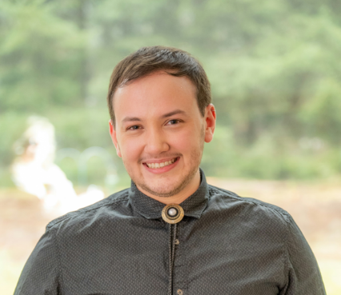
Cathán Tautfest, Cohort 5 Student Speaker
I also want to highlight Kimmie Garner, who made the trip from North Carolina, with her husband, Sam, and two young children, to celebrate with us. Kimmie is an Assistant Director of Field Education, Clinical Assistant Professor, and also serves in the vital Student Support role for the MSW Online program. Many of you have had her as your Field Liaison/Seminar Instructor. Kimmie is an alum of the MSW program here at UM, so it was very special to have her back in Missoula, celebrating new graduates
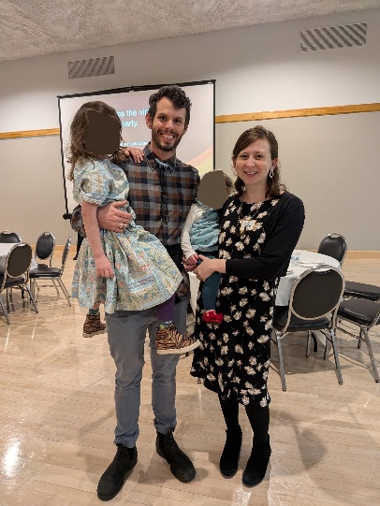
Kimmie, husband Sam, and kiddos at December's celebration.
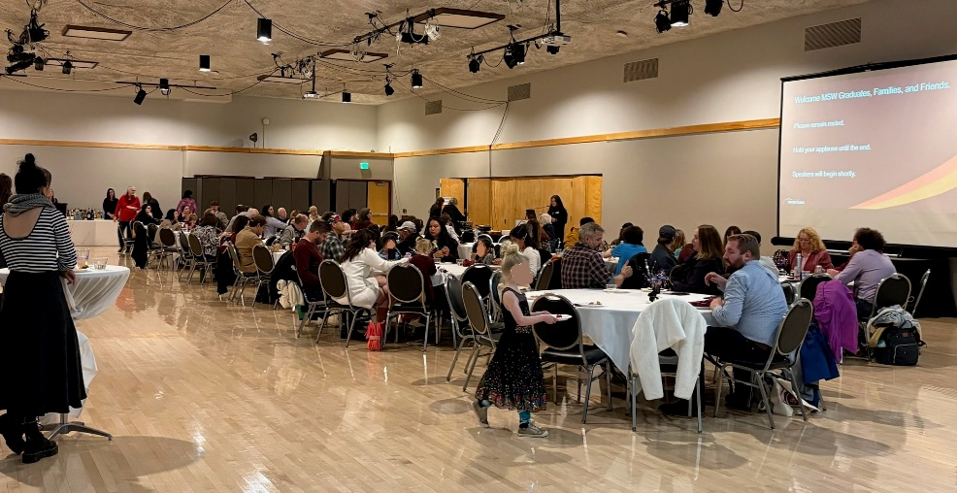
View of the South Ballroom and all guests.
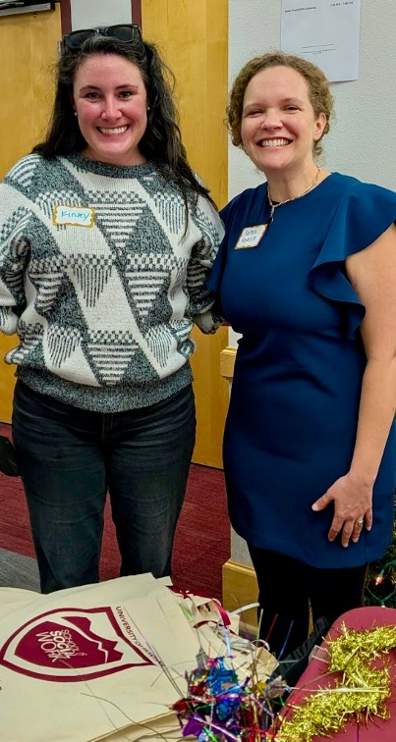
Kinsey Webb, MSW Online Program Manager, and Dr. Sarah Reese, UMSSW Chair, pose for a quick picture
Mariah’s Challenge Fundraiser – Local MSW Student Requesting Contributions
By John Lappin
The School of Social Work is proud to co-sponsor this lecture on February 4th. Please mark your calendars. This is an in-person event, should an online option become available, we will email the information.
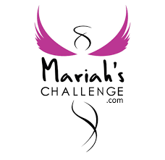
My name is John Lappin and I am currently in my second year in the Masters of Social Work Program through the University of Montana. I grew up in Butte, MT. I graduated from Butte High School in 2006. I work as a Clinical Treatment Supervisor with Community, Counseling, and Correctional Services, Inc at the Butte Men’s and Women’s Prerelease Center.
I am currently on the board of Mariah’s Challenge. As a member of the Mariah’s Challenge Board of Directors, I am able to be part of a group of great people that help advance the organization’s mission to inspire young people to make positive choices and to honor the legacy of Mariah Daye McCarthy. In this role, I contribute to fundraising, governance, and strategic direction, ensuring that programs and outreach efforts remain true to the mission of promoting safe, healthy, and responsible lifestyles.
We are currently in the beginning stages of collecting donations for our annual fundraising event. Each year, our auction and raffle play a key role in raising the funds needed to support Mariah’s Challenge Scholarships—awarded to high school seniors who pledge to live with integrity, refrain from underage drinking, and act as positive leaders in their communities. Since 2008, we’ve awarded over $300,000 in scholarships thanks to the generosity of donors like you.
This year, we will once again gather to celebrate our mission—and we’re seeking in-kind donations for our silent auction and raffle. Whether it’s a gift basket, art piece, weekend getaway, professional service, restaurant gift certificate, or other unique item or experience, your contribution will help us inspire the next generation of responsible, purpose-driven youth.
In return for your donation, your name or business will be recognized during the event, on our website, and across our social media platforms—reaching thousands of community members who support our mission and values.
Mariah’s Challenge was born from tragedy but has grown into a powerful movement of hope. With your help, we can make this year’s event the most impactful yet—and continue to honor Mariah’s spirit by lifting up the voices and values of Montana’s youth. If you are able to contribute to our raffle or silent auction, please contact me directly at lappinjf@gmail.com or (406) 498-3522.
Alumni Alert!
Alumni of UMSSW (BSW, MSW), please reach out to have your work highlighted. We always want to know about, and uplift, what former students are doing, and the positive ways you are now impacting communities. Or other cool things you’re doing!
Send a short blurb to social.work@mso.umt.edu, subject Newsletter.
Student Advisory Council (SAC)
The SAC is back and ready for a new semester! Join us for our next meeting on Jan 23rd (Friday) at 5:30 pm in UC Room 224 OR online via Zoom: https://umontana.zoom.us/j/3420294593. We’ll be taking care of key setup items such as leadership roles, the mission statement, and bylaws, and brainstorm ways to grow our membership and work toward UM ASUM recognition. Be part of building the SAC this semester!
You're receiving this update because you're part of the UM School of Social Work community.
University of Montana – School of Social Work • Jeanette Rankin Hall • Missoula, MT

