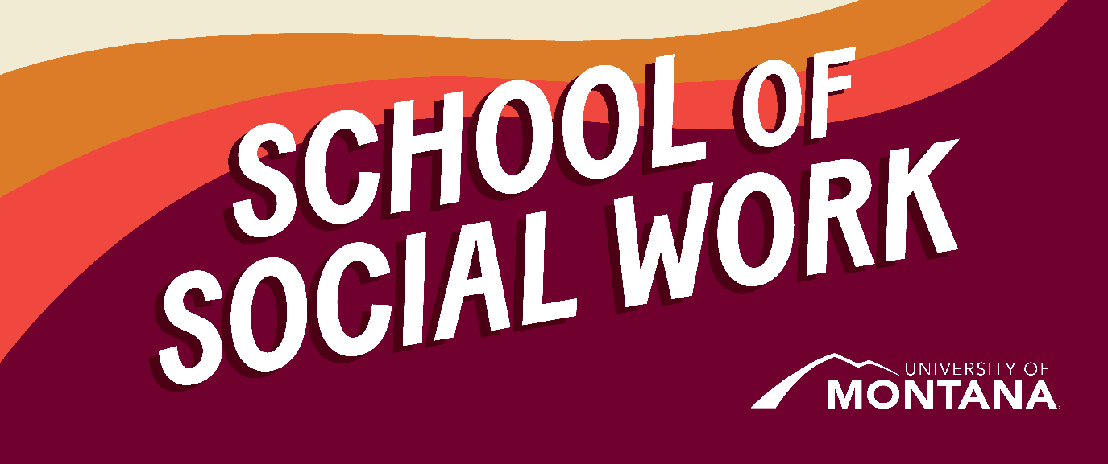
What's Up – A Newsletter from the UM School of Social Work
Transition to Canvas – Goodbye Moodle!
The Montana University System recently adopted Canvas as the next statewide learning management system (LMS). An LMS (currently Moodle) is used to deliver educational content. Beginning in Fall '24, all courses will be housed in Canvas instead of Moodle.
To start you off with using Canvas, a student tutorial called UM Passport to Canvas is available to help orient you to the Canvas environment and support your transition to the new LMS. This online, self-paced tutorial takes approximately 2 hours to complete fully. You can select which topics to do and complete them in smaller chunks to fit your schedule. No account login is needed to access this tutorial— use this link to begin: UM Passport to Canvas. Please complete this tutorial on Canvas before the start of your Fall Canvas course.
To log in to Canvas, go to my.umt.edu, select the Canvas icon, and then use the Net ID login link. Log in with your usual Net ID and password to access your Canvas Dashboard. Once your instructor has opened the course, you will see it on your Dashboard. In the meantime, you can view and edit your profile (as explained in the UM Passport to Canvas tutorial). If you have any issues logging in to Canvas, please get in touch with Canvas.umt@umontana.edu.
While we recognize that no one usually likes change, we are excited to report that students who trialed Canvas have vastly preferred it to Moodle. We know that there will be bumps/glitches, but we are hopeful that we can all have grace with the transition. Please reach out with questions.
Again- this change will occur in the Fall semester. For Summer, please plan to continue using Moodle.
Of note- some students have already begun working in Canvas (all Advanced Standing MSWs and all of the Summer Cohort 2024 of the Online MSW program). You'll be ahead of the learning curve in August!
ONLINE MSW Students- be sure to get into Moodle and save key assignments for portfolio. You have been getting information about this, but if you have questions after you review those emails, please reach out to Laura, laura.guay@mso.umt.edu.
Social Work Votes!

Image of Latino Voter Empowerment Coalition Logo, a blue fist in the air with red and white text "tu voto cuenta."
What is at stake in November? In Montana alone, All Ballot Issues include reproductive freedom, public land use, and tiered elections. Each of these issues has a huge impact on social workers.
By registering and encouraging people to vote, social workers:
- Improve individual well-being (micro)
- Empower individuals and communities to be decision-makers (micro/mezzo)
- Strengthen organizations and communities (mezzo)
- Influence government decision making (macro)
- Secure social policies that promote social justice (macro)
- Overcome voter suppression (macro)
LCSW and other Licensing in MT
LCSW licensing requires an MSW degree. Recently, Nathan Stahley, Director of the MT NASW, spoke to the graduating class of MSWs regarding the licensing process. If you'd like to hear more about this process and watch the recording- see this link!
For additional licensing information, visit the Board of Behavioral Health website. There, you'll find information about all social work licenses at both bachelor's and master's levels.
Trauma Skills Course Coming to UM
By Professor Sarah Fielding
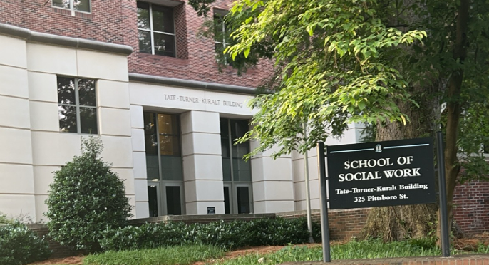
Image of a school of social work sign in front of the Tate-Turner-Kuralt building
During the first week of June, I had the opportunity to attend The National Initiative for Trauma Education and Workforce Development Summer Institute at the University of North Carolina. During the institute, I met with professors around the US, learning how to teach the Core Components and Skills for Trauma Informed Practice. This course facilitates students' acquisition of the knowledge, skills, and attitudes necessary to effectively use 12 common trauma-informed practice elements in interventions for the treatment of traumatized children and their families. This course highlights consideration of the impact of trauma, intervention objectives, and the practice elements needed to accomplish intervention objectives. This course is taught using an inquiry-based learning (IBL) pedagogy to enhance students' engagement and learning, using full-length cases that exemplify the diverse clients a clinician might encounter in practice. This elective course will help future social workers have a tangible skill-based tool kit who want to work with children and families who have experienced trauma, understanding the combined impact of disproportionate exposure to current trauma, and experiences of historical trauma, marginalization, racism, and oppression shapes the perceptions of children and families, cultural groups, and the broader systems they live in. This course is currently in development for all the MSW programs and will be offered Summer and Fall of 2025.
Student Spotlight: Emma Simuns Lands a Fulbright Research Fellowship in Italy!
By Professor Jen Barile
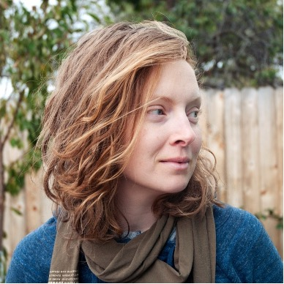
Image of Emma Simuns with blonde hair, blue sweater, and a brown scarf.
Tell us a little about yourself and why you chose the UM School of Social Work for your degree.
I grew up in Eureka, Montana, and moved to Missoula about 15 years ago to attend the University of Montana. I was the first person in my family to attend college, and I graduated with a degree in Classics. I spent about a decade working fulltime in both for- and nonprofit sectors. During this time, I became curious about pursuing a graduate degree. My own experience with therapy led me to explore social work. As a non-traditional graduate student, I chose UM's School of Social Work program for a couple of reasons, including its online class offerings and its community connections, especially around practicum placements.
Where are you doing your practicum?
I am doing my practicum at the Center for Children, Families, and Workforce Development at the University of Montana. We're currently facilitating a statewide community health worker committee (CHW) that's working to develop a set of recommended definitions for the workforce that will include the scope of practice, CHW definition, code of ethics and training requirements. It's the hope that these recommendations will inform education with decision-makers to address sustainability and additional funding needs for this workforce.
What have been the most challenging and rewarding aspects of your practicum?
The most challenging aspect of my practicum is facilitating the committee, as it's been my first time doing group work outside of a classroom setting, and I am not a big talker. I've found continuing to prepare in advance for the committees eases the anxiety. A rewarding aspect would be translating my writing skills from previous jobs in marketing and communications into researching and writing reports that inform key stakeholders of the CHW workforce.
What are your future plans and/or job interests after completing your social work degree and practicum?
I'll be heading to Catania, Sicily, in early fall for a 9-month Fulbright research fellowship. I was inspired to apply last year during my practicum at Missoula Interfaith Collaborative, where I was involved in the social enterprise program at Missoula Works. MW employs individuals struggling with long-term unemployment in addition to providing them with social services such as housing navigation, job coaching, and service coordination. The importance of centering values and relationships was always highlighted, and it planted the seed for my research project. As someone who comes from a low-income family that engaged with programs that failed to center user voices, I am passionate about examining the nexus of reflexivity, positionality, values, and power differences that exist between those who provide services and those who receive them. At the University of Catania, I will research the impact of social enterprises' stated core values on program participants in Southern Italy. My goal is to enhance the lens through which social enterprises implement values by centering participant perspectives to lead to better outcomes and care. Even though the Fulbright application (and waiting period!) was lengthy and intense, it was time well invested. I'm excited (and nervous!) to be doing research in another language for the upcoming year. I want to give a shout-out to Kylla Benes at the Office of External Scholarships and Fellowships, professors Jim Caringi and Logan Cook, and my AFI Zeke Campfield for investing in my Fulbright application.
Restorative Justice
By Jen Molloy
As a reminder…Restorative Justice is a philosophy with associated practices rooted in Indigenous teachings that emphasize our interconnection by repairing relationships when harm occurs while proactively building and maintaining relationships to prevent future harm. Restorative Justice can be practiced in education, criminal legal, and community settings. – Amplify RJ
This month, I wanted to provide us all with an invitation for reflection:
What If?
- We believed that our community was wise enough to solve our own conflicts?
- We actually listened when survivors told us what they need?
- We provided a space where everyone could share their whole story?
- We helped people listen to one another with empathy?
- We gave people responsible for harm the choice to actually make a difference?
- We focused on healing and safety, rather than punishment and rules?
What if? Reach out to me at jen.molloy@mso.umt.edu if you would like to explore implementing restorative justice in the spaces you live, work, or have influence.
You're receiving this update because you're part of the UM School of Social Work community.
University of Montana – School of Social Work • Jeanette Rankin Hall • Missoula, MT

