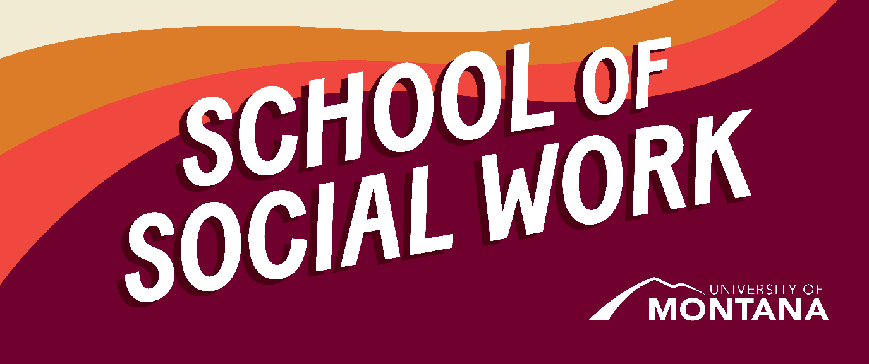
What's Up – A Newsletter from the UM School of Social Work
Holly Harris, MSW Student Recipient of Prestigious Graduate Studies Scholarship
By Kinsey Webb
The School of Social Work is honored to announce Holly Harris as the recipient of the prestigious Bertha Morton Scholarship.
Holly, a second-year student in the MSW online program, currently resides in Great Falls, Montana. Holly’s long-term goal is to become a counselor specializing in loss, grief, and bereavement as well as anxiety, depression, and trauma.
Bertha Morton was a Helena, Montana native who worked most of her adult life for the Internal Revenue Service in Helena. She was not an alumnus of The University of Montana, nor did she attend any university. She worked hard and saved her money. When she died in 1977, she left a large part of her estate to the UM Foundation because she desired to encourage and help serious students obtain an education here. Bertha Morton fellowships and scholarships have subsequently become our most prestigious awards for graduate students.
This prestigious award acknowledges Holly’s place among the top five percent of the University’s graduate students in areas of academic performance, research, and creative activities.
Congratulations, Holly!
The School of Social Work’s Dr. Phyllis Ngai Receives Distinguished Teaching Award
By Sarah Reese
The School of Social Work wishes to congratulate Dr. Phyllis Ngai on receiving this year’s Distinguished Teaching Award.
The Distinguished Teaching Award is a significant honor bestowed on one UM faculty member with a history of excellence in teaching and demonstrated exceptional impacts on student learning and success.
Dr. Phyllis Ngai, Clinical Associate Professor of Social Work, creates classroom experiences that are both rigorous and deeply human-centered. Her students describe her as “the best professor I’ve ever had,” and her feedback as “transformative.” Dr. Ngai challenges students to think critically, reflect deeply, and grow personally. Through her relational approach, students feel seen, supported, and inspired to give their very best. As one student said, “She didn’t just teach the class—she took the class with us.”
Congratulations, Dr. Ngai!
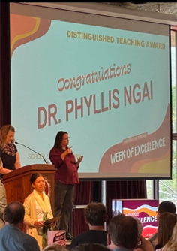
Dr. Phyllis Ngai
Recruiting for the 2025-2026 Student Advisory Council
By Meghan Intermill, Susan MacLean
The School of Social Work has been actively engaged in the reaccreditation process with the Council on Social Work Education this past year. Throughout the process the need for a Student Advisory Council (SAC) came into focus. Over the past year, we have collected information from current undergraduate and graduate social work students in both in-person and online programs about their vision for an SAC. Thank you to everyone who contributed your thoughts and ideas. The purpose of the SAC moving into the upcoming academic year is structured around:
- Advising: The SAC will advise on topics that impact students, such as programs, promotions, and outreach.
- Advocating: The SAC will advocate for student concerns and grievances.
- Promoting: The SAC will promote innovative ideas and initiatives.
- Communicating: The SAC will serve as a communication channel between students and the School of Social Work.
If you are interested in a leadership role on the Council, please use this link, to indicate such.
Coming Soon to the School of Social Work! Dr. David Kilmnick
By Amanda Cahill
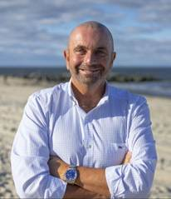
Dr. David Kilmnick
We are thrilled to announce Dr. David Kilmnick has been hired as our newest Clinical Assistant Professor in the School of Social Work! A more complete introduction will be sent to students and faculty in July, but a quick preview:
Dr. David Kilmnick is a seasoned social work educator and practitioner with over 27 years of teaching experience, including 18 years in online instruction. He is known for creating student-centered, equity-driven online learning environments that integrate theory and practice. As a Council on Social Work Education (CSWE) Accreditation Site Visitor, Dr. Kilmnick brings deep expertise in curriculum development and assessment. He is also the Founder and longtime President of the LGBT Network, where he has led national efforts in advocacy, coalition-building, and community empowerment. His forthcoming textbook, LGBTQ Macro Practice & Social Change, reflects his lifelong commitment to social justice. Dr. Kilmnick is dedicated to preparing future social workers to confront complex challenges and advance dignity, equity, and systemic change.
Dr. Kilmnick was recently featured in this video of the Pride Event in Long Island.
BSW Students Present at the University of Montana Conference on Undergraduate Research (UMCUR)
By Dr. Hannah Knipp
Congratulations to the four BSW students who presented at the 2025 University of Montana Conference on Undergraduate Research (pictured below, left to right, top to bottom): April Jackson-Andal, Shawn Bouffard, David Payseno, & Erin Heaton. An additional congratulations to Erin for receiving the “Engaged Scholarship Award” and Shawn for receiving the “Performing Arts Award.” The School of Social Work Faculty commends these four impressive BSW students for their outstanding scholarship and scholastic contributions.
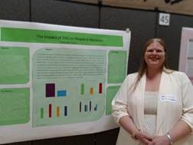  April Jackson-Andal: The Impact of THC on People in Recovery. | 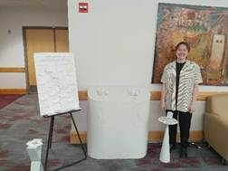  Shawn Bouffard: Sound of Us: An Interactive Experience Sound of Us.
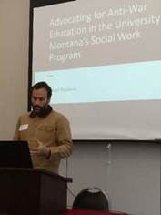  Dave Payseno: Advocating for Anti-War Education in the University of Montana's Social Work Program. | 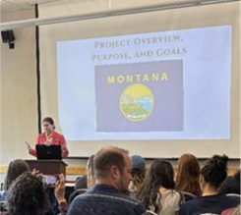  Erin Heaton: Queer In & Out of Montana: Oral Histories of the LGBTQ+ Exodus from Montana.

Social work education beyond the classroom - global, grounded, and deeply human.
University of Montana Social Work students recently completed a 10-day immersive study abroad course: Social Justice & Integration – German Perspectives on Refugee Resettlement. Developed and led by Professors Kat Werner and Zak Reimer - both UMSSW graduates and practicing social workers in the U.S. and Berlin - the course explores refugee and migration policy through a transatlantic lens.
Students engaged directly with German and EU policymakers, frontline social workers, NGOs, and refugee advocates. Workshops with a Center for Deliberations facilitated critical discussions on democracy, populism, and values-based dialogue. Visits to refugee arrival centers run by the State Office for Refugee Affairs and the German Red Cross highlighted frontline service delivery. Site visits to Sachsenhausen Concentration Camp, Topography of Terror, and the Documentation Centre for Displacement deepened students’ understanding of Germany’s historical reckoning (Vergangenheitsaufarbeitung) and its ongoing work around integration and democracy.
As one student reflected: “Themes in Berlin’s refugee crisis closely mirror U.S. debates. We can learn so much about cultural humility, diversity, and engaging with sensitive topics by looking to successful models abroad.”
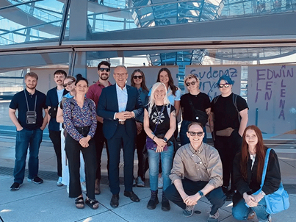
Group picture with Tobias Winkler, MdB after an engaging discussion.
Honoring our Leaders Celebration
By Jen Molloy and Carew
The School of Social Work relies on faculty who serve in both informal and formal leadership roles to support the school’s mission and vision, ensure integrity of programs, manage resources and growth, and much more. While their work often goes unnoticed by faculty, staff, and students, it is critical to the school’s success.
At the end of the spring semester, we had a celebration to recognize our formal leaders and honor their contributions. This year the celebration was marked with a transition of two important roles—Sarah Reese took on the chair position previously held by Ashley Trautman and Laura Guay took on the BSW Director position previously held by Deanna Cooper. As is tradition, Co Carew led the ceremony and crafted a sash, worn as part of graduation regalia, for Ashley to present to Sarah. The celebration also included a prayer song by Benji Headswift, UM Alum and Northern Cheyenne Tribal Member, that reminded us of the great honor and responsibility of leaders.
Followership plays a vital role in effective leadership. Key traits of strong followership include deep listening and a willingness to walk alongside leaders in support of solution-oriented, collaborative work. The faculty thoughtfully expressed their commitment to supporting both the leadership and the broader team, with the shared goal of uplifting everyone and fostering success. Our current leaders continue to be mentored by former leaders—individuals who exemplify dedication, respect, and a deep commitment to the success of all our programs.
We are deeply grateful to these individuals who are stepping into leadership positions. Under their guidance, we will collectively foster growth while sustaining and strengthening all of our programs. Together, individuals in the School of Social Work are building a thriving, supportive community that remains focused on serving students and communities well into the future.
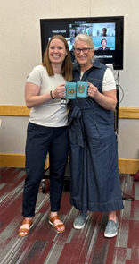  Laura Guay and Deanna Cooper | 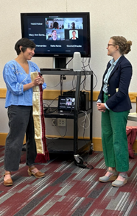  Ashley Trautman and Sarah Reese | 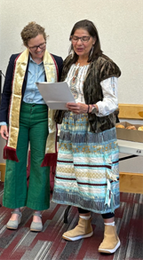  Sarah Reese and Co Carew

Global Perspectives on Restorative Justice: Supporting Children on the Move
By Jen Molloy
In May, I attended the 13th International Seminar of the European Forum for Restorative Justice (RJ), titled Crossing Borders – Building Futures: Restorative Justice for Children and Young People on the Move hosted by the University of West Attica School of Social Work in Athens, Greece. The seminar provided a space for restorative justice practitioners and researchers from around the world to consider the transformative potential of RJ in addressing the vulnerabilities – violence, exploitation, and discrimination – faced by children on the move. It was extremely inspiring to be part of such critical discussions. Time was spent considering what pathways RJ might provide for children impacted by migration and dislocation where healing, rebuilding trust, and inclusion can be experienced. Attendees also explored how to create inclusive spaces for dialogue and mutual understanding with host communities and institutions. The seminar challenged participants to ask difficult questions about what transformative approaches are possible, that foster supportive environments in schools, families, communities, and institutions upon arrival and during the integration process. The best part was meeting new colleagues and exploring opportunities to bring students together virtually to learn from one another and for global collaboration on research projects.
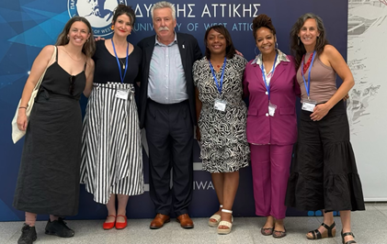
You're receiving this update because you're part of the UM School of Social Work community.
University of Montana – School of Social Work • Jeanette Rankin Hall • Missoula, MT

