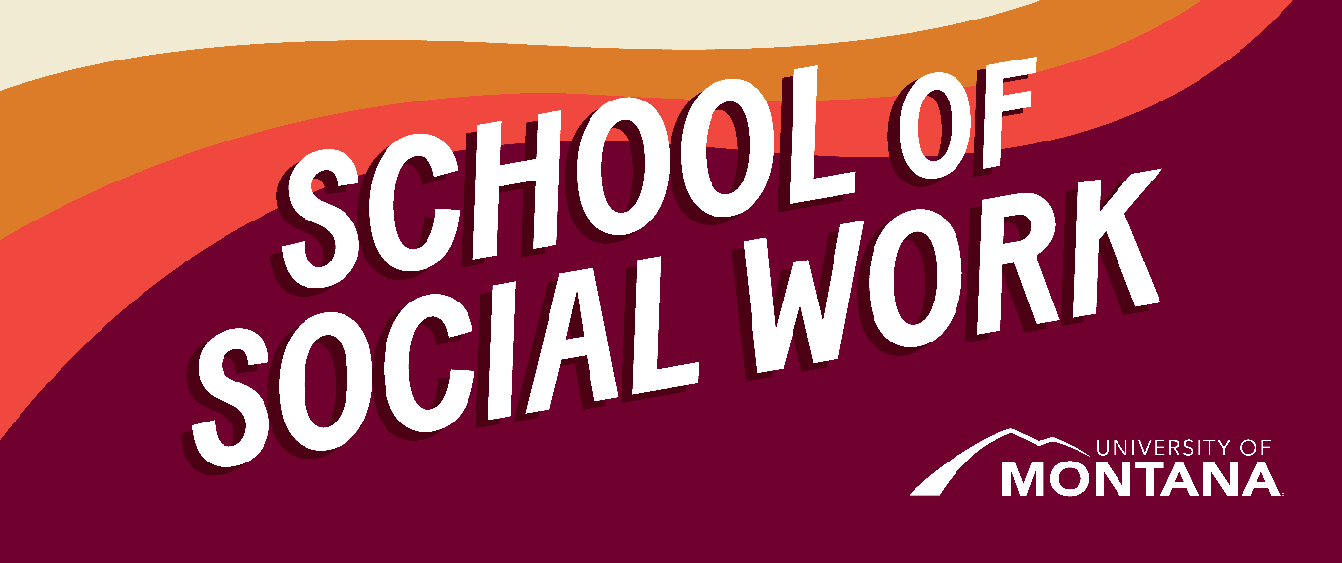
What's Up – A Newsletter from the UM School of Social Work
Practicum Student Spotlight: Jess Monis-Hernandez
Supporting BIPOC Youth
By Professor Jen Barile
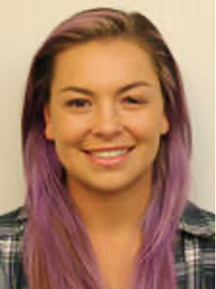

Jess Monis-Hernandez is a first-year MSW student completing her practicum placement at EmpowerMT as a Youth Program Coordinator in Missoula, Montana. As part of her role, Jess runs the ABY youth program for middle and high school students – the Association of Black, Indigenous, & Youth of Color – an after-school affinity club recently highlighted by KPAX News for their important work in supporting BIPOC (Black, Indigenous, People of Color) youth in the Missoula community. The ABY group provides a safe space for BIPOC youth to "cultivate resilience, learn a more inclusive history, elevate leadership, and build collective power toward racial justice" (Empower MT, n.d.).
As part of her work, Jess also supports LGBTQ2S+ youth through EmpowerMT's Youth Forward and Be You Crew programs, both designed to "empower queer youth by providing a safe space for LGBTQ2S+ youth to connect and organize around relevant issues" (EmpowerMT, n.d.). Through their work, Jess and the EmpowerMT team help to ensure that the voices and experiences of underrepresented youth are centered, increasing their confidence and creating a sense of belonging. These youth are also provided with additional support and leadership skills so that they can become thoughtful leaders in their communities, exploring complex issues like identity and systems of oppression (EmpowerMT, n.d.; Sam, 2024).
To learn more about EmpowerMT, follow this link: Learn more about EmpowerMT.
For the full KPAX article, follow this link: Read the full KPAX article.
BSW Spotlight: Kailey Hall
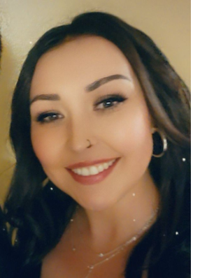
I am a UMSSW Alumna. I graduated in 2022 with high honors from the 2+2 BSW Program and was a speaker for the SSW for graduation. I faced many tough obstacles during my enrollment, including my enrollment and financial aid into the University. I explored many options for funding to help pay for my enrollment into the University of Montana and Blackfeet Community College. My role with the students is to help connect UMSSW 2+2 students with scholarships and other fund resources and help them through the program with their educational/program questions to alleviate the stress so they can finish the program.
As a part of the program, I look forward to helping the students become successful and being the tribal liaison between our indigenous students and program staff.
BSW Advising
If you have not yet made an appointment for advising, please reach out to Heidi Holzer at heidi.holzer@mso.umt.edu.
Reminder: Stay Informed; Connect with Campus with Griz Hub

Visit Griz Hub to search events, organizations, and news articles from UM and beyond.
International Studies…Did You Know?
By Dr. Phyllis Ngai
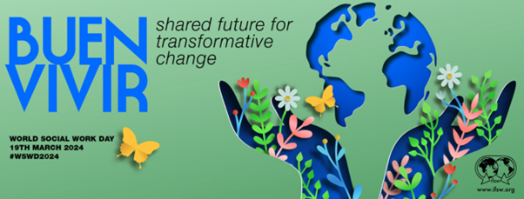
Did you know March 19th is World Social Work Day?
Read more about this year's theme, Buen Vivir: Shared Future for Transformative Change, and learn more about the History of World Social Work Day.
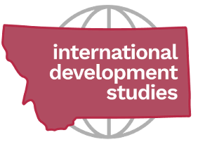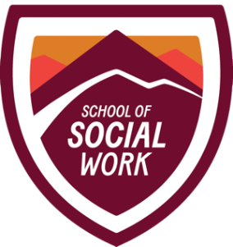
Did you know UM's International Development Studies Program (IDS) is now affiliated with the School of Social Work? IDS offers a minor, a graduate certificate, and the Peace Corps Prep certificate for both on-campus and online undergraduate students and on-campus graduate students. (Information for online graduate students will be forthcoming). If you're interested in EXPLORING the world, DEVELOPING a global mindset, and SERVING underserved near and far, find more information about various learning opportunities, a student club, scholarships, and a graduate mentor position by following this link: Learn more about the International Development Studies Program.
Engage in Local and National Elections
By Kimmie Garner
With many local primaries underway across the country and a federal election coming up in November, there is no better time than the present to ensure you are registered to vote, up to date on the constituents representing you, and aware of ways to get involved in voter registration and engagement more broadly.
Please check out the attached Call to Action from Voting is Social Work for ideas on engaging in this year's local and national elections. Voting is Social Work is a nonpartisan initiative that supports social workers in voter registration and engagement. Your voice matters and ensuring voting rights are protected and upheld is a key pillar of social work practice!
graduate mentor position by following this link: Learn more about the International Development Studies Program.
Democracy Summit – March 27th!
(3 Events available online! See below in blue)
On March 27, 2024, in conjunction with a President's Lecture visit from noted democracy scholar Danielle Allen, UM's Co-Lab for Civic Imagination and its Director, Professor Michael Rohd, will co-host a campus wide summit on democracy and democracy education. The day will feature lots of ways to engage across multiple locations, student-led activity, faculty voices, creative approaches to participatory dialogues, and performance/art. Three questions will guide our activities and conversations across the day's events:
- What does UM do in the classroom and beyond to prepare students to participate actively in a democratic society?
- What do UM students want from the University regarding democracy education?
- What can we imagine together- UM students, faculty, and staff- that can build and sustain institutions and communities rooted in healthy democratic practices?
Full Democracy Summit Schedule-
Available Online:
10 am- 10:30 am
In this session, award-winning UM history professor Kyle G. Volk talks about his approach to researching the history of U.S. democracy and his current project exploring the place of “personal liberty” in American public life.
Kyle Volk
Zoom session: https://umontana.zoom.us/j/98287536006?pwd=VkxMY25VQ1hTQlIwY1RPVFMwaC9ldz09
11:15am- 12 noon
Join Missoula County Election Advisory Board chair and election scholar Christina Barsky for a spirited dialogue about how seemingly small choices can have tremendous impact on democracy. From the infamous butterfly ballot and Cyber Nijas to increasing calls for hand counting ballots and stricter voter ID requirements, this session will explore contemporary issues of consequence to the American elections system and everyday citizens.
Christina Barsky
Zoom session: https://umontana.zoom.us/j/99780159700?pwd=ZHJQZXdDMEJkbGRzbWJ1SmZuRWhKUT09
1:30-2:15 pm
During the 6th century BCE, the Greeks invented a new form of government that they called demokratia (“power of the people”), whose defining characteristics were equality among and meaningful participation by all citizens, regardless of their socio-economic status. In this session, Professor Scott Arcenas (History & Classics) will give a short presentation and lead a longer conversation on this highly influential but widely misunderstood form of government.
Scott Arcenas
Zoom session: https://umontana.zoom.us/j/92224075157?pwd=b0t6M1Z1OXJTb1BucWxQZmVnQ1ZRUT09
UMSSW MSW Alumna wins national Heart of Social Work Award
By Kat Werner
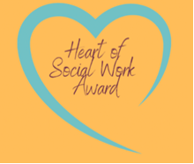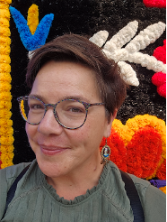
Each year the North American Network of Field Educators and Directors (NANFED) recognizes and honors excellence in social work field instruction via the Heart of Social Work Award. The UMSSW Field Education Team nominated Emily Dillow (LMSW, LCSW) and is excited to announce that NANFED officially chose Emily as this year's award winner.
Emily's career in social work has taken many paths since graduating with her master's degree from the University of Montana School of Social Work in 2011. Since then, she has worn many hats: from group home manager to case management and program management with the state of Montana to providing behavioral interventions in a primary care setting. Since 2019, Emily has dedicated her time to improving behavioral health systems within the medical setting at Community Medical Center in Missoula, MT. She was first started as a clinician within a clinic and moved into management to oversee the growth and improvement of Integrated Behavioral Health. She is an advocate for suicide prevention and intervention by providing training for the outpatient teams, supporting policy changes, and cultivating partnerships within the Missoula community. Most recently, she filled the role of Southwest Representative with the NASW-MT board to further support and advocate for the empowerment of social workers within the state of Montana. Here at UMSSW, Emily has served in various roles and as a critical mentor to many students as an outside supervisor, field liaison, and long-term Agency Field Instructor for many students in various practice settings. In her personal life, Emily is an enthusiastic novice hockey player, paddleboarder, and dog mom of two adorable mutts in Missoula, Montana.
The Field Education Program here at UMSSW is so GRATEFUL to have had Emily as such a valuable member of our team. Her kindness, support and experience has been invaluable to many of our students and this award is well deserved. Thank you Emily for all you do for our community and our students!
Restorative Justice (RJ) in Practice
By Dr. Jen Molloy
(This feature builds on the introduction to Restorative Justice offered by Dr. Jen Molloy in February's SSW Newsletter.)
RJ is as much a way of being, as it is a theory and practice that can be implemented in education, criminal legal, and community settings. Check out this Healing School Framework and consider the ways the questions posed can inform your practice. The invitation is for you to consider the ways your relationships support the creation of equitable and just spaces, regardless of the setting and on an internal-, interpersonal-, organizational-, and societal-level.
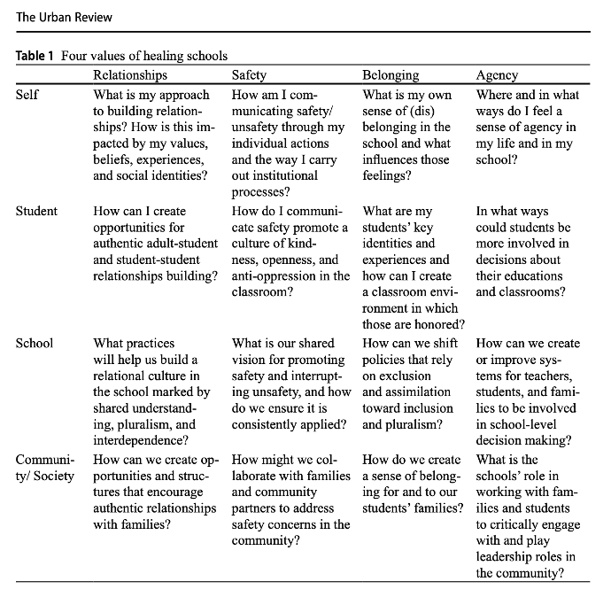
Image from: Parameswaran, U.D., Molloy, J. & Kuttner, P. (2023). Healing Schools: A Framework for Joining Trauma-Informed Care, Restorative Justice, and Multicultural Education for Whole School Reform. Urban Review. https://doi.org/10.1007/s11256-023-00666-5
You're receiving this update because you're part of the UM School of Social Work community.
University of Montana – School of Social Work • Jeanette Rankin Hall • Missoula, MT

