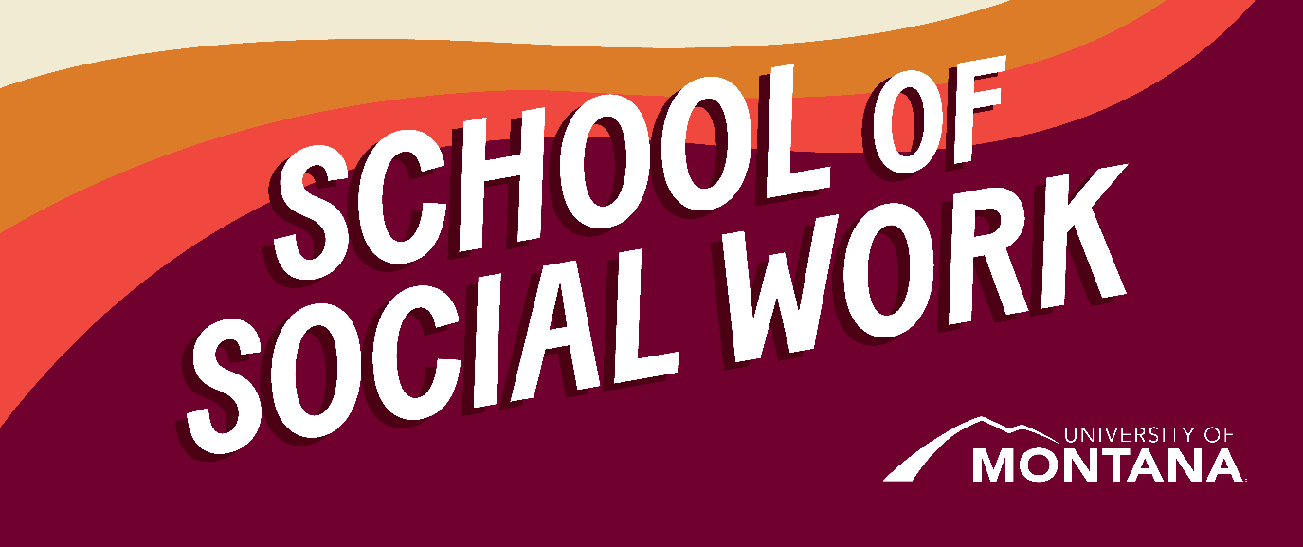
What's Up – A Newsletter from the UM School of Social Work
Happy Native American Heritage Month! Join us in celebrating by reviewing ideas in this article from NASW California on honoring Native American Heritage Month.
A Legacy of Giving Back
The University of Montana has been named the top university in the country for its service to its community and the country. The report comes from Washington Monthly, a U.S. politics and government magazine based in Washington, D.C.
Research Excitement
Congratulations to Dr. Jessica Liddell, Assistant Professor of Social Work, and UM MSW Student, Tess Carlson, for the publication of the following article in the Journal of Community Practice: “We Have to Learn How to Balance All of That: Community Health Needs of a State-Recognized Gulf Coast Tribe.” (Jessica L. Liddell, Tess Carlson & Haley H. Beech)
What about Thanksgiving?
Many social workers will find themselves conflicted about celebrating the holiday of ‘Thanksgiving.’ Below are some reflective articles that you might find helpful as you wade through thoughts and feelings that might arise this time of year.
- Ten Ways to Make Your Thanksgiving About Social and Environmental Justice
(Note: this is from 2016, but the ideas laid out are relevant and helpful).
- A Racial Justice Guide to Thanksgiving is a resource by the Center for Racial Justice in Education. I find this especially helpful and have sent lesson plan ideas to my son’s grade school teacher from this list.
Advocacy Spotlight
By Dr. Co Carew
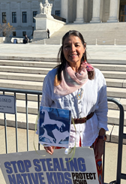
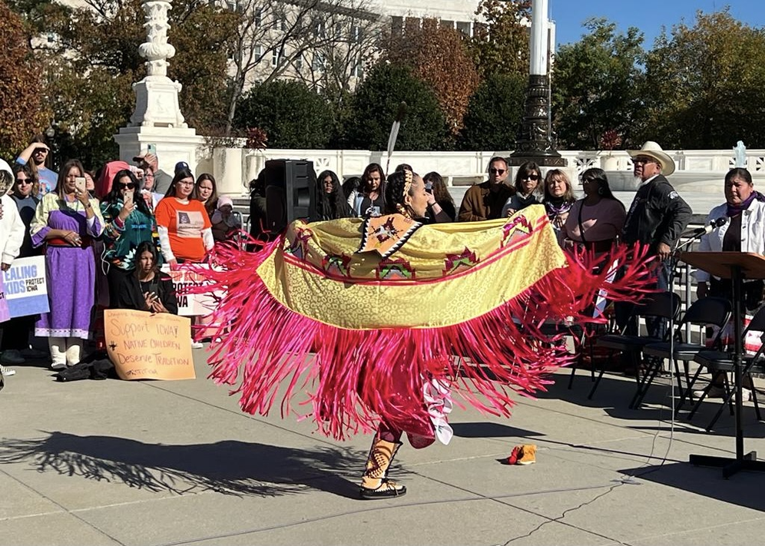
More than 300 supporters of ICWA attended the rally. The rally began with a sunrise blessing ceremony and continued with traditional Native American songs and prayers from Tribal elders, youth, and tribal organizations. I felt compelled to attend the Washington, D.C. rally to support ICWA and represent the University of Montana School of Social Work.
You're receiving this update because you're part of the UM School of Social Work community.
University of Montana – School of Social Work • Jeanette Rankin Hall • Missoula, MT

